The CROWN Act

“Creating a Respectful and Open World for Natural Hair”

HB 2935 (2021)



The CROWN Act which stands for “Creating a Respectful and Open World for Natural Hair,” is a law that prohibits race-based hair discrimination, which is the denial of employment and educational opportunities because of hair texture or protective hairstyles including braids, locs, twists or knots.

**History**

****First introduced in California in January 2019 and signed into law on July 3, 2019, the inaugural CROWN Act expanded the definition of race in the Fair Employment and Housing Act and state Education Code, to ensure protection in both workplaces as well as K-12 public and charter schools. Since then the CROWN Act has galvanized support from federal and state legislators in the movement to end hair discrimination nationwide. The U.S. Congress passed the CROWN Act of 2020 on September 21, 2020. The Oregon Legislature introduced HB 2935 in January 2021. Governor Brown signed the Act into law on June 2, 2021, making Oregon the 12th state in the Union to pass its version of the CROWN Act.

**Purpose**

The CROWN Act prohibits discrimination based on protective hairstyles. Protective hairstyles are defined as “hair color or manner of wearing hair that includes, but is not limited to, braids, regardless of whether the braids are created with extensions or styled with adornments, locs, and twists.” The law also expands the definition of “race” under ORS 659A to include “physical characteristics that are historically associated with race, including but not limited to natural hair, hair texture, hair type, and protective hairstyles.”

The CROWN Act specifically applies to Oregon employers and public schools. The CROWN Act also addresses dress codes that may have a disproportionate adverse impact on members of a protected class. Oregon anti-discrimination Act, ORS 659A, does not prohibit employers from enforcing an otherwise valid dress code or policy so long as the policy provides reasonable accommodations. The CROWN Act further specifies that the dress code or policy must not have a disproportionate adverse impact on members of a protected class to a greater extent than the policy impacts persons generally.

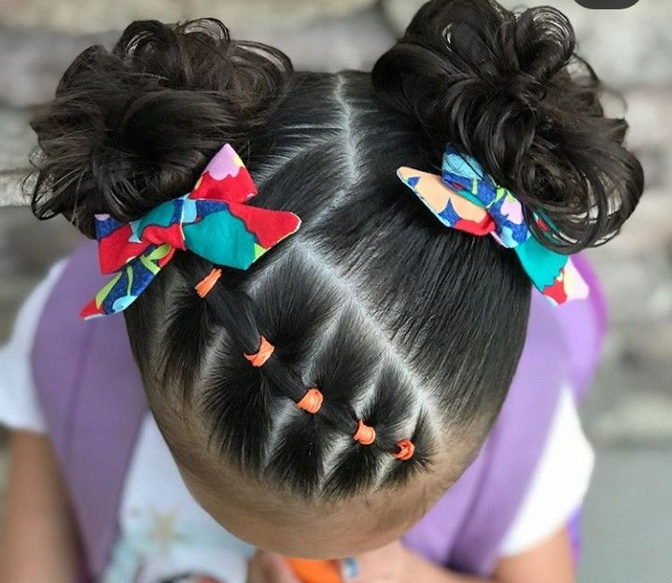**Complaint Process**

Complaints alleging race-based hair discrimination should be address using the district’s complaint process**.** If the complaint is not resolved to the complainant’s satisfaction, the complainant can file a complaint with ODE. If you would like more information about ODE’s complaints and appeals work, please visit the ODE website: <https://www.oregon.gov/ode/about-us/Pages/Complaints.aspx>

The complaint can also consider filing a complaint with the US Department of Education Office for Civil Rights.

Additional Resources

ODE has created a website to provide additional information about the CORWN Act. Please visit <https://www.oregon.gov/ode/about-us/Pages/CROWN-Act.aspx> for additional reading resources, examples of protected hairstyles and a free downloadable version of the CROWN Act poster.