STATE BOARD OF EDUCATION – TOPIC SUMMARY
Topic: Opal Public Charter School Waiver Request
Date: September 19, 2013
Staff/Office: Kate Pattison/Student Learning
Action Requested: Informational Only Adoption Later Adoption Adoption/Consent Agenda

ISSUE BEFORE THE BOARD: Whether the State Board of Education should approve a request for enrollment priority to be given to the children of the Opal Public Charter School employees for the remainder of their contract with Portland Public School District.

BACKGROUND:
The Opal Public Charter School serves approximately 88 students in grades K-5, and is sponsored by the Portland Public School District. Opal Public Charter School has operated since September 2001 in Portland, Oregon as a charter school. In 2011-12, Opal received an Outstanding rating on the Oregon Report Card and a score of “5” on the new school performance rating.

The request is to give employees’ children preference in enrollment. The Portland Public School District supports this waiver request.

The request to provide enrollment priority to the children of employees is consistent with the US Department of Education Title V, Part B of the ESEA Charter Schools Program Nonregulatory Guidance, (2011, E-4) “Children of a charter school's founders, teachers, and staff (so long as the total number of students allowed under this exemption constitutes only a small percentage of the school's total enrollment.)”

The Opal Public Charter School states in their letter: “Each year Opal School has a wait list with hundreds of children. It is very difficult for the children of staff to be selected by the annual lottery for admission and this endangers the quality of the program.”

OAR 581-020-0341 Procedure to Waive Certain Provisions of the Charter School Law
(1) A public charter school may petition the State Board of Education for a waiver of any provision of ORS 338. The written petition must specify the reason(s) the charter school is seeking the waiver and any other relevant information.
(2) The public charter school must notify the sponsor if a waiver under this section is being considered. Waivers granted by the State Board to a charter school may require amending the charter under the provisions of OAR 581-020-0311(5).
(3) The State Board of Education, upon receipt of a waiver petition, will review the petition and may grant the waiver upon a showing that approving the waiver would:
(a) Promote the development of programs by providers;
(b) Enhance the equitable access by underserved families to the public education of their choice;
(c) Extend the equitable access to public support by all students; or
(d) Permit the development of high quality programs of unusual cost.

This request is consistent with waiver criteria as stated in OAR 581-020-0341 and supports promoting the development of programs by providers. By giving teachers and board members at their school that have children preference to enroll at the school, the school is able to recruit and retain teachers and board members thereby promoting the development of programs by providers.

POLICY QUESTIONS: If a public charter school gives priority enrollment to children of staff at a public charter school, does it put the staff at risk of an ethics violation?

STAFF RECOMMENDATION: The Deputy Superintendent and ODE staff recommend approval of the Opal Public Charter School waiver request for the length of the current contract with Portland Public School District.

ATTACHMENT – Waiver Request Letter & Minutes
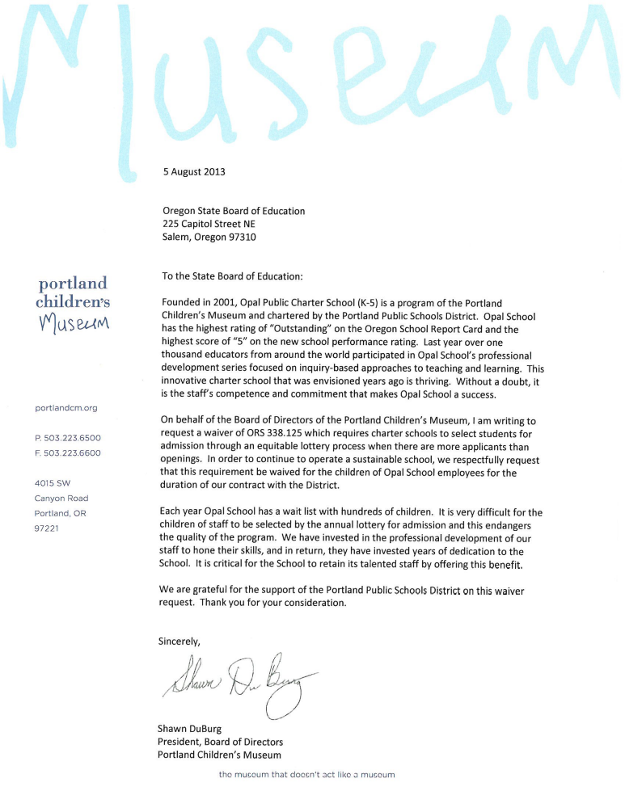
MINUTES OF THE REGULAR MEETING OF THE BOARD OF DIRECTORS OF
PORTLAND CHILDREN’S MUSEUM

A duly called meeting of the Board of Directors of Portland Children’s Museum, an Oregon nonprofit corporation, was held in Portland, Oregon on June 20, 2013 at Union Bank – 407 SW Broadway, Portland, OR 97205.

Directors Present: Shawn DuBurg, Tom Flynn, Rene Gonzalez, Jodi Jordan, John Karasaki, Kirsten Kilchenstein, Brendan O’Scannlain, Rob Stackhouse

Directors Absent: Karen Chong, Joe Francis, Ashleigh Gunter, Sheila Fox Morrison, Jason Porter, Felicia Tripp-Folsom, and Joani Wardwell

Staff Present: Fiona Fox, Ruth Shelly, and Brenda Smith

-------------------------------------------

June 20, 2013 meeting called to order at 11:43am. Shawn DuBurg welcomed everyone and thanked them for their time. We’ve had a number of exciting things take place at the Museum over the last few weeks – such as the ground breaking and Ruth’s reception – and have received great press over these events! Ruth has been meeting with community members and we are receiving positive feedback about her being a great asset for the Museum and the Portland Community.

May Minute Approval: John Karasaki motioned to approve the May 2013 Minutes as presented. Tom Flynn seconded. Motion passed unanimously.

Governance: John Karasaki: The governance committee recommends three votes to be taken today: to approve second terms, officers, and a new board member for 2013-2014. Ruth recommended standardizing the committee chairs as the board officers and the executive committee and governance committee agree with this plan. There will no longer be a separate development committee, as development work will be done by the whole board. BAKA will be managed as an event committee, not a standing board committee. Scott Marsh is being presented as a candidate for the board. He was on the BAKA committee last year, and regardless of board membership he has agreed to chair the BAKA committee next year. From an officer standpoint it is understood that any of the officers can ascend into the President role, it doesn’t have to be the Vice President.

2013-2014 Board Membership Approval: Rob Stackhouse motioned to approve second terms ending 2016 for board members Rob Stackhouse, John Karasaki, and Jason Porter; to approve officers Shawn DuBurg as President, Karen Chong as Vice President, Ashleigh Gunter as Secretary, Rob Stackhouse as Treasurer, and Tom Flynn as Officer-at-Large for the 2013-14 board year; and to approve Scott Marsh as a new board member to fulfill Melinda Rogers’ unexpired term ending 2014. Brendan O’Scannlain seconded. Motion passed unanimously.

The governance committee is presenting a standard process for board nominations. This is similar to what we have presented earlier but it is more concise and fits on one page. When the committee met it focused on point number one, to determine the needs of the board so we can strategically pursue candidates that fit these needs and not rush anyone through the process. In reviewing a matrix of the current board members, they determined that the priority qualities of future board members include: diversity; capacity—the ability to give or obtain donations; expertise in education or academics, corporate connections (particularly Intel), as well as health/wellness retail, high tech, or human resources; and prospects who are a senior or a grandparent. The committee also wants board representation from all Portland neighborhoods.

The usual timeline would be leading up to a board retreat in spring, but this year the retreat is in the fall. The committee is working to have the new board members elected in time to attend the September retreat. The plan is to fill the seats for two unexpired terms (one of which was just filled by Scott Marsh) as well as two additional new seats before the retreat. This would bring us to 17 active members at the board retreat. Our bylaws allow us to get up to 21 members, and by adding 4 new members during the coming fiscal year we would reach this number and stagger the rotation schedule.

Governance committee wants the board to think of who they know and submit names within the next month. Once prospects have been identified the committee will vet them and submit a slate of prospects to the board for a vote over the summer, before they approach prospects to determine their interest. After meeting with candidates and gathering their prospective board member materials, the governance committee will present a final slate of candidates for approval by the board. Candidates who are approved by the board will have an orientation as a class, be paired with a “board buddy,” and attend the board retreat as their first meeting.

As the committee approaches prospects they will ask if they are interested in joining our board this year or next year, which allows the most flexibility for the individual and the Museum. Another recommendation is to have prospects serve on committees so we get to know them and they get to know the organization. There is a lot of value in this for the board as well as for the work of the committees. Committees can be as big as we want, as long as all members of the committee are actively engaged in the work.

The governance committee is also recommending that we move to having 6 board meetings a year, and alternating with committee meetings on the months that the board does not meet. All board members will be required to serve on one committee, and are welcome to serve on more if they so desire. Committee sign-ups for next fiscal year will take place at the board retreat.

ACTION: Ruth will email board members to ask for the names of board prospects; this email will include the current priority of qualities in new board members.

ACTION: all board members to submit names for consideration to John or Ruth by early July. Two prospects with education expertise who were brought up in the meeting were: John Branam, formerly with Portland Public Schools, and Preston Pulliams, with Portland Community College.

Finance Committee: Rob Stackhouse

May Financials: looking at the dashboard you’ll see that earned revenue for the month of May was close to plan. The contributed revenue line is a little deceiving as there are still BAKA receipts coming in. Overall when looking at the month and year to date you’ll see that we are behind in earned and contributed revenue and ahead on operating expenses. Bottom line, we are behind plan. But due to the changes and transitions, not being able to do all planned fundraising events, and low attendance, we knew this was coming. We are in line with our January reforecast. Ruth credited staff for keeping expenses in line, especially considering there were a number of larger unbudgeted expenses that staff could not control.
Another thing to note is that our membership sales are increasing and are above plan. Attendance is going up and our conversion rate is higher than it has been historically for the incremental visitor. Our box office is doing a good job selling them, and with gate prices going up but membership prices remaining the same for now, there is more value for visitors in a membership.

FY14 Budget: Finance committee and Museum leadership have all reviewed support the budget as presented. There have been no significant changes to the draft version that was presented last month. There have been minor changes in classification as staff fine-tuned plans for FY2014. The management intent for this budget is to break even, not to grow reserves. There is enough going on next year with opening Outdoor Adventure that it isn’t the right time to build reserves.
Budget discussion:
- There is a small $25K contingency built in for one-off type things or for staff retention, as needed. This will be used at the Executive Director’s discretion. Ruth has worked with the staff directors to identify areas of risk within the staff and they are monitoring these areas.
- We are projecting a 7% increase in earned revenue. We have budgeted on flat attendance numbers, but expect to earn more money due to the raise in gate price, as well as the soon-to-occur cost increase to membership levels. Attendance number of 297K visitors is the average of the last few years of attendance, but we actually think we will have greater attendance than we have budgeted. We assume that there will be a 50% drop in the lowest membership level, but given the increase in upper levels, we will still have an increase in revenue. Attendance was down this current fiscal year due in part from the carryover of having Wonder of Learning and Chagall here, neither of which had the draw of a blockbuster for the Museum visitor. Prior to this year we have been running a 3% increase in attendance numbers and we believe that this year’s decrease in attendance was just a blip, not a downward trend. During the upcoming fiscal year we have Dora the Explorer, our own internal exhibit, and we will open Outdoor Adventure. We believe these will drive attendance and bring in more visitors than we have budgeted on.
- There is some concern over the fundraising goal, but, with the capital campaign being completed we can go back to donors who previously supported Museum operations, but shifted their support to the campaign and ask them to continue giving to support operations. Additionally, having a new Executive Director on board will help raise community awareness of the Museum. Board members can continue to introduce Ruth to prospective friends of the Museum. We were unable to do all fundraising events this year, only completing one out of two (BAKA), but next year we expect to hold three events.
- Finance committee reminds the board that we will do a mid-year budget review in January and make any necessary budget revisions. Additionally, Ruth and Brenda will be doing monthly analysis of the budget and report to the finance committee who can bring any items of concern to the board as the year goes on.
- Ruth is looking at the makeup of staff and may make strategic adjustments. She is also working with the staff directors to look for ways to be more efficient and leverage the resources of the Museum. Ruth will be working with Brenda to do a salary analysis and will make recommendations for FY2015 market adjustments.
- The finance committee has reviewed and approved the budget and recommend that the board approve it.

Budget Approval: Rob Stackhouse motioned to accept the 2013-2014 Museum Budget as presented with the understanding that the Opal Charter School Budget is included. Jodi Jordan seconded. Motion passed unanimously.

Outdoor Adventure Cash Flow Report: Looking at the pledges we have in hand and when we expect to collect these pledges, and comparing it to when we expect to make payments for exhibit construction, we will likely have to go into the line of credit in August or September of this year, unless we raise more money. We would begin making payments on the line of credit in December 2013 or January 2014, and expect that we would pay it off in October or November of 2014.

Ruth is talking with Bank of the Cascades to find out if we can roll the line of credit over so we don’t have to start making payments in January. Our loan officer has also agreed to negotiate a lower interest rate for us.

We need to continue to raise money, both to help with the campaign and for operations. When we dip into the line of credit our operational costs will go up as we pay interest on the debt. Shawn DuBurg asked all board members to make their annual gift before the end of the month. Ruth Shelly underscored the importance of 100% board giving, regardless of the amount. This is an important statistic when applying for grants, and companies want to see how committed the Museum’s leadership is.

There have been a number of board members who have made introductions and the board would like to see what tracking is in place and what follow-up has been done so they know how to continue to help with those relationships. ACTION: Ruth will work with Sue to report back to the board.

Executive Director Report: Ruth Shelly: It has been 40 days since my first day and I have had more than 40 meetings (board members, all but two of the Leadership Council, and many community members). Asked each person the same three questions: what are the greatest challenges, the greatest opportunities, and what should I tackle first? The three big areas that rose to the top were: finish the outdoor exhibit campaign, build the board, and integrate the school, museum and center for learning.

Governance committee has reported the plan for building the board. Regarding Outdoor Adventure, we are in the same place that we were in May. We have not added any new money. We did have a good meeting with Murdock and have been invited to reapply for $300K in November as well as being encouraged by Jill Tatum to ask for an additional $150K community match. We also still have the potential topper gift from the Randall Foundation but can’t be complacent and need to continue to go after new funds.

Regarding integration: we are moving away from talking about ourselves as a three-legged stool, and instead are looking at ourselves as three interconnected rings of joyful learning. The three areas or “rings” are informal learning, formal learning, and professional learning. We will go into this in more depth at the upcoming board retreat. The Center acts as a consultant sharing the what of Reggio practice and why it is important. The outside department rings are the experts of implementation, managing how we translate Reggio on the floor, and for whom.

One missing “ring” is the Director of Programs position, formerly filled by Anne Kluesner who went back to Iowa to care for her grandmother. The summer plan is to have one of the Programs staff, Kristi Riedel, be the interim Program manager. The remaining directors are looking at the group of circles and determining how best to craft this position so that everything works well together and strengthens the overall leadership team. We are looking to have someone in place in Fall.

One consequence of the transition in Programs leadership is putting the volunteer program on hold and eliminating the volunteer coordinator position. We plan to go through summer with current volunteers reporting to the Director responsible for the area in which they are volunteering. We are working to determine how to strengthen the program and how supervision will take place in the future, and would like the new Director of Programs to be a part of this decision process.

The when of what we are doing will be shared in master milestone calendar for 2013-2014 that the Directors are putting together to help each department see where the crunch times are for other departments. It will be a busy summer as we lay groundwork for the retreat. Staff will present their best recommendations for the organization and will look to the board for strategic direction.

The areas where entities overlap are the ones with the most ambiguity, and perhaps the most potential. For example: formal learning is done in the classroom and the symposium is the professional dissemination of what we’ve learned in the classroom and sharing it in a professional learning manner, in schools as well as in children’s museums. Next year we want to have a track specifically for children’s museums on how we are using Reggio theories on the museum floor.

Symposium lives in a crossover area and there is ambiguity because the Center is pulling resources from the entire organization to manage the event. It is a museum-wide event, but those in charge might not be aware of the workloads from the other areas of the museum and how they are being impacted to support Symposium. As a team we want to look more proactively at crunch times and determine how to respect people and their workloads while still having all the right people involved.

Opal School Waiver Request: this is a continuation of waiver that the board has granted before. State law requires charter school admission to be conducted through a lottery. The board can grant a waiver that allows Opal School staff to have preference in enrollment, and bypass the lottery when there is space available. This is standard practice for charter schools and Portland Public School district is supportive of this request. Opal School is asking that this waiver be effective for the duration of our charter contract.

Approval of Opal School Waiver: Rene Gonzalez motioned to extend the Opal School staff waiver through the duration of our charter contract and to allow the children of Opal School staff preference in enrollment when space is available. Rob Stackhouse seconded. Motion passed unanimously.

Closing comments: Shawn DuBurg: reflecting on 2012-2013 and board goals, it is disappointing that we didn’t meet our budget – but, we did have unplanned expenses and believe the investment in leadership and the café are going to pay dividends in the future. Shawn thanked the board for all the work it undertook at the beginning of the year, and for their engagement as the organization went through changes. We have a talented Executive Director and Directors Team. We didn’t meet our goal of completing the campaign and we need to stay focused on finishing this fundraising. We will work on the strategic plan during the September board retreat. We did meet our goal of hiring a new Executive Director! Shawn thanked the committee chairs for all their work to lead the board: John with the governance committee, Rob with the finance committee, Jodi with the BAKA committee, Jason with the development committee, and Rene and Ashleigh with the education committee.

We have three board members who are retiring: Sheila Fox Morrison, Joani Wardwell, and Brendan O’Scannlain. Sheila and Joani are not able to be here today, but we thank them for their work with the board over the years they have served. Brendan is here today and is retiring with one year left on his third term! Brendan went going above and beyond expectations and has served the organization as past treasurer and board president.

Board thanked Shawn for keeping the organization moving forward during transitions and for agreeing to serve a third term as President.
Kirsten Kilchenstein has committed to staying on the board as the Opal Advisory Representative for another year, and the board thanked her for her willingness to serve in this capacity.

Meeting adjourned at 1:21pm.

Next Board meeting will be the September board retreat. Dates for the retreat are September 27 from 4-6pm and September 28th from 8am – 1pm.

Respectfully submitted,
Sheila Fox Morrison, Secretary

