Collaboration by State Agencies on Issues Related to Career and Technical Education
ORS 344.125
December 2023
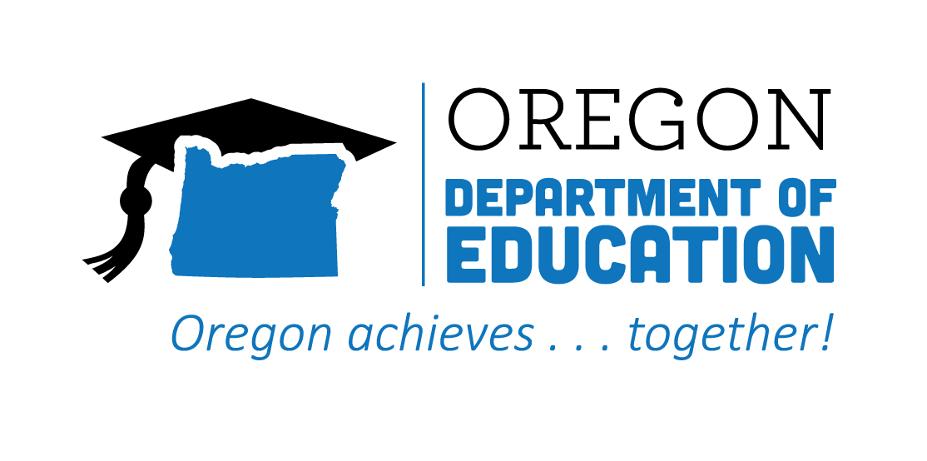
Table of Contents
Executive Summary 2
Background 5
Progress on Goals Outlined in ORS 344.125 6
Goal #1 6
Goal #2 14
Goal #3 17
Goal #4 18
Goal #5 24
Goal #6 25
Goal #7 29
Recommendations 30
Recommendation #1 30
Recommendation #2 32
Recommendation #3 33
Conclusion 33

Executive Summary
We are pleased to present this report on behalf of the Oregon Department of Education, the Office of Community Colleges and Workforce Development, and the Oregon Bureau of Labor and Industries (hereafter: Partnering State Agencies), highlighting their joint collaboration on issues related to Career and Technical Education (CTE). The Partnering State Agencies continued to make progress on the goals outlined in ORS 344.125. This report highlights the key achievements and challenges pertaining to CTE throughout the 2022-23 school year, along with recommendations for improving Career and Technical Education in Oregon.
ORS 344.125 Goals
#1—Ensure that career and technical education programs are available at the public schools of this state and through youth job development organizations as defined in ORS 344.415 (Definitions for ORS 344.415 to 344.425), are founded on partnerships with business and industry and receive appropriate investments of time, money and other resources.
Progress on Goal #1
- Enriched educational pathways for postsecondary learners by approving 73 new community college CTE certificate and degree offerings last year.
- Amplified opportunities for skill development and career exploration among secondary students over the past few years through a 6% growth in CTE Programs of Study.
- Increased the total number of apprentices in select new and emerging occupations by 57% from July 2022 to June 2023, reflecting a dedicated effort to propel the workforce into a future of innovation and success.
#2—Develop regional centers that establish any appropriate partnerships between public schools, community colleges, public universities, businesses, unions and other entities and that ensure that every student of this state has access to a regional center in person or online.
Progress on Goal #2
- Lane Career Academy's innovative approach, supported by BOLI Future Ready Oregon grants, showcases the expansion of Pre-Apprenticeship Training Programs, the creation of mobile training units, and the involvement of students in program design and promotion.
- Medford Pre-Apprenticeship Construction Training program's efforts to create a regional hub connecting high school CTE students with registered apprenticeship training programs highlight successful initiatives to bridge the gap between education and workforce needs.
#3—Encourage the establishment of joint high school and community college advisory committees that may include representatives of public schools, community colleges, public universities, businesses and unions.

Progress on Goal #3
- The Statewide CTE Advisory Council convened regularly to offer valuable advice and delve into crucial priorities such as equity, systems alignment, and communication.
- Sector-specific advisory groups published new knowledge and skill statements for Automotive and Heavy Equipment; Law, Public Safety, and Security; Education and Training; and Natural Resources/Forestry CTE programs. This will help ensure the curriculum remains dynamic, relevant, and aligned with the evolving demands of the workforce.
#4—Address academic requirements and regulatory barriers that inhibit successful movement of students in career and technical education from high schools to post-secondary school programs and the workforce.
Progress on Goal #4
- Engaged in a cohort focused on leveraging learner voices to improve CTE across the state through participation in Advance CTE’s Learner Voice Initiatives.
- Established a CTE Youth Advisory Council to begin in the 2023-24 school year.
- Worked collaboratively to acknowledge challenges in implementing youth apprenticeship programs in Oregon and actively sought solutions, engaged in conversations, and explored options to ensure equitable access and opportunities for youth apprentices.
#5—Implement accelerated college credit programs that allow students to move seamlessly from public schools to post-secondary education or training to the workforce.
Progress on Goal #5
- Developed and implemented a comprehensive plan for further action after recognizing a statewide pattern of reduced engagement in CTE dual credit experiences.
#6—Increase professional development opportunities for teachers and learning opportunities for students through industry mentorships, internships, summer programs, after-school programs and career-based student leadership opportunities.
Progress on Goal #6
- Kicked off a new series of professional learning communities by bringing together CTE teachers from across the state to network and share perspectives on program improvement.
- Announced the BOLI Apprenticeship and Training Division Council’s approval of the K-12 Teacher Registered Apprenticeship Program.
- Enhanced support for apprenticeship opportunities by releasing guidance that outlined the steps for CTE programs to become Oregon Certified Pre-Apprenticeship Training Programs, complemented by a Pre-Apprenticeship Question and Answer session.
- Successfully implemented the Perkins V Work-Based Learning requirement for the third year, resulting in CTE educators providing nearly 42,000 WBL experiences to students across different career learning areas.
#7—Establish partnerships between public and private entities for the purpose of educating students, parents, teachers, school advisors, policymakers and the general public about the benefits and opportunities related to career and technical education.
Progress on Goal #7
- Partnered with the Oregon Lottery for the Play it Forward campaign, incorporating CTE promotion through TV spots, social media, and a dedicated web page, garnering over 11,000 views and fostering ongoing engagement with Oregonians.
- Launched the Career Connected Learning newsletter in September 2022, delivering monthly updates on CCL information, research, professional development, and statewide examples, empowering schools to integrate career development into classrooms and guide students toward CTE pathways.
- Participated in Advance CTE’s recruitment-focused cohort to enhance postsecondary CTE participation for members of Oregon’s nine federally recognized tribes, emphasizing a commitment to centering tribal feedback and engagement in the development of materials and systems.
Recommendations
Based on progress toward goals outlined in ORS 344.125, community engagement, and lessons learned during the past year, the Partnering State Agencies offer the following recommendations to the legislature for improving opportunities related to Career and Technical Education:
- Allocate targeted funding to support and expand CTE programs across the state.
- Reaffirm and strengthen commitments to the intentional alignment of education and workforce development priorities, projects, and processes.
- Change Oregon Revised Statutes and Oregon Administrative Rules impacting youth apprenticeship to encourage program development by aligning youth apprenticeship to the K-12 system.

Background
Throughout the past year, the Oregon Department of Education (ODE), the Office of Community Colleges and Workforce Development (CCWD) administered by the Higher Education Coordinating Commission (HECC), and the Oregon Bureau of Labor and Industries (BOLI) continued their collective efforts to prepare young Oregonians for their future professions. HECC worked with partners to strengthen the state's workforce and ensure all students receive quality educational opportunities, including access to postsecondary CTE and registered apprenticeship programs. They moved forward alongside ODE, which coordinated secondary CTE programs, aiming to create seamless pathways for students transitioning from high school to community college. Both agencies administered the federal Perkins V (Strengthening Career and Technical Education for the 21st Century Act) funds to advance equity in access to high quality CTE programs. They also collaborated with BOLI's Apprenticeship and Training Division (ATD) in support of their efforts to provide workforce development training, including pre-apprenticeship and youth apprenticeship within CTE programs.
The Partnering State Agencies focused on advancing their common expectations for high quality CTE Programs of Study, Registered Youth Apprenticeship, and Registered Pre-Apprenticeship. In the Perkins V Act, the term CTE “Program of Study” means a coordinated, non-duplicative sequence of academic and technical content at the secondary and postsecondary level. In Oregon, CTE programs are offered within six career clusters: Agriculture, Food, and Natural Resources Systems; Arts, Information, and Communications; Business and Management; Health Sciences; Human Resources; and Industrial and Engineering Systems. Apprenticeships are structured training programs that combine on-the-job training with related classroom instruction. Apprentices are full-time, paid employees who earn while they learn. In Oregon, registered apprenticeships are available in a range of industries, including traditional trades like construction and newer sectors like healthcare and education. Youth apprenticeships are integrated within a secondary CTE Program of Study to provide students 16-18 years of age with the opportunity to receive paid, on-the-job training alongside classroom instruction. Pre-apprenticeship programs are designed to prepare individuals to enter and succeed in a registered apprenticeship program. These programs build foundational skills and knowledge, making potential apprentices more competitive when applying for a registered apprenticeship program. Pre-apprenticeship programs are offered at many of Oregon’s community colleges or in conjunction with a secondary CTE program.

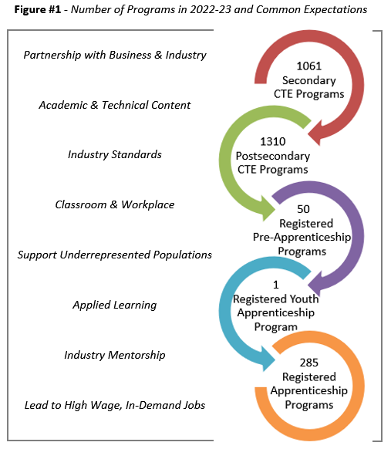
The Partnering State Agencies conveyed a unified message regarding the expectation that all programs assist learners in exploring potential career interests and acquiring the industry-specific knowledge and skills needed to take their next steps (see Figure #1 - Outline of the Common Expectations and Number of Programs in 2022-23). The Partnering State Agencies provided programs with guidance, professional development, and resources to ensure learners actively participate in direct, practical experience with the tasks and skills they will need in their chosen career. They helped programs continue to expand opportunities that allow apprentices, pre-apprentices, and CTE students to engage in hands-on learning alongside experts in the field. The Partnering State Agencies remained focused on providing equitable access to education and workforce development opportunities that empower individuals from all backgrounds to pursue their aspirations and contribute to their communities. This includes efforts to support more paid Work-Based Learning opportunities for CTE students, similar to apprenticeship requirements. The efforts of the Partnering State Agencies furthered their shared purpose of advancing Oregon’s workforce readiness while promoting equity and growth in the state’s socio-economic landscape.

Progress on Goals Outlined in ORS 344.125

Goal #1
Ensure that career and technical education programs are available at the public schools of this state and through youth job development organizations as defined in ORS 344.415 (Definitions for ORS 344.415 to 344.425) are founded on partnerships with business and industry and receive appropriate investments of time, money and other resources.

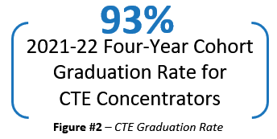
Over the past year, the Partnering State Agencies remained committed to ensuring the widespread availability and accessibility of Career and Technical Education programs in Oregon’s schools and through youth job development organizations. The collective efforts aimed to bolster and expand learning experiences and better prepare learners for the demands of the workforce. The Partnering State Agencies sought available funding sources to ensure programs were able to continue delivering the long-term benefits everyone recognizes for learners and employers. Worth highlighting is the 93% graduation rate among high school CTE concentrators as shown in Figure #2. The information and data below show the growth trajectory of CTE and apprenticeship programs and learner participation, underscoring the growing need for sustained support.
The Partnering State Agencies, along with business and industry partners, continued efforts to create robust, well- aligned, and equitable pathways for Oregon’s learners both into CTE, and from CTE, into postsecondary opportunities and/or the workforce. On the postsecondary side, 73 new CTE certificate and degree offerings were approved by HECC during the 2022-2023 academic year. Figure #3 represents the breakdown of these new postsecondary CTE options by career area.
Figure #3 - 2022-2023 New Community College CTE Certificate and Degree Offerings
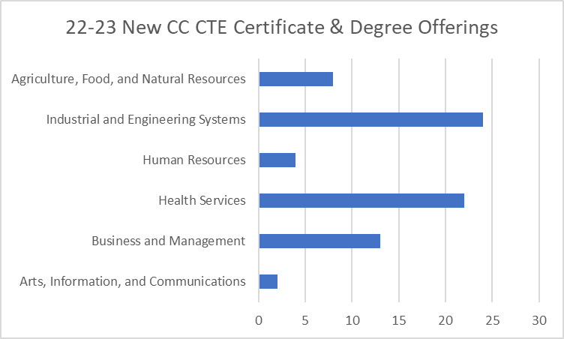
On the secondary side, the Oregon Department of Education supported a 6% expansion in secondary CTE Programs of Study over the past few years, as shown in Figure #4. Oregon high schools launched new Programs of Study across all career clusters aligned to their regional labor markets based on conversations with local, regional, and statewide business and industry partners. Specifically, manufacturing programs have seen an increase of almost 9%, health science programs have risen by 14%, and information technology programs have grown by 1.3%. Efforts to ensure sustained engagement and optimize the impact of these programs are critical to shaping the future workforce.

Figure #4 - Number of Secondary CTE Programs of Study from 2020-21 through 2023-24
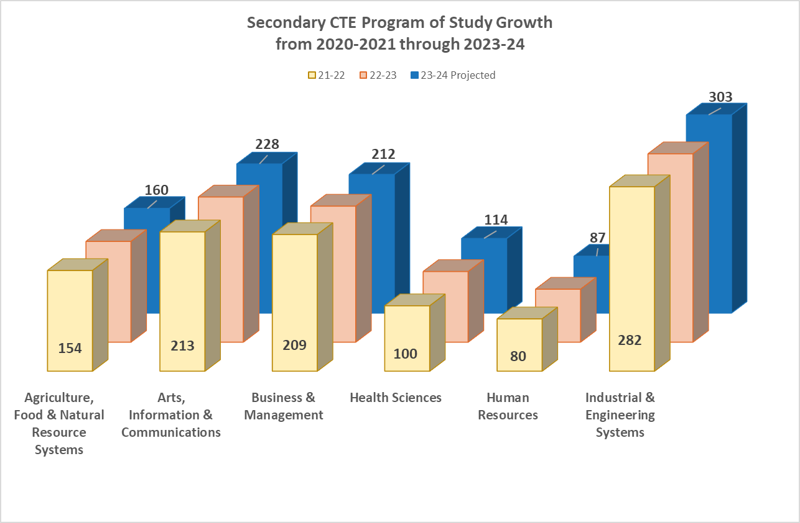
While the number of CTE programs has expanded over the past few years, the number of CTE student participants and concentrators has remained consistent or seen a marginal decline, emphasizing the importance of continued support and adaptation to meet evolving educational needs. The number of postsecondary CTE participants and concentrators at Oregon community colleges exhibited a slight decline compared to the past year. The number of secondary CTE concentrators in Oregon high schools experienced a similar decline, while the number of CTE participants increased by 4.5% over the previous year. Figure #5 shows the number of CTE secondary and postsecondary CTE participants and concentrators in 2021-22. (Please note: the 2022-2023 CTE data will be released in January 2024.)

Figure #5 - Number of Secondary and Postsecondary CTE Student Participants and Concentrators in 2021-22
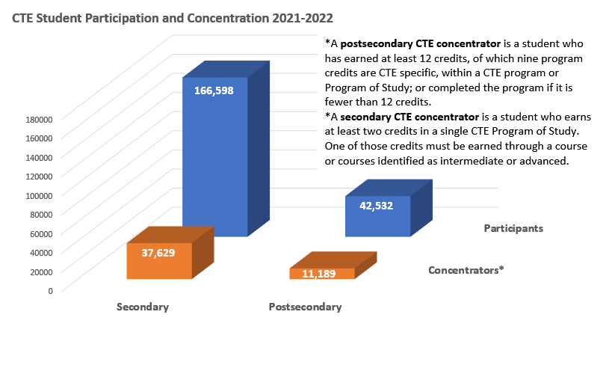
The Partnering State Agencies continued to implement targeted Career Connected Learning (CCL) activities with support from federal Elementary and Secondary School Emergency Relief Fund (ESSER) dollars. This year, a full cohort of Career Connected Learning Systems Navigators were brought on board at Oregon’s community colleges. In collaboration with regional partners, these CCL Systems Navigators worked to establish aligned learner pathways into CTE, postsecondary education and training, and the workforce with a focus on middle school and high school learners most impacted by the pandemic. The Navigators help to enhance regional CCL systems and support equitable access to CCL and CTE opportunities. Figure #6 represents the self-reported number of connections made by Navigators with regional partners in support of regional CCL and CTE systems for learners through May 2023, per their biannual grant reporting.

Figure #6 - Navigator Connections By-The-Numbers
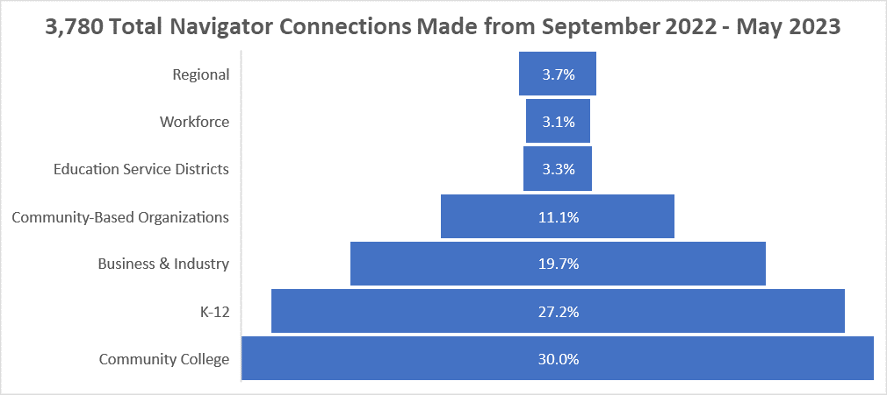
The BOLI Apprenticeship and Training Division (ATD) in partnership with HECC also received federal funds to improve support for pre-apprenticeship programs. The State Apprenticeship Expansion, Equity, and Innovation (SAEEI) grant funding allowed for the establishment and implementation of a new pre-apprenticeship portal. Programs received training on the Oregon Pre-Apprenticeship Tracking (OPAT) system in mid-February 2023 in advance of the March 1 launch. OPAT allows programs to submit participant registrations, graduations, and terminations directly into the portal, which then feeds into the ATD database. As Registered Apprenticeship Programs are registering a graduated pre-apprenticeship participant, the new portal allows the registering program to record the detail that the apprentice is a pre-apprenticeship graduate, which will provide ATD with more data and information about the pipeline, including the apprenticeship programs into which pre-apprenticeship graduates are registering. As shown in Figure #7, pre-apprentices were recorded as being registered as apprentices for the quarter of March 2023 to June 2023, with an equal distribution between those who were ages 17-21, 22-31, and over 32 years old. The new data gives insight into the skew toward younger pre-apprentices in construction in comparison to the overall ages of construction apprentices.

Figure #7 - Pre-Apprentices who were registered as Apprentices from March to June 2023, by Age at Registration
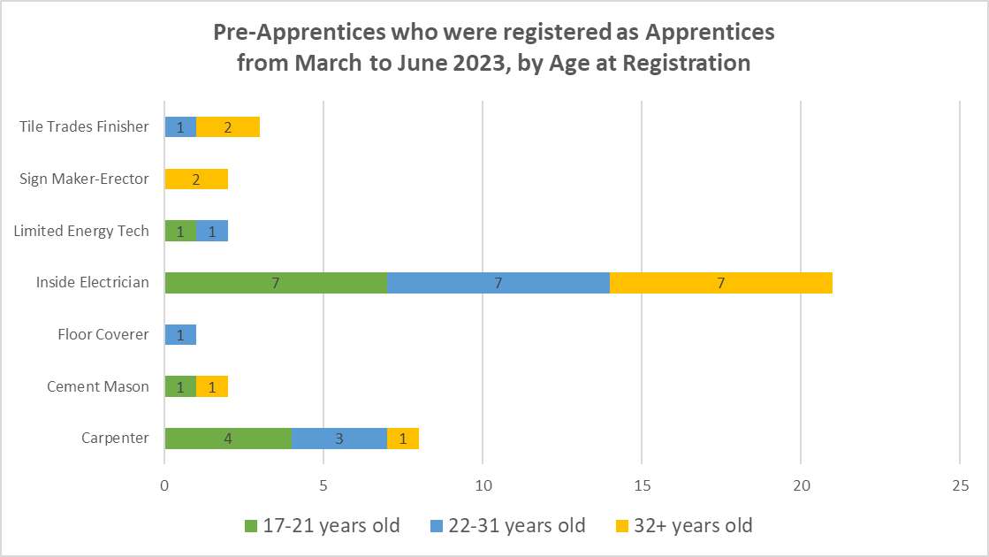
Oregon BOLI has also been working to support a variety of apprenticeable trades that have been the focus of new expansion efforts as part of both federal investments (including SAEEI grants) and state investments (including Future Ready Oregon). Figure #8 shows the diversity and number of new journey workers in select new and emerging occupations: Healthcare Support Occupations (CNA and Medical Assistant) and Other Occupations (Alcohol and Drug Counselor, and Mental Health Associate).

Figure #8 - Apprentice Completions between July 2022 and June 2023 in Select New and Emerging Occupations
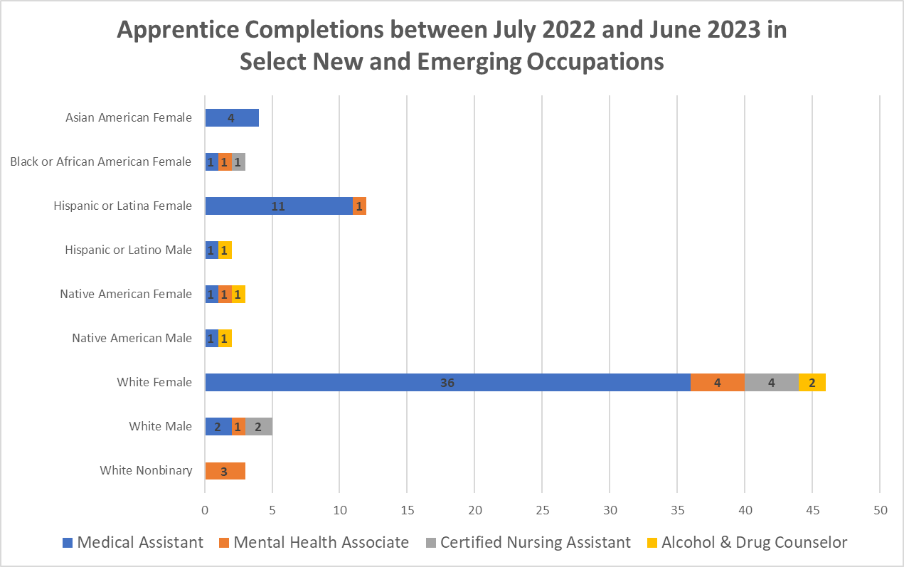
Although the new and emerging occupations have not operated long enough to see many completions, the number of active participants at specific points in time (July 1, 2022, and July 1, 2023) gives a sense of their growth. The total number of apprentices for these eight occupations increased 57% from 143 (in July 2022) to 224 (in July 2023) as shown in Figure #9.

Figure #9 - Change in Numbers of Active Apprentices in Select New and Emerging Occupations, July 2022 to June 2023
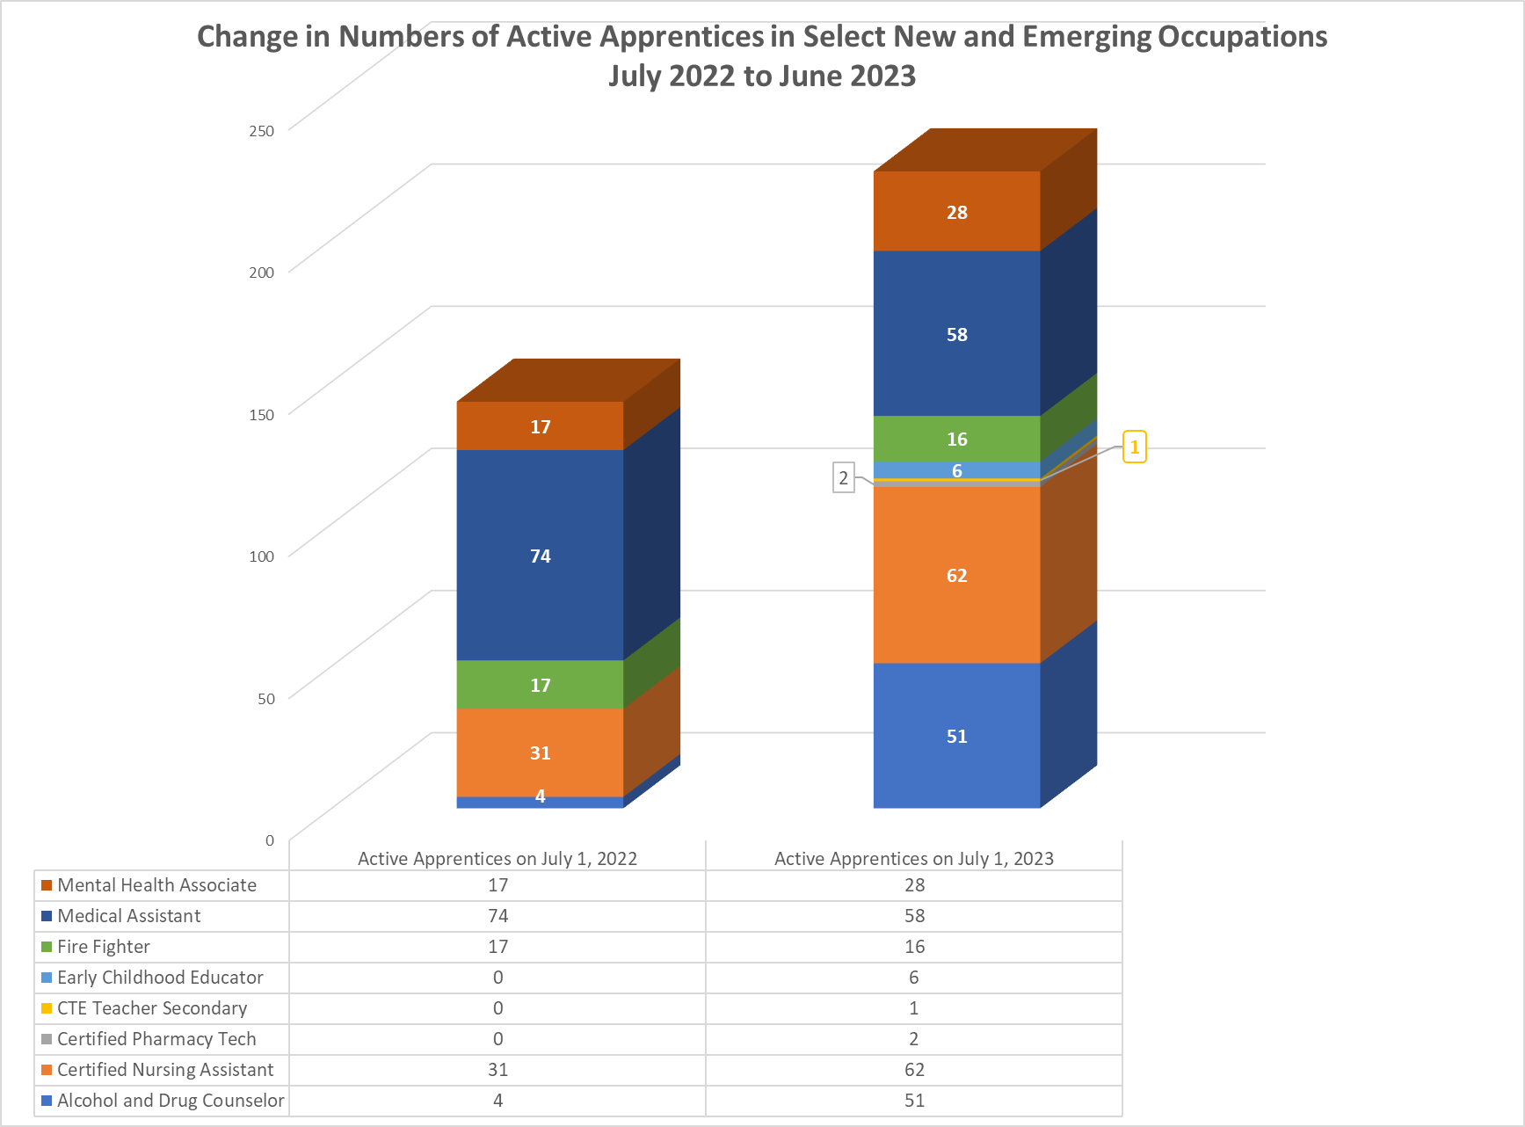
The Partnering State Agencies, educational institutions, and industry partners continue to demonstrate a strong dedication to expanding and strengthening CTE programs in Oregon. The collaborative efforts have yielded significant milestones, including strong graduation rates among high school CTE concentrators and the approval of a substantial number of new postsecondary CTE offerings. Despite the expansion of CTE programs, the number of participants and concentrators has seen marginal declines, highlighting the ongoing need for sustained support. The implementation of Career Connected Learning activities and the establishment of a new pre-apprenticeship portal reflect proactive approaches to aligning educational pathways with workforce demands. The data presented not only charts the growth trajectory of CTE and apprenticeship programs, but also advocates for sustained commitment to navigating the evolving landscape of education and employment. As we advance these efforts, we look forward to realizing even greater achievements in the years ahead, promoting not only the success of our learners but also the prosperity of our communities.

Goal #2
Develop regional centers that establish any appropriate partnerships between public schools, community colleges, public universities, businesses, unions and other entities and that ensure that every student of this state has access to a regional center in person or online.

Regional CTE centers serve as focal points, offering a diverse range of specialized courses that individual schools or smaller districts may find challenging to provide. By centralizing resources, expertise, and industry-standard equipment, regional CTE centers ensure students have access to high-quality training tailored to real-world job markets. While centers such as the Lane Career Academy and the Medford Pre-Apprenticeship Construction Training program model how schools, businesses, and communities can team up for everyone's benefit, there remains both widespread interest and challenges in replicating their success across all regions in Oregon.
The Lane Career Academy (LCA) is an innovative approach to regional Career and Technical Education where Lane Education Service District (LESD) constituent school districts share students and programming at Work-Based Learning sites, usually at industry locations. LESD and its constituent school districts believe this model offers advanced CTE opportunities to all students and expands access to students from smaller and rural districts that are interested in programming not available at their resident high school. The first program is at the Hope Community Foundation’s HOPE Factory, which will provide students with experience working alongside craft professionals in all aspects of building manufactured homes. Students will earn high school credit, Lane Community College (LCC) credit, either Construction or Manufacturing BOLI Pre-Apprenticeship Certificates, and other industry-related certifications. The collaboration so far has involved all 16 LESD school districts, the HOPE Factory itself, St. Vincent de Paul of Lane County, LCC (Welding, Manufacturing, Construction, Writing, and Math departments), BOLI, and Lane Workforce Partnership (LWP), as well as union and non-union apprenticeship groups. The model is currently being considered for expansion into other CTE programmatic areas such as emergency services and healthcare.
LESD is a two-time BOLI Future Ready Oregon grant recipient. In 2022 and 2023, through Future Ready Oregon, BOLI invested just over $10.6 million in the creation and expansion of 33 Pre-Apprenticeship Training Programs in the construction, healthcare, and manufacturing industries across the state. LESD received a total of $264,000 to expand its construction Pre-Apprenticeship Training Program (Lane PACT) to serve 40 new participants through targeted marketing and outreach strategies to recruit individuals from communities of color, women, low-income communities, and rural and frontier communities across the region. LESD’s construction grant includes supportive services in the form of $2,000 of tuition support per participant for coursework offered at LCC, as well as a $500 incentive stipend per participant.
Given its wide geographic scope, LESD requested funds to purchase a truck and mobile trailer to house and transport tools and program equipment to locations across Lane County. This truck and mobile trailer will allow for more schools, and therefore more individual participants, to be reached and gain access to career opportunities upon completing Lane PACT. LESD CTE students designed the wrap that covered the truck and trailer to advertise the program in advance of the 2023-2024 school year. LESD’s approach is innovative in two respects: one, for their student involvement in the process, and two, for their idea to use a mobile training unit as additional advertising and a way to reach more students in the district with hands-on learning and new career pathways. For the first time, students and parents in all 16 school districts within Lane County will be exposed to the numerous opportunities that are created by Pre-Apprenticeship.
After receiving its first BOLI Future Ready Oregon grant for construction, LESD successfully applied for and received a second grant in the amount of $482,856 to support the development of a new manufacturing Pre-Apprenticeship Training Program within the county. LESD proposed to serve a total of 95 students with its second grant, including communities of color, women, rural and remote communities, persons with disabilities, members of Oregon’s nine federally recognized tribes, and individuals who identify as members of the LGBTQ2SIA+ community.
When LESD applied for its second grant to support the development of its manufacturing Pre-Apprenticeship Training Program, there were already 10 manufacturing CTE Programs of Study across schools in the district. By leveraging Future Ready Oregon grant funds, LESD was able to successfully enhance its existing manufacturing CTE program by also becoming a BOLI-certified Pre-Apprenticeship Training Program that received approval from the Oregon State Apprenticeship and Training Council at the Quarter 3 meeting. As of October 1, 2023, students were able to register for the new program as featured in Figure #10, wherein they will receive relevant coursework, mentoring, guidance, and support as they work to complete the certificate that will prepare them for entry into a manufacturing Registered Apprenticeship Program.
Figure #10 - Signing Day, August 2023, at HOPE Factory with students and parents from across Lane County
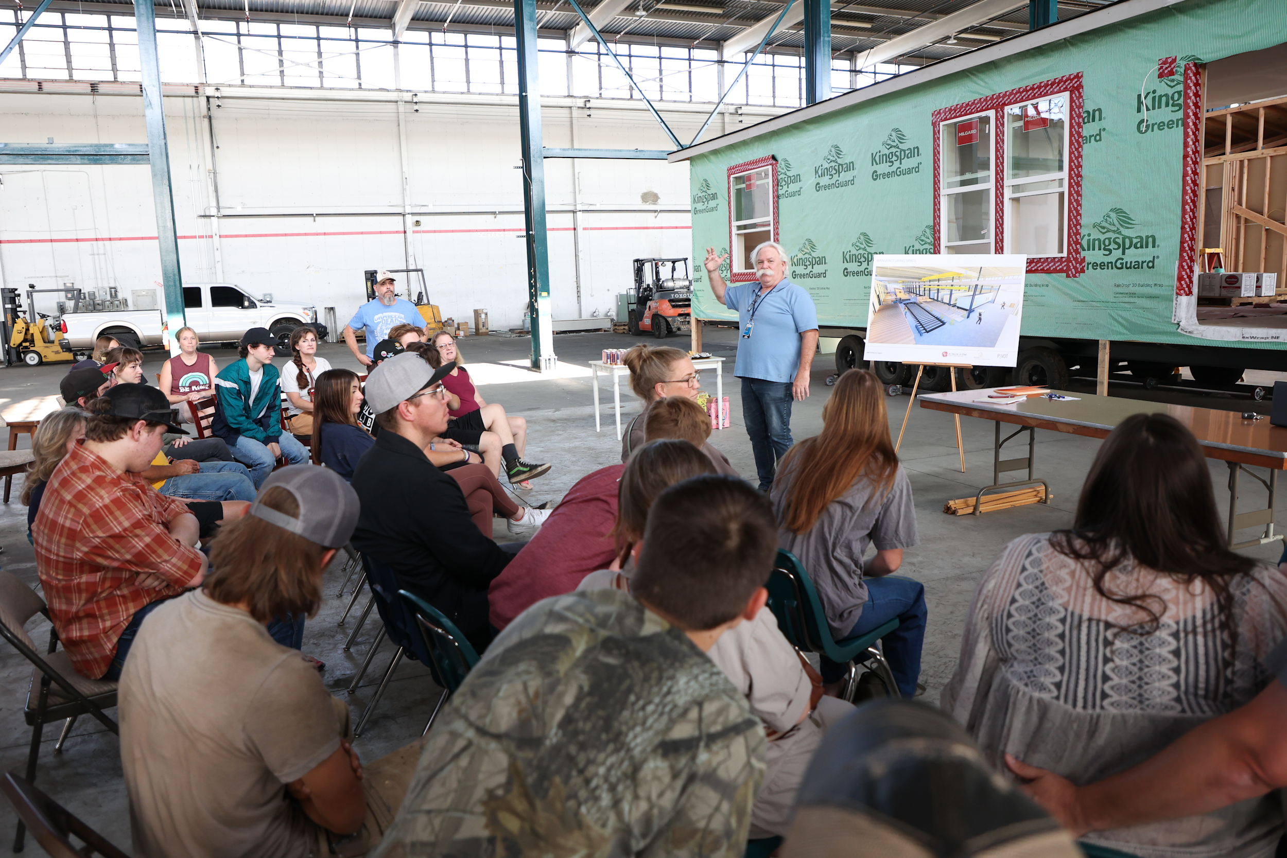
Since its Council approval in 2020, the Medford Pre-Apprenticeship Construction Training (MPACT) program has expanded its efforts to develop a regional hub that links high school CTE students to registered apprenticeship training programs and community college routes in the skilled trades sector. MPACT has made efforts to expand the opportunities to other school districts across Jackson County and connect the established program with other high school CTE programs. MPACT wants to share its known success in supporting schools and students to better understand the registered apprenticeship career pathway. Ashland High School joined MPACT effective October 1, 2022. This new partnership and expansion offered Ashland High School students the opportunity to register as pre-apprentices in the MPACT program, giving them the ability to visit sites for employers who participate in registered apprenticeship. MPACT hopes to be able to provide its support to other schools in Jackson County and, as mentioned above, develop a regional hub for all schools in the county.
The Partnering State Agencies have encouraged other schools and education service districts to follow the model that LESD and the Medford School District have set. By also becoming a BOLI-Certified Registered Pre-Apprenticeship Program, existing CTE Programs can provide students with a new credential (Pre-Apprenticeship Graduation Certificate) and a new opportunity for preferred or direct entry into a registered apprenticeship program in a career that will provide a family wage.
Most regions do not have the capacity or funding to establish regional centers, but they have made efforts to provide access to CCL activities across their regions. For example, HECC and ODE supported Lane Community College’s (LCC’s) successful Career Z Challenge proposal, Difference Makers in Lane County: Addressing Opportunity Gaps in Work-Based Learning. For Phase 1 of this US Department of Education-sponsored challenge—the submission and selection phase—LCC proposed a regional approach to closing equity gaps in Work-Based Learning opportunities for learners in its service district, with an emphasis on students who identify as people of color in two of its most rural and economically disadvantaged school districts. This regional approach includes educator professional development, toolkits, and online workshops in collaboration with national partners, with free and open access for their regional schools and youth serving organizations. As they move into Phase 2 of the Career Z Challenge this fall—the implementation and results phase—LCC will continue to create a collaborative ecosystem of students, state agency partners, educators, employers, industries, and community stakeholders aiming to address these equity gaps in Work-Based Learning.
In addition, efforts to promote pre-apprenticeship in eastern Oregon during the past year included a Summer Pre-Apprenticeship Bootcamp in Pendleton sponsored by the Pacific Northwest Carpenters Institute (PNCI) and two Future Ready Oregon recipients:
- Confederated Tribes of Umatilla Pre-Apprenticeship Development - Approved Quarter 3, 2022 Oregon State Apprenticeship and Training Council (OSATC)
- Baker Technical Institute Heavy Highway Pre-Apprenticeship
ATD has also been involved in discussions with Intermountain ESD and Malheur ESD regarding the alignment between CTE pathways and pre-apprenticeship, as well as with Ontario High School regarding the development of a Construction CTE Program of Study so they can implement a Youth Apprenticeship program. Although there have been many meetings and much interest at Ontario High School, it is costly to implement and the Future Ready Oregon funds for the Construction trades have been limited to pre-apprenticeship.
CTE centers such as those offered by the North Clackamas School District (Sabin-Schellenberg Center), Salem-Keizer Public Schools (Career Technical Education Center), Portland Public Schools (Benson Polytechnic High School), and Willamette Education Service District (Willamette Career Academy) provide a regional approach to providing CTE opportunities. These regional CTE centers provide instruction and access to specialized equipment, business and industry professionals, and additional career clusters that are often not feasible for individual schools or small districts to offer their students. Many other models exist that can be explored, including the possibility of mobile centers that can reach new audiences and meet the evolving education and workforce needs across the state. In order to advance Goal #2 and to support the expansion of CTE centers across more regions and Oregon’s federally recognized tribes, more innovative and creative options need to be considered, along with strategic investments.

Goal #3
Encourage the establishment of joint high school and community college advisory committees that may include representatives of public schools, community colleges, public universities, businesses and unions.

The commitment to fostering strong collaborations between high schools, community colleges, and key business and industry partners is fundamental to successful outcomes for CTE students. ODE and HECC furthered inclusive partnerships through the Statewide CTE Advisory Council and sector-specific advisory groups. For the second year, the groups continued to bridge any informational or structural gaps, ensuring that CTE Programs of Study align with current and future industry needs.
Leaders of the Partnering State Agencies continued serving as ex officio members of the Statewide CTE Advisory Council alongside the advisory members made up of students, counselors, educators, administrators from secondary and postsecondary education institutions, workforce development, business and industry partners, and community-based organizations. During its second year, the Council convened four times to continue offering advice, guidance, and feedback on the strategies and corresponding progress being made throughout the implementation of the CTE State Plan and its goals. During the 2022-2023 school year, Council members also met in subcommittees to take a deeper dive into the Council’s top priorities: equity, systems alignment, and communication. The Council also began work to create a Youth Advisory team to increase the opportunities for and diversity of student voices. Council meetings are open to the public and more information, along with meeting materials and the membership roster, can be found on the Statewide CTE Advisory Council web page.
After the successful launch of the statewide CTE Program of Study framework last year—encompassing the four industry clusters of Architecture and Construction; Information Technology; Manufacturing; and Business, Management and Administration—this year's focus turned to a second set of sectors to expand the initiative. Sector-specific advisory groups from Automotive and Heavy Equipment; Law, Public Safety, and Security; Education and Training; and Natural Resources/Forestry convened throughout the 2022-2023 school year to contribute to the formulation of the framework. The framework aims to uphold uniform program quality, foster clearer pathways to college credit, and ensure alignment with the expectations of business and industry. The contributors to the sector-specific advisory groups included Oregon-based employers, professional associations, CTE advisory committee members from both community colleges and high schools, CTE Regional Coordinators, and CTE administrators. The Oregon Department of Education partnered with Education Northwest to steer this work, incorporating insights from HECC and BOLI.
In the spring of 2023, the sector-specific advisory groups published the new knowledge and skill statements for secondary and postsecondary CTE programs. The new benchmarks ensure the CTE curriculum remains relevant to the evolving demands of the workforce and bolsters the synergy and progression between high school and community college CTE programs. In the 2023-24 academic year, advisory groups representing sectors such as Hospitality, Tourism, and Recreation; Arts, A/V Technology and Communications; Marketing; and Engineering Technology will undertake a similar process.
The collective endeavors during the second year of the Statewide CTE Advisory Council and sector-specific advisory groups have paved the way for a more aligned and relevant educational experience for Oregon students. The continuous engagement and expansion of these partnerships will be vital in propelling the state's education and workforce sectors into a promising future.

Goal #4
Address academic requirements and regulatory barriers that inhibit successful movement of students in career and technical education from high schools to post-secondary school programs and the workforce.

Navigating the transition from high school to postsecondary education and subsequently into the workforce is a pivotal journey for students involved in CTE. Yet, there are academic requirements and regulatory barriers that often hinder a seamless progression. The Partnering State Agencies sought to simplify the path for students through a variety of approaches, including expanding competency-based education, supporting the creation of the new career path skills courses, and broadening the statewide CTE Program of Study framework. Additionally, integrating the voices of the youth through new advisory channels and identifying the challenges around youth apprenticeship requirements and the need for earlier CTE exposure, especially given the starting age of incoming apprentices, were essential to furthering Goal #4.
HECC, in collaboration with BOLI, submitted a Competency Based Education (CBE) report to the legislature this year. CBE is an evidence-based strategy that is being used increasingly across the nation to accelerate postsecondary student progress toward skill gains and certificate and degree completion, often in CTE programs. BOLI supported HECC by providing information on Oregon’s competency-based approaches to Registered Apprenticeship and connecting HECC staff to programs for additional information. This report contained funding and policy recommendations for CBE expansion in Oregon. Registered Apprenticeship programs that utilize a competency-based education approach provide flexibility for apprentices to learn at the pace that works for them; they can master competencies quickly or take more time if needed. This approach can support increased engagement with training and empower apprentices as they build knowledge and skills as they move toward the completion of their apprenticeship.
In 2023, Senate Bill 3 added a 0.5 credit course in higher education and career path skills, striving to ensure that Oregon high school graduates are better prepared for the transition from high school to both postsecondary education and the workforce. The course aims to provide all students with a holistic view of the paths available to them post-graduation. Students will undertake career exploration activities related to future planning, such as building resumes, developing job interview skills, and obtaining financial aid. Students will also receive guidance around applying to postsecondary institutions and job training programs, including non-four-year degree opportunities like apprenticeships. Career awareness often leads to career exploration; thus, the new requirement could in turn lead to increased student interest in CTE courses and programs. The Partnering State Agencies look forward to collaborating on development of the academic content standards for the new course and providing technical assistance to education partners to ensure that information about high-wage, in-demand career opportunities through CTE and Registered Apprenticeship pathways are fully integrated into this new course. Oregon high school graduates in 2027 and beyond should be more prepared to navigate their pathway to both further studies and future employment.
The expansion of the statewide CTE Program of Study framework as outlined in Goal #3 also aims to mitigate some of the challenges that hamper student readiness for postsecondary education and careers. As CTE programs adopt the new framework, students will benefit from a broader reach of CTE offerings across different regions, enhanced alignment between education and workforce development, and more pathways to college credit. Additionally, the framework prioritizes the alignment between high school and community college programs through course sequencing. Growing support for the framework will bolster cooperation between secondary and postsecondary CTE programs and their partners, enrich student experiences through resource sharing, and provide a clearer path for students transitioning to higher education and job opportunities throughout Oregon.
To better understand the needs of students and improve CTE programs and student transitions, Oregon CTE leaders have been participating in Advance CTE’s Learner Voice Initiatives. They first assisted in the creation of “With Learners, Not for Learners: A Toolkit for Elevation Learner Voice in CTE,” published in August of 2021. Moving into the 2022-2023 school year, Oregon participated in the Leveraging Learner Voice to Strengthen CTE Technical Assistance cohort. The cohort involved monthly cross-state meetings, one-on-one coaching calls, sharing of resources, and the creation of a learner voice Action Plan. As part of that plan, Oregon conducted a series of nine learner focus groups, engaging a total of 62 secondary and postsecondary students from across the state. Learners shared a desire for more funding for CTE, expanded CTE opportunities (availability, access, options) for all students, more CTE teachers, advisors and student support, and more communication and marketing of CTE and the opportunities available to students. The focus groups also shared ideas for how student voices can be incorporated into all aspects of CTE decision-making and helped Oregon develop a plan to create a CTE Youth Advisory Council. The kickoff meeting was held in August and regular meetings began in the fall of 2023. Moving forward, Oregon is also participating in the Advance CTE Leveraging Learner Voice Community of Practice that was formed at the end of the 2022-2023 school year.
Despite substantial public sector funding for emerging and innovative apprenticeship programs, the construction industry continues to make the largest private sector investment into apprenticeship to train its future workforce. Additionally, the regulatory framework for construction occupations, including licensing and prevailing wage requirements, encourages the use of registered apprenticeship. Consequently, most existing programs train workers in the building and construction trades, and they account for the vast majority of new journey workers over the past year, as highlighted in Figure #11.

Figure #11 - Apprentice Completions between July 2022 and June 2023 by Occupational Group
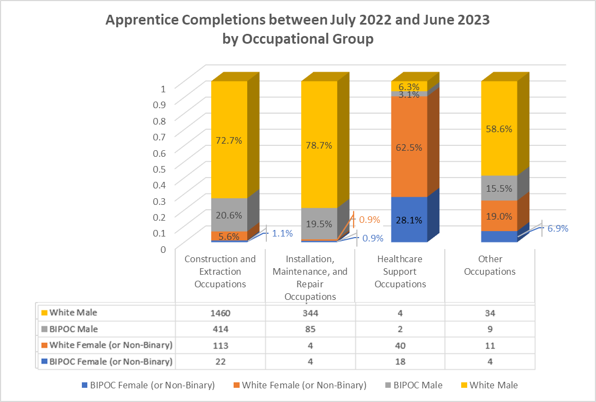
In future years, the numbers of construction apprentices and new journey workers can be expected to grow as market forces and public investments in housing create more demand for both new and replacement workers. Also, House Bill 2649 (from the 2023 regular legislative session) is expected to increase utilization of apprentices on large state-funded projects. The challenges of exposing young learners to both CTE and apprenticeship opportunities continues to impact participation. Over at least the last twenty years, the average journey worker entered a registered apprenticeship program in their late 20s (for men) and early 30s (for women), as shown in Figure #12. Although the data reveals an increase of nearly 60% in female journey workers and an increase of more than 11% in males in construction from 1994 to 2017, the total number of new female journey workers lags behind the males.

Figure #12 - New Journey Workers in Construction Trades by Gender and Age at Registration during the years 1994-2001, 2002-2009, and 2010-2017
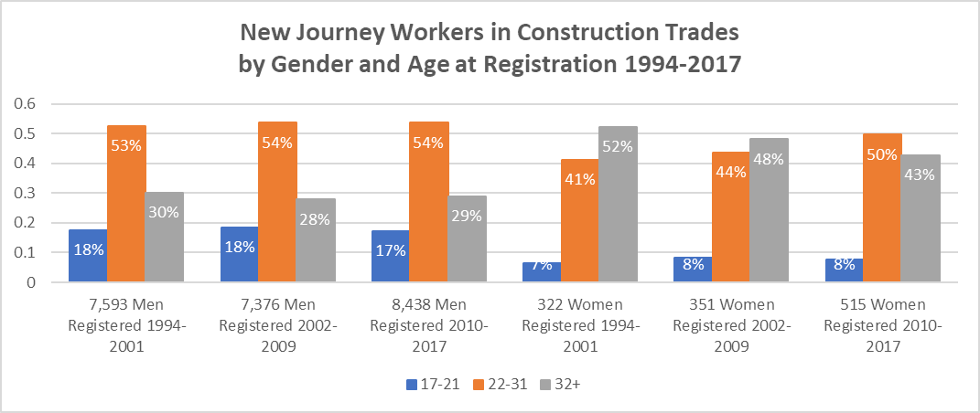
Compared to the men, the women who become journey workers in construction were much less likely to be registered in the 17–21-year-old age group and much more likely to be registered in the age group of 32 years and older. This suggests that we may be under-serving young women in the years right out of high school relative to the young men. On the other hand, women in the 22–31-year-old age group have been increasing in both raw numbers and as a percentage of all women registered, which may reflect improved services for this age group.
Overall, more than half of new journey workers entered their apprenticeship between the ages of 22 and 31 (slightly over half for the men and just shy of half for the women). Most of these journey workers did not enter registered apprenticeship directly from high school. In terms of the life course of their Career Connected Learning, much of the career counseling and career placement services they needed happened in the decade or so after they left high school. Hence, efforts to promote opportunities to younger audiences along with new strategies to connect graduates with opportunities such as adult pre-apprenticeship programs could be beneficial in guiding earlier exploration of available career paths.
Looking at new journey workers who were registered from 2010-2017 by both gender and race/ethnicity in Figure #13, it is clear that the 22-31 age group is still the largest (1,938 total in age group), but white male journey workers and Hispanic/Latino male journey workers tend to enter construction apprenticeships at a younger age.

Figure #13 - New Journey Workers in Construction Trades by Gender and Race/Ethnicity, Registered 2010-2017
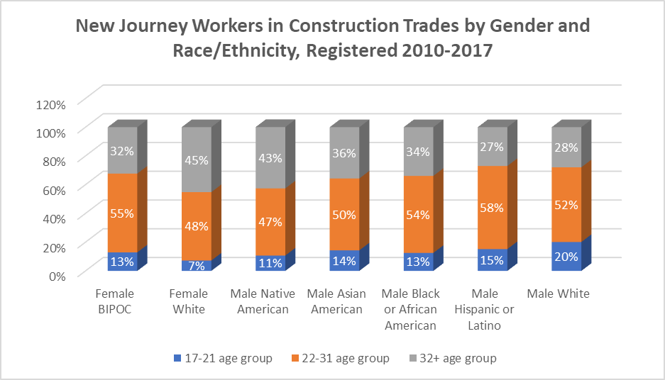
All other demographic groups tend to have fewer in the 17–21-year-old age group (696 total in age group) and more who find their way into the trades at ages 32 years-old and up (1,087 total in age group). White female apprentices are the least likely to enter construction programs in the 17-21 age range, while white male apprentices are the most likely to enter in that age range. Hispanic/Latino male apprentices are the least likely to enter construction at ages 32 and older, followed closely by white male apprentices, while white female apprentices are the most likely to enter at ages 32 and older, followed closely by Native American male apprentices. In order to create a smoother transition to construction apprenticeship programs for students in the 17–21-year-old age group, more work needs to be done in Oregon to provide earlier exposure to CTE, overcome barriers, and provide support for white female students and both male and female students of color.
Over the past few months, the Partnering State Agencies have each listened and leaned in to understand the challenges of implementing youth apprenticeship programs in Oregon. The Hillsboro School District's Advanced Manufacturing Apprenticeship is Oregon’s sole Youth Apprenticeship Program, approved by the Oregon State Apprenticeship and Training Council (OSATC) in July 2022. The program aims for students to finish the two-year apprenticeship program and earn a nationally recognized certified credential as manufacturing technician. However, they are finding that current interpretations of the statutes are making it nearly impossible for students to complete the program while in high school.
Hillsboro and its partnering employers built and marketed to students a competency-based approach to apprenticeship that would result in students earning their occupational certificate. For students, the main reason to engage in apprenticeship is directly correlated to that outcome. Although the term of the occupational standard for the program was approved by the committee with the 2,000-hour requirement, it was not clear to the school district or partnering employers that statutory language requires at least 2,000 hours of on-the-job training under the competency-based approach, just as it does under the time-based and hybrid approaches. The application of this requirement means that youth apprentices cannot complete a program while also adhering to other statutes requiring that apprentices are at least 16 years old, enrolled in a high school CTE program, and not working more than 20 hours per week while they are enrolled. Students would need to work 20 hours per week across two typical school years (approximately 76 weeks) and 40 hours per week over two winter and spring breaks, and one summer (17 weeks) to accumulate 2,200 hours. That leaves almost no latitude for a student to be ill or work less than 20 hours in any given week across almost two years. Students cannot complete their hours in the second summer after graduation as they are no longer “enrolled in a CTE program” and there is some question as to whether students are “enrolled in a CTE program” during school breaks and able to work 40 or even 20 hours during those weeks.
All parties desire to find a solution for the current cohort of youth apprentices, the Hillsboro Advanced Manufacturing program moving forward, and future youth apprenticeship programs. The Partnering State Agencies, Hillsboro School District, employers, and other partners have engaged in conversations jointly and independently. Discussions have centered around proposed exceptions to the 2000-hour minimum, allowances for classroom competency time to count, and options for students to finish the program after graduation. Although all parties agree that providing a pathway for youth into apprenticeship is needed, there is no consensus on the most equitable design of programs. One suggested rule change would require that the establishment of a youth apprenticeship program must have an active adult program with the same occupational standard in order for it to be approved. However, not all parties are in support of this proposal, as some believe students will meet competency-based program completion requirements and should be able to complete just as any other apprenticeship program. Other parties support a rule change that would require that an adult registered apprenticeship program be active. Through the matriculation into an adult program, this would provide opportunities for students to enter the youth apprenticeship program during either their junior or senior year and continue on to complete their apprenticeship and earn a nationally recognized certified credential after high school graduation. A beneficial path forward might allow youth to complete an apprenticeship program while in high school when that is appropriate for the student while also creating opportunities for youth apprentices to matriculate into adult programs when that is appropriate for the student.
Oregon needs to address the regulatory barriers around youth apprenticeship programs in order to capitalize on growing interest, help address workforce shortages, and support underserved students in attaining high-paying jobs. Expanding youth apprenticeship to other schools and industries can be achieved through the thoughtful review of current statutes and rules and better alignment to the K-12 and registered apprenticeship systems.
While the commitment of the Partnering State Agencies to improve the CTE landscape in Oregon has yielded many promising initiatives and potential pathways, it is clear that substantial challenges remain, particularly the statutory and rule barriers associated with actualizing youth apprenticeship in the state. Nevertheless, as we move forward, these challenges only underscore the importance of our work: ensuring that every student in CTE has an unhindered path from the classroom to the workforce.

Goal #5
Implement accelerated college credit programs that allow students to move seamlessly from public schools to post-secondary education or training to the workforce.

Accelerated college credit programs are an effective strategy in streamlining the educational journey, facilitating a smoother progression from high schools through to postsecondary institutions. Dual credit opportunities aim to equip students with college-level skills while they're still in high school, paving the way to higher education or direct workforce entry.
In 2022-23, the HECC and ODE Accelerated Learning Team, along with research partner Education Northwest, collaborated to ensure the release of updated data in dashboards for both Accelerated Learning and CTE Participation. As part of this collaboration, the team identified a statewide trend of declining participation in CTE dual credit experiences that warranted further research and action. Thus, HECC and ODE took the following actions:
- Applied and selected as one of four states to participate in the College in High School Alliance’s State Dual Enrollment Academy, Policy Issues Impacting CTE Dual Enrollment, in October 2023.
- Created and delivered a presentation for ODE’s Secondary/Postsecondary Transitions (SPST) team to share the data, and created a plan to collaborate with them to investigate further.
- Secured a commitment from the Dean of Career and Technical Education from at least one impacted community college to assist with further inquiry and analysis.
- Invited an SPST team member who specializes in CTE programs to join the Accelerated Learning state team’s biweekly meetings and collaborate on the investigation, including a deeper investigation into a possible community college survey related to dual credit CTE.
- Enhanced a survey for community college partners to get feedback on root causes of CTE dual credit participation drops and seek additional research partners via a required data collection through OAR 715-017-0005. The HECC and ODE Accelerated Learning Team is in the process of analyzing survey results and planning next steps actions to support robust CTE dual credit participation.

The proactive planning in the past year underscores the importance of accelerated learning in bridging the gap between high school and postsecondary experiences. By pinpointing areas of concern and taking immediate action, HECC and ODE are laying the foundation for a more integrated, efficient, and student-centric approach to transition. The Partnering State Agencies eagerly await sharing further updates and developments in the next year.

Goal #6
Increase professional development opportunities for teachers and learning opportunities for students through industry mentorships, internships, summer programs, after-school programs and career-based student leadership opportunities.

The Partnering State Agencies organized a variety of comprehensive professional development opportunities for educators throughout the 2022-23 school year designed to expand and improve real-world learning experiences for students. This included forming professional learning communities, hosting Career Connected Learning office hours, and offering Work-Based Learning specific professional learning. Additionally, new guidance resources and the K-12 Teacher Registered Apprenticeship Program were introduced. Collectively, these opportunities aimed to equip educators with the tools, insights, and resources needed to introduce students to the world of work and help CTE students develop their academic, technical, and employability skills.
CTE teachers from across the state were invited to attend a pre-conference event hosted by ODE and HECC preceding the Oregon ACTE Annual Conference. The day kicked off with a local industry partner as the keynote speaker, followed by a panel of Career and Technical Student Organization students, and brief updates around implementing Work-Based Learning and industry approved credentials in CTE programs. The primary purpose in planning the pre-conference day pertained to the afternoon professional learning community gatherings for each career area. The teachers received updates on the statewide Program of Study framework within their career area, engaged in networking and small discussions around providing students with a high-quality program, and shared their perspective on what is working or needs improvement in order to better support students in CTE.
The intent is to continue a professional learning community pre-conference day at the Oregon ACTE Annual Conference moving forward, along with regularly scheduled virtual gatherings throughout the school year. A core planning team, consisting of members of the Partnering State Agencies, alongside CTE teachers/instructors, and other partners is undertaking additional community engagement to ensure continuity across the career clusters, align statewide and regional efforts, and plan the shared learning opportunities for educators across the state. The professional learning communities will improve outcomes for all CTE students through collaborative continuous improvement while providing another avenue of support for new teachers.
In an effort to expand technical assistance, offer professional development, answer questions, and encourage the sharing of promising practices, statewide partners supporting Career Connected Learning were invited to attend monthly office hours. Professionals from both K-12 schools and postsecondary institutions joined sessions throughout the 2022-23 school year based on their interest in Career Counseling and Advising, Work-Based Learning, Oregon CIS, and/or YouScience. With support from ODE, HECC, BOLI, Willamette ESD, Oregon CIS, High Desert ESD, YouScience, and others, the office hours brought together educational partners dedicated to creating and expanding high-quality Career Connected Learning activities for students.
The Partnering State Agencies collaborated on guidance outlining the steps to “Enhance your CTE Program of Study by Becoming an Oregon Certified Pre-Apprenticeship Training Program.” The release of the document was followed by a pre-apprenticeship question and answer session during the Work-Based Learning Office Hours, hosted by the Partnering State Agencies. Additional efforts to promote apprenticeship opportunities and the role of Education Service Districts (ESD) in helping students explore the benefits of apprenticeship were offered in the spring. The six regionally focused virtual trainings included basic information on apprenticeship, youth apprenticeship, and pre-apprenticeship programs while introducing potential partners for schools.
A variety of professional development opportunities focused on CTE Work-Based Learning were offered throughout the year. Each of the options listed below assisted teachers—and others supporting teachers—to expand student access to meaningful WBL experiences.
- Accessing Union Apprenticeship Conference - Increasing Opportunity for Oregon Learners: CCL, WBL, and Pre-Apprenticeships
- Oregon ACTE New Teacher Monday Mingle Series and InterMountain ESD CTE Directors Meeting - Mapping Career Connected Learning in a CTE Program of Study
- Oregon ACTE Conference - Clarifying the Criteria: Examining the Elements of a High Quality Work-Based Learning Experience and Explore New Tools and Resources for Designing Meaningful Work-Based Learning Experiences
- Career Connected Learning Systems Navigator Network Meetings - Introduction to WBL and Your Role in Supporting CTE Work-Based Learning
In addition to the synchronous options, ODE released a Work-Based Learning Canvas course to help schools build high quality, equitable WBL experiences that engage students in relevant career development. The content includes guidance, activities, tools, and resources to support the planning, implementation, and continuous improvement of WBL. The asynchronous course helps WBL coordinators, administrators, and teachers connect classroom learning to the world of work and assist Oregon students in achieving their education and career goals.
In 2022-23, representing the third year of implementation of the Perkins V Work-Based Learning requirement, CTE educators across all career learning areas provided their students with nearly 42,000 WBL experiences. Figure #14 shows the greatest number of WBL opportunities were provided in Business and Management, while CTE Programs of Study in Human Resources and Health Sciences provided the least. Although there are some barriers to providing WBL in these two career areas, they also represent the fewest number of programs.

Figure #14 - Number of Work-Based Learning Experiences by Career Learning Area in 2022-23
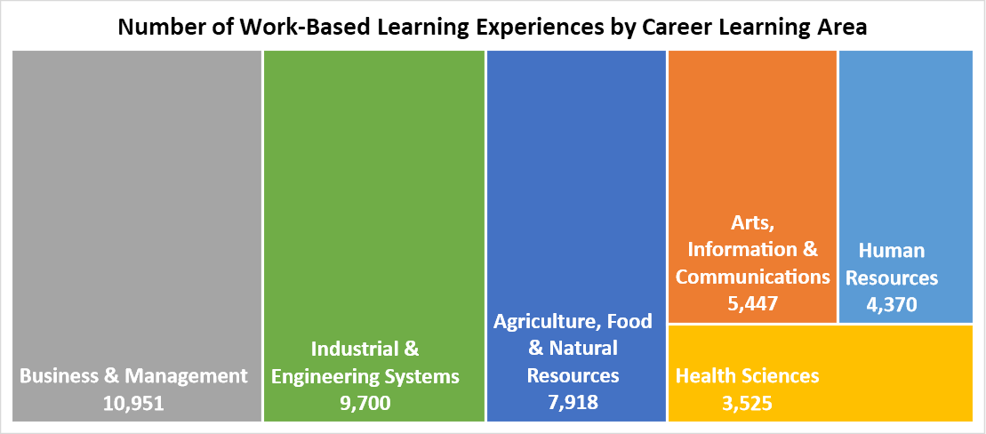
Over three-fourths of the experiences centered around School-Based Enterprises and Workplace Simulations, as shown in Figure #15.

Figure #15 - Percent of Work-Based Learning Experiences by Type in 2022-23
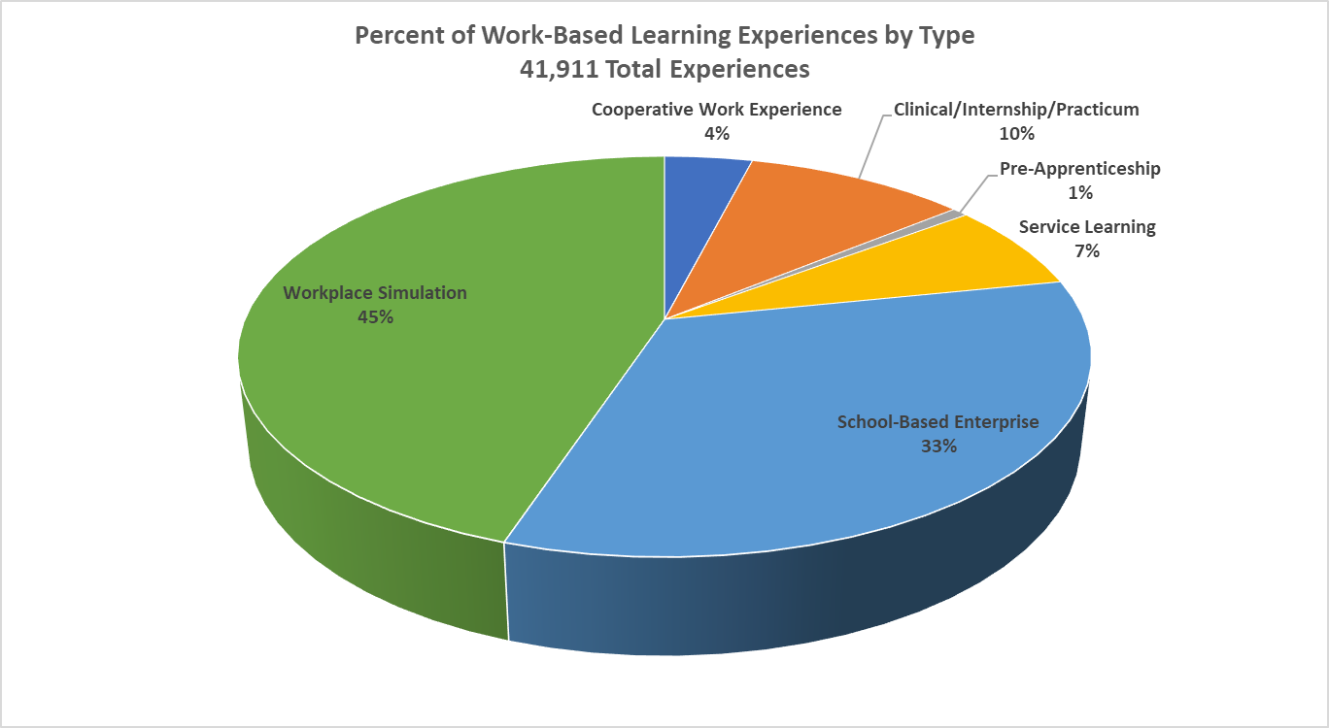

Regardless of the type of experience, WBL across all career learning areas must address the four-state defined WBL criteria:
- Align with CTE Program of Study curriculum and instruction
- Include sustained interaction with industry, business, or community professionals
- Be offered in-person, virtually, or in a simulated workplace setting
- Lead to earning of credit and/or outcome verification
ODE’s WBL Rubric and related technical assistance have been effective in helping programs design and deliver quality and equitable Work-Based Learning experiences that meet the criteria. The data also shows that its focus on equity considerations has resulted in WBL experiences with fewer barriers to access and participation. For example, the participation rate of Hispanic/Latino students and students with disabilities in Work-Based Learning exceeded their representation in the broader population of Oregon students.
Educators and students also benefited from new Career Connected Learning (CCL) tools and resources made possible through recent investments utilizing short-term ESSER dollars from ODE and implemented in partnership with HECC. For example, Free and Open Access to the Oregon Career Information System (CIS) has been a remarkable benefit to all Oregonians, with 39,502 people having accessed CIS with a total of 50,385 accounts set up since October 2022. School districts also have free administrative access. An elementary school version has also been added to support earlier CCL exposure with developmentally appropriate activities. Another example is the YouScience pilot project that helps students identify their aptitudes and interests to assist in making course selection and career development decisions. To date, 31,007 Oregon students have completed the assessment, and 234 Oregon schools use YouScience currently as part of the pilot. Community colleges also have access to the YouScience platform through another funding source, which will allow for more seamless secondary-to-postsecondary transitions for students and enhanced partnership opportunities utilizing this tool.
In support of the legislature’s efforts to help more Oregonians become teachers and improve the diversity in the educator workforce, the ATD Council approved the K-12 Teacher Registered Apprenticeship Program in September 2023. This established a minimum standard for this occupation with the collaborative efforts of the Oregon Teacher Standards and Practices Commission (TSPC), HECC, ODE, Educational Program Providers (EPPs), and many other agencies. TSPC has made an effort to close the apprenticeship knowledge gap among educators and removed hurdles by bringing together agencies which are engaged in education in some form. As of October 1, 2023, two school districts were piloting the program in Oregon. Funding was the subject of legislation during the 2023 regular session and was included in an omnibus education bill (SB 283) that passed June 24, 2023.
In the years ahead, the Partnering State Agencies will continue to provide educators with diverse professional development opportunities, focused on enhancing the learning experiences of CTE students. The continuous improvement of CTE programs and educators will help ensure that Oregon’s learners acquire the knowledge and skills needed for success in their future careers.

Goal #7
Establish partnerships between public and private entities for the purpose of educating students, parents, teachers, school advisors, policymakers and the general public about the benefits and opportunities related to career and technical education.

One of the most transformative ways to enrich the student experience in CTE is by forging robust partnerships, both public and private. Collaborations not only help in bolstering the educational framework, but also play a crucial role in promoting the benefits of CTE to a wider audience, ranging from parents and educators to policymakers and the general public. The following endeavors highlight how the Partnering State Agencies have been leveraging these partnerships to promote and elevate CTE.
The Oregon Lottery conducts annual studies to find out what people want to hear or learn more about regarding the lottery. Oregonians consistently express a desire to know what the dollars support in their own communities. Given that lottery funds help support education, the Oregon Lottery communicates with ODE to identify topics to spotlight. Its Play it Forward campaign ran from January through March of 2023 and highlighted CTE within a TV spot, social media, and as a feature on the Oregon Lottery web page. The page received over 11,000 views via the Oregon Lottery app, showcasing a video and emphasizing the benefits of CTE and the opportunities available to students. As opportunities arise, the Oregon Lottery may update the CTE promotional page and communicate with ODE regarding future campaigns due to the high level of engagement with CTE from Oregonians.
In addition to raising general awareness about CTE, it is also critical to spark curiosity at an early age, as previously communicated. Career awareness and exploration in elementary and middle school helps students discover career areas that interest them, form academic and career plans, and enroll in CTE programs aligned to their future goals. In an effort to support Oregon schools in expanding career development opportunities for students, the Career Connected Learning newsletter launched in September 2022. The monthly e-newsletter provides subscribers with current information, research, professional development, and statewide examples of CCL across the key stages. By providing schools with the resources needed to integrate career development into their classrooms, students will be empowered to navigate their own pathways from middle school to CTE and into the workforce.
Beyond the promotional efforts, the Partnering State Agencies have also engaged in a structured approach to industry collaboration that has been set in motion to directly align education with current and future workforce demands. Through the Future Ready Oregon investment package, three statewide industry consortia launched in 2022-23, representing the priority industry sectors of healthcare, manufacturing, and technology. The purpose of each consortium is to establish strategic partnerships, develop structured processes to address mutual industry goals, identify industry-specific workforce needs in this state, develop recruitment strategies to increase equitable participation, and promote workforce development programs and activities in the priority ​industry sectors.​​​ Members of these three statewide industry consortia include the Partnering State Agencies. CTE leaders are key partners in this work and the role and benefits of CTE in meeting workforce needs for these priority sectors is represented in consortia work group efforts. These efforts include identifying high-value skills and credentials, defining the connected continuum of learning and working that best aligns with hiring and advancement, and analyzing gaps and disconnects in education and training programming. CTE serves as a vital link between education and workforce development. Through Future Ready and the Industry Consortium, new opportunities are emerging to build stronger connections between systems.
As efforts to intertwine education with industry progressed, special initiatives were also underway to cater to diverse sections of Oregon’s population. In 2022-23, HECC—with the support of ODE—was selected along with five other states to participate in Advance CTE’s recruitment-focused cohort, Building Sustainable State Recruitment and Communications Systems to Reach Diverse Learners, which builds on pilots conducted in over a dozen states since 2017. Oregon’s project is focused on messaging and recruitment systems that will improve postsecondary CTE participation for members of Oregon’s nine federally recognized tribes. Although this project is still in its early stages, it will proceed with a commitment to centering tribal feedback and engagement in any materials or systems that are developed.
While statewide initiatives and partnerships are essential, regional events also play an indispensable role in highlighting career paths, especially in rural regions. BOLI-ATD continued to engage in the planning committee for the Career Connect Conference hosted in Pendleton every spring. This event showcases local career pathways in eastern Oregon that align with existing CTE pathways and in-demand occupations.
From leveraging media platforms to raising awareness, to fortifying the link between educational institutions and industries, and ensuring that diverse students are represented and engaged in CTE, the Partnering State Agencies are uncovering new avenues to spread the word about CTE. They remain dedicated to strengthening these collaborations in the years ahead, aiming to elevate CTE and make it an essential experience for students, parents, and the entire community by emphasizing the potential and opportunities it provides.

Recommendations
In the context of Oregon's evolving economy, aligning education with workforce demands is increasingly important. As we look to the future, ensuring that young talent is adequately prepared for the challenges and opportunities of tomorrow's job market becomes paramount. This will not only aid learners in forging successful career paths, but also ensure that industries have access to a skilled and dynamic workforce. With this in mind, the Partnering State Agencies present three recommendations aimed at enhancing the synergy between education and industry, fostering robust Career and Technical Education pathways, and bolstering the state's commitment to youth apprenticeship.

Recommendation #1
Allocate targeted funding to support and expand CTE programs across the state.

Career and Technical Education programs play a critical role in preparing Oregon students for the workforce by providing them with the necessary skills and knowledge to excel in high-wage, in-demand careers. CTE concentrators from the class of 2011 in Oregon earned over $2,000 more annually seven years after leaving high school than non-CTE concentrators. Committing resources to CTE and Career Connected Learning yields substantial rewards, benefiting both students and the broader community, as shown in Figure #16 from the Association for Career & Technical Education.
Figure #16 - Investing in CTE Yields Big Returns
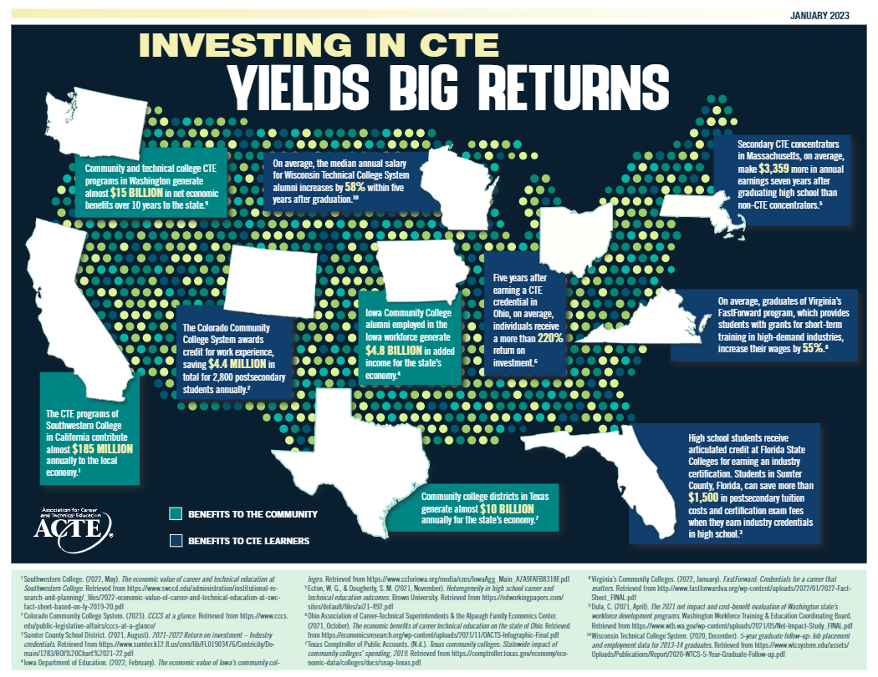
Oregon has no state directed CTE funding beyond foundational education funding to maintain the efforts. Some funding is available for specific purposes, such as the CTE Revitalization Grant, a competitive grant that offers short-term funding to start or strengthen a CTE program. The Secondary Career Pathway Fund provides incentive funds to secondary CTE programs whose students earn at least three credits, with additional dollars awarded for students identified as underserved. Other grants are dedicated to building Career and Technical Student Organizations, most significantly FFA (formerly Future Farmers of America) associations. Funding inadequacies have impacted the support and quality of CTE programs statewide.
Increasing state funding to align with the growing costs associated with administering CTE programs and allocating funds for CTE regional leadership will ensure essential state and regional support to CTE programs. State staff administrative costs related to CTE have been on the rise. However, the current funding allocations have not kept pace, resulting in budgetary strains and operational challenges. The CTE Regional Coordinators serve as the central connection between secondary and postsecondary CTE programs and industry. Despite their essential role, they are not funded at the state level. Additionally, the Career Connected Learning Systems Navigators contribute to a statewide network that supports K-12 schools with the connections and tools needed to offer CCL opportunities to all students. The CCL Systems Navigators are housed at each of the 17 community colleges and are currently funded only by the Elementary and Secondary School Emergency Relief Fund III through September 2024.
Given their hands-on nature, CTE programs often involve consumables that are regularly used and need replacement, making them more cost-intensive than traditional educational programs. Exploring mechanisms to provide targeted funding specifically for consumables within CTE programs in high schools and community colleges will ensure that CTE programs remain up to date with the latest equipment and materials, facilitating practical, real-world training for students. Investments in CTE are investments in the state's future workforce. By addressing these funding and support gaps, we can ensure that CTE programs across the state are equipped to provide high-quality education and training, producing a skilled, industry-ready workforce that meets the evolving needs of the economy.

Recommendation #2
Reaffirm and strengthen commitments to the intentional alignment of education and workforce development priorities, projects, and processes.

The relationship between education and the workforce is evident through Career and Technical Education programs, youth/pre-apprenticeships, and Career Connected Learning initiatives. However, ensuring seamless alignment and collaboration between the systems requires intentional efforts, streamlined processes, and dedicated funding. While the inherent link between CTE, youth apprenticeships, K-12, and workforce development is understood, a strategic framework to formally align the initiatives is needed to ensure a cohesive approach to preparing youth for the workforce.
Ongoing and required connections around a unified vision and actionable plan will ensure education systems, the Workforce and Talent Development Board, and workforce priorities are in sync. When these structures are well-funded and have clear expectations, they will naturally align their objectives and work more collaboratively, benefiting students, businesses, and the broader economy. This includes providing financial resources that advance the alignment of education and workforce priorities and make transitions smoother for students and more responsive to industry needs. For example, allocating funding for ORS 344.753 or other efforts to expand CTE Work-Based Learning will ensure ODE, BOLI, and employers work together to build student opportunities and contribute to the holistic development of youth for the job market.
Alignment between education and workforce initiatives is not just beneficial—it's essential. By intentionally bridging the gaps between CTE, workforce development, and educational systems, Oregon can pave the way for a future where learners are better prepared for the world of work, and industries receive talent that's tailor-fit for their needs.

Recommendation #3
Change Oregon Revised Statutes and Oregon Administrative Rules impacting youth apprenticeship to encourage program development by aligning youth apprenticeship to the K-12 system.

Reviewing and potentially updating the Oregon Revised Statutes and Oregon Administrative Rules related to youth apprenticeship is needed to establish better integration with the K-12 system. This alignment can help streamline education-to-workforce pathways, making it more accessible for schools to build programs and students to participate in apprenticeship. By fine-tuning these regulations, Oregon can offer a more cohesive approach to youth apprenticeships, facilitating broader program access and ensuring students not only enroll but also successfully complete their apprenticeships and/or seamlessly transition to adult registered apprenticeships where appropriate. Such alignment ultimately strengthens the bridge between education and viable career paths for Oregon's youth while simultaneously helping industries meet their workforce demands.

Conclusion
In 2022-23, collaboration between the Partnering State Agencies led to significant results and progress in several key areas:
- Increased access to CTE program opportunities for Oregon’s secondary and postsecondary learners, including a notable increase of 57% in the number of registered apprentices statewide.
- Positive early impacts from ESSER III Career Connected Learning Investments, including CCL Systems Navigators located at all 17 community colleges working with regional partners to align systems in support of seamless CTE pathways for learners.
- Support for, and collaboration around, innovative programming in Lane County and with the Medford School District creating pathways to priority sector careers through Pre-Apprenticeship and Registered Apprenticeship.
- Additional progress on statewide CTE advisory and the release of updated, sector-specific CTE knowledge and skill statements aligned with workforce needs.
- Attention to learner needs and voice and elimination of system barriers in CTE through cross-state collaboration, CTE youth advisory, and burgeoning efforts to ensure access to Youth Apprenticeship opportunities.
- Focused attention on determining the root causes of declines in accelerated college credit earning in CTE in an effort to ensure access to equitable and purposeful accelerated college credit opportunities for high school students.
- Purposeful professional development opportunities for CTE educators and sustained focus on bridging the classroom with business and industry through over 42,000 CTE Work-Based Learning experiences completed by Oregon’s secondary CTE learners.
- Guidance and technical support provided to support CTE programs in becoming Registered Pre-Apprenticeship Programs.
- Addressing teacher shortages through BOLI-ATD’s approval of a K-12 Teacher Registered Apprenticeship Program.
- Sustained commitment to promoting the benefits of, and opportunities in, CTE through a statewide CCL newsletter, partnership with Oregon Lottery, and the early launch of engagement with Oregon’s nine federally recognized tribes and with other states around marketing CTE to tribal communities.
The joint report for ORS 344.125 demonstrates the commitment and efforts made by the Department of Education, the Office of Community Colleges and Workforce Development, and the Oregon Bureau of Labor and Industries to collaborate on issues related to Career and Technical Education. Through various opportunities, initiatives, and partner engagements, positive outcomes were achieved, although challenges were also encountered. The Partnering State Agencies remain dedicated to furthering the goals of ORS 344.125 and look forward to continued collaboration and improvement in the years ahead.

The Carl D. Perkins Career and Technical Education Improvement Act of 2006 as amended by the Strengthening Career and Technical Education for the 21st Century Act (Perkins V), (Public Law 109-270).
A secondary CTE concentrator is a student who earns at least two credits in a single CTE Program of Study. One of those credits must be earned through a course or courses identified as intermediate or advanced.

