How to Access SECC Regional Reports
- Login through the district home page site https://odedistrict.oregon.gov/Pages/default.aspx. The Login web application link is located in the center of the page.
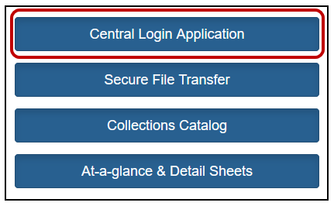
- Login on the district Central Login web application.
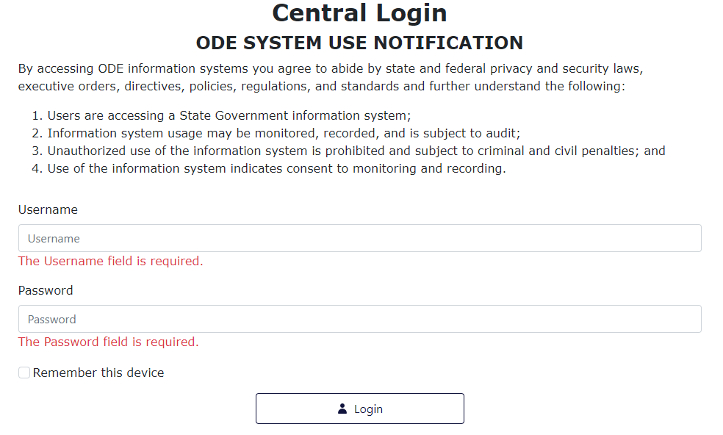

- An Applications list will appear on the next page. Click on Consolidated Collections.
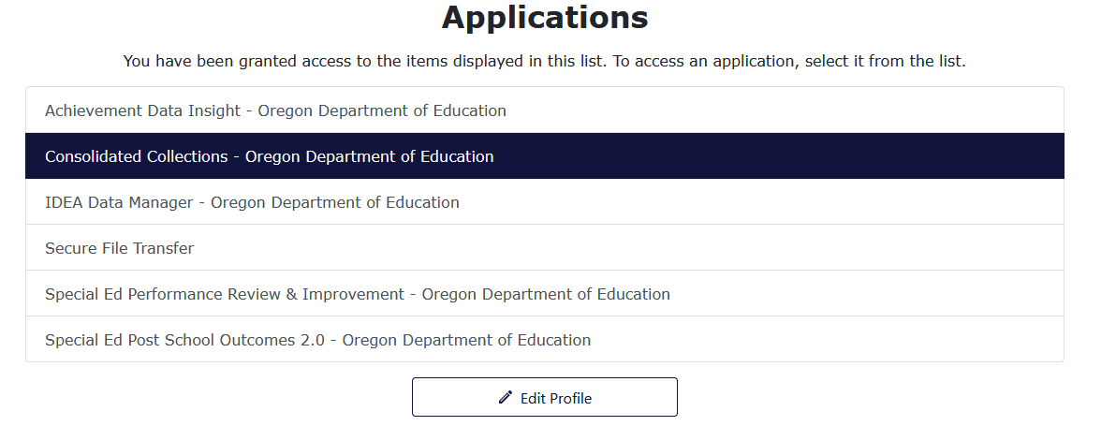
- Select Reports tab, located next to Status Tracking tab.
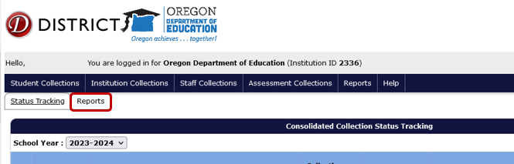
- From the Collection menu, select “Special Education Child Census (SECC).”
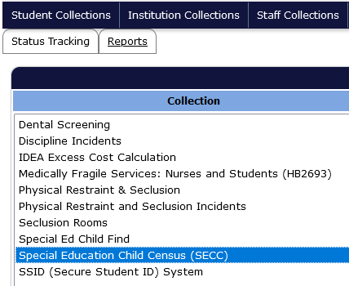
- In the Report Year menu that appears below or to the right, select the DecSECC Report from the collection year needed.
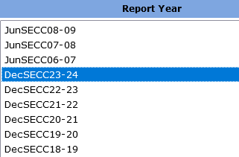
- In the Report menu that appears below or to right, select “Regional Report - Detail” or you can choose “Regional Report – Summary.”
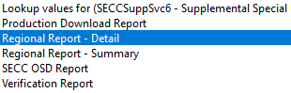
- A new tab will open with the appropriate report, identifying the year requested. This popup will contain a table with students with Agency Serving Codes 13, 23 and 33 (Regional Inclusive Services). This report can be exported to Excel by clicking the Export to CSV button.
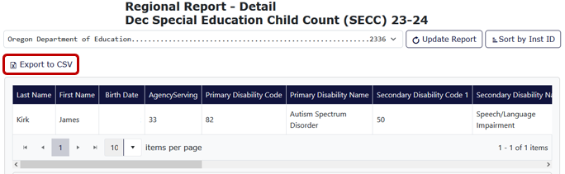
If you need assistance with this process, call anyone in the Data Team:
- Jackie McKim, 503-947-5629 or jackie.mckim@ode.oregon.gov
- Cynthia Garton, 503-947-5817 or cynthia.garton@ode.oregon.gov
- Maxwell Swope , 971-208-0259 or maxwell.swope@ode.oregon.gov

