Do not include this page with application submission

Oregon State Weed Board
Grant Program

Section 28-5 – Application Form
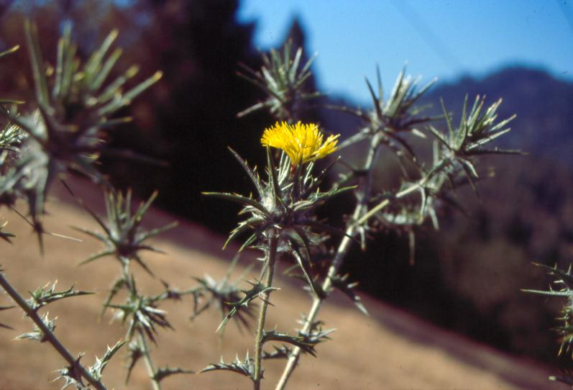

Oregon State Weed Board
635 Capitol St NE • Salem, OR 97301-2532
Tristen Berg, Noxious Weed Grant Coordinator
503-986-4622 • Fax: 503-986-4786

Do not include this page with application submission

Do not include this page with application submission
Application Submission Requirements

- Provide the Oregon State Weed Board (OSWB) with and electronic version submitted through
FTP server upload: http://files.oda.state.or.us/?login=oswb

- Submit by mail two SIGNED - single sided original versions of your completed application.

- Electronic versions MUST be submitted in workable format Microsoft Word preferred.

- Mandatory attachments: must be included or your application will automatically be rejected. These items include: project budget, photos of project area, maps of project area, required project partner form and landowner lists for cost reimbursement projects.

- All documents must be submitted by December 12, 2014 and mailed to:
Tristen Berg, Noxious Weed Grant Program
Oregon Dept. of Agriculture
635 Capitol St NE
Salem, OR 97301

OSWB Grant Application Form 2015 Cycle
Grant Cycle 28-5 – Application Due Date: December 12, 2014

Project title: (Using 6 words or less give your project a descriptive title)

County or Counties project is located in:

Type of Organization:
Cooperative Weed Management Area Not-For-Profit Organization
Political Subdivision (not a state agency) Private
Institute for Higher Education Tribe
Soil & Water Conservation District Watershed Council
OSWB dollars requested: $ Total cost of project: $

Name of Applicant or Organization:
Contact: email:
Address:
City: State: Zip:
Phone: Fax:
Project Manager for Applicant or Organization:
Contact: email:
Address:
City: State: Zip:
Phone: Fax:
Fiscal Agent for Applicant or Organization:
Contact: email:
Address:
City: State: Zip:
Phone: Fax:
Project Information
1.Weed Species: (List all state listed noxious weeds pertaining to this project. Use common name plus genus and species. If your project has more weeds than the allowable space please duplicate this table on a separate sheet and attach to this application)
*Habitat | **Method of treatment | *Weed species | Net/treatment acres | Gross/survey acres | Herbicide(s) | Define the timing of treatment
Wetland | Bio-Control | Purple loosestrife, Lythrum salicaria | 1 | 13 | N/A | Late June
*Choose the primary habitat the weed exist – Upland, Riparian, Wetland, Instream, Estuary. It is recognized that some projects have mixed habitat types, chose only one habitat per weed per line. Habitats are described within the instructions. Use only state listed noxious weeds as described within the instructions Exhibit B.
**see section (5) below for designated treatment types
Total estimated project acreage: net: gross:
(see appendix c with instructions for understanding calculation of your total project net/gross project acreage)
2. Project location: (directions to the site)
Latitude: Longitude: (at least one lat/long reading is mandatory)
3. Does this project exist within a designated weed control district?
(Refer to ORS569.360)
Yes No If Yes, provide district name:
4. Is this part of an established Cooperative Weed Management Area? Yes No If yes provide name:
**5. Identify your integrated pest management methods: (all activities must be directly related to the proposed project):
Assessment/Management Plan Development
Biological control Education and outreach
Herbicide control Manual control
Mechanical control Monitoring
Prevention Restoration
Other – Explain:
Survey –
Describe the method of survey planned:

6. Have you consulted with ODA staff? Yes No
If yes who?
7. Is this a landowner reimbursement (cost share) project? Yes No
Remember to attach a list of landowners with acreage by weed species. Updated landowner lists are required with your progress reporting.

8. Project summary: In 200 words – give a statement about your overall project. Provide a summary in 200 words (1000 characters) or less describing what the project will accomplish and what problems will be addressed. The information you provide will be used for project review, OWEB reporting purposes and will be displayed to the general public.

9. What are you proposing to do? (1,300 words which is approximately 8,000 characters) give an overview of the project.
This should include: if this is an extension of a previously funded project if so, include details of past treatments such as successes and failures • estimated acreage for treatment • method of control • objectives • restoration component • how this project relates to other projects within the area. It is important be concise and keep this to the 1,300 word limit, but give the details outlined above, this portion is essential in the overall review process.
Was this project previously funded by OSWB? Yes No
If yes what year(s) and provide the grant number?

Proposal details:

10. Using a bulleted list: Explain the project goals and objectives.
(See Instructions section for specific guidance on goals and objectives writing)

11. Is the project part of an existing weed management plan?
Yes No (if yes, provide the plan name, author & date published)

12. Are there additional partners? Yes No
Who are the additional partners and what are their roles and responsibilities?

13. Which elements of the project will OSWB funds be used for? Be specific to activity and specific timing of the activity.

14. How does this project relate to other projects (BLM, USFS or local projects) completed or planned? If the project is related to work funded in part with another grant from OWEB (i.e. restoration, land acquisition, or technical assistance)? List the OWEB grant number and briefly describe the relationship to this proposal.

15. How does this project fit into the statewide and/or local weed management objectives? Identify the county weed listing priority if known.

16. How will restoration be a part of your project? If restoration is not a component of this project please explain.

17. If this project protects a high priority species or habitat, please give a brief description of the species or habitat/land use designation.

18. Salmon/Steelhead Populations Targeted and Expected Benefits to Salmon/Steelhead
The information provided will be used by OWEB to better meet federal and state reporting requirements. Completion of this section is required but will not be used to evaluate this application for funding.

This project is NOT specifically designed to benefit salmon or steelhead.
- If you check this box do not answer supplemental question 18(A)

Targeted Salmon/Steelhead Populations: Select one or more of the salmon ESUs (Evolutionary Significant Unit) or steelhead DPSs (Distinct Population Segment) that the project will address/benefit. Additional information on the designation and location of the salmon/steelhead populations can be found at http://www.nwr.noaa.gov/ESA-Salmon-Listings/Salmon-Populations/Maps/Index.cfm

Chinook Salmon (Oncorhynchus tshawytscha) |  | Coho Salmon (O. kisutch)
 | Deschutes River summer/fall-run ESU |  |  |  | Lower Columbia River ESU
 | Lower Columbia River ESU |  |  |  | Oregon Coast ESU
 | Mid-Columbia River spring-run ESU |  |  |  | Southern Oregon/Northern California ESU
 | Oregon Coast ESU
 | Snake River Fall-run ESU |  | Steelhead (O. mykiss)
 | Snake River Spring/Summer-run ESU |  |  |  | Klamath Mountains Province DPS
 | Southern Oregon and Northern California Coastal ESU |  |  |  | Lower Columbia River DPS
 | Upper Klamath-Trinity Rivers ESU |  |  |  | Middle Columbia River DPS
 | Upper Willamette River ESU |  |  |  | Oregon Coast DPS
 |  |  |  |  | Snake River Basin DPS
Chum Salmon (O. keta) |  |  |  | Washington Coast DPS (SW Washington)
 | Columbia River ESU |  |  |  | Upper Willamette River DPS
 | Pacific Coast ESU |  |  |  | Steelhead/Trout unidentified DPS

18(A). Expected Benefits: Write a brief description of the goals and purpose of the project and how it is expected to benefit salmon/steelhead habitat.

19. How will success be determined, what elements will be monitored/evaluated and by whom, how often and for how long? Who will maintain the project and for how long?

Make sure to attach
Oregon State Weed Board Project Budget
with your application.
This page left intentionally blank
Project Partners
List agencies/organizations from which funding is anticipated for the proposed project.
The Oregon State Weed Board requires 25% match for projects, however if you concerns with this requirement please contact the
Tristen Berg, ODA Grant Program Coordinator at 503-986-4622.
Show all anticipated funding sources, and indicate the dollar value for cash and in-kind contributions. Be sure to provide a dollar value for each funding source. For all funding please provide within the “use of contribution” column exactly what the cash/in-kind will be used for, this helps the OSWB gain a better understanding of the roles and responsibilities the partners will have with the project. Check the appropriate box to denote if the funding status is secured or pending. In the Amount/Value Column, provide a total dollar amount or value for each funding source. Match should be directly related to the noxious weed project. OWEB funding is no longer eligible for match toward OSWB grants, SWCD and Watershed Councils must provide proof their match is from a source other than OWEB.
NOTE: If your project is selected for funding your organization will be asked to provide signatures for 25% match as a component of agreement procedures.

Funding Source (Name the Partner) | Use of Contribution | Cash | In-kind | Secured  (x) | Pending  (x) | Amount/Value
Sample Agency | GIS mapping, and ATV use |  | $2,500 | X |  | $2,500
OSWB |  | $ | N/A |  |  | $
Oregon Dept. of Agriculture |  | N/A | $ |  |  | $
 |  | $ | $ |  |  | $
 |  | $ | $ |  |  | $
 |  | $ | $ |  |  | $
 |  | $ | $ |  |  | $
 |  | $ | $ |  |  | $
 |  | $ | $ |  |  | $
 |  | $ | $ |  |  | $
 |  | $ | $ |  |  | $
 |  | $ | $ |  |  | $
 |  | $ | $ |  |  | $
 |  | $ | $ |  |  | $
Total Estimated Funds (add all amounts in the far-right Column): | (The total should equal the total cost  of the project on page 1 of the application) |  |  |  |  | *$
Have any conditions been placed on matching funds that may affect completion? Yes No
If Yes , Explain:

NOTICE of Grant Award Conditions

If this proposal is funded, you will be required to:
- Sign a Grant Agreement containing the terms and conditions for the project implementation, release of funds, and documentation of completion.
- Payments will be made only for work started after the effective date of the grant agreement, unless special conditions have been placed by ODA/OWEB.
Before ODA/OWEB releases the Grant Agreement, you will be required to:
- Resolve any and all outstanding issues from your previous grants with ODA/OWEB.

Upon signing the Grant Agreement, you will be required to:
- Certify in the Grant Agreement that prior to starting work on private land, you have or will obtain cooperative agreements with the private landowner(s). Exhibit D of the ODA/OWEB Grant Agreement may also require you to submit copies of those agreements to ODA/OWEB prior to the release of funds.
- Agree that monitoring information resulting from projects are public domain.
- Determine whether and what permits and licenses are required.

Before ODA/OWEB releases any payments, you will be required to:
- Document that 25% match funding has been secured.
- Submit a Public Certification Form
- Submit copies of all applicable permits and licenses from local, state, or federal agencies or governing bodies, or certify that permits and licenses not needed.

Upon completing the project, you will be required to:
- Submit a Project Completion Report as required in the Grant Agreement, including maps, photos and Match Form that documents at least 25% actual match. OGMS Online Project Completion Reporting can be completed at http://apps.wrd.state.or.us/apps/oweb/fiscal/default.aspx.
- Submit your Oregon Watershed Restoration Inventory report(s) electronically at http://apps.wrd.state.or.us/apps/oweb/owrio/default.aspx.
- Submit data to Oregon Weedmapper at http://www.oregon.gov/ODA/programs/Weeds/Pages/WeedMapper.aspx

Initial each category and be sure this page is submitted along with your completed proposal.

CERTIFICATION:
I certify that this application is a true and accurate representation of the proposed work for watershed restoration and that I am authorized to sign as the Applicant or Co-Applicant. By the following signature, the Applicant certifies that they are aware of the requirements (see Application Instructions) of an OSWB/OWEB grant and are prepared to implement the project if awarded. I have read and initialed the NOTICE of Grant Award Conditions

Applicant Signature: |  | Date:
Print Name: |  | Title:
Co-Applicant Signature: |  | Date:
Print Name: |  | Agency:

All appendices are housed within the application instructions section and can be downloaded at: http://www.oregon.gov/ODA/programs/Weeds/Pages/GrantProgram.aspx
Mandatory attachments:
- Maps highlighting specific area of project activities
- Photos (please use the same photo points as you will use on interim progress reporting and project completion reports should this project be awarded)
- For landowner reimbursement projects – landowner list with acreages listed by weed species
- Project partners form
- Initialed notice of grant condition statement and signed certification form

