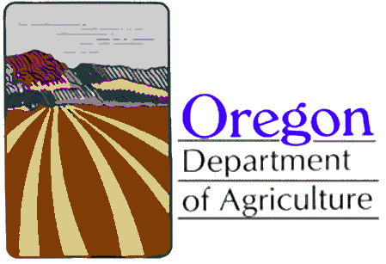
Food Safety Program
Variance Application
Website: http://www.oregon.gov/oda/programs/foodsafety

Please send the completed variance application form to the Oregon Department of Agriculture’s Food Safety Program. Please submit a separate application form for each variance request, using additional pages if necessary.

Date:_______________________________________________________________
Name of Applicant / Owner/ Operator: ____________________________________
Name of Establishment: _______________________________________________
Mailing:____________________________________________________________
Physical Address:____________________________________________________
Statewide Chain Establishment: ________ Independent: _____________________
Telephone: _________________________________________________________
Email: _____________________________________________________________
Signature: __________________________________________________________

Product or Process Requested: __________________________________________

Request for Variance: (OAR 603-25-0030 Section 8-103.11):

- Describe the proposed Code variance being requested, citing the relevant Code section numbers.

- Explain specifically how your proposed procedure will adequately control the public health hazards addressed in the Code. Please include supporting documentation.

- Include a HACCP plan if required as specified under OAR 603-25-0030 Section 8-201.13(A), including the information specified under OAR 603-25-0030 Section 8-201.14.

OAR 603-25-0030 Food Code Website:
http://www.oregon.gov/ODA/shared/Documents/Publications/FoodSafety/FoodCode.pdf

Oregon Department of Agriculture
Food Safety Program
635 Capitol Street NE, Salem, OR 97301-2532
Phone:(503) 986-4720 and Fax: (503) 986-4729

