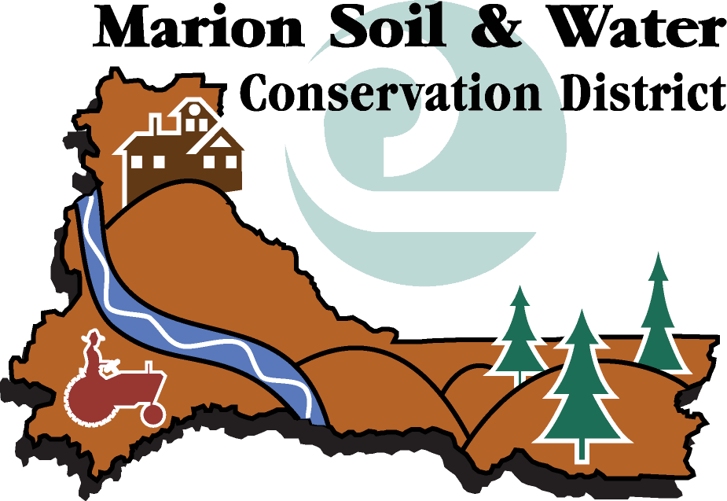

CONSERVATION TECHNICIAN

General Summary

This is a regular, at will, non-exempt, full-time position which serves as Conservation Technician for the Marion Soil and Water Conservation District. This position exists to provide technical and programmatic assistance for the District. The position will perform tasks associated with conducting water quality monitoring, water flow monitoring, field surveying, and other tasks related to technical field work. In addition, the position will perform tasks of downloading and transferring data, maintaining field monitoring sites, and conducting analysis of data. This position will work closely with the District’s Resource Conservationists in order to assist them with technical programs.

The Conservation Technician must have strong field and data management skills; the ability to work independently and as a part of a team; and be able to communicate with project leaders and teams.
Supervision Received
The Conservation Technician reports to the Technical Manager. In the field, the Conservation Technician may be supervised by other District employees, such as Resource Conservationists. Some work is accomplished independently with technical guidance available from the resource manuals and specialists. The position acts on behalf of the Technical Manager and the District Board of Directors, within the authority delegated by the Board and this description, and is governed by the policies of the District’s Personnel Policy Manual.

Duties and Responsibilities
- Assists in implementing the Water Quality and Flow Monitoring programs of the District. Tasks include collecting field data (manually and via computer), maintaining field equipment and monitoring sites, conducting water quality testing, measuring stream flows, etc.
- Assists with analysis and interpretation of water quality and quantity data for the District.
- Provides assistance to the District’s technical programs, including, but not limited to the Knotweed Program, Native Plant and Tree Sale, and Weather Station Program.
- Understands, interprets, and uses various maps, aerial photography and soils information in assisting property owners and operators in the District.
- Assists with basic surveying projects to help develop conservation practice designs for implementation.
- Communicates and works directly with property owners and operators through face-to-face contact, the telephone, written correspondence, or e-mail.
- Communicates with federal, state, and local agency personnel involved in similar work to coordinate work and avoid duplication.
- Conducts outreach on natural resource issues, water quality, and conservation, at workshops, seminars, fairs, shows and conventions or assist the District Board and/or staff in these activities.
- Participates in office meetings with District board members, District employees, and other agency employees to coordinate work and prioritize where technical assistance will be provided.
- May act as the liaison to a watershed council as assigned by the Technical Manager.
- Provides a monthly report of work activities to the District Board.
- Performs other duties as assigned by the District Board.

Qualifications
- A Bachelor’s degree with the major course work in natural sciences, natural resource management, soils, water quality, agriculture sciences, or a related natural sciences discipline is preferred. Equivalent work or volunteer experience may substitute for the Bachelor’s degree.
- Experience in collecting field data, especially water-related data, and maintaining field notes is required.
- Good oral and written communication skills are required.
- The ability to use a personal computer for information entry and retrieval, correspondence, developing data spreadsheets and graphs, mapping, and conservation practice design is required. Must be proficient with Microsoft Excel and Word; knowledge of ArcView and/or ArcGIS, Microsoft Access, PowerPoint, and Outlook is helpful.
Job Conditions
- This position works both in the field and in the office.
- The fieldwork will include working in and around such locations as farms and dairies; rivers, streams, and ponds; properties with dense vegetation or woodlands; and other areas with steep, slippery, muddy rocky, or other hazardous terrain.
- The office work may include working at a desk; using a computer; or working or standing at a table.
- This position requires travel to field sites, workshops, training sessions, plus daytime and evening meetings outside the office. Occasional overnight travel may be involved. In order to carry out these assigned duties, a valid Oregon driver’s license is required. Although the District has some vehicles, occasional use of the employee’s own vehicle may be necessary (available reimbursement is based on mileage).
- Some physical exertion may be required during field work such as walking, planting vegetation, and using technical or power equipment and hand tools.

Salary Range
Per Marion Soil and Water Conservation District Salary Administration Plan,
Range 2/3 = $____________ per month.

Date (N=new, R=revised)
Approved by the Board – May 4, 2005 (N)

________________________________________ ________________

Employee Date

________________________________________ ________________

Technical Manager Date

________________________________________ ________________

Board Chair Date

