Penalty Fee Reimbursement Request
Payroll Verification Procedures
Note: Verifications from and to a manager must occur via email and payroll’s emailed response to the manager must include the name and title of the individual in payroll conducting the verification.
When an email request comes in from a manager for reimbursement of penalties associated with the transition to Workday Payroll below is the following steps to identify if an employee qualifies.
Payroll will run this report: PAY | Gross Pay and Worker Base Pay for Period
- Pay Run Groups and/or Pay Group Details – Agency number
- Periods: By Selected Pay Group Details
  - Last Completed Run (1 option)
  - Current in Progress (1 option)
  - By Selected Group (All months that have a payroll set built)
- Payroll Result Pay Cycle Type
  - Off Cycle – Mid-Month Checks or On Demand payments
  - On-Cycle – 1st of the month check
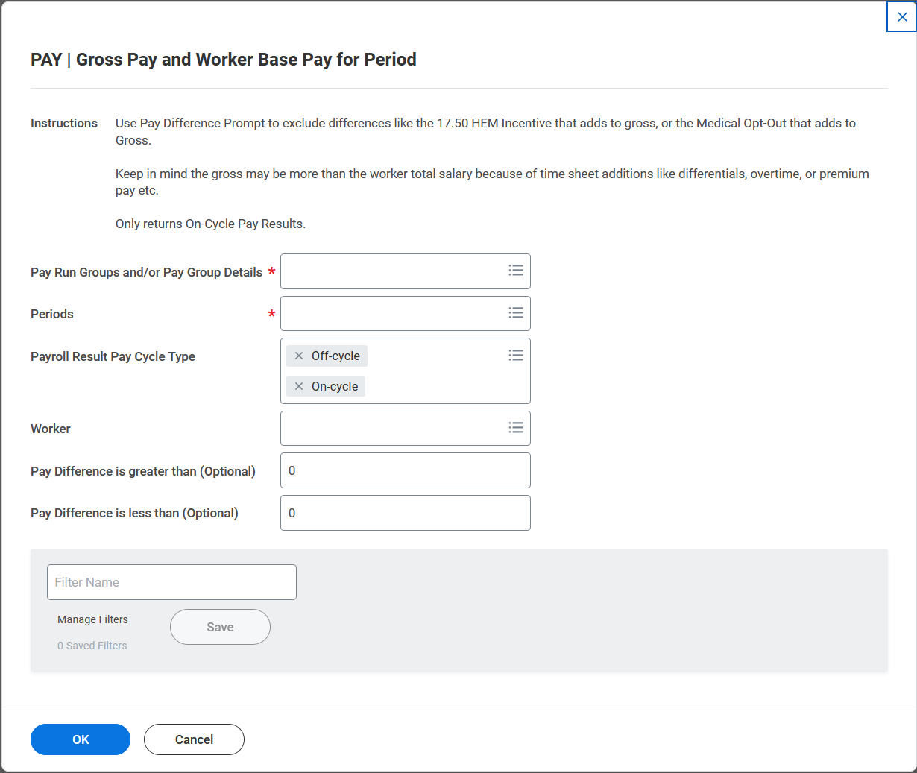

- Results:
Payment Date: Date of the Payment
Note: Pay Period Pulls the month the payment was made. Example above pulled 043023 pay period, however the 04/14/23 payment date was for overtime in the March Pay Period.
Payroll Results Pay Cycle Type: On-Cycle 1st of the Month; Off-Cycle mid-month or requested checks
Total Salary and Allowance: information pulled from the compensation page
Gross Pay: Wages paid for that pay cycle.
Pay Difference: Difference between the Total Salary and Allowance and Gross Pay
- Negative Pay Difference the employee was underpaid
- Positive Pay Difference indicates the employee was overpaid
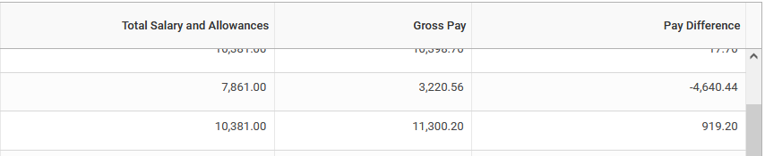
To review pay results, click on the magnifying icon to be routed to the payslip.
Payroll unit will determine if the employee was impacted by system issues that left them with wages more or less than expected. Notifying the manager via email if the employee was impacted by a system issues that left them with wages underpaid, or overpayments requiring payback. Accounting will then move forward in the process, the payment will not be through payroll.

