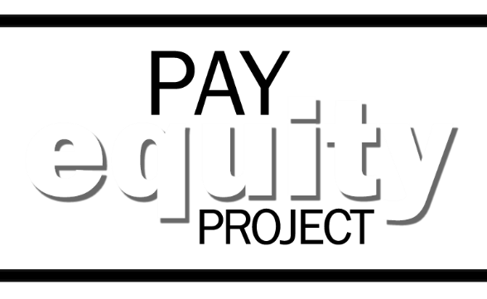
Why should you take that survey?

EQUAL PAY FOR EQUAL WORK…
THAT’S WHY YOU NEED TO TAKE THAT SURVEY!
In response to a revision of state law, the Pay Equity Project is conducting a mandatory survey of all state employees to help identify and address pay inequities within our workforce.
To complete your survey,
go to http://payequity.oregon.gov

While taking the survey, be sure to include all of your relevant experience, education, training and certifications. If it is determined your current compensation is too low, it may be adjusted upward, however no one’s pay will be reduced. The survey closes on Wednesday, February 28, so don’t miss it!

Thank you for doing your part in making
Oregon’s compensation equitable for
you and your co-workers.

Visit http://payequity.oregon.gov for more information on the Pay Equity Project.

