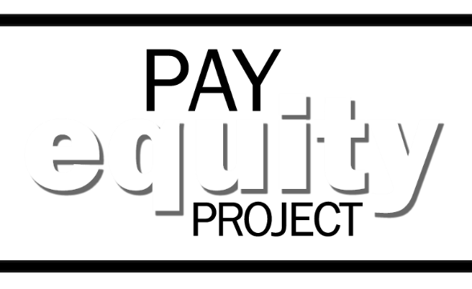
Need help taking
the survey?

WORK NEAR SALEM OR PORTLAND?
NEED ASSISTANCE WITH TAKING YOUR PAY EQUITY SURVEY?
COME TO A SURVEY POP-UP!
Pop-ups are held in computer labs at the agency buildings listed below and staffed by Human Resource Professionals to provide you access to the online survey and answering questions.
No appointment necessary but be sure to let your manager you plan to drop-in during your work day.
Bring any materials that might help, such as your iLearn transcript, resume, job history, or job application. If you do not have those materials in print form, you can access iLearn or the Oregon Jobs webpage at the pop-up, as long as you have your login information.
DATE | LOCATION | HOURS
January 25  (Thursday) | ODOT, 355 Capitol St. NE, Salem  (Basement level, Room B04/B05.  Check in with building reception first) | 8:30AM to 4:30PM
January 30  (Tuesday) | DCBS, L&I Bldg, 350 Winter St. NE, Salem  (Basement level, Room #24) | 8:30AM to 4:30PM
February 7  (Wednesday) | DAS East, 1225 Ferry St. SE, Salem  (Basement level, Computer lab  Check in with building reception first) | 8:30AM to 4:30PM
February 15  (Thursday) | Portland State Office Bldg, 800 NE Oregon, Portland  (Computer lab) | 8:30AM to 4:30PM
Feb 22  (Thursday) | DHS Training Center, 3414 Cherry Ave, Salem  (Room(s) Badger Creek and Quartz Creek) | 8:30AM to 4:30PM

