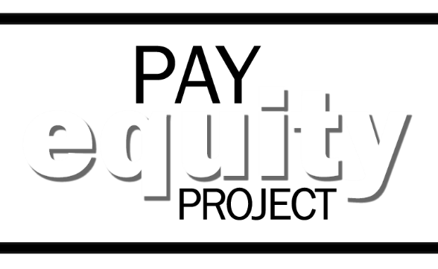
Where to take
the survey

WORK IN THE FIELD OR FAR FROM YOUR MAIN OFFICE? DON’T HAVE READY ACCESS TO THE INTERNET TO TAKE YOUR PAY EQUITY SURVEY?
VISIT YOUR LOCAL
WORKSOURCE OREGON CENTER!
The Pay Equity Project has partnered with the Oregon Employment Department to provide access to Oregon state employees taking their Pay Equity Survey via their network of WorkSource Oregon centers.
No appointment necessary but be sure to let your manager know you plan to drop-in. Visit the WorkSource Oregon center in the nearest city below. For specific address and business hours, visit worksourceoregon.org or call 503-779-6905.
Albany | Eugene | Medford | Prineville
Astoria | Florence | Newport | Redmond
Baker City | Grants Pass | Ontario | Roseburg
Bend | Hermiston | Oregon City | Salem
Brookings/Harbor | Klamath Falls | Pendleton | Springfield
Burns | La Grande | Portland Metro - Beaverton/Hillsboro | St. Helens
Canyon City | Lebanon | Portland Metro - Gresham | The Dalles
Coos Bay | Lincoln City | Portland Metro - N/NE | Tillamook
Corvallis | Madras | Portland Metro - SE | Woodburn
Dallas | McMinnville | Portland Metro - Tualatin

NOTE: Besides technical help to access a computer, there will not be on-site survey assistance at any WorkSource Oregon center.
Bring any materials that might help, such as your iLearn transcript, resume, job history, or job application. If you do not have those materials in print form, you can access iLearn or the Oregon Jobs webpage at the WorkSource Oregon center, as long as you have your login information.

