Log in to Print Batch Utility and print the previous day’s OregonBuys (OB) batch (E type batch, #002).
Link: DASWHSGN: DAS Web-to-CICS Signon (state.or.us)
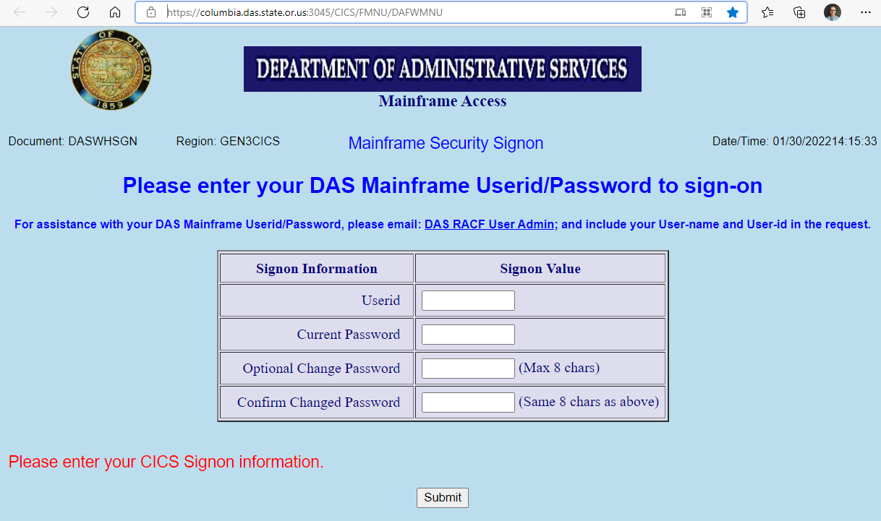
Review batch:
- Effective date column, should all be in the current month.
- Due date column, look for any future dates. If found, change to current date.
- PCA column, look for any missing, can’t be blank.
- AY column, must all be 2023, change if needed.
- Agency Object column, look for any missing, can’t be blank

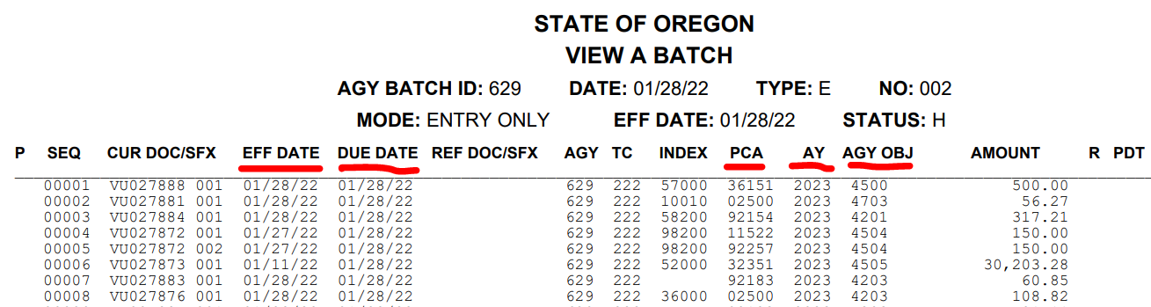
Check OregonBuys Error Log for entries that processed in the current batch. Note the changes on the printed batch sheet. Get any changes made in R*STARS (SFMS) and the batch released again.

In OregonBuys, go to “AdHoc Reporting”.
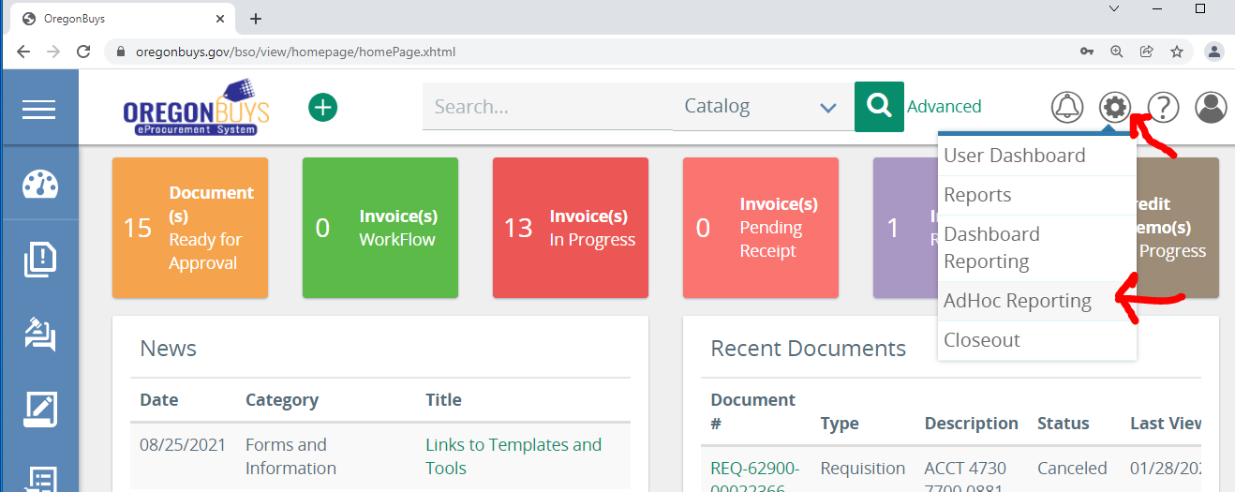

Open report with previous day’s released transactions.

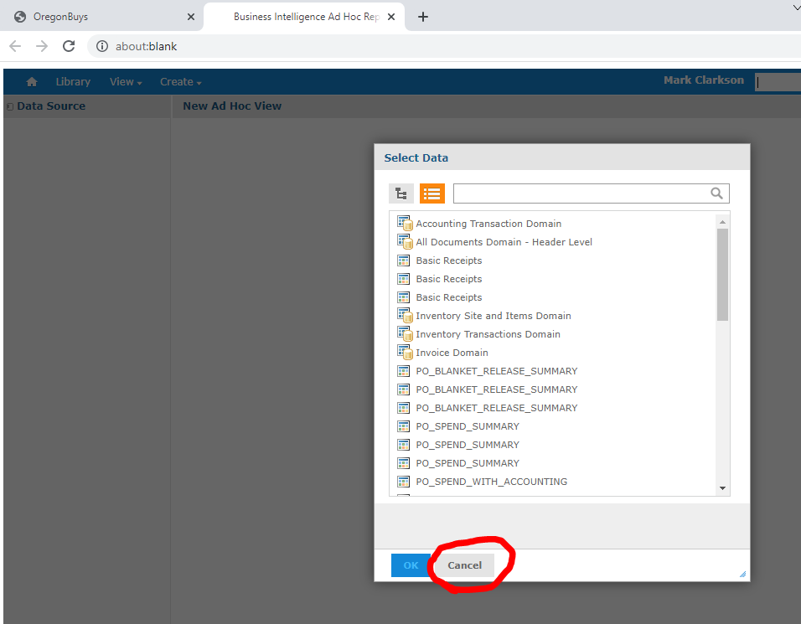

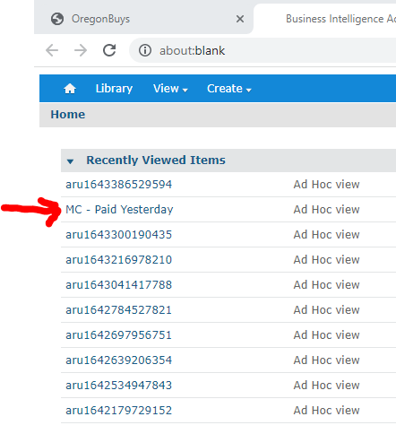

Change filter dates to capture desired day, then click Apply

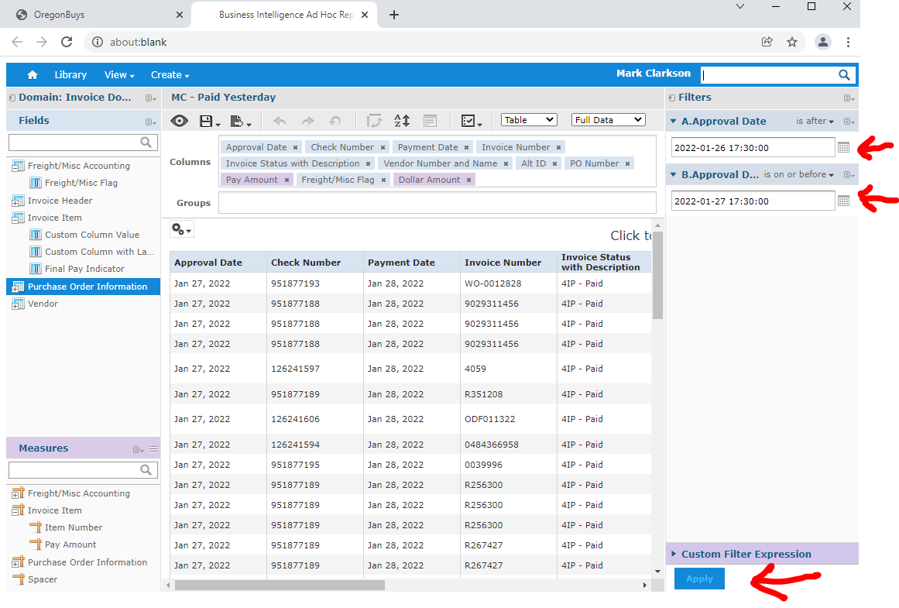
Scroll to the bottom of the report and check the total. It should match the SFMS total. Investigate if they don’t match. Document results on both reports.

Save Ad Hoc View

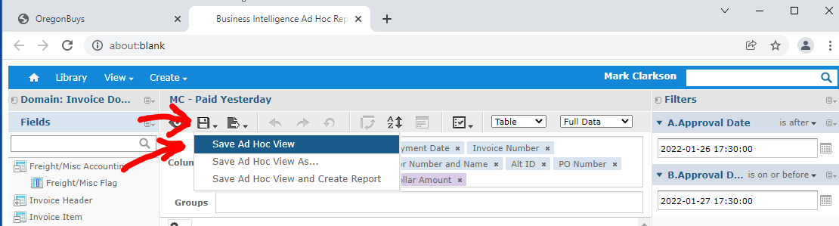

Save the report as XLSX

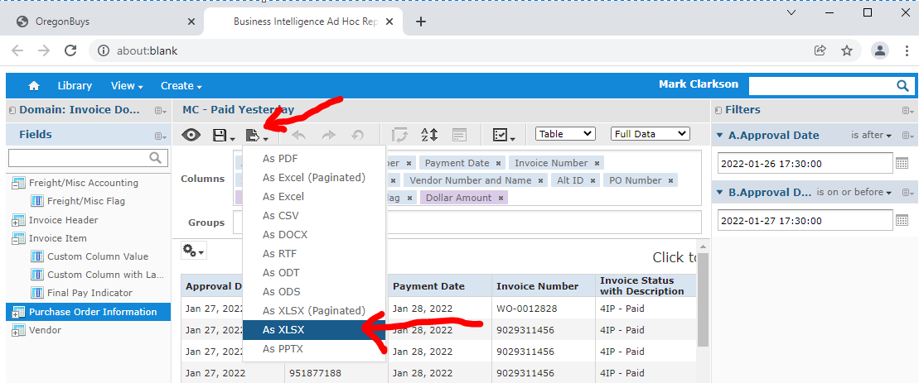

Open Report

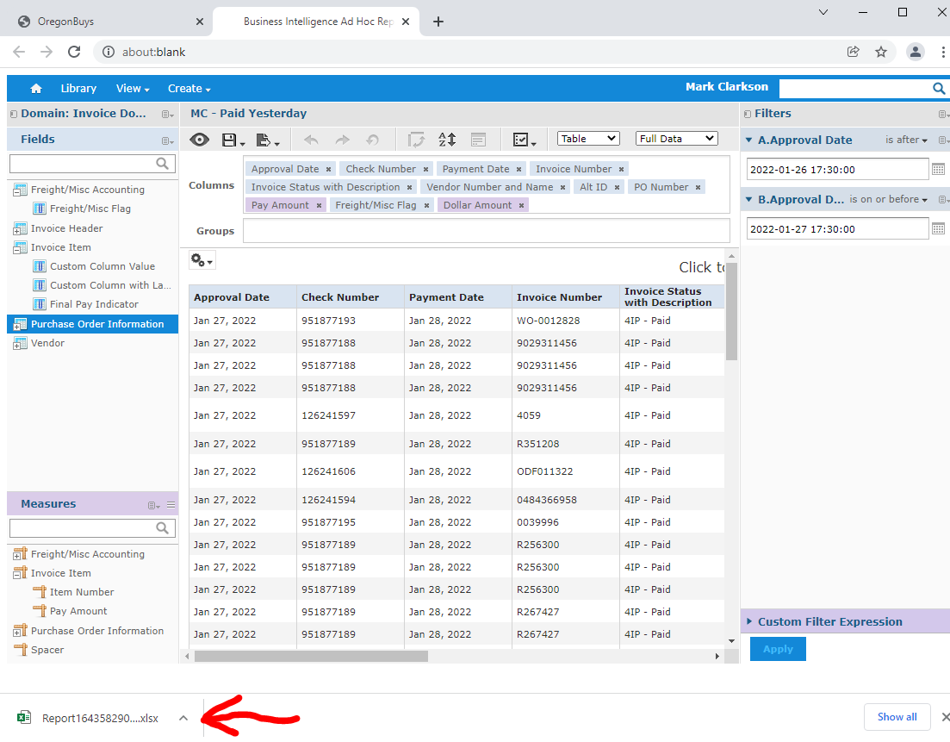

Enable Editing

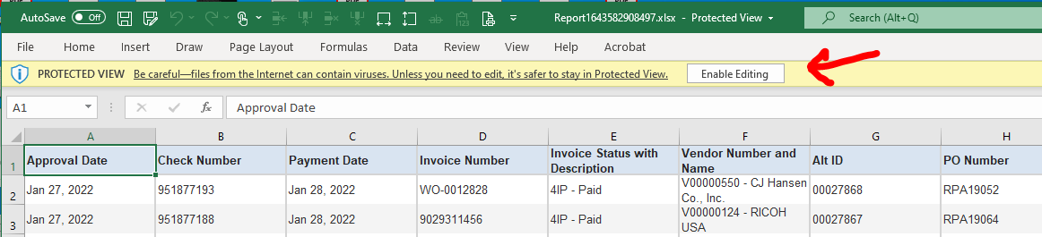

Save the report to:

\\Wpodffpsl02\public\PubFin\Fiscal Services\Accounts Payable\OregonBuys\Reconcile\Daily\2022

Use the same file name format as previous files.

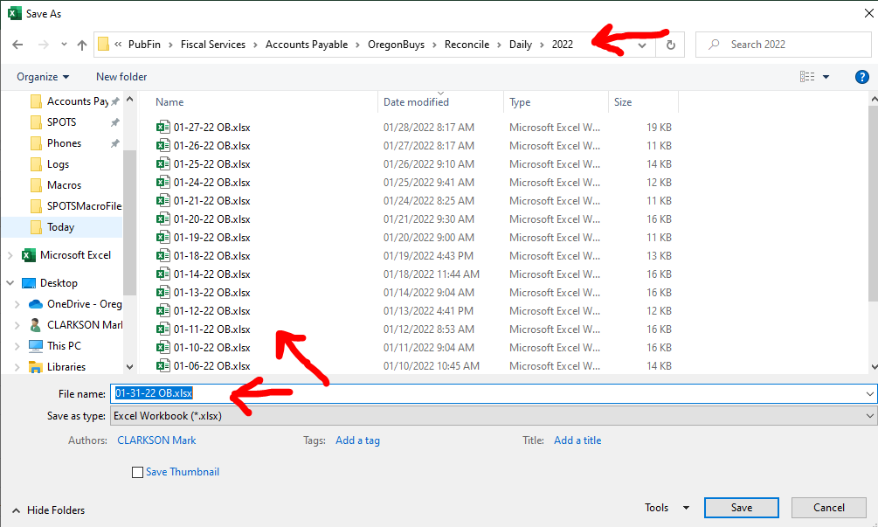

Use Vendor Number and Name Column to check for Assignment vendors. If there are any, make notes on the SFMS report and have the changes made to the SFMS batch prior to release. Assignment list is here:

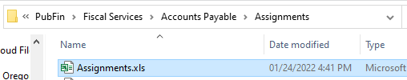

Note the completion of the Error Log and Assignments checks on the SFMS report.

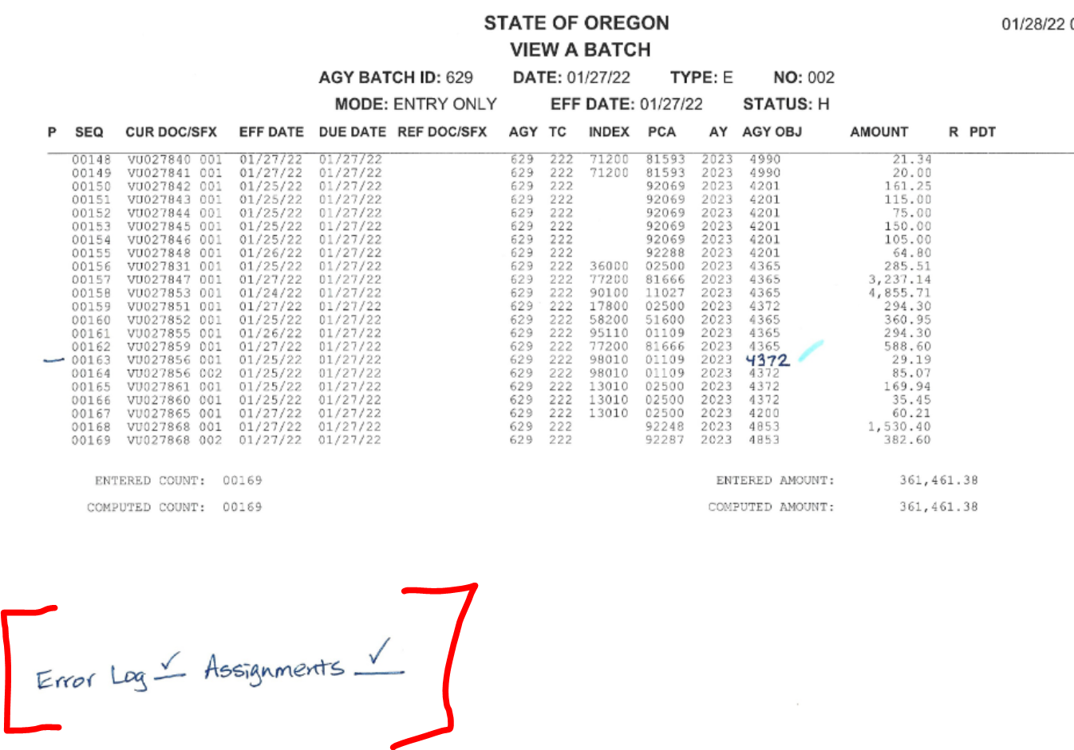

Give completed SFMS reports to AP Coordinator.

File location: \\Wpodffpsl02\public\PubFin\Fiscal Services\Accounts Payable\OregonBuys\Reconcile\Daily OB and SFMS Reconciliation.docx

