OregonBuys Bid Solicitation Guidance
Table of Contents
Introduction 2
Creating & Sending a Bid 2
General Tab 2
Attachments Tab 5
Notes Tab 5
Bidders Tab 6
Questions Tab 8
Q&A Tab 9
Q&A Report 9
Reminders Tab 12
Summary Tab 13
Public Bid Opening for ITBs 14
After Bid Opening Occurs 15
Quotes Tab 15
Score Tab 15
Reminders Tab (on Bid) 15
Summary Tab 16

Introduction
This guidance document will help Basic Purchasers (BP) as they create Bid Solicitations in OregonBuys. To facilitate enhanced learning and ease of use among users, this document has been broken up into two main sections – Creating & Sending a Bid and After Bid Opening Occurs. Each section reviews each tab with detailed descriptions of required fields for completion.

Creating & Sending a Bid

General Tab
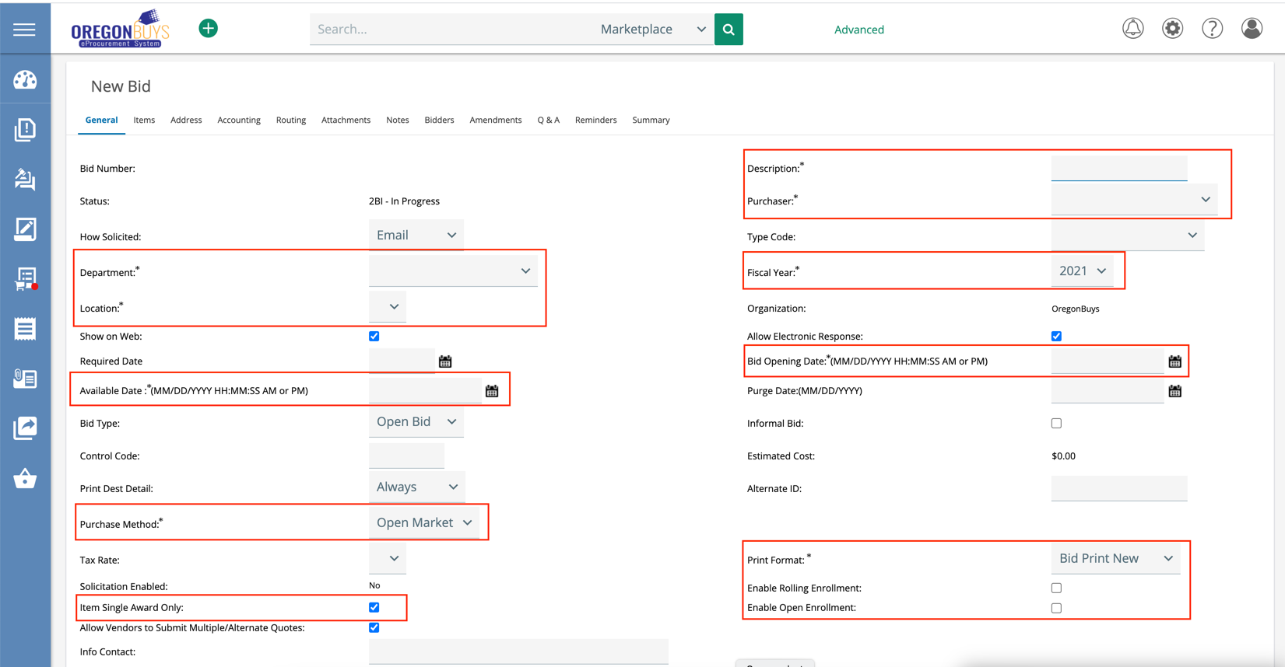
- Description – format in this field should reflect what is being procured. This field is publicly viewable, searchable and reportable. Please ensure that this field is detailed and titled similarly to a document title and adheres to the format listed in the sub bullet.
  - For the Description field use the following format for the procurement: TYPE – Description [e.g. “RFP – Leaburg Hatchery Residential Roof Replacement”].
- Purchaser – this field is automatically populated with the user’s first and last name. The Purchaser can be changed by clicking the dropdown and selecting from the list of users available in your department and/or agency.
- Department – this field requires the user to select the department that is facilitating the bid. The Basic Purchaser can select the correct department by clicking the dropdown and selecting from the list of departments available to their agency.
- Location – this field requires the user to select the location where the bid is being facilitated.
- Fiscal Year – this field will default to the current biennium fiscal year. If the user is posting a bid during the transition between fiscal years (i.e., fiscal year roll days), they can select to change the fiscal year from the dropdown list.
- Bid Opening Date – this field is the same as the Bid Closing Date in ORPIN and is the date/time when vendor responses are no longer accepted.
- Available Date – this field is the date the Bid Solicitation becomes available to vendors online.
- Purchase Method – this field allows the Basic Purchaser to select between Open Market, Contract, or Blanket types of bids.
- Print Format – this field defaults to a certain style of printed document and should not be changed.
- Enable Rolling Enrollment – this field allows users to review and award vendors’ submitted quotes before and after the Bid Opening Date expires.
- Enable Open Enrollment – this field allows the user to set a multiple periods of time where vendors can submit quotes.
- Informal Bid – this field allows quotes to be accessible throughout the solicitation submission period. When this field is checked, the Buyer can see quotes before the Bid Opening Date. Informal bids are part of Phase II. Please leave this field unchecked for Phase I.
- Item Single Award Only – this field limits an item to be awarded to only one vendor rather than an item that could be awarded to multiple vendors.
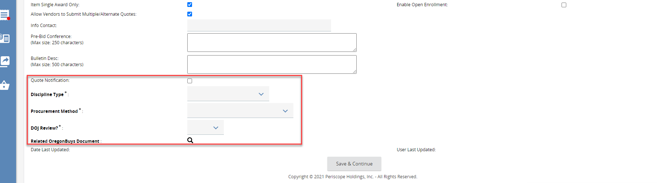
- Quote Notification – this field allows the Buyer on the Bid to be notified when a vendor submits a quote to the Bid. Please note that the notification will only trigger on the submission of a Quote. If a vendor creates, but does not submit, a Quote there will not be a notification. Also, if a vendor submits a Quote, then withdraws it, there will not be notification of the withdrawal.
- Discipline Type – this field allows a Buyer to select the discipline type from the following list:
A and E; A and E Related Services; Ordinary Construction; Personal Services; Public Improvement; Supplies; Trade Services; ORS190; Subgrantee (non-procurement).
- Procurement Method – this field is used to capture the type of procurement required for this Bid Solicitation including Competitive Sealed Bid, Notification, etc.
- DOJ Review? – If the Bid Solicitation requires DOJ Review select “Yes” and the date/time, attorney name for reporting purposes. Note: The actual DOJ review is conducted outside of OregonBuys.
- Related OregonBuys Document – this field is used to link an existing document within OregonBuys that is related to this Bid Solicitation. Use the magnifying glass to search within the system for a document.

Attachments Tab
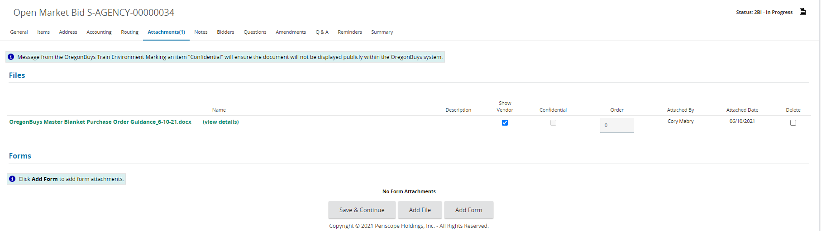
- All necessary documents are to be added to the Attachments tab.
- Show to Vendor – the checkbox enables attachment to be viewed publicly.
- Confidential – this checkbox disables all users, even vendors, from viewing the attachment.

Notes Tab
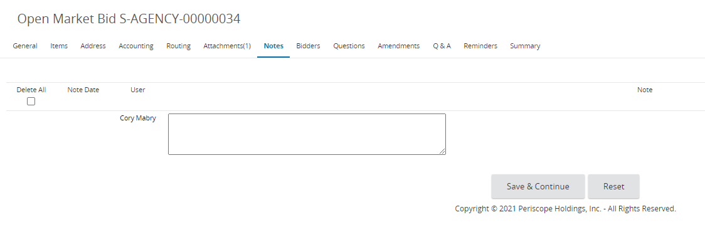
- The Notes Tab is used for internal notes.
- Adding document history or other important information necessary to the Bid Solicitation is encouraged. Notes should be used as a keeper of important information and should not be substituted with an attachment to encourage shareability and enhance search results.
- Notes are subject to public record requests.

Bidders Tab
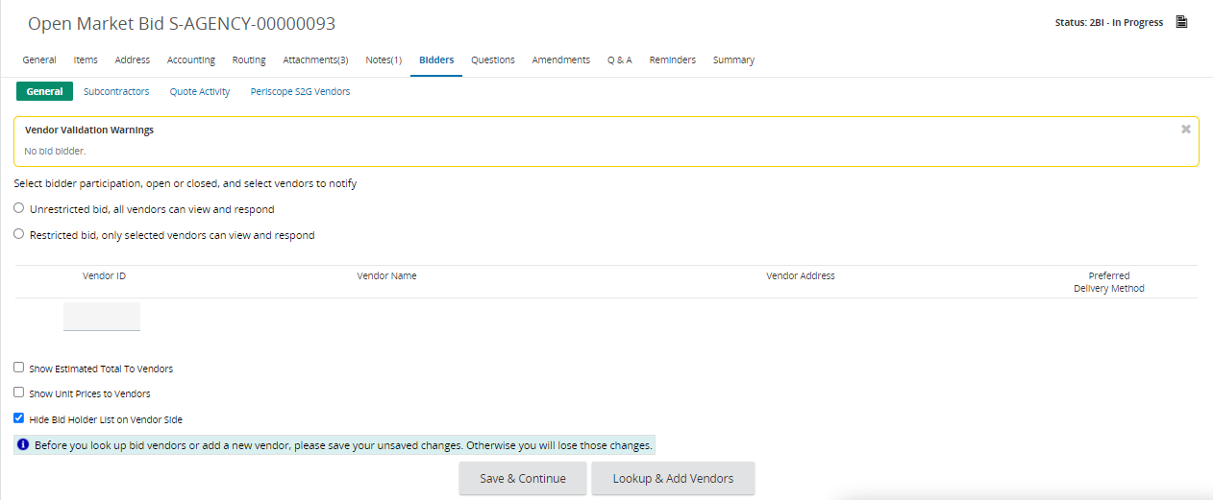
- The Bidders tab is used to select vendors you want to notify via email about the Bid Solicitation once it is published. (NOTE: You must select vendors on this tab to trigger email notifications about your Bid. The system will not automatically send out emails to vendors unless you perform this step.)
- You will see a Vendor Validation Warning Message “No bid bidder” by default, indicating you have not chosen any vendors to be notified about the Bid Solicitation.
- To begin selecting vendors you want to notify, click “Lookup & Add Vendors”. This brings you to the Lookup & Add Reference Vendors screen.
- Scroll to the bottom of the page and select “Find Vendors for All Commodity Codes on the Bid”. Vendors will display based on the NIGP Codes you selected for your items on the Items tab.
- You can also search and add vendors to the Bid Solicitation by COBID categories (search criteria include COBID vendors).
Using the COBID categories to search for vendors facilitates compliance with the Oregon Governor’s Executive Order on vendor diversity and inclusion.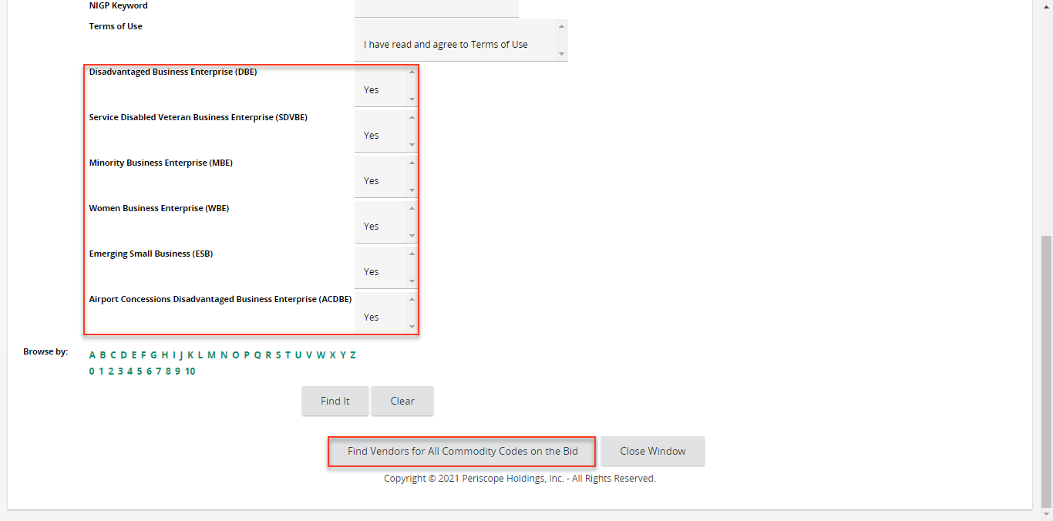
- Check the Select Header Box to select all the listed vendors.
- Select “OK” in the popup window.
  - The popup warning message lets you know that all vendors have been selected and will be notified about the Bid Solicitation via email notification once its published.
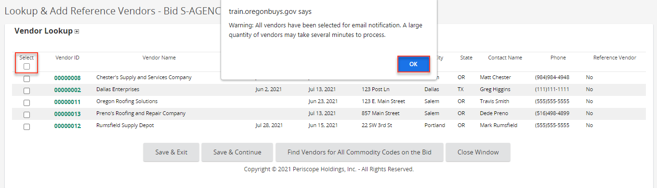
- Click Save & Exit, which brings you back to the Bidders tab. Vendors selected on the previous screen will display.
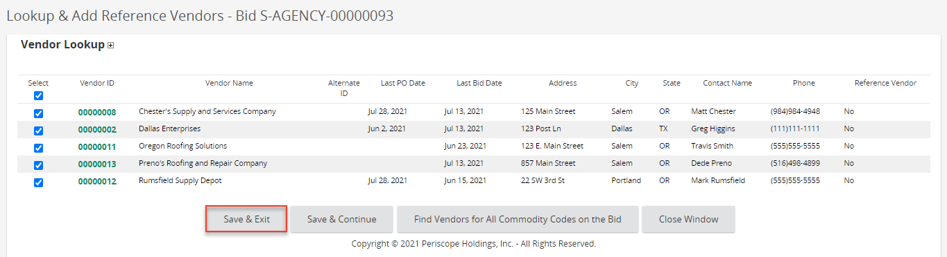
- The vendors listed on the Bidders tab will be notified via email about the Bid Solicitation once it is published.
- Other fields to consider when posting a Bid Solicitation are:
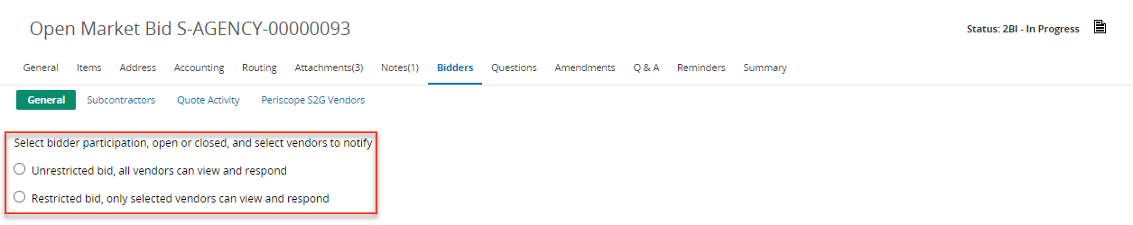
- Unrestricted Bid, All Vendors can View and Respond – when selected, all vendors listed on the Bidders tab and any other vendor registered in OregonBuys can view and respond to the Bid Solicitation logged into the system. This also allows the public to search for the Bid Solicitation using the external search.
- Restricted Bid, Only Selected Vendors can View and Respond – when selected, only the selected vendors on the Bidders tab can view and respond to the Bid Solicitation logged into OregonBuys. This also hides the Bid Solicitation from being accessed using the external search.

Questions Tab
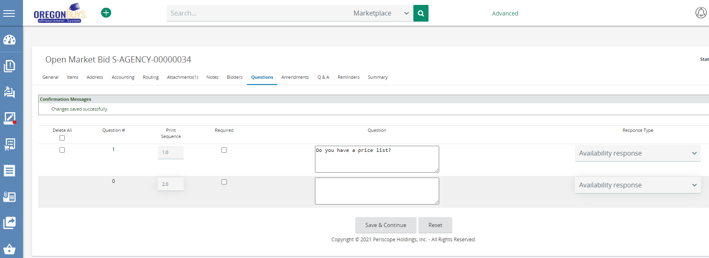
- Enter questions that you would like to ask of the vendors.
- Vendors will see these questions when they review the solicitation.

Q&A Tab
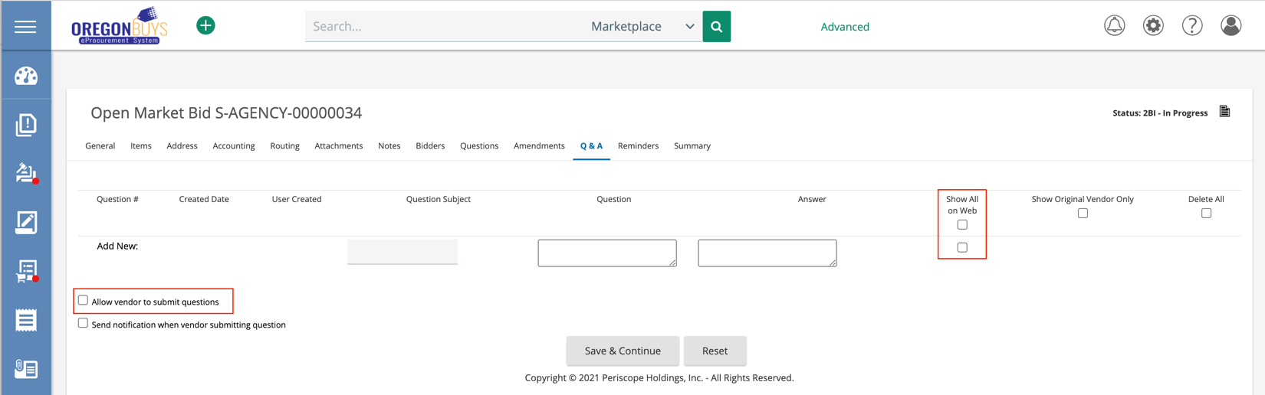
- Use this tab to enable a Vendor Q&A period for a Bid Solicitation.
- Vendor Q&A must be manually disabled after the period is over. The Basic Purchaser can add a reminder to disable this in the Reminders Tab. Please see the Reminders Tab section below.
  - To disable Vendor Q&A, deselect the Allow vendor to submit questions, then click Save & Continue.
- Show All on Web displays the Question & Answer publicly, including the Supplier’s name who submitted the question.
- Show Original Vendor Only displays the Question & Answer to ONLY the Supplier who submitted the question.

Q&A Report
The Q&A Report allows you to extract all the vendors questions on the Q&A Tab of the Bid Solicitation. After extracting the Q&A Report from OregonBuys you can provide all the answers and attached it onto the Bid Solicitation via the Amendment process.
- From the Home screen, click the Settings icon.
- Select Reports in the popup window.
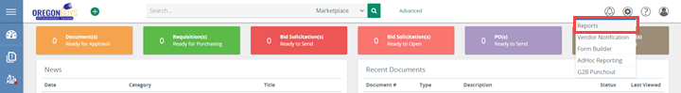
- Select Bid Q&A, which brings you into the Business Intelligence tool.
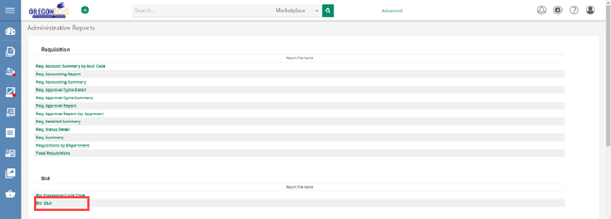
- Click the Magnifying Glass button.
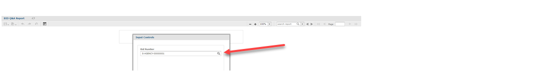
- Select the Bid Solicitation number in the dropdown.
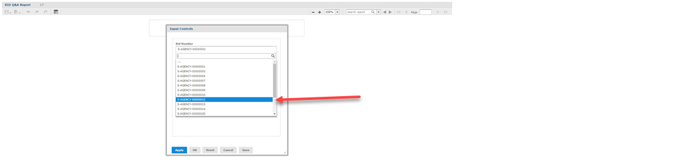
- Click Apply, which renders the questions submitted by vendors on the Q&A Tab in the background.
- Click Ok, which closes the Input Controls window.
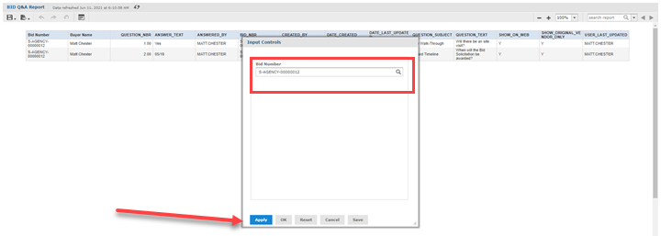
- Select the Icon located in the top left corner of the screen. A dropdown field appears.
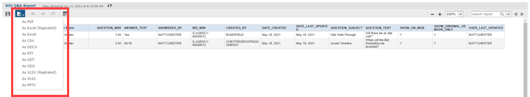
- Choose the format you want to download the Q&A Report.
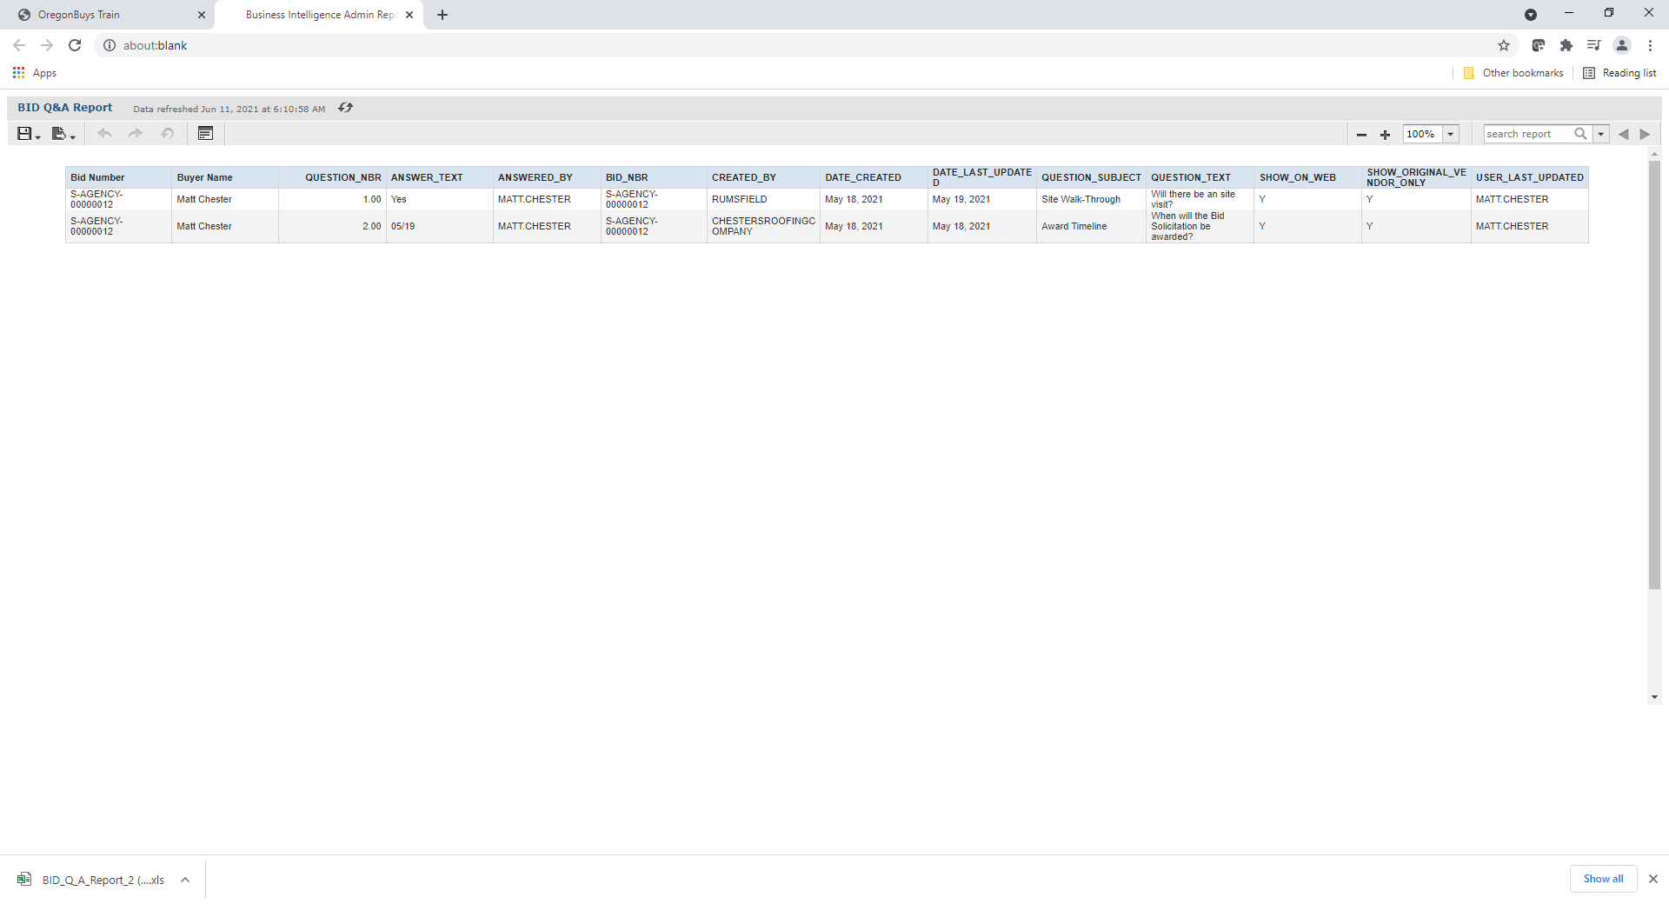
- Click the downloaded Q&A Report, which will open it on your computer.

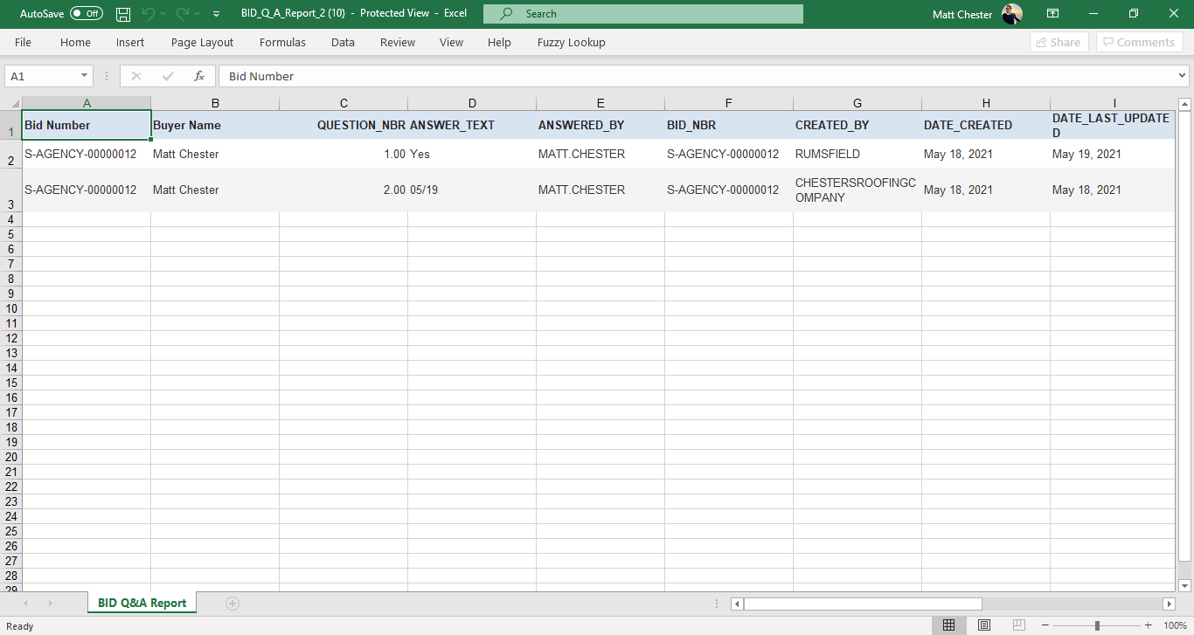
- Answer the questions and save the Q&A Report to your computer.
- Once you have answered the questions, add the final Q&A Report to the Bid Solicitation via the Amendment process.

Reminders Tab
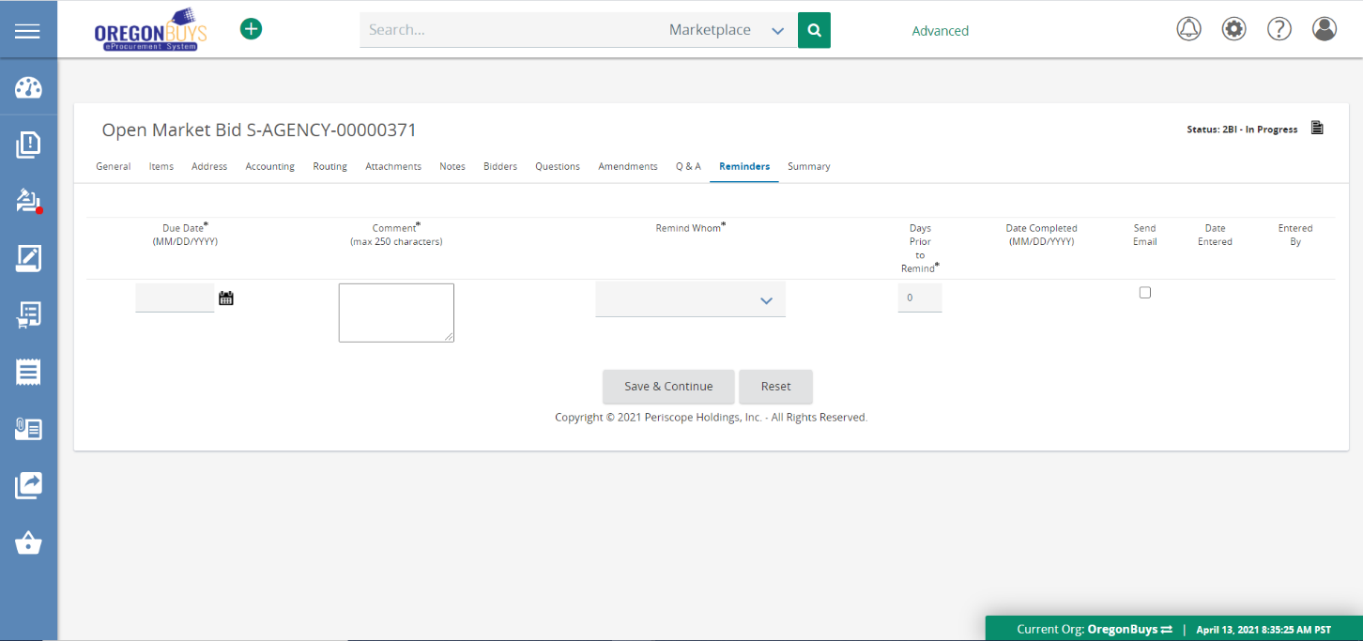
- Create reminders for users within OregonBuys that trigger at specific times.
- Configure reminders to send email notification [e.g., reminder to close the Q&A period].
- Create reminders to turn off Bid-solicitation Q&A and to convert to MBPO after Intent to Award, and completion of Protest Period.

Summary Tab
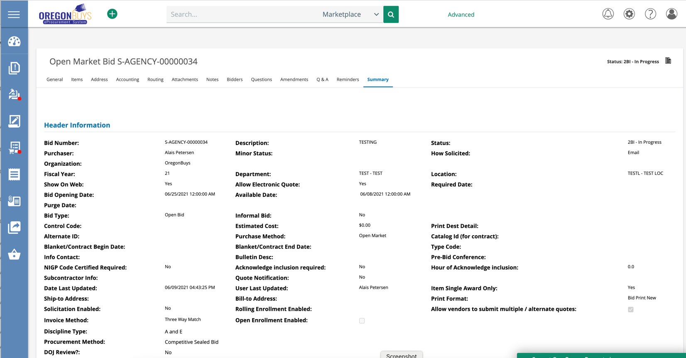
- Review all of the information included in the bid solicitation before sending.
- By clicking the “send” button, the information becomes available for vendors to respond.

Public Bid Opening for ITBs
The intention of the Bid Opening process is to provide the submitted bid amounts, along with the company’s name, to bidders and interested parties. Per the solicitation document C.7.2 Public Bid Opening and rule 137-049-0330 (2), the process is as follows:
- The public Bid Opening will occur immediately following the Bid Opening Date, unless otherwise specified. Only the name of each Bidder and the Bid amounts will be read at the public Bid Opening. Award decisions will not be made at the public Bid Opening.
- DAS will hold the public Bid Opening through electronic means. Interested parties may attend the public Bid Opening for this solicitation electronically as follows (it is attendee’s choice to use video or audio only.):
A Microsoft Teams meeting will be held at [Insert Time] PM for the Bid Opening following the specific time included in the Bid Opening Date. Be sure to have MS Teams access available on your computer or mobile phone and follow the following link [Insert Link], or via telephone at (number), using PIN (enter pin).

After Bid Opening Occurs

Quotes Tab
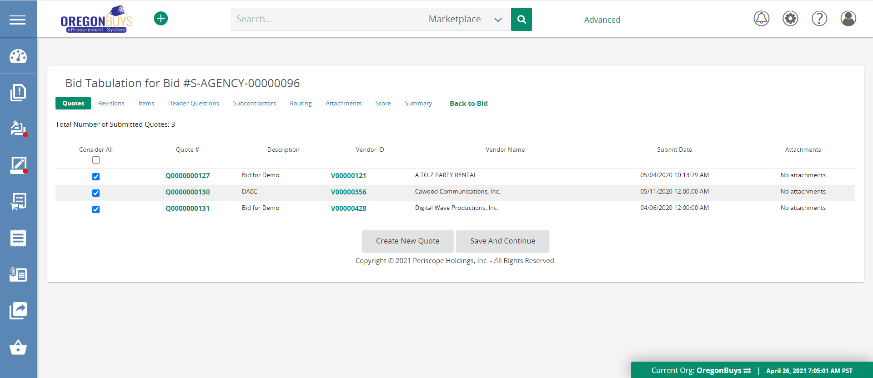
- Review electronic quotes (aka responses) submitted by vendor.
- Add quotes submitted by vendors outside of the system
- This tab does not need to be completed immediately.

Score Tab
- May be done outside of OregonBuys at Agency’s discretion.

Reminders Tab (on Bid)
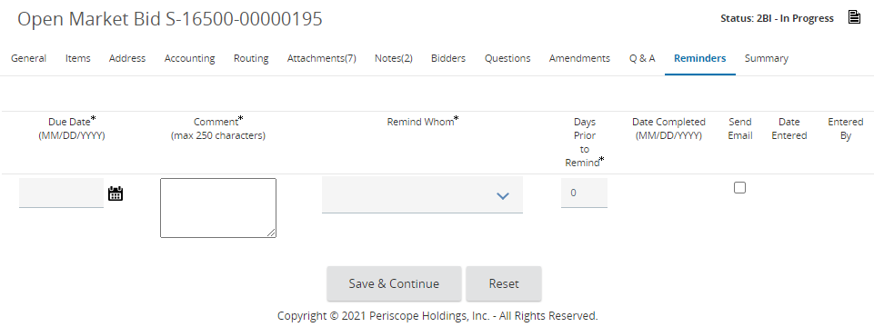
- Set a reminder that protest period has elapsed and Master Blanket Purchase Order can be created.

Summary Tab
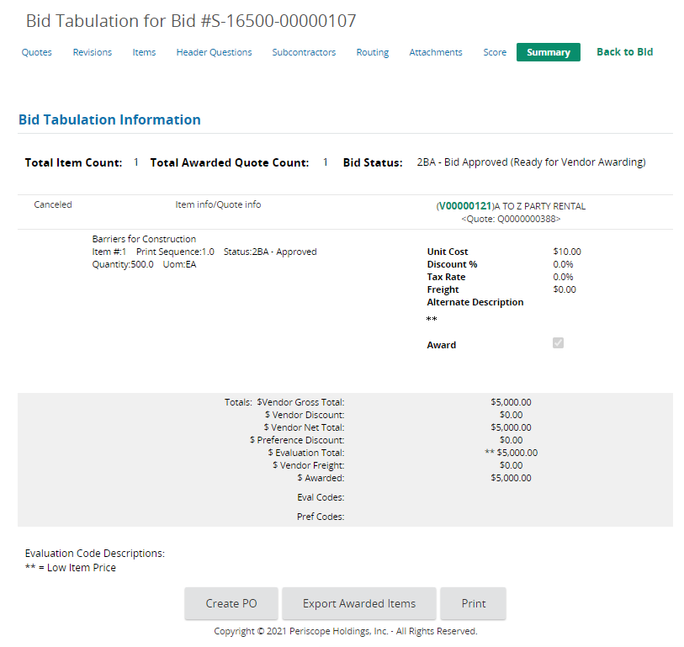
- Export Awarded Items – if selected, items are exported, and a PO cannot be created from the Bid.

