DAS On-Behalf Of Guidance for Non-DAS Agencies

Vendor Help Desk support.oregonbuys@oregon.gov or 1-855-800-5046
State Agency / OrCPP User Help Desk epro-support@periscopeholdings.com or 1-888-472-9102

Table of Contents
Organizational Structure 3
DASOBO – DAS on-Behalf Of 3
Agency Access Controls 3
Initial Setup For Non-DAS Agencies (One Time Only) 3
Maintain Agency Users With Access to DASOBO 3
How To Submit A Request to DAS PS in DASOBO 4
Step 1 – Log into OregonBuys 4
Step 2 – Switch to the DASOBO Organization 5
Step 3 – Create a Requisition To Request DAS PS Services 5
Step 4 – General Tab, Complete All Required Fields 6
Step 5 – Items Tab, Add Relevant Item Information 7
Step 6 – Vendor Tab, Select Relevant Vendor(s) 8
Step 7 – Address Tab, Select the Bill To & Ship To Address 8
Step 8 – Attachments Tab, Add Relevant Attachments 9
Step 9 – Notes Tab (optional) 11
Step 10 – Summary Tab, Review and Submit for Approval 11

Organizational Structure
Each agency was set up in OregonBuys as an Organization and the Agency Core Teams then designed the rest of their agency’s stucture. This can be a little confusing because the system uses terminology that doesn’t directly correlate to Oregon.

DASOBO – DAS on-Behalf Of
Requests for DAS PS to do work on behalf of a non-DAS agency will be submitted to this Org and any resulting solicitations and contracts will then be developed and published here as well.
Organization DASOBO has a single Department of AGENCY – State Agency with a Location set up for each agency with an active contract that DAS PS maintains as [Agency Org ID] – [Agency Name]. If a Location hasn’t been set up to represent the agency in DASOBO, the Agency DPO will need to submit a request to the DAS eProcurement Team before they can submit a request through the system.

Agency Access Controls

Initial Setup For Non-DAS Agencies (One Time Only)
Agencies that currently have an active contract that is maintained by DAS PS should already be set up in the DASOBO organization. If an Agency would like to be able to submit requests for DAS PS to do work On-Behalf Of the Agency:
- Agency DPO must send an email to eprocurement@oregon.gov with the following information:
  - Agency Org ID – Agency Name (ie 10700 – Department of Administrative Services)
  - Request that the agency be set up to submit requests for DAS PS to do work on behalf of the agency
  - Include the users who need access to be able to submit requests to DAS PS on behalf of the agency

Maintain Agency Users With Access to DASOBO
Access to the DASOBO organization is maintained by the eProcurement Team at DAS PS, but the Agency Org Administrator maintains User Maintenance for their Agency. The Agency may submit requests to DAS PS to add/remove access for their agency users to be able to submit requests to DAS PS on behalf of the agency. To make these requests:
- Agency DPO must send an email to eprocurement@oregon.gov with the following information:
  - Agency Org ID – Agency Name (ie 10700 – Department of Administrative Services)
  - Request access for users who need access to be able to submit requests to DAS PS on behalf of the agency
  - Revoke access for users who no longer need this ability

How To Submit A Request to DAS PS in DASOBO

Step 1 – Log into OregonBuys
- Navigate to https://oregonbuys.gov/bso
- Select the orange “Sign In” button to bring up the pop-up box to input login credentials 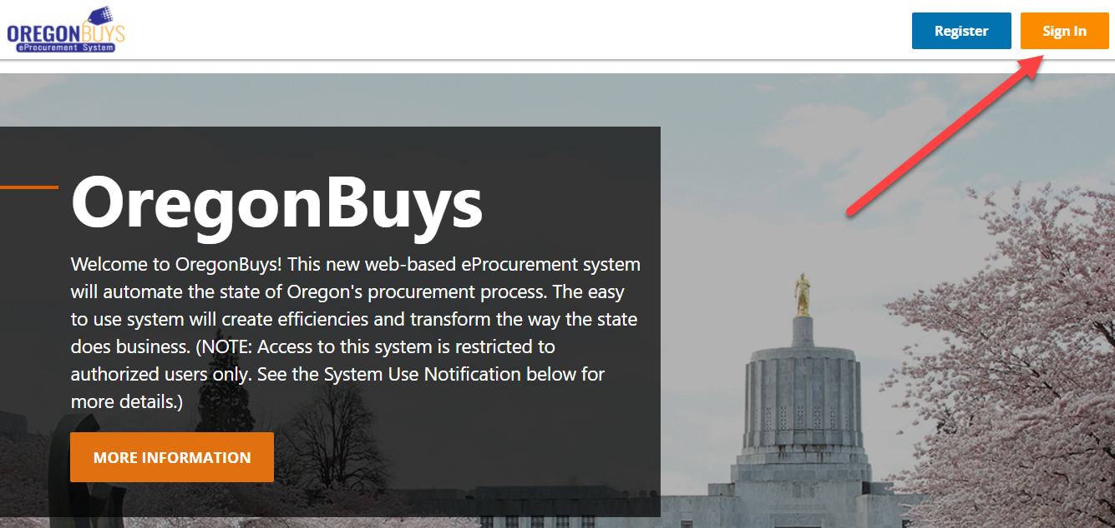
- Input Production login credentials provided to you. Please note that the Login ID is your OR number, the temporary password will be provided to you via email.
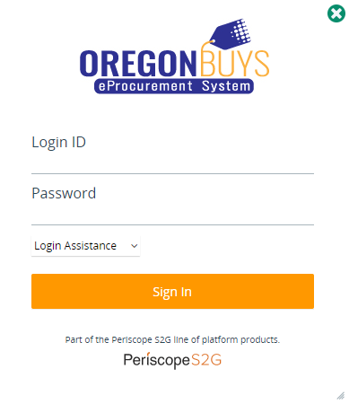

Step 2 – Switch to the DASOBO Organization
- From the Homepage, click the double arrows to switch from your default organization
- Click the DAS On-Behalf Of organization option and click Select:
  - If DASOBO is not an option in this list, then you do not have access to send a request to DAS PS in OregonBuys. Please refer your Agency DPO to the Agency Access Controls section of this document
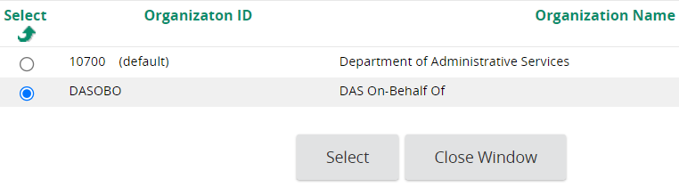
- Confirm that your Current Org is now DAS On-Behalf Of:

Step 3 – Create a Requisition To Request DAS PS Services
- Click the green + symbol at the top of the screen to create a new document:
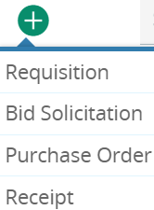
- Select Requisition to create a request for DAS PS Services
  - Please note, although the other document types are selectable from this dropdown, only DAS PS staff will be allowed to post non-requisitions in DASOBO

Step 4 – General Tab, Complete All Required Fields
- Enter a unique and descriptive title of your request in the Short Description field
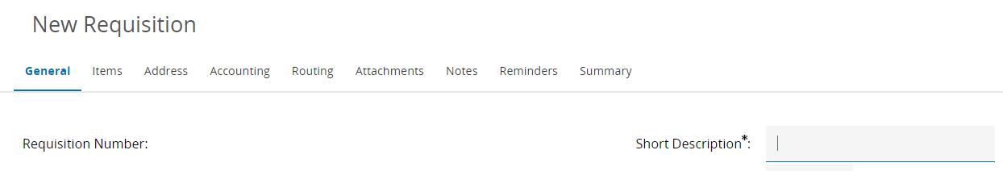
- Select the AGENCY – State Agencies Department from the dropdown
- Select your Agency from the Location dropdown. If your Agency does not appear in this list, refer to the Initial Setup For Non-DAS Agencies (One Time Only) section on Page 3 of this document for instructions
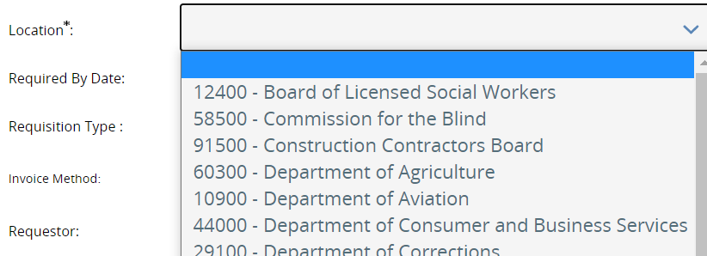
- Requisition Type – Select Open Market from the dropdown
- Agency Subject Matter Expert – SME at the agency with specific knowledge about the need
- Agency Procurement Pro – Procurement Staff at the agency that DAS PS will work with
- Type of Request – Select which type of request this is (default is Request for Procurement)
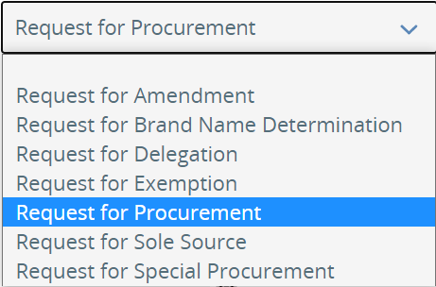
- Agency Billing Number – Billing Number that should be used to pay for the requested work

- Discipline Type – Select the best Discipline that fits the request
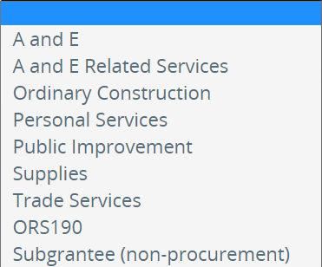
- Timeframe – Is this a One Time or Ongoing Need?
- Date Needed By – When does this work need to be complete?
- Contract Expiration Date – (optional) When should the resulting contract expire?
- Max Contract Length (yrs) – How long should the resulting contract be good for (in years)?
- Related OregonBuys Document – (optional) Link to another related OregonBuys Req/Bid/PO
  - Requests for Amendment may be Disapproved if this field is left blank
- Estimate $ Value – (only on Request for Procurements) Best estimate of the Contract Value
- Attached Required Backstory – Select Yes to confirm that you will compile and upload all relevant Backstory Information to help with your request. For example, Market Research, Past Procurements/Contracts, historical details relevant to this request, etc.
- Attached Required Specifications – Select Yes to confirm that you will compile and upload all relevant Specifications Information to help with your request. For example, Drawings, Statement of Work/Services, details relevant to the specific need identified in the request, etc.
- Attached Required Forms – Select Yes to confirm that you will compile and upload all Forms that will be required to complete this request. For example, Project Intake Form, Risk Assessment Outcome Form, any Agency Forms, etc.
- Click Save & Continue to save your progress on the General tab

Step 5 – Items Tab, Add Relevant Item Information
The Items Tab requires adding at least one Normal item with some pieces of key Item Information, like the NIGP Code and Quantity.
- Click the Items tab to add any item information that is relevant to your request
- Click Add Open Market Items to add a new line item to the Requisition
- Provide as much info as you can to explain the need (NIGP code, Description, UOM, etc):
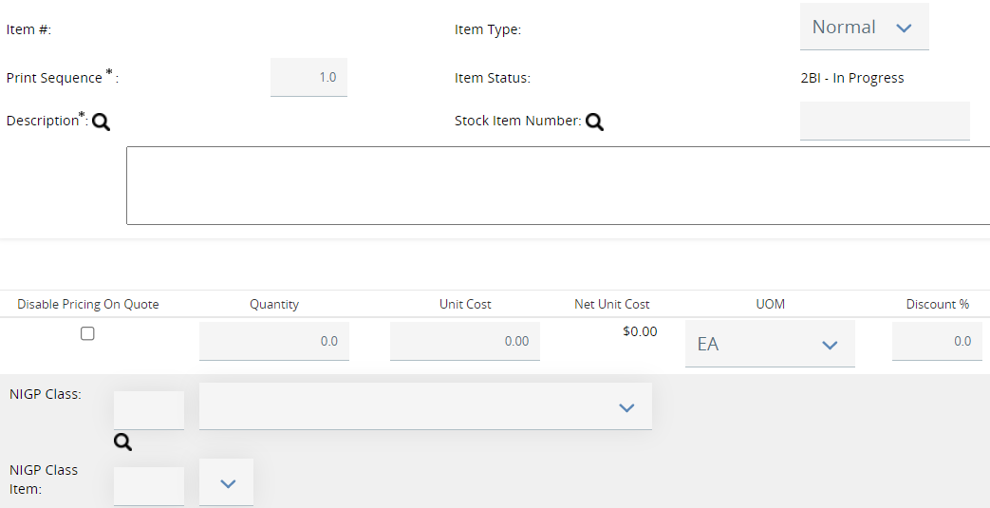
- Include any relevant Additional product information (ie Brand Name Determination)
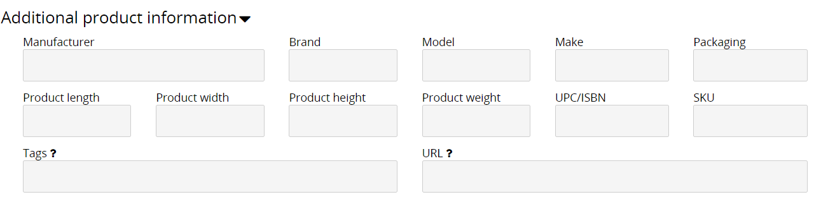
- Click Save & Add New to save your progress on the Items tab and to generate a new line item
- Click Save & Exit to save your progress on the Items tab

Step 6 – Vendor Tab, Select Relevant Vendor(s)
- Click the Vendors tab to select vendor(s) related to this request, if applicable (ie Sole Source)
- Add relevant vendor(s), if any:
  - If you know the OregonBuys Vendor ID, enter it in the provided field and click Save & Continue to add them
  - Scroll down and click Lookup & Add Vendors to open a vendor search page that will allow you to find the relevant vendor(s) and add them
- Click the Save & Continue button to save your selected vendor(s)
- If no vendor(s) are added, a Vendor Validation Warnings box will remain at the top, but it will not prevent the Requisition from being completed. This warning may be ignored if a vendor does not need to be added.
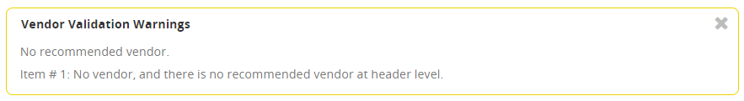

Step 7 – Address Tab, Select the Bill To & Ship To Address
- Click the Address tab to add the placeholder Bill To and Ship To address
- Click the magnifying glass next to the Ship-to Address and Bill-to Address fields
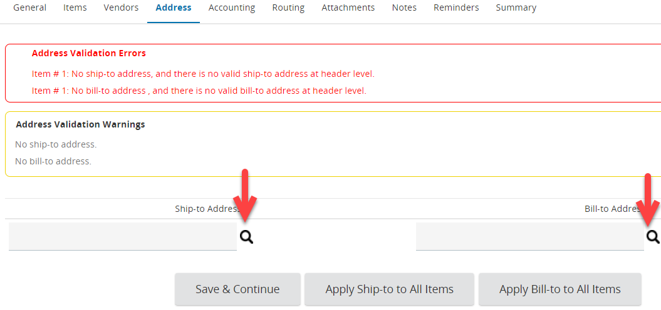
- Click Find It in the new window to display the only Department Address that is available in DASOBO
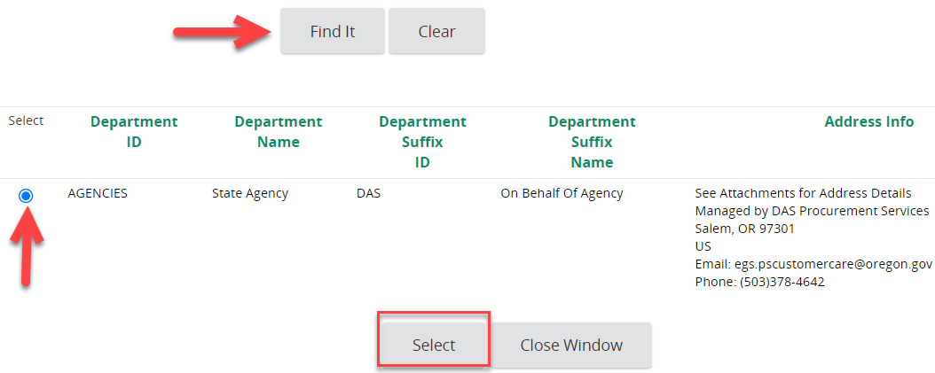
- Select the radio button next to the State Agency Department and click the Select button to add it to the Address tab
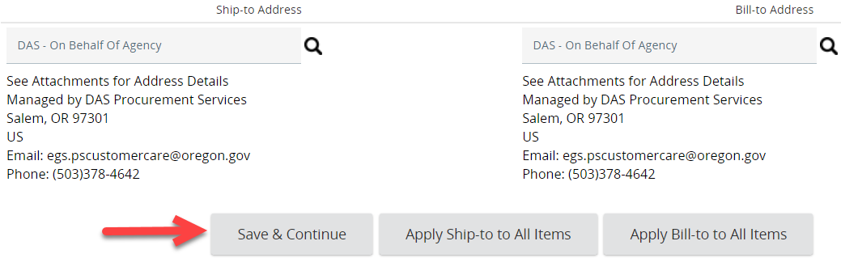
- Click the Save & Continue button to save your progress
- The Address Validation Warnings box will still appear on this document, but will not prevent the Request from being submitted.
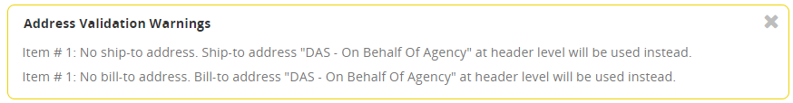
  - Optionally click the Apply Ship-to to All Items and Apply Bill-to to All Items buttons to make the Warning box go away. This is optional because it will default to the selected addresses if these buttons are not clicked.

Step 8 – Attachments Tab, Add Relevant Attachments
- Download, complete, and/or compile all materials that are relevant to this request. Please name your documents with something meaningful and descriptive of what it contains. For example:
  - Backstory of Procurement Need.pdf
  - Specifications & Drawings.docx
  - Risk Assessment Form.xlsx
  - Special Procurement or other Draft documents
  - Any other attachments that will be needed to complete the request. Please know that the request may be Disapproved if the necessary attachments are missing!
- Click the Attachments tab, then click Add File
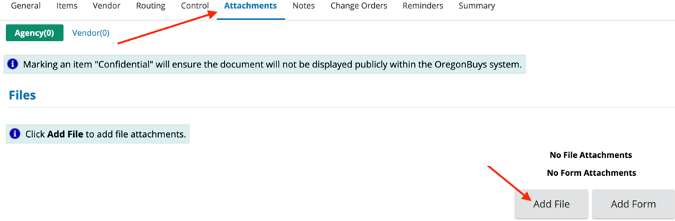
- Choose the document to upload either by:
  - Clicking Choose File, navigating to the document, and double clicking the desired document in the new window (or selecting it and clicking Open)
  - OR simply drag and drop your attachment onto the Choose File button
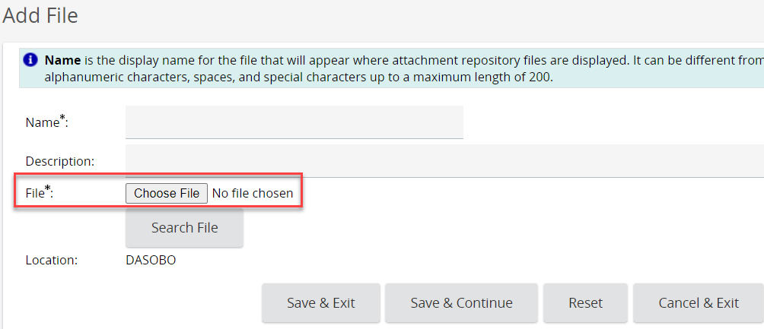
- Name the document. The Name field automatically populates with the document name and extension, so you can save yourself a little time by naming it something meaninful before attaching it!
- The Description field is an optional field that allows more detail regarding the attached document. Suggested best practice is to include a Name (AB Form) and Description (Completed AB Form for new construction)
- Emails cannot be attached as files; you will need to save emails in a different file format to be able to attach them
- Click Save & Exit. Once all the attachments are added move to the next step.

Step 9 – Notes Tab (optional)
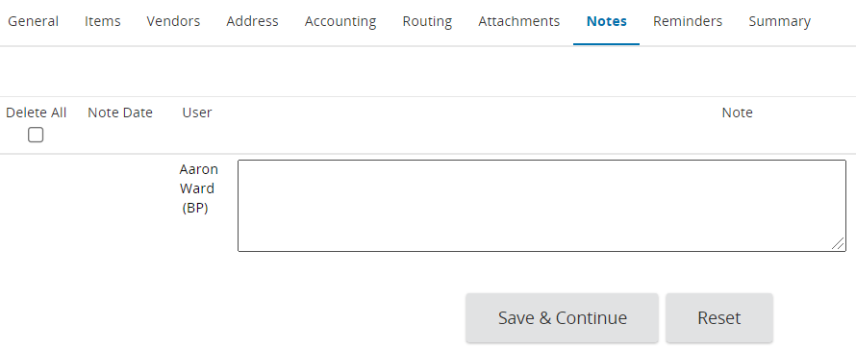
- Optionally, add a note to the request for future reference or for the DAS PS staff member who will review this request and will ultimately do the work
- DAS PS staff will update the Notes tab as the request is being processed

Step 10 – Summary Tab, Review and Submit for Approval
- Click on the Summary tab and confirm that all of the entered information is complete and accurate
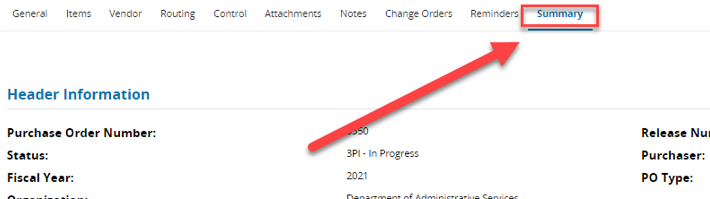
- After validating all of the information is correct, click Submit for Approval.
- All Requisitions in DASOBO will trigger a DASINTAKE Approval Path, which will notify the DAS PS Intake staff of your new request, which will look something like this:
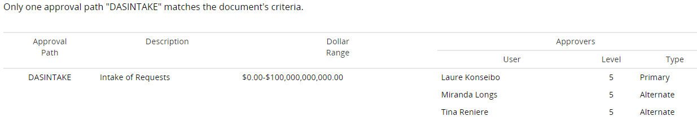
- The DAS PS Intake staff will review your request for completeness and accuracy and may Disapprove (aka reject the submission) of the Requisition if they determine any required materials are missing. If this occurs, you will need to make the necessary updates to your Requisition and Submit for Approval again
- Once final Approval is given by the DAS PS Contract Administrator, they will work with the agency as needed to fill the request

