How a DAS Division Submits a Request to DAS PS

in OregonBuys

Vendor Help Desk support.oregonbuys@oregon.gov or 1-855-800-5046
State Agency / OrCPP User Help Desk epro-support@periscopeholdings.com or 1-888-472-9102

Table of Contents
Overview 4
Validate Ability to Submit a Request 4
How To Submit a Request to DAS PS 4
Step 1 – Log into OregonBuys 4
Step 2 – Create a Requisition to Request DAS PS Services 5
Step 3 – General Tab, Complete All Required Fields 6
Step 4 – Items Tab, Add Relevant Item Information 7
Step 5 – Vendor Tab, Select Relevant Vendor(s) 8
Step 6 – Address Tab, Select the Bill To & Ship To Address 9
Step 7 – Accounting Tab 10
Step 8 – Attachments Tab, Add Relevant Attachments 12
Step 9 – Notes Tab (optional) 15
Step 10 – Summary Tab, Review and Submit for Approval 15

Overview
This Guidance document outlines the process internal DAS Divisions use to submit a request to DAS PS to do work on their behalf.

Validate Ability to Submit a Request
A user trying to submit a request for the first time will need to validate their ability to take this action. Basic Purchasing users and properly configured Department Access users can submit Open Market Requisitions for DAS PS to do work on their behalf. If the user cannot create an Open Market Requisition, the user’s Manager will need to contact the Organization Administrator (OA) to grant this ability.
NOTE: The Organization Administrator role for DAS is currently being handled by the eProcurement team and can be contacted at eprocurement@das.oregon.gov. This will change in the future.

How To Submit a Request to DAS PS

Step 1 – Log into OregonBuys
- Navigate to https://oregonbuys.gov/bso
- Select the orange “Sign In” button to bring up the pop-up box to input login credentials 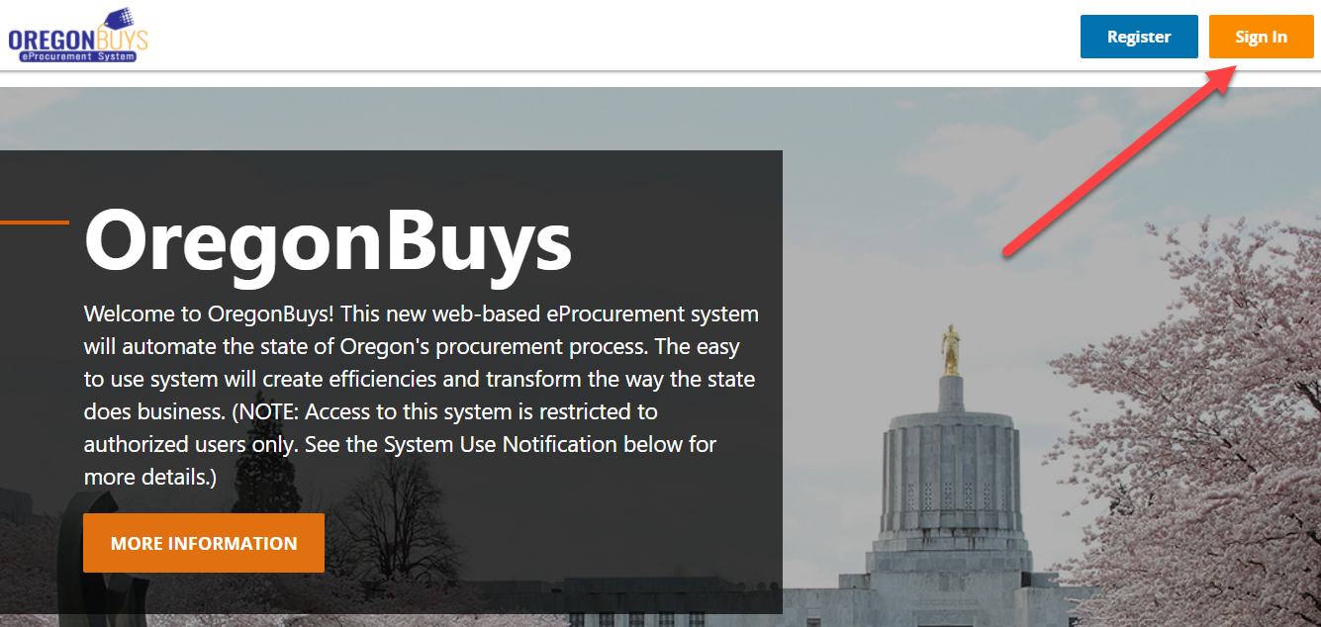
- Input Production login credentials provided to you. Please note that the Login ID is your OR number, the temporary password will be provided to you via email.
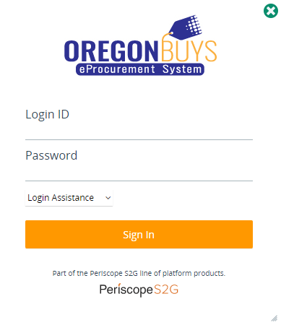

Step 2 – Create a Requisition to Request DAS PS Services
- Click the green + symbol at the top of the screen to create a new document:
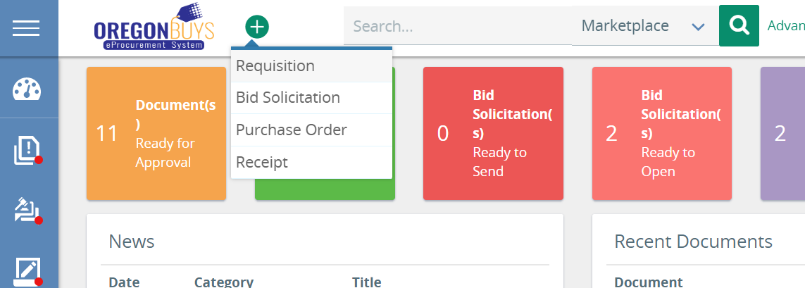

- Select Requisition to create a request for DAS PS Services.

Step 3 – General Tab, Complete All Required Fields
- Enter a unique and descriptive title of your request in the Short Description field.
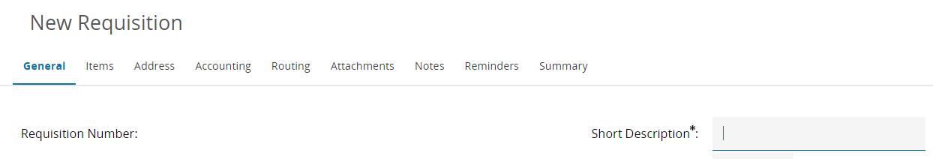
- Select the DAS Division associated with the request from the Department dropdown.
- Select the DAS Division business unit associated with the request from from the Location dropdown.
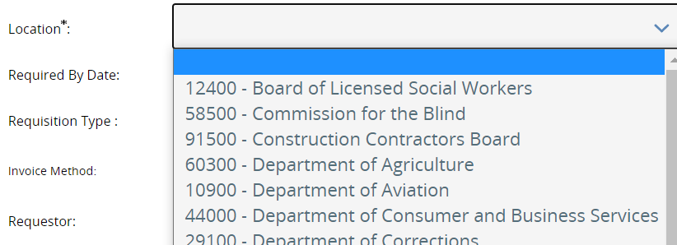

- Requisition Type – Select Open Market from the dropdown
- Agency Subject Matter Expert – SME at the agency with specific knowledge about the need
- Agency Procurement Pro – Procurement Staff at the agency that DAS PS will work with
- Type of Request – Select which type of request this is (default is Request for Procurement)
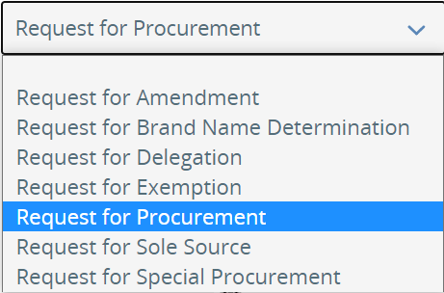
- Agency Billing Number – Billing Number that should be used to pay for the requested work

- Discipline Type – Select the best Discipline that fits the request
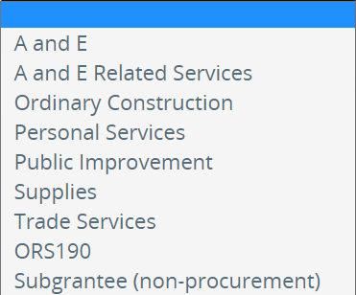

- Timeframe – Is this a One Time or Ongoing Need?
- Date Needed By – When does this work need to be complete?
- Contract Expiration Date – (optional) When should the resulting contract expire?
- Max Contract Length (yrs) – How long should the resulting contract be good for (in years)?
- Related OregonBuys Document – (optional) Link to another related OregonBuys Req/Bid/PO
  - Requests for Amendment may be Disapproved if this field is left blank
- Estimate $ Value – (only on Request for Procurements) Best estimate of the Contract Value
- Attached Required Backstory – Select Yes to confirm that you will compile and upload all relevant Backstory Information to help with your request. For example, Market Research, Past Procurements/Contracts, historical details relevant to this request, etc.
- Attached Required Specifications – Select Yes to confirm that you will compile and upload all relevant Specifications Information to help with your request. For example, Drawings, Statement of Work/Services, details relevant to the specific need identified in the request, etc.
- Attached Required Forms – Select Yes to confirm that you will compile and upload all Forms that will be required to complete this request. For example, Project Intake Form, Risk Assessment Outcome Form, any Agency Forms, etc.
- Click Save & Continue to save your progress on the General tab

Step 4 – Items Tab, Add Relevant Item Information
The Items Tab requires adding at least one Normal item with some pieces of key Item Information, like the NIGP Code and Quantity.
- Click the Items tab to add any item information that is relevant to your request
- Click Add Open Market Items to add a new line item to the Requisition
- Provide as much info as you can to explain the need (NIGP code, Description, UOM, etc.):
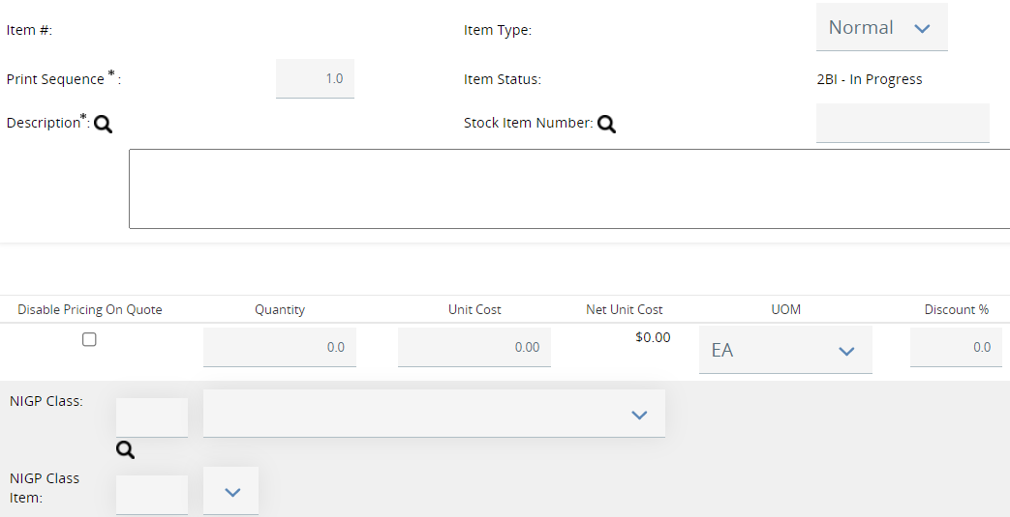
- Include any relevant Additional product information (i.e. Brand Name Determination)
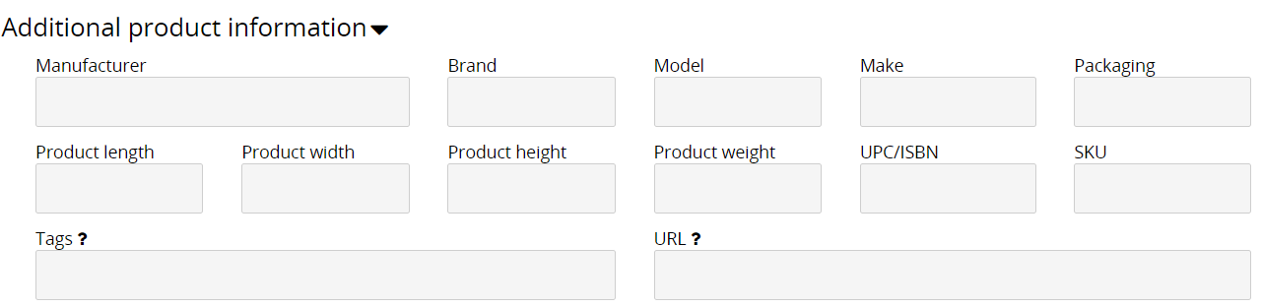
- Click Save & Add New to save your progress on the Items tab and to generate a new line item
- Click Save & Exit to save your progress on the Items tab

Step 5 – Vendor Tab, Select Relevant Vendor(s)
- Click the Vendors tab to select vendor(s) related to this request, if applicable (i.e. Sole Source)
- Add relevant vendor(s), if any:
  - If you know the OregonBuys Vendor ID, enter it in the provided field and click Save & Continue to add them
  - Scroll down and click Lookup & Add Vendors to open a vendor search page that will allow you to find the relevant vendor(s) and add them
- Click the Save & Continue button to save your selected vendor(s)
- If no vendor(s) are added, a Vendor Validation Warnings box will remain at the top, but it will not prevent the Requisition from being completed. This warning may be ignored if a vendor does not need to be added.
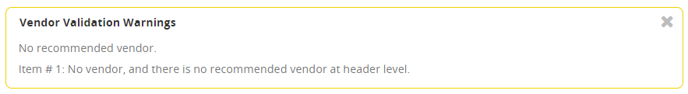

Step 6 – Address Tab, Select the Bill To & Ship To Address
- Click the Address tab to add the placeholder Bill To and Ship To address
- Click the magnifying glass next to the Ship-to Address and Bill-to Address fields
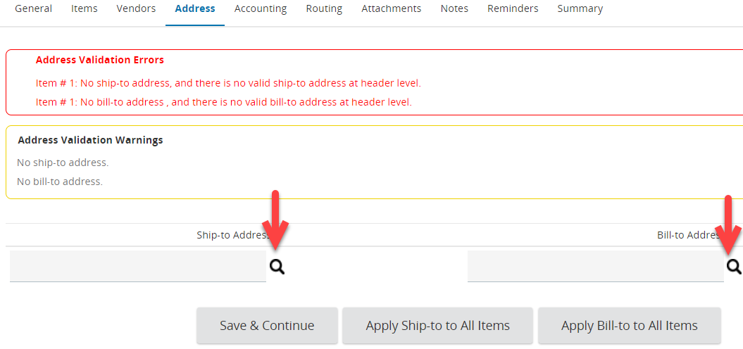
- Click Find It in the new window to display the Department Address relevant to their Division request.
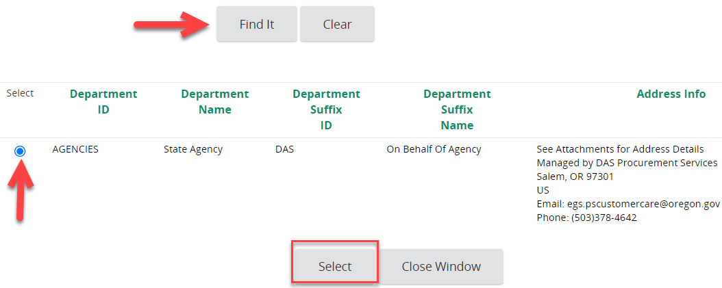
- Select the radio button next to the State Agency Department and click the Select button to add it to the Address tab
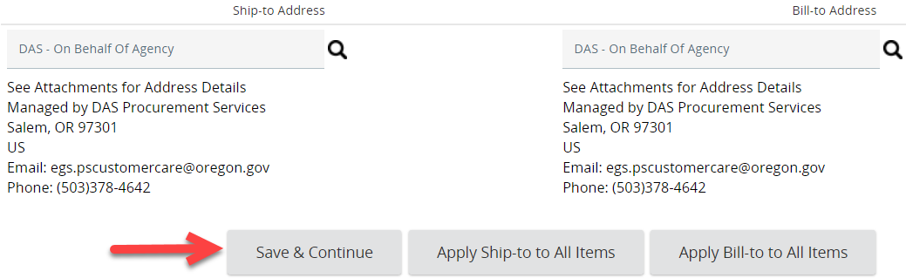
- Click the Save & Continue button to save your progress
- The Address Validation Warnings box will still appear on this document, but will not prevent the Request from being submitted.
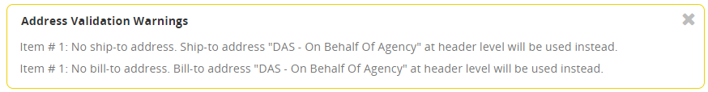
  - Optionally click the Apply Ship-to to All Items and Apply Bill-to to All Items buttons to make the Warning box go away. This is optional because it will default to the selected addresses if these buttons are not clicked.

Step 7 – Accounting Tab
- Click the Accounting tab to add the necessary Account Code Segments such as Index, Program Cost Account (PCA), Agency Object, etc. that make up the Account String for your specific request.
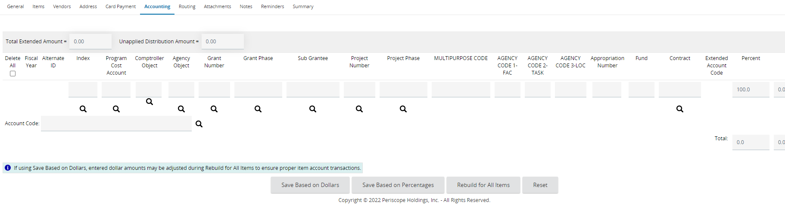
- Click into the segment that you are selecting and simply start typing or scroll down to the number you’re trying to add. For example, DAS mainly uses PCAs so you would simply need to click into the Program Cost Account field and start typing your PCA to see the matching loaded options appear in a dropdown in that field.
  - If only one Account String is being utilized, simply click the “Save Based on Percentages” button to Save and then proceed to # 3 below. Saving Based on Percentages is the easiest way to save a single row of account code segments to generate the Account String because the percentage field defaults to 100%.
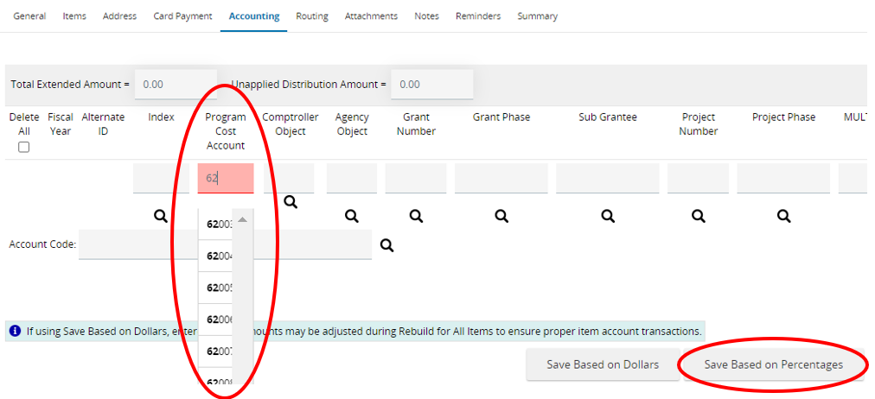
  - If more than one Account String is being utilized, additional Account Code Segments can be added by changing the allocation of Dollars or Percentages to the existing Account String and Save Based on whichever field (Percent or Dollars) was edited.

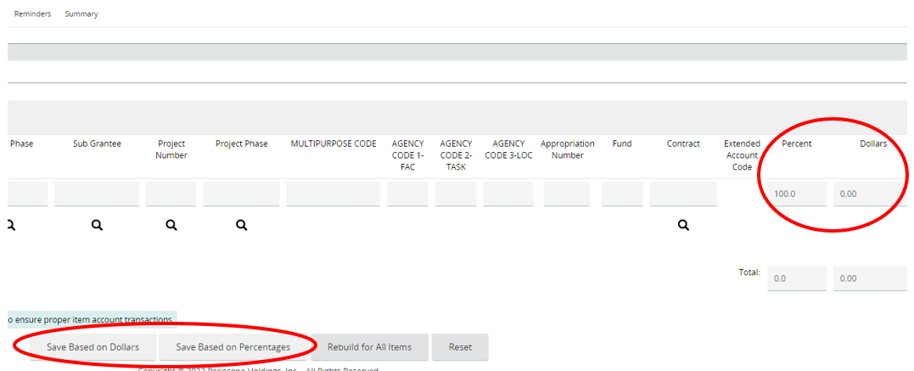
  - OregonBuys will then generate a new row to be used for additional Account Strings when needed.

- Regardless the number for Account Strings being utilized, the final step for completing the Accounting Tab information is to click the “Rebuild for All Items” button. This will clear the “Validation Errors: Accounting distribution is missing and required” red error message.

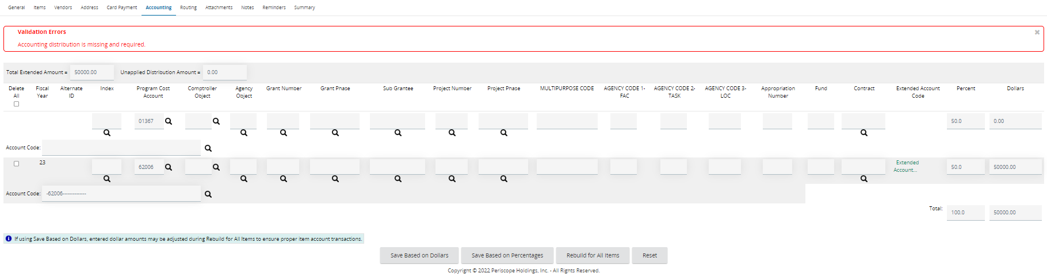
HOW TO DELETE AN ACCOUNT STRING: If an Account String needs to be deleted, select the checkbox located to the far left of the Account String needing to be removed. Next, click on either the “Saved Based on Dollars” or “Saved Based on Percentages” button. After the Account String has been removed, proceed to adjust the Percent or Dollar allocation fields of the remaining Account Strings accordingly.
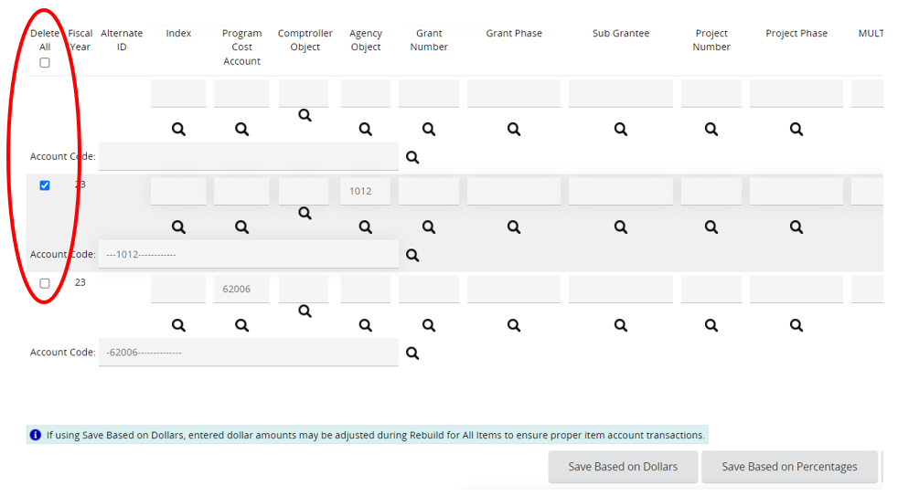

Step 8 – Attachments Tab, Add Relevant Attachments
- Download, complete, and/or compile all materials that are relevant to this request. Please name your documents with something meaningful and descriptive of what it contains. For example:
  - Backstory of Procurement Need.pdf
  - Specifications & Drawings.docx
  - Risk Assessment Form.xlsx
  - Special Procurement or other Draft documents
  - Any other attachments that will be needed to complete the request. Please know that the request may be Disapproved if the necessary attachments are missing!
- Click the Attachments tab, then click Add File
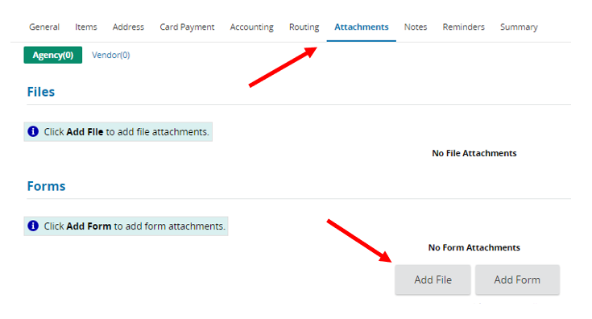
- Choose the document to upload either by:
  - Clicking Choose File, navigating to the document, and double clicking the desired document in the new window (or selecting it and clicking Open)
  - OR simply drag and drop your attachment onto the Choose File button
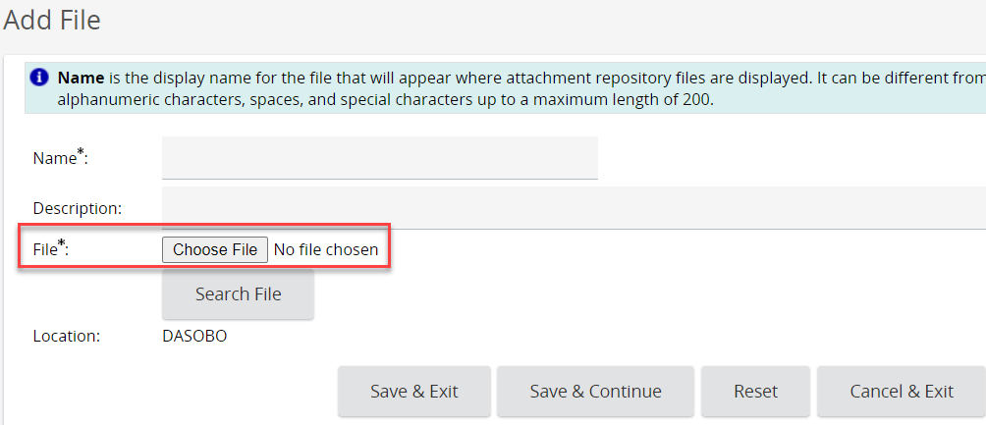
- Name the document. The Name field automatically populates with the document name and extension, so you can save yourself a little time by naming it something meaningful before attaching it!
- The Description field is an optional field that allows more detail regarding the attached document. Suggested best practice is to include a Name (AB Form) and Description (Completed AB Form for new construction)
- Emails cannot be attached as files; you will need to save emails in a different file format to be able to attach them
- Click Save & Exit. Once all the attachments are added move to the next step.

Step 9 – Notes Tab (optional)
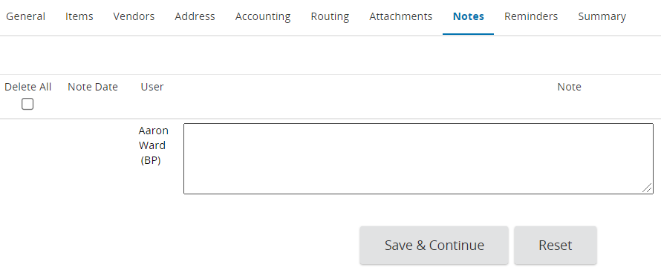
- Optionally, add a note to the request for future reference or for the DAS PS staff member who will review this request and will ultimately do the work
- DAS PS staff will update the Notes tab as the request is being processed

Step 10 – Summary Tab, Review and Submit for Approval
- Click on the Summary tab and confirm that all of the entered information is complete and accurate
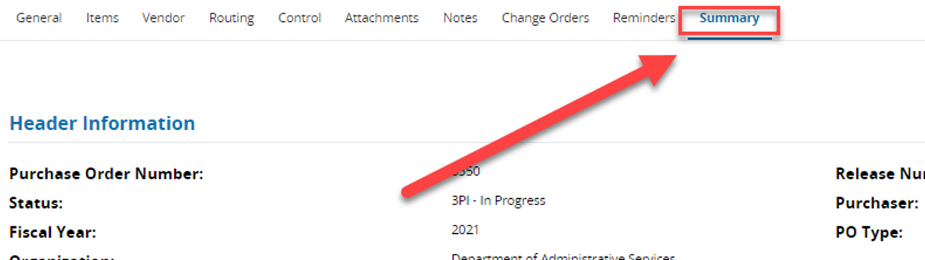
- After validating all of the information is correct, click Submit for Approval.
- All Open Market Requisitions will trigger the Approval Paths associated with the Department and Location on the General Tab.
Once approved, it will trigger the DASINTAKE Approval Path, which will notify the DAS PS Intake staff of your new request. It will look something like this:
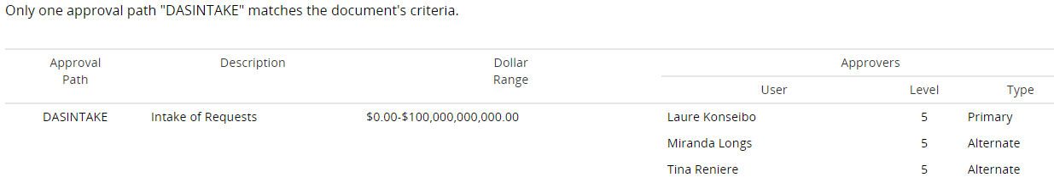
- The DAS PS Intake staff will review your request for completeness and accuracy and may Disapprove (aka reject the submission) of the Requisition if they determine any required materials are missing. If this occurs, you will need to make the necessary updates to your Requisition and Submit for Approval again
- Once final Approval is given by the DAS PS Contract Administrator, they will work with the agency as needed to fill the request

