Department of State Lands
General Permit Application to Maintain Drainage for Protection of Agricultural Lands

1. LANDOWNER CONTACT INFORMATION
Name (print): |  | Affiliation (company or agency):
Mailing address or PO Box:
City: | State: |  |  |  |  | Zip Code:
Phone number: | Cell or alternate number:
E-mail: | Fax number:
2. APPLICATION PREPARATION CONTACT PERSON (if different than Landowner)
Name (print):
Mailing address or PO Box:
City: | State: |  |  |  | Zip Code:
Phone number: |  |  |  | E-mail:
3. PROJECT LOCATION INFORMATION
County: |  |  | Nearest City:
Physical address:
Township: Range: Section: ¼ - ¼ Section: Tax lot(s):
Latitude: (in decimal degrees) Longitude: (in decimal degrees)
4. PROJECT PURPOSE and ACTIVITIES. Check all that apply
The purpose of the project is to maintain a drainage to protect agricultural land
The project involves removal of up to 100 cubic yards of material from below ordinary high water or highest measured tide*
Disposal will be on uplands
Disposal will be on converted wetlands **
* Volumes under this GP are limited to removal or alteration of 100 cubic yards per landowner annually.
** Converted wetlands are agriculturally managed wetlands that, on or before June 30, 1989, were brought into commercial agricultural production by diking, draining, leveling, filling or any similar hydrologic manipulation and by removal or manipulation of natural vegetation, and that are managed for commercial agricultural purposes.

5. NATURAL RESOURCES
Removal Area
Name of stream(s): | Approx River mile | Tributary to which larger stream :
Is this designated essential salmon habitat (ESH)? |  | Yes | No
Is this a designated State Scenic Waterway? |  | Yes | No
6. PROJECT DESCRIPTION
Describe how work will be conducted. Please answer the following questions. This information is needed to demonstrate compliance with the condition requirements.

a. What pieces of equipment will you use? (e.g. Excavator with 18” bucket, 5 yd dump truck)
b. How you will get equipment into the excavation area? Off which road? Through farm field?
Cut vegetation? Build a road?

c. Are you working in the channel or from the top of the bank?

d. Will fish be trapped in the excavation area in late summer or at low-flow water? (Y/N)
If Yes, you cannot qualify for this authorization. Please change the entrance and exit of the excavation to match the streambed elevations upstream and downstream so fish can leave the
area.
e. Will you be removing trees and brush from the south or west sides of the streambank or in the channel? (Y/N)
If yes, please explain why it is necessary.

f. How are you going to dispose of the material (side-casting or trucking away)?

g. If you are side-casting to uplands, is all the material going to be placed on an upland berm?
(Y/N)
If No, please explain where the material will be placed.

h. If you are side-casting into converted wetlands:
Will the material be spread so you do not convert the wetlands to upland? (Y/N)

Will the material be spread prior to onset of winter rains? (Y/N)

i. If you are trucking the material away:
Are you stock piling in an upland area for future personal use or dumping and spreading in an upland area?

Anticipated project dates: Start (mo) (yr) Completion (mo) (yr)
7. OTHER METHODS ALTERNATIVES ANALYSIS
Explain briefly why it is not practical to use these other methods.

Explain other ways to maintain the drainage to protect the agricultural lands that do not involve
working in the waterway.

8. ADJACENT PROPERTY OWNER INFORMATION
Please provide all adjacent landowners’ names and mailing addresses

9. REQUIRED ATTACHMENTS
For a complete application attach all of the following maps and drawings: A Project Location Map
The project and disposal area must be clearly marked. Map must have enough detail to allow a person to drive to the site from the nearest city/town or major highway intersection.
Tax Lot Map
The tax lot with the excavation and disposal areas identified

Plan View Drawing or recent aerial photograph with line drawing that shows:
- The extent of the excavation or alteration (with length and width specified).
- The ordinary high water or highest measured tide line.
- Where you will access the excavation or alteration area with your equipment.
- Where you will dispose of the material.
Cross-section Drawing that has:
- A solid line showing the ordinary high water mark or highest measured tide line from bank to bank.
- The distance (in feet) from bank to bank at ordinary high water or highest measured tide.
- A solid line showing the slope of the existing streambank of the waterway and a dotted line showing the slope of the streambank after the excavation, if you are changing the bank slope.
- A solid line showing the bed of the existing waterway and a dotted line showing the new bed of the waterway after excavation. Mark how deep the excavation area is in feet.

Example drawings are on the back of the application.

10. General Permit Specific Conditions

- Responsible Party. The person listed on the application as the landowner is responsible for the activities of all contractors or other operators involved in project work covered by the authorization under the GP.
- Copy of Authorization Available for Inspection. A copy of the authorization must be available at the work site whenever authorized activities are being conducted.
- Site Access Required. Employees of the Department and all authorized representatives must be permitted access to the project area at all reasonable times for the purpose of inspecting work performed under this authorization.
- Archeological Resources. If any archeological sites, resources or artifacts are discovered during construction, work must immediately cease and the State Historic Preservation Office must be contacted.
- ODFW Fish Passage Requirement. The authorized activity must meet Oregon Department of Fish and Wildlife requirements for fish passage before commencing the project (ORS 509.580 through 509.901 and OAR 635-412-0005 through 635-412-0040).
- Hazards to Recreation, Navigation or Fishing. The activity must be timed not to interfere with or create a hazard to recreational or commercial navigation or fishing.
- Work Period in Jurisdictional Areas. Fill or removal activities below the Ordinary High Water Line must be conducted when recommended by ODFW, unless otherwise coordinated with Oregon Department of Fish and Wildlife and approved in writing by DSL. Work is prohibited when fish eggs are present within the reach where the authorized activities are being conducted.
- Erosion Control Methods. The following erosion control measures must be installed at the construction site before construction and maintained during and after construction to prevent erosion and minimize movement of soil into waters of this state:
  - All exposed soils must be stabilized during and after construction in order to prevent erosion and sedimentation;
  - Filter bags, sediment fences, sediment traps or catch basins, leave strips or berms, or other measures must be used to prevent movement of soil into waterways and wetlands;
  - To prevent erosion, use of compost berms, impervious materials or other equally effective methods, must be used to protect soil stockpiled during rain events or when the stockpile site is not moved or reshaped for more than 48 hours;
  - Unless part of the permanent fill, all construction access points through, and staging areas in, riparian and wetland areas must use removable pads or mats to prevent soil compaction. However, in some wetland areas under dry summer conditions, this requirement may be waived upon approval by DSL. At project completion, disturbed areas with soil exposed by construction activities must be stabilized by mulching and native vegetative plantings or seeding. Sterile grass may be used instead of native vegetation for temporary sediment control if native vegetation is unavailable. If soils are to remain exposed for more than seven days after completion of the permitted work, they must be covered with erosion control pads, mats or similar erosion control devices until vegetative stabilization is installed;

  - Where vegetation is used for erosion control on slopes steeper than 2:1, tackified seed mulch must be used so the seed does not wash away before germination and rooting;
  - Dredged or other excavated material must be placed on upland areas having stable slopes and must be prevented from eroding back into waterways and wetlands;
  - Erosion control measures must be inspected and maintained as necessary to ensure their continued effectiveness until soils become stabilized; and
  - All erosion control structures must be removed when the project is complete and soils are stabilized and vegetated.
- Hazardous, Toxic, and Waste Material Handling. Petroleum products, chemicals, fresh cement, sandblasted material and chipped paint, wood treated with leachable preservatives or other deleterious waste materials must not be allowed to enter waters of this state. Machinery refueling is to occur at least 150 feet from waters of this state and confined in a designated area to prevent spillage into waters of this state. Barges must have a containment system to effectively prevent petroleum products or other deleterious material from entering waters of this state. Project-related spills into waters of this state or onto land with a potential to enter waters of this state must be reported to the Oregon Emergency Response System (OERS) at 1-800-452-0311.
- Raising or Redirecting Water. The project must not cause water to rise or be redirected and result in damage to structures or property.
- Waste Disposal. Old piling and other waste material generated by the project must be disposed of in an appropriate disposal facility. There must be no temporary storage of piling or other waste material below top of bank, in wetlands; in a Federal Emergency Management Administration designated floodway, or in an area historically subject to landslides.
- DSL May Halt or Modify. DSL retains the authority to temporarily halt or modify the project in case of unforeseen damage to natural resources.
- Temporary impacts only. No conversion of wetland to upland is allowed. All material placed in wetlands must be spread in a thin layer before the onset of winter rains.
- Removal of Woody Vegetation. Removal of woody vegetation must be limited to the minimum amount needed to complete the activity, including removal site access.
- Maintenance of Riparian Buffer. Where practicable and necessary to complete the activity, removal of woody vegetation is limited to the north or east sides of the stream channel.
- No Operation in the Water Allowed. Equipment used to remove material must operate from top of bank position when feasible, otherwise from a dry position below top of bank.
- Design to Limit Maintenance. To the extent practicable, the project must be implemented to naturally maintain inlet and outlet connections with the main stream channel.
- Erosion Control. As necessary, erosion control measures must be installed and maintained during the activity and after disposal, so as to prevent discharge into waters of this state.

11. Signature
By signing below, I understand:

- The information provided herein is, to the best of my knowledge and belief, true, complete, and accurate.
- I am responsible for complying with the requirements and conditions set forth in the applicable administrative rules for General permit activities.
- This approval does not authorize trespass on the lands of others. The responsible party shall obtain all necessary access permits or rights-of-way before entering lands owned by another.
- If this is state-owned submerged or submersible land, there may be additional easements, royalties and/or other requirements of DSL’s Aquatic Resource Management-Proprietary Waterway Authorizations.
- This approval does not authorize any work that is not in compliance with local zoning or other local, state or federal regulation pertaining to the operations described herein. The responsible party shall obtain necessary approvals and permits before proceeding under this authorization.
- All work done under this general permit must comply with OAR Chapter 340, Standards of Quality for Public Waters of Oregon.
- When listed species are present, the responsible party must comply with the State Endangered Species Act and the Federal Endangered Species Act.
- Violations of the terms and conditions of this permit are subject to administrative and/or legal action, which may result in revocation of the approval or damages. The responsible party is responsible for the activities of all contractors or other operators involved in work done at the site or under this approval.
- The Department of State Lands may, at any time, by notice to the responsible party, revoke or modify this approval if it determines the project scope or conditions of the General permit are insufficient to minimize individual or cumulative environmental effects in accordance with OAR 141-085.
- Employees of the Department of State Lands and all duly authorized representatives of the Director shall be permitted access to the project area at all reasonable times for the purpose of inspecting work performed under this approval.
- In issuing this authorization, the Department of State Lands makes no representation regarding the quality or adequacy of the approved project design, materials, construction, or maintenance except to approve the project’s design and materials, as set forth herein, as satisfying the resource protection, scenic, safety, recreation, and public access requirements of ORS Chapter 196 and related administrative rules.
- Responsible person shall defend and hold harmless the State of Oregon, and its officers, agents, and employees from any claim, suit, or action for property damage or personal injury or death arising out of the design, material, construction, or maintenance of the approved improvements.
- When approval from ODFW for Fish Passage is required, written autorization must be received from ODFW prior to ground disturbing activities.
- A permit from the U.S. Army Corps of Engineers may also be required.
Land Owner Signature |  | Date

State Lands Signature: For project work proposed on state-owned submerged and submersible lands, DSL will coordinate and provide signatures below. A signature by the Department of State Lands for activities proposed on state-owned submerged/submersible lands only grants the applicant consent to apply for authorization to conduct removal-fill activities on such lands. This signature for activities on state-owned submerged and submersible lands grants no other authority, express or implied.
Land Management Print/Type Name: | Title:
Land Management Signature: | Date:

Please mail completed form to DSL at the appropriate regional office for your project:

DSL – West of the Cascades Department of State Lands  775 Summer Street, Suite 100  Salem, OR 97301-1279  Phone: 503-986-5200  Fax: 503-378-4844 | DSL - East of the Cascades  Department of State Lands  951 SW Simpson Ave., Suite 104  Bend, Oregon 97701  Phone: 541-388-6112  Fax: 541-388-6480

Example Plan View Drawing
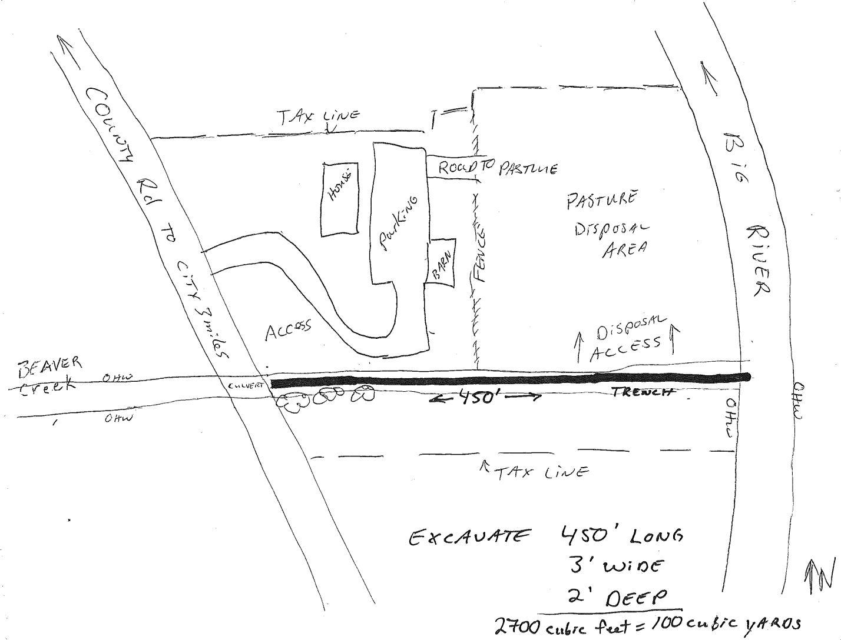

Example Cross Section Drawing

