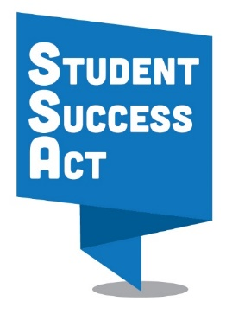
Social Media Posts (TEMPLATE)
  - Community Input Session

Sample Facebook Posts

Sample 1
You are invited to a Community Input Session on the Student Success Act (link to your customized invitation). Come learn more about the historic opportunity for our students, contribute to a discussion on key areas supporting student success, and get your questions answered by local education leaders. Your voice matters - [location] from [time] on [date].

Sample 2
Superintendent [name] and local education leaders want to hear from you! Come to the [town] community input session and help share your thinking on how we can improve our schools. Join in at [location] from [time] on [date] to add your voice to the conversation.

Sample 3
Have questions about education in [school district]? Want to learn more about the Student Success Act? Come to the [town] stakeholder input session, hear from superintendent [name] and local education leaders, and share your views on how to invest in our schools.

Sample Twitter

Sample 1
Come join a stakeholder input session to discuss #studentsuccessact – [date], from [time] at [location].

Sample 2
Help improve #studentsuccessact at a stakeholder input session - [date], from [time] at [location]

Sample 3
Want to be a part of an historic investment in our schools? Share your views for #studentsuccessact on [date], from [time] at [location]

Hashtag
#studentsuccessact

