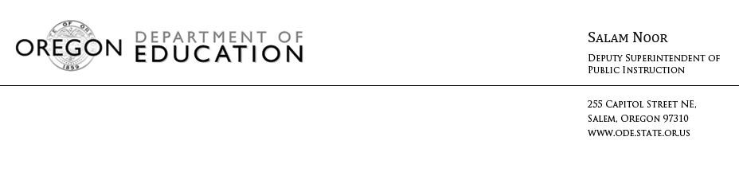
NEWS RELEASE
November 30, 2016
Media Contact: Peter J. Rudy, peter.rudy@state.or.us

2015-16 Oregon Statewide Report Card Released

(Salem, Ore) – The 2015-16 Oregon Statewide Report Card is now available on the Oregon Department of Education (ODE) website. This annual report provides a statewide look at Oregon’s kindergarten through grade 12 education system, including key data on our students, teachers, and schools.

“While no single report can summarize every aspect of education in our state, the statewide report card can be a helpful tool to provide a current snapshot and historical data on education topics and trends,” said Deputy Superintendent Salam Noor. “Education is the key to moving our state forward, and the information in this report is a great overview of the challenges we face and the opportunities for excellence ahead of us.”

The 2015-16 Statewide Report Card includes:
• Graduation and dropout rates
• Early childhood data
• Attendance and chronic absenteeism data
• Student demographics and information on specific student groups
• School funding and staff information
• Test results
• Charter school data and information on alternative education programs

# # #

