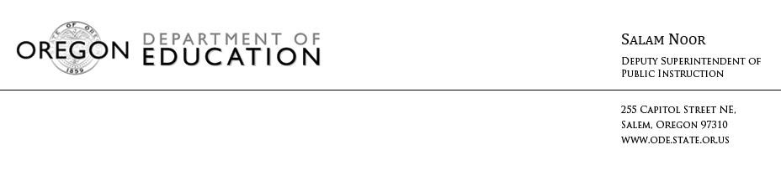

Statement from Deputy Superintendent Noor on the College Board’s AP Report to the Nation

Deputy Superintendent Salam Noor released the following statement about the College Board’s AP Report to the Nation. Click here to access national and Oregon-specific data.

“We know access to rigorous, engaging content and the opportunity to earn college credits in high school plays a critical role in preparing students for their futures. While we continue to see slight increases in both participation and performance on Advanced Placement exams, I know our state can do better. Our students have incredible potential, but for far too many, this potential remains untapped. We need to intentionally reach out to students who have historically been underrepresented in these courses and encourage them to enroll. It is up to the education community to create a school culture that provides access to college-level rigor for each and every one of our kids and pairs that access with the encouragement and support to help students succeed.”

