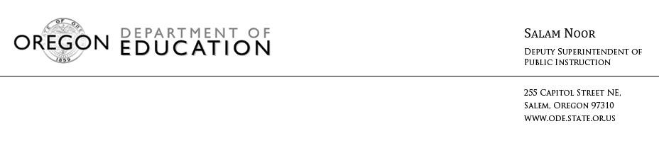
PRESS ADVISORY
March 30, 2016
Media contact: Meg Koch, 503-947-5990, meg.koch@state.or.us

State and Local Education Leaders to Hold Community Forums to Reimagine Education in Oregon

(Salem, Ore) – Deputy Superintendent of Public Instruction Salam Noor, in partnership with local education leaders, is asking Oregonians to help reimagine education in our state. Community members are invited to learn more about our state’s education initiatives, and help build the Oregon State plan for the new federal Every Student Succeeds Act (ESSA) which replaces No Child Left Behind. ESSA allows Oregon to create a State Plan with increased flexibility in assessment, accountability, school improvement and educator effectiveness.

“I want to hear from Oregonians across the state about what they want for our schools,” said Deputy Superintendent Noor. “A new federal law provides us with an opportunity to reimagine education in Oregon, and the best way to accomplish that is with community input and involvement. I look forward to starting this conversation with Oregonians in a series of community forums.”

Parents, students, teachers and community members are invited to attend education forums in the coming months. These events are designed to encourage all community members to discuss how we support student success in Oregon. This includes providing ideas and having the opportunity to ask questions about the opportunities ESSA provides us.

Details on upcoming Community Education Forums are provided below.

*Dates and times are subject to change.

Milwaukie
Thursday, March 31, 2016 – 6:00 pm
Wichita Center for Family and Community (Gym)
6031 SE King Road; Milwaukie, OR 97222

Pendleton
Monday, April 11, 2016 – 6:30 pm
Pendleton Early Learning Center
455 SW 13th Street; Pendleton, OR 97801

Medford
Wednesday, April 20, 2016 – 6:00 pm
Medford School District Education Center (Board Room)
815 S. Oakdale Avenue; Medford, OR 97501

Redmond
Monday, April 25, 2016– 6:00 pm
High Desert Education Service District (Board Room)
2804 SW Sixth Street; Redmond, OR 97756

Salem
Thursday, April 28, 2016– 6:00 pm
Claggett Creek Middle School (Cafeteria)
1810 Alder Drive NE; Keizer, OR 97303

Ontario
Monday, May 2, 2016– 6:00 pm
Four Rivers Cultural Center (River Rooms)
676 SW 5th Avenue; Ontario, OR 97914

Eugene
Tuesday, May 10, 2016– 6:00 pm
South Eugene High School (Cafeteria)
400 East 19th Avenue; Eugene, OR 97401

Portland
Thursday, May 12, 2016– 6:00 pm
Location To Be Determined

Portland
Monday, May 16, 2016– 6:00 pm
Location To Be Determined

Coos Bay
Monday, May 23, 2016– 6:00 pm
Southwestern Oregon Community College (Lakeview Rooms in Hales Center/Empire Hall)
1988 Newmark Avenue; Coos Bay, OR 97420

Hood River
Wednesday, May 25, 2016– 6:00 pm
Best Western Hood River Inn (Columbia Room)
1108 East Marina Way; Hood River, OR 97031

Please help get the word out about these events.
For more information on these education forums, please contact Jenni Knaus at Jenni.Knaus@ode.state.or.us, 503-947-5860 or Meg Koch at meg.koch@state.or.us, 503-947-5990.
Additional information about upcoming events will be posted online at: http://www.ode.state.or.us/go/ESSA.
# # #

