Smarter Balanced Assessment Consortium

Claims for the Mathematics Summative Assessment
Claim #1: Concepts and Procedures
Students can explain and apply mathematical concepts and interpret and carry out mathematical procedures with precision and fluency.
Claim #2: Problem Solving
Students can solve a range of complex well-posed problems in pure and applied mathematics, making productive use of knowledge and problem solving strategies.
Claim #3: Communicating Reasoning
Students can clearly and precisely construct viable arguments to support their own reasoning and to critique the reasoning of others.
Claim #4: Modeling and Data Analysis
Students can analyze complex, real-world scenarios and can construct and use mathematical models to interpret and solve problems.

Common Core State Standards for Mathematical Practice
- Make sense of problems and persevere in solving them.
- Reason abstractly and quantitatively.
- Construct viable arguments and critique the reasoning of others.
- Model with mathematics.
- Use appropriate tools strategically.
- Attend to precision.
- Look for and make use of structure.
- Look for and express regularity in repeated reasoning.

What are Summative Assessment Claims?
Claims are broad statements of an assessment system’s learning outcomes.
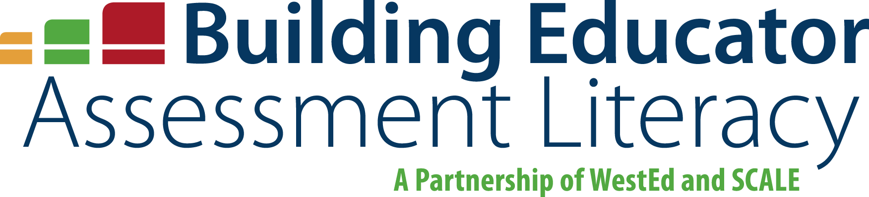
A claim is a statement of what students know and can do, based on the evidence they produce.

Standards for Mathematical Practice

The Common Core State Standards for Mathematical Practice define the mathematical expertise that students are expected to develop while acquiring the knowledge specified in the content standards.
They describe student actions, and can be thought of as defining the content of one’s mathematical character.

