ODE PSAT/NMSQT Invoicing Review

Beginning December 4th, all Oregon schools can generate their PSAT/NMSQT review their invoice and make grade level corrections to avoid receiving an invoice for PSAT/NMSQT tests that should be covered by the state. As a reminder, the state will cover the cost of the Fall 2017 PSAT/NMSQT exam administered on Wednesday, October 11th or the alternate date of Wednesday, November 25th for all 10th grade students enrolled in Oregon public high schools.

When generating an invoice, schools can correct “mis-grids.” A student who bubbled an incorrect (or omitted) grade level in his/her answer sheet is considered a mis-grid. For example, a 10th grade student indicated they are in 9th grade on their answer sheet. As a result, this student will be reported as a 9th grade test taker when a school is completing the invoice process. This is considered a mis-grid and would need to be corrected in order to avoid being charged $16 for that test. PSAT/NSMQT Coordinators should have reviewed the answer documents for correct grade levels before returning them, but errors may still occur.

The window for schools to review and make any needed corrections is December 4, 2017 to January 18, 2018. Schools that do not review and/or revise their remittances during this time will be invoiced for “mis-grids” at $16 per test. Corrections to Fall 2017 PSAT/NMSQT invoices will not be made after January 18, 2018.

Each PSAT/NMSQT Coordinator should follow the steps below to review their school’s remittance and correct mis-grids as needed:

- Log into the College Board’s Test Ordering System (TOS) using your Professional Educator username and password at http://www.collegeboard.com/school/.

- Click on Generate Invoice.

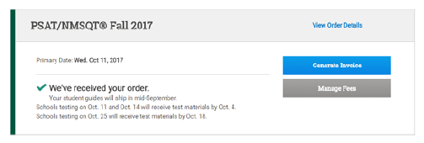

- Review the section Number of Students Tested. Schools will see the number of answer sheets returned by grade level (see image below). If your school only tested 10th and 11th grade students, any students listed as 12th grade, 9th grade, other, or not reported, are mis-grids that need to be corrected. If your school tested students in other grade levels, verify that the number of students per grade level is accurate.

If your school tested students who are not eligible for the state funding (unaccredited schools, home school students, etc.), please report those students as other grade, regardless of the actual grade of the student. The school will receive an invoice for these students and should send payment as directed.

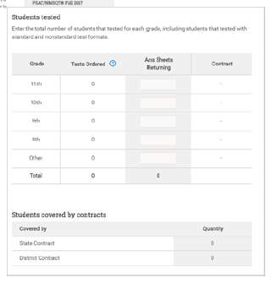

- If there are mis-grids, click on the link at the top of the chart Grade Adjustments. A message will appear regarding the ability to make grade level changes. Click Continue.

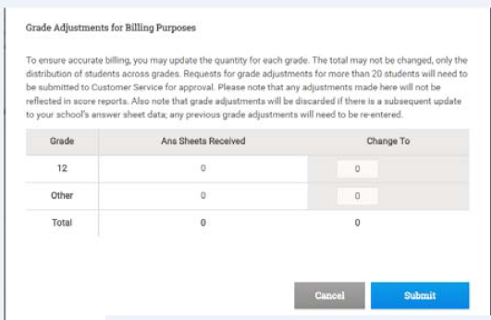
- In the Adjust Quantities chart, make the necessary corrections. After making corrections, the total of the changes column must match the total number of answer sheets that have been scanned for the school. When making corrections, please note the following:

  - 20 or less corrections: Make the necessary correction in the chart. Click Submit. A message that changes have been applied will appear. The corrections then appear in the Number of Students Tested chart.

  - 21 to 45 corrections: If the total number of grade level changes is between 21 and 45, the PSAT/NMSQT Coordinator must enter the list of student names that are mis-grids. Enter the names of the students in the dialogue box provided, and then click Submit. The request will be reviewed for approval. Pending will display next to the requested adjustments until the request is reviewed. Upon approval, the status will be changed to Approve. Approval typically occurs within 2-3 business days.

  - 46 or more corrections: If there are more than 46 corrections, follow the same steps noted above (b) for 21-45 corrections. Requests for more than 46 corrections require additional review and will take longer to process.

NOTE: If you copy/paste student names from an electronic document, be sure to delete any extra spaces at the end of the student names. Failure to do so will result in an error in your submission.

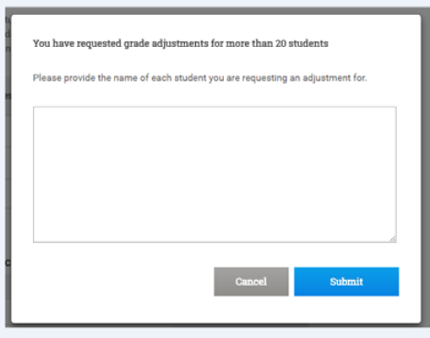

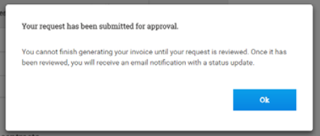

NOTE: The PSAT/NMSQT Coordinator can utilize the K12 Online Score and Report Portal to identify students that are “mis-grids” by using the Roster - Detailed Report to quickly identify the students at each grade level. Or, the PSAT/NSMQT Coordinator can contact Customer Service (877-477-7728) for assistance in identifying the students listed for each grade level.

The school will be able to see the amount owed via their PSAT/NMSQT invoice. However, this may not be you final invoice total because ODE and the College Board still need to complete a data match in the coming month. Please DO NOT pay based off of this invoice amount. Please wait until you received a mailed invoice in late spring.

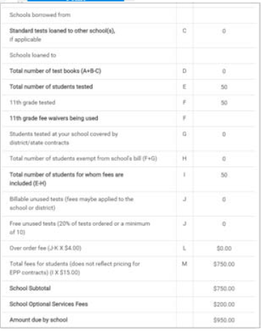

Correcting Report Data: It is important to note that a mis-grid adjustment requested is for invoicing purpose only, and does not change the score reporting grade the student entered in his/her answer sheet. Students must contact Customer Service for Students and Parents (866-433-7728) to change the grade level that is included in on their score report. Once the grade level has been updated, it will take approximately one week for the corporation/school K12 online reports to reflect the change(s) made.

If you have questions regarding the mis-grid or invoice process, please contact Karly Nelson-Aparicio at knelson-aparicio@collegeboard.org or 541-705-5122.

