Developing grade-level learning progressions

Learning Progressions

According to Popham (2014) “In plain language, a learning progression is an ordered sequence of the stuff a student must learn in order to achieve a significant curricular outcome.” (p. 300). The learning progression includes the building blocks that students must master in order to reach this significant curricular outcome. As you will see in Figure 1. the concepts within the learning progression grow substantially more complex from the bottom to the top of the sequence. The benefit of a learning progression is that it provides guidance for how to make progress in learning.

.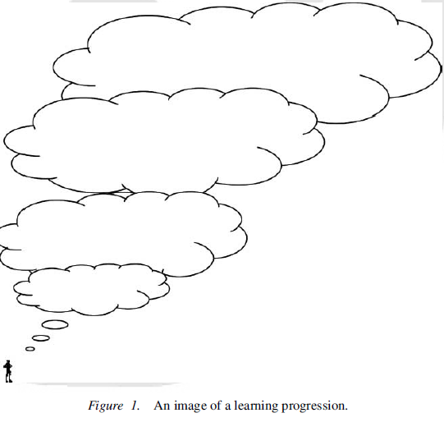

Learning progressions need to be differentiated from overall curriculum plans and from rubrics. Compared to a curriculum or a scope and sequence, a learning progression is finer grain sized and wholly organized around a single curricular outcome. Across a curriculum, there may be ten or more learning progressions. On the other hand, rubrics are more topic or assignment specific and a single learning progression will likely encompass content for multiple rubrics.
Guidance for how to develop learning progressions for the grade level

Upper Anchor
Knowledge and skills as represented in the grade level standard

# | What students know | Potential misconceptions | What the student needs to learn
Building Blocks
Sequence of how knowledge and understanding develops.

By unpacking the grade level standard (see Unpacking Standard Template), you can get a clear sense of all that is required in the standard.

Look at the nouns and verbs from the standard as well as the standards that precede your grade level standard; what do students need to know?

Increasing
sophistication

Lower Anchor

How do your most struggling students typically think about
this topic before instruction?

Given what you know about your students, determine if this should assume mastery of the standard for the previous year or if you need a lower anchor that is lower.

Developing a Learning Progression

Before beginning work on the grade-level learning progression, look at the K-12 learning progression maps that were developed based on the standards. These show what students should be able to do at the end of each year and illustrate how knowledge builds across the grades. Make sure to look at least one to two grades above and below the grade you teach so that you can ensure that your planning for the sequence of learning within your course fits well with the sequence of learning that students will experience across multiple grades.

Step 1: Upper Anchor
The first step is to insert the upper anchor, which is the grade-level standard. If you are finding that a single grade-level standard is too narrow, you can identify a more substantial upper anchor by looking at the and look at the anchor standard or domain. The upper anchor should represent a higher-order skill. The cognitive rigor matrix provides examples of higher orders of thinking by moving from top to bottom and by moving from left to right. The highest orders of thinking or the thinking that requires the greatest cognitive rigor are shown in the lower right section of the cognitive rigor matrix. As you become more comfortable with learning progressions, you may develop learning progressions based on other significant curricular outcomes.

Step 2: Lower Anchor
The second step is to determine what the lower anchor should be. The lower anchor should represent how your most struggling students typically think about this topic before instruction. The lower anchor should come from a pre-assessment or from content provided by teacher who taught the students in the previous grade. If neither of these sources of information are available, then use your professional judgment to estimate where students will start. Given what you know about your students, determine if this should assume mastery of the standard for the previous year or if you need a lower anchor that is lower. It is better to establish a lower anchor that is too low rather than a lower anchor that is too high. If you find out that students knew more than you expected you can accelerate your instruction and find the appropriate starting point. If you assume they know more than they do, students will not be able to benefit as much from the instruction because they will not have the appropriate pre-requisite knowledge.

Step 3: Building Blocks
The third step is to develop the middle levels in the learning progression. These represent the building blocks that students must master in order to reach this significant curricular outcome. These building blocks will include both knowledge and skills; the sequence of the building blocks should represent the optimal order in which students should master this knowledge and skills. (For some districts, these may be called learning targets. If this is the case, please substitute learning targets for building blocks.)

Step 3.A: Identifying Building Blocks

The first step is to unpack the significant curricular outcome, whether it is a grade-level standard or another outcome. To unpack the outcome, use the templates included below as a starting place.

The value of unpacking is to show the subskills or building blocks that student need to develop en route to accomplishing a significant curricular outcome. Identifying these building blocks is important for developing a sequence of the instruction (developing a learning progression), item development (formative and summative), and for scaffolding. There is potential danger in unpacking, though. Kansas State Department of Education (2011) stated, “‘Unpacking’ often results in a checklist of discrete skills and a fostering of skill-and-drill instruction that can fragment and isolate student learning in such a way that conceptual understanding, higher order thinking, cohesion, and synergy are made more difficult. Too often, the process of ‘unpacking" is engaged in an attempt to isolate the specific foundational or prerequisite skills necessary to be successful with the ideas conveyed by the overall standard and is a common precursor to test preparation and reductive teaching. Although this process may be important work in some instances and can certainly be enlightening, it also poses substantial problems if those completing the work never take the time to examine the synergy that can be created when those foundational or prerequisite skills are reassembled into a cohesive whole. Metaphorically speaking, ‘unpacking’ often leads educators to concentrate on the trees at the expense of the forest.” It is as a result of this concern that we encourage educators to use a process similar to the one below to identify the deep understandings and guiding questions that coordinate the content.

Please adapt the template to meet the needs of your content area.

Template for Unpacking Standards
Standard/significant curricular outcome:

To be able to understand, students should consider such questions as…
To meet this, students need to understand that…
In order to effectively consider such questions, students need to…
DO
KNOW

Step 3.B: Sequencing Building Blocks

After unpacking into the Know and Do columns, the next step is to develop the sequence of the building blocks that represents the optimal order in which students should master this knowledge and skills. This decision about sequence draws upon the educator’s professional expertise about their pedagogy and can be informed by the Hess’ Cognitive Rigor Matrix, which illustrates how depth of thinking increases both in terms of the type of thinking required and the depth with which the student must understand the content in order to successfully interact with it.

Directions for Using the Learning Progression Template

Developing a learning progression will be an iterative process. After you take your first attempt, you will start to develop items and in doing so will likely find that you want to adjust your learning progression in some ways. Similarly, when you score student work, you may find new information about the sequence in which student build knowledge and skills.

Please adapt the template to meet the needs of your content area.

Grade-Level LEARNING PROGRESSION

Optional
Required

Directions |  | What Students Know/Are Able to Do | Potential misconceptions associated with this knowledge or skill | Relevant understandings and questions from unpacking template
Upper Anchor: Grade-level standard, domain, or other significant curricular outcome | 7
Building Blocks:  Sequence of how knowledge and understanding develops.  Look at the nouns and verbs from the standard as well as the standards that precede your grade level standard; what do students need to know? | 6
 | 5
 | 4
 | 3
 | 2
Lower Anchor: How do your most struggling students typically think about this topic before instruction? | 1

Image from: Duckor, B., Draney, K., & Wilson, M. (2009). Measuring measuring: Toward a theory of proficiency with the constructing measures framework. Journal of Applied Measurement, 10(3), 296-319
Kansas State Department of Education. (2011) “A Cautionary Note about Unpacking, Unwrapping, and/or Deconstructing the Kansas Common Core Standards.” as quoted by Jay McTighe and Grant Wiggins, http://grantwiggins.files.wordpress.com/2012/09/mctighe_wiggins_final_common_core_standards.pdf
Adapted from Wiggins, G., & McTighe, J. (2012). “Designing an Understanding-based Curriculum around Common Core Standards” http://midwestprincipalscenter.org/wp-content/uploads/2012/10/McTighe-handout-CCSS-and-UbD.pdf

