Local Assessment Capacity Project

The purpose of this project is to grow classroom assessment capacity statewide so that we can increase the credibility of teachers as assessment developments and confidence in using data from classroom assessments.

Oregon Department of Education
255 Capitol Street NE
Salem, OR 97310-0203
Phone: 503.947.5600
Fax: 503.378.5156
12/10/2014
Assessment

Overview
The purpose of the Local Assessment Capacity project is to grow classroom assessment capacity statewide by equipping teachers with assessment literacy knowledge and training. Ultimately, this project will increase the credibility of teachers as assessment developers and the esteem of evidence from local assessment practices as valid representations of student mastery.
Throughout this project, teachers are trained on the BEAR Assessment system, an iterative, four-step process centered on learning progressions:
- Develop learning progression
- Develop and implement a unit test that includes high-quality items that measure content in the learning progression
- Score and interpret student data from the unit test
- Utilize tools and processes to evaluate the quality of the local assessment

A unit test based on a learning progression is in contrast to a unit test that focuses solely on measuring whether students achieved the objective of the unit. The latter test only provides information about whether each student did or did not meet the objective but does not include the additional detail about far along the learning progression each student got, which limits teachers’ abilities to locate learning gaps that require targeted instruction. By developing, administering, scoring, and evaluating a unit test based on a learning progression, teachers can measure how much of the content in the learning progression each student learned, which is important for instructional planning and differentiation, and for evaluating the effectiveness of the instruction in the unit. An additional value of developing learning progressions is that they create a sequence for instruction and guide formative assessment practices. Through developing learning progressions, educators deepen their pedagogical content knowledge and provide a strong connection between instruction and assessment.
Through this project, teachers developed a:
- A learning progression and
- A unit test that measures how much of the content in the learning progression student learned.
The skills they developed for making a unit test, could easily be applied to develop a pre-test (double the items and create two different forms of the same test). Likewise, the learning progression serves as a guide for lesson planning and formative assessment strategies.

 | EXAMPLE Unit Outline
 | Learning Progression |  | Lessons | Assessment Activities
5 | Buoyancy depends on the density of the object relative to the density of the medium. |  | Relative Density | Unit Test (Or Post Test)
4 | Buoyancy depends on the density of the object |  | Density of Object | Formative assessment
3 | Buoyancy depends on the mass and volume of the object. |  | Mass and Volume | Formative assessment
2 | Buoyancy depends on the volume of the object. |  | Volume | Formative assessment
1 | Buoyancy depends on the mass of the object. |  | Mass | Formative assessment
 |  |  | Introduction | Pretest

Learning Progression
Following is a graphic representation of a learning progression to illustrate the increasing sophistication and complexity from the lower anchor to the upper anchor (or significant curricular outcome).
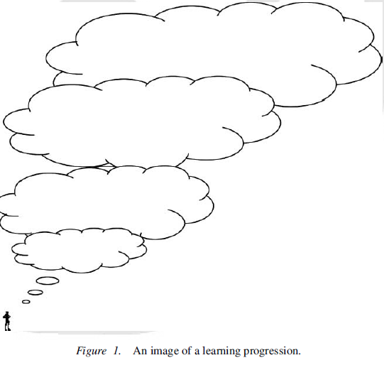

Image from: Duckor, B., Draney, K., & Wilson, M. (2009).
According to Popham (2014) “In plain language, a learning progression is an ordered sequence of the stuff a student must learn in order to achieve a significant curricular outcome.” The learning progression includes the building blocks that students must master in order to reach this significant curricular outcome.

