Assessment Score Reporting Template
Teacher
Grade
Standard(s)

Directions:
- Select a balanced representative sampling of student assessments that were administered to your class (5 lower range, 5 middle, 5 high).

- Place student in order—lowest overall score to highest overall score and assign each student a corresponding number 1-15 (1-lowest performing, 15-highest)

- Only include selected response items in your analysis. Referring to your assessment and learning progression---enter the selected response assessment item numbers in the chart below for each item that represents the corresponding level on your learning progression. For items that span more than one level on the learning progression, identify the learning progression level needed for a student to get the item completely correct. Adjust the columns as needed to reflect your assessment.

- In each cell, indicate whether the student got the question right (1) or wrong (0).

- Reflect on what you see across all selected response items and students. Note: Ideally, what you should see is for the lower left hand part of the chart to be mostly 1s and the upper right to be mostly 0s. If this pattern doesn’t hold for one of the items or one of the students, make note of it and investigate a little further.

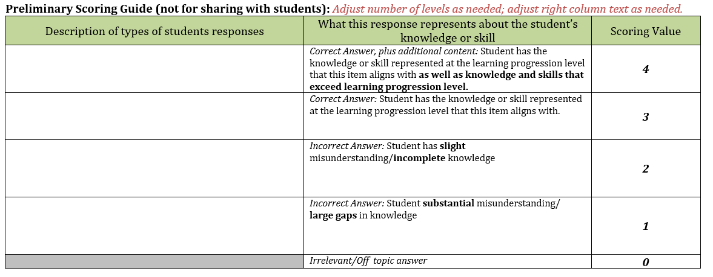

Location on  Learning Progression | LOWER ANCHOR |  | LEVEL 1 |  | LEVEL 2 |  | LEVEL 3 |  | LEVEL 4 |  | LEVEL 5
 | Item #___ | Item #___ | Item #___ | Item #___ | Item #___ | Item #___ | Item #___ | Item #___ | Item #___ | Item #___ | Item #___ | Item #___
Student 1
Student 2
Student 3
Student 4
Student 5
Student 6
Student 7
Student 8
Student 9
Student 10
Student 11
Student 12
Student 13
Student 14
Student 15

Location on  Learning Progression | LEVEL 6 |  | LEVEL 7 |  | LEVEL 8 |  | LEVEL 9 |  | LEVEL 10 |  | UPPER ANCHOR
 | Item #___ | Item #___ | Item #___ | Item #___ | Item #___ | Item #___ | Item #___ | Item #___ | Item #___ | Item #___ | Item #___ | Item #___
Student 1
Student 2
Student 3
Student 4
Student 5
Student 6
Student 7
Student 8
Student 9
Student 10
Student 11
Student 12
Student 13
Student 14
Student 15

Based on the results—what can you identify about your students’ understanding of this concept?
 | What is this student’s level of understanding of this concept? | Where does this student have gaps in their understanding of this concept?
Student 1
Student 2
Student 3
Student 4
Student 5
Student 6
Student 7
Student 8
Student 9
Student 10
Student 11
Student 12
Student 13
Student 14
Student 15

How do these results inform your instruction? (Where do you go from here based on the results?)

