Figure B

5th grade skills/content knowledge

6th grade skills/content knowledge

7th grade skills/content knowledge

Figure C

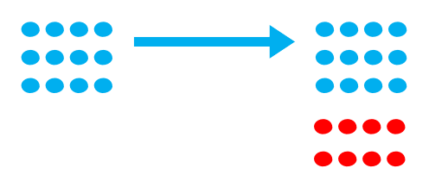

5th grade skills/content knowledge

6th grade skills/content knowledge

7th grade
skills/content knowledge

Figure A

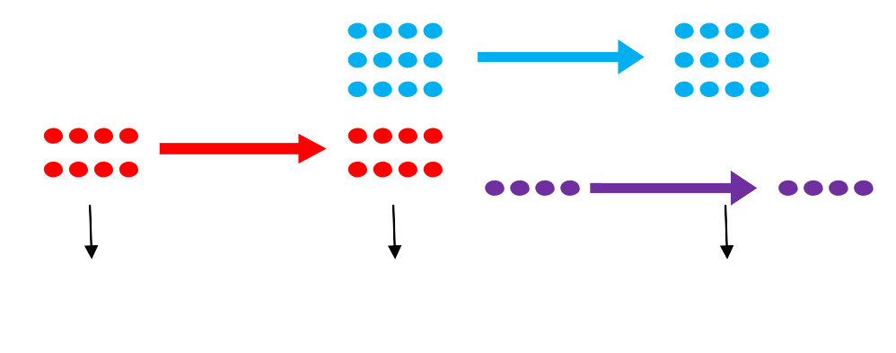
5th grskills/conten

7th grade skills/content knowledge
6th grade skills/content knowledge
5th grade skills/content knowledge

