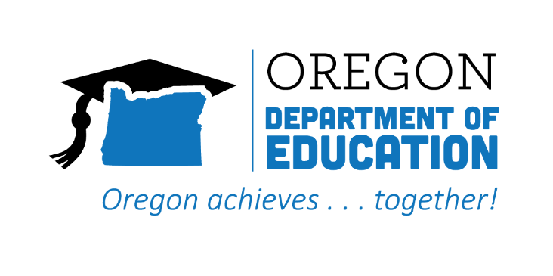
CTE STATE PLAN ACCOMPLISHMENTS 2022-2023

Career Exploration

The Oregon CTE State Plan is a high level, four-year strategic plan that integrates state and federal priorities to implement the "Strengthening Career and Technical Education for the 21st Century Act" (commonly known as Perkins V). A robust system of career exploration enables students to gain insight into potential careers. Expanding career exploration will help diversify options, increase participation and success of focal students, and create a brighter future for all learners. The following are Local and State accomplishments made around Career Exploration goals during the third year.
2022-2023 ACCOMPLISHMENT HIGHLIGHTS
Exposed students to career fields through purchase of current industry technology and work-based learning projects.

Assisted youth explore career options, especially prior to high school, through the CCL Navigator, who collaborated with key personnel in all schools within the region.
Utilized YouScience aptitude results to support students in career exploration, focusing on data at the 8th grade level to use in the transition to high school and in the development of more effective educational planning.

Facilitated better understanding of career opportunities through the work of a Career Navigation Specialist who worked directly with school-to-career coordinators, counselors, and career center coordinators.
Created resources to support early career awareness– including Career Journeys Videos, YouScience, eDynamic–for rural, remote and frontier schools.

Established partnerships within the Career Connected Learning team and the K-12 system, community colleges, workforce, STEM Hubs, and student support entities, such as C3 and the Aspire program.

