Data and Accountability Workgroup Meeting Notes
July 9, 2019
Workgroup Objectives
- Prioritize data necessary to support Oregon’s CTE system, determining what is already available and what new data is needed.
- Review and provide input on draft definitions of CTE concentrator at the secondary and postsecondary level.
- Develop recommendation on the secondary program quality indicator.
- Review and provide input into draft definitions of numerators and denominators for secondary and postsecondary measures.
- Develop recommendations for secondary and postsecondary state determined levels of performance.
- Review and provide input into other Perkins accountability related requirements, such as required state plan elements.
- Develop recommendations for state activities around data technical assistance and guidance to local recipients, use of leadership funds, and data-driven decision-making.

Strengths Identified
Brainstorm data elements you collect/use well or other strengths of your current data system
- Consistency and longevity of data collection
- Completion data
- Enrollment data
- Accessibility of data
- Disaggregated data
- CTE structure
  - Programs of study

Challenges Identified
Brainstorm challenges in your current data system or data elements you need
- Data system is too complex
  - Duplicative collection of data
  - Data is collected that is not used
- Lack of definitions
- Reliance on self-reporting for demographic and education intent information
- Lack common student ID between secondary and postsecondary
- Lack of consistency in measurements between institutions and across state systems
  - “Why is the CTE data reporting different from anything else that we see out of ODE?”
- Connecting data across secondary, postsecondary and the workforce
- CIP and SOC misalignment for employer outcomes
- Since Oregon is next to Washington and Idaho, some learners become employed in those states, which makes it difficult to conduct the data match for employment
- Concerns about staffing and funding
- People responsible for submitting data are untrained on how to submit
  - Puts rural schools at a disadvantage

Secondary Program Quality Measure
Under Perkins V, states must choose not less than one indicator of program quality:
- Attainment of recognized postsecondary credentials
- Attainment of postsecondary credit in the CTE program
- Participation in work-based learning
Additional, optional quality indicators:
- Any other measure that is statewide, valid, and reliable, and comparable
- This is where technical skills assessment would fit

Findings from Needs Assessment
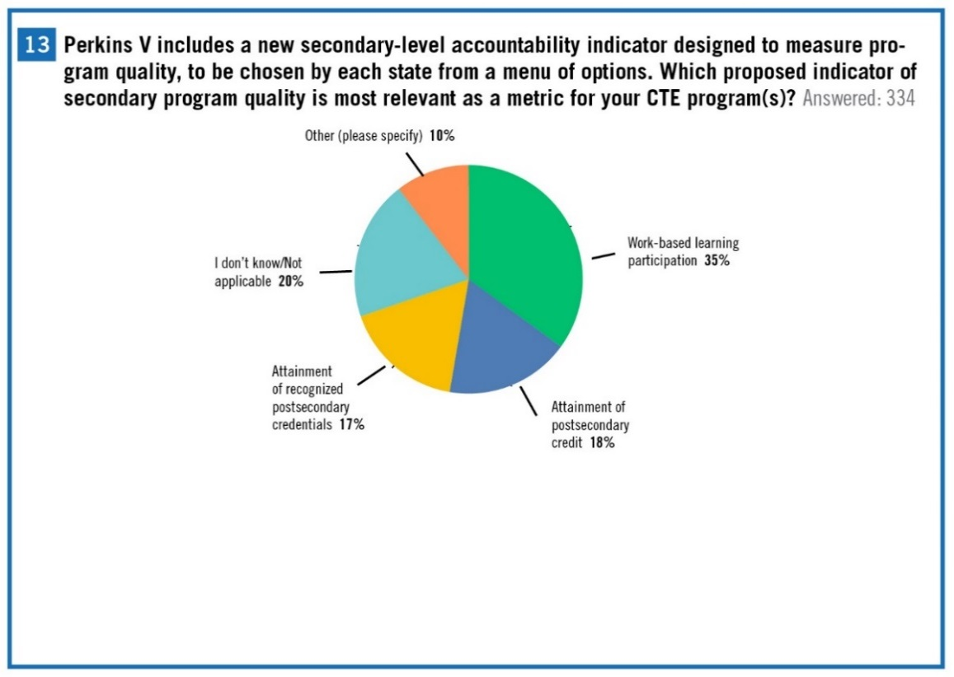

Deep Dive on Secondary Quality Measure

Attainment of recognized postsecondary credentials
- Concerns:
  - Lack of equity and capacity
    - Most of the industry recognized credentials (IRC) are given in English
    - Staffing
    - Cost per credential (who would pay for it?)
    - Data collection for issuer (IRC)
    - Some credentials are direct assets to the workforce. However, many don’t have data that shows many of these equate to higher wages
  - Opportunity to get a meaningful credential at the secondary level is limited in certain areas
- IRC vs. recognized postsecondary credentials
  - How do they relate? Can the IRC be localized?
  - Suggestion: Oregon create its own definition of what those are
    - This could provide an opportunity to strengthen relationships between secondary and postsecondary
  - Industry credentials don’t necessarily correlate to postsecondary credentials
- Create pathways to postsecondary
- Postsecondary credentials must match workforce needs

Attainment of postsecondary credit in the CTE program
- If true alignment exists between secondary and postsecondary, then dual credit will naturally occur
- Identify core classes and facilitate intentional credit
- Supports the concept of multiple entry points for continuing CTE credentials
- State of Oregon already prioritizes accelerated college credit
- Measure number of students or percent who earn credit?
- Postsecondary quality assurance for programs oversight by NWCCU (regional accreditation)
- Could spur statewide collaboration
- Supports students’ goals
  - 94% of students on a national survey said their goal was to receive postsecondary education
- Concerns:
  - Random acts of dual credit
    - Negatively affects Pell eligible students
  - Inequities
    - Access of credit- rural vs. urban or program limitations
      - Small school districts may not be able to afford sponsored dual credit
      - Rural limitations
  - Teacher/instructor licensure and turnover
    - Ex: Business teachers can’t offer college credit because they don’t have the appropriate degree
  - Postsecondary intent not aligning with credit earned
- Amongst the three options, this would be the most reliable
- Can’t be based on the availability of dual credit

Participation in work-based learning
  - What does work-based learning mean?
  - Work-based learning varies whether you are in an urban vs. suburban vs. rural setting
  - Concerns:
    - How do you ensure access?
    - The burden this may place on CTE teachers
    - Inequity of access- rural vs. city
    - Local control vs. state control of program definition
    - Too broad of a definition of WBL
    - Online instructor may restrict WBL access
  - Do not have to be over 18 to get “real-world experiences”- learners can be covered by school insurance or students can sign up for Career Work Experiences (CWE)

New Concentrator Definitions

Secondary Definition
Current Oregon Definition
- A student who has earned a minimum of 1 credit in CTE courses, with at least .5 credit being designated by the school as required
  - Note: In this use, required means that this course curriculum and instruction is based on industry-recognized standards approved for the applicable CTE program and may be addressed by the technical skill assessment used to measure student achievement.
Perkins V Definition
- A student served by an eligible recipient who has completed at least two courses in a single career and technical education program or program of study
New Proposed Concentrator Definition
- A CTE Concentrator must take a least two courses in an approved CTE Program of Study, of which at least one course must be deemed as intermediate.
Proposed Perkins V Course Definition
- A course is a single semester or trimester course equating to either .5 credits or .33 credits respectively.
Additional Definitions Needed
- Introductory Course
- Intermediate Course
- Advanced Course

Postsecondary Definition
Current Oregon Definition
- A student who is enrolled for credit and has completed 18+ program credits, of which 9+ credits are CTE core credits, within a single program of study that terminates in the award of a degree, a certificate of completion or an industry-recognized credential.
Perkins V Definition
- A student enrolled in an eligible recipient who has:
  - Earned at least 12 credits within a CTE program or program of study; or
  - Completed such a program if the program encompasses fewer than 12 credits or the equivalent in total.

Questions to Consider about the Concentrator Definitions
- What questions do the new definitions raise?
- What concerns do the new definitions raise?
- Do the operationalized versions of these definitions capture the “right” population of students?

