Data and Accountability Workgroup Virtual Meeting
September 9, 2019
Workgroup Objectives
- Prioritize data necessary to support Oregon’s CTE system, determining what is already available and what new data is needed.
- Review and provide input on draft definitions of CTE concentrator at the secondary and postsecondary level.
- Develop recommendation on the secondary program quality indicator.
- Review and provide input into draft definitions of numerators and denominators for secondary and postsecondary measures.
- Develop recommendations for secondary and postsecondary state determined levels of performance.
- Review and provide input into other Perkins accountability related requirements, such as required state plan elements.
- Develop recommendations for state activities around data technical assistance and guidance to local recipients, use of leadership funds, and data-driven decision-making.

Concentrator Definition Update
- If a “two credit/course” definition is adopted for the concentrator definition then Oregon would lose about 50 to 70 percent of the students that are captured with the current definition and performance level data will be impacted
  - Under the proposed “two credit/course” definition at least one of the courses would be an intermediate or advanced course, which means at least one of the courses needs to be above an introductory course
- For federal reporting purposes, ODE anticipates that the “two credit/course” concentrator definition will be adopted. However ODE will still collect data based on the “one credit/course” concentrator definition.

Numerator/Denominator Discussion Items
2S1: Academic Proficiency in Reading/Language Arts
- Numerator: # of CTE concentrators who have met the proficient or advanced level on Oregon’s reading/language arts assessment administered under Section 1111(b)(3) of the Elementary and Secondary Education Act (ESEA) as amended by the No Child Left Behind Act based on the scores of CTE concentrators who, in the reporting year, completed high school.
- Denominator: # of CTE concentrators who took the ESEA assessment in reading/language arts and who, in the reporting year, completed high school.
- Discussion:
  - OCTAE recommends that states report the students who took the test in any given reporting year and whether or not the students passed the test
  - Recommendation: Report the testing scores in the year that students take the test.
    - Even though the denominator would be smaller and the CTE concentrators may be fewer, this would provide a true reflection of the students who are bettering themselves through CTE
  - Concern: Students don’t just meet academic proficiency in reading/language arts by completing and passing the exams. There are elements important to proficiency that are not always reflected on the exams.
    - Concern that Oregon is missing many students’ capacity by reporting this correctly
    - Concern that performance measurement goals are based on incomplete data because the only consideration is the exams
  - If data under ESSA is not taking into account other components that people would like to measure, then there is no way to add it to Perkins
    - ODE: Oregon should take better look at the state data to ensure it is encompassing those other components
    - Oregon’s ESSA plan was approved by the federal government a while ago, so it would take major actions to change the plan
  - Concern: Publishing CTE data undermines the confidence of the field if the federal data does not match local data
  - Concern: Every additional clause in the denominator makes it difficult to understand the measure and therefore the data
    - The fewer clauses in the denominator the better, as it helps people to make better data informed decisions
    - For instance the language “in the reporting year, completed high school” makes it difficult to understand the measure
  - Oregon needs to define what the state is trying to measure
    - What is the impact of being a CTE concentrator is what Oregon should be measuring
5S3: Participated in work-based Learning
- Oregon chose participation in work-based learning as the secondary CTE program quality indicator
- Law text: The percentage of CTE concentrators graduating from high school having participated in work-based learning.
- Possible measurement:
  - Numerator: Total number of CTE concentrators graduating from high school during the reporting year having participated in work-based learning in any year during high school.
  - Denominator: Total number of CTE concentrators graduating from high school during the reporting year

Definition of Work-based Learning
Perkins V Definition of Work-based learning: "sustained interactions with industry or community professionals in real workplace settings, to the extent practicable, or simulated environments at an educational institution that foster in depth, firsthand engagement with the tasks required in a given career field, that are aligned to curriculum and instruction."
Data Systems Options for Work-based Learning
What constitutes work-based learning?
- Work-based Learning: Structured learning in the workplace provides students an opportunity to apply knowledge and skills in the work environment and gain an understanding of workplace expectations.
  - Does this constitute work-based learning? Majority of participants said yes.
- Clinical Experience/Practicum/Internship: A structured work experience involving specific, occupational skills and development goals; the awarding of school credit/outcome verification; and the expectation that the student will demonstrate the skills necessary for entry-level employment.
  - Does this constitute work-based learning? Majority of participants said yes (9 yes, 1 no votes)
  - Discussion:
    - These experiences should be an extension of students’ coursework.
- Service Learning: Structured experiences in organized community service projects that meet actual community needs, while demonstrating academic and career-related knowledge and skills. Students design service-learning projects collaboratively with community partners.
  - Does this constitute work-based learning? Majority of participants said yes (11 yes, 1 no)
  - Discussion:
    - This does not constitute work-based learning if it does not include specific skills that the student is learning in his or her CTE program of study
- School-based Enterprise: A business venture (not a simulation) which is striving for economic viability and operated by students. School-based enterprises are generally directed by a business, which sponsors the enterprise and supervises the student staff.
  - Does this constitute work-based learning? Majority of participants said yes (11 yes, 1 no)
  - Discussion:
    - This constitutes work- based learning if the skills at the School Based Enterprise care entered on the student’s CTE program of study skillsets. If it does not, then it isn’t work-based learning.
    - Some school-based enterprises are high-quality, others are not.
    - Sometimes school-based enterprises may be the only work-based learning opportunities that learners have access to.
- Workplace Simulation/Technology-Based Learning: Classroom opportunities for observation and participation in a variety of real-world, worksite activities to assist in understanding what it’s like to work in a business, without visiting the actual worksite. Uses a variety of technological tools.
  - Does this constitute work-based learning? Majority of participants said no (7 no, 4 yes)
- Field-based Investigations: Classroom opportunities for observation and participation in a variety of real-world, worksite activities to assist in understanding what it’s like to work in a business, without visiting the actual worksite. Uses a variety of technological tools.
  - Does this constitute work-based learning? Majority of participants said yes (9 yes, 2 no)
  - Discussion:
    - Unclear where this is a real extension of work-based learning in this definition
    - Can CTSOs be added to the definition?

Work-based Learning: Other Questions?
- What other business rules are needed?
- Are there items missing from survey/data set that you think need to be captured?
  - Oregon needs to be cautious about saying no to certain things based on semantics
    - Oregon should focus less on the wording/descriptions and more on setting up specific expectations
      - This allows smaller communities to create opportunities with limited resources
      - Oregon needs to quantify what those expectations are
- As you think about setting targets, what should be considered?

Target Setting
- What might impact performance?
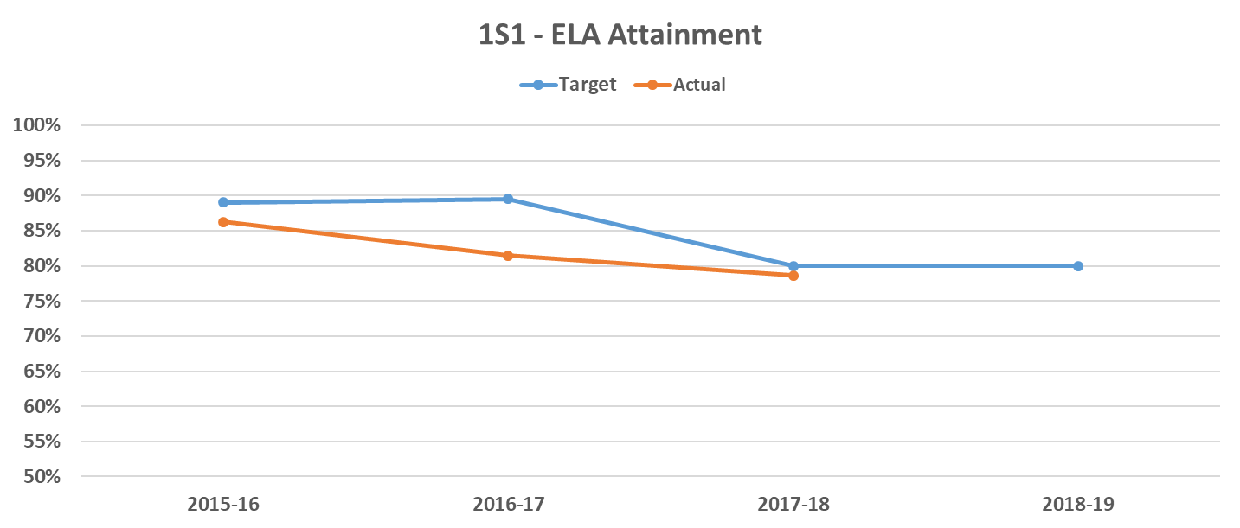

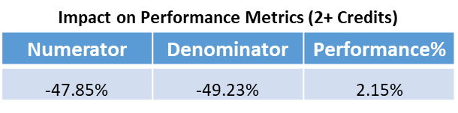

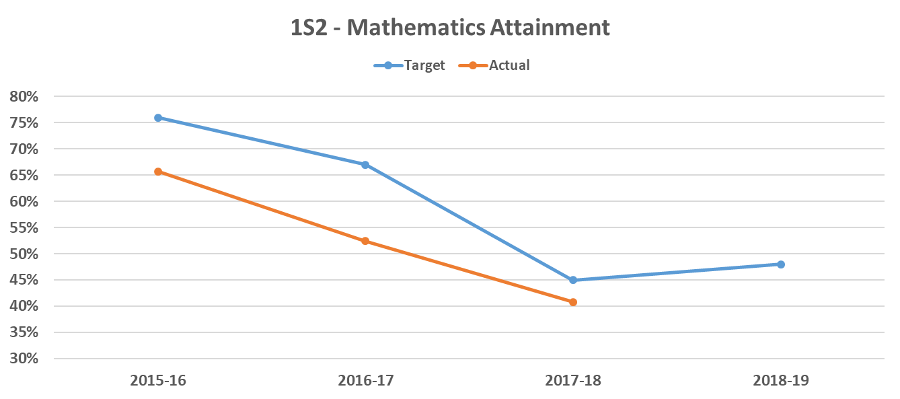

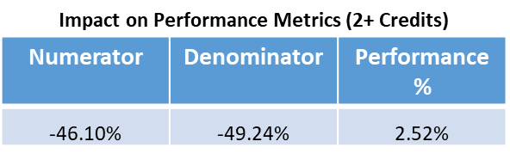

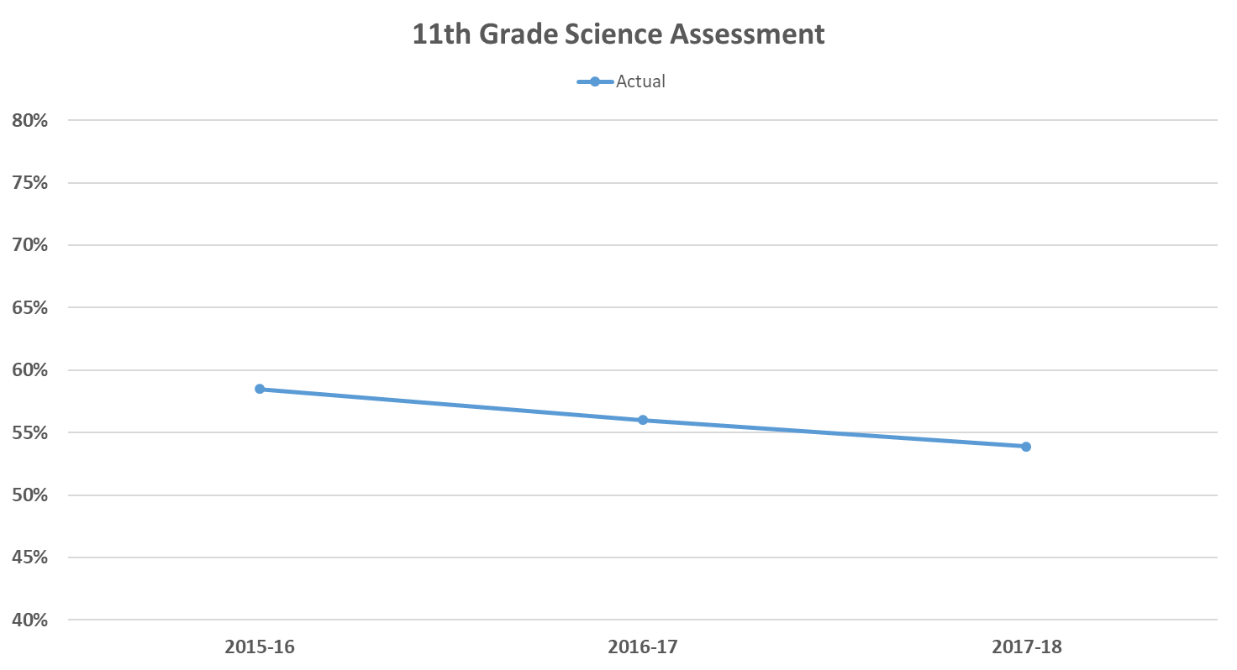

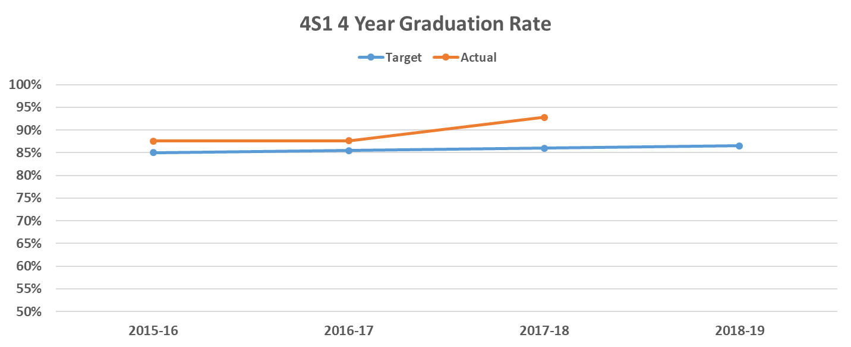

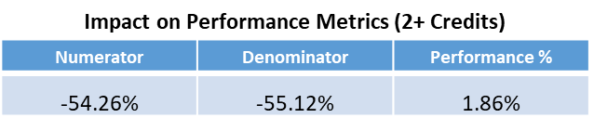

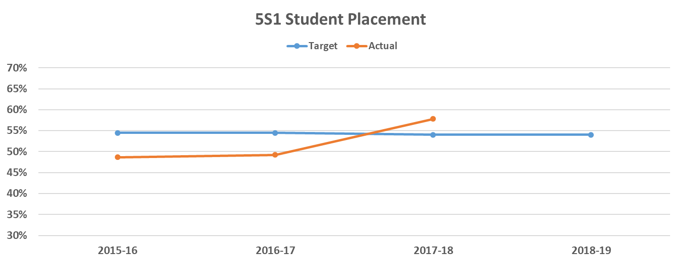
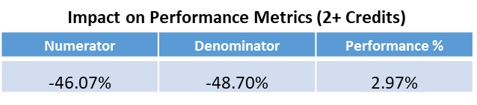

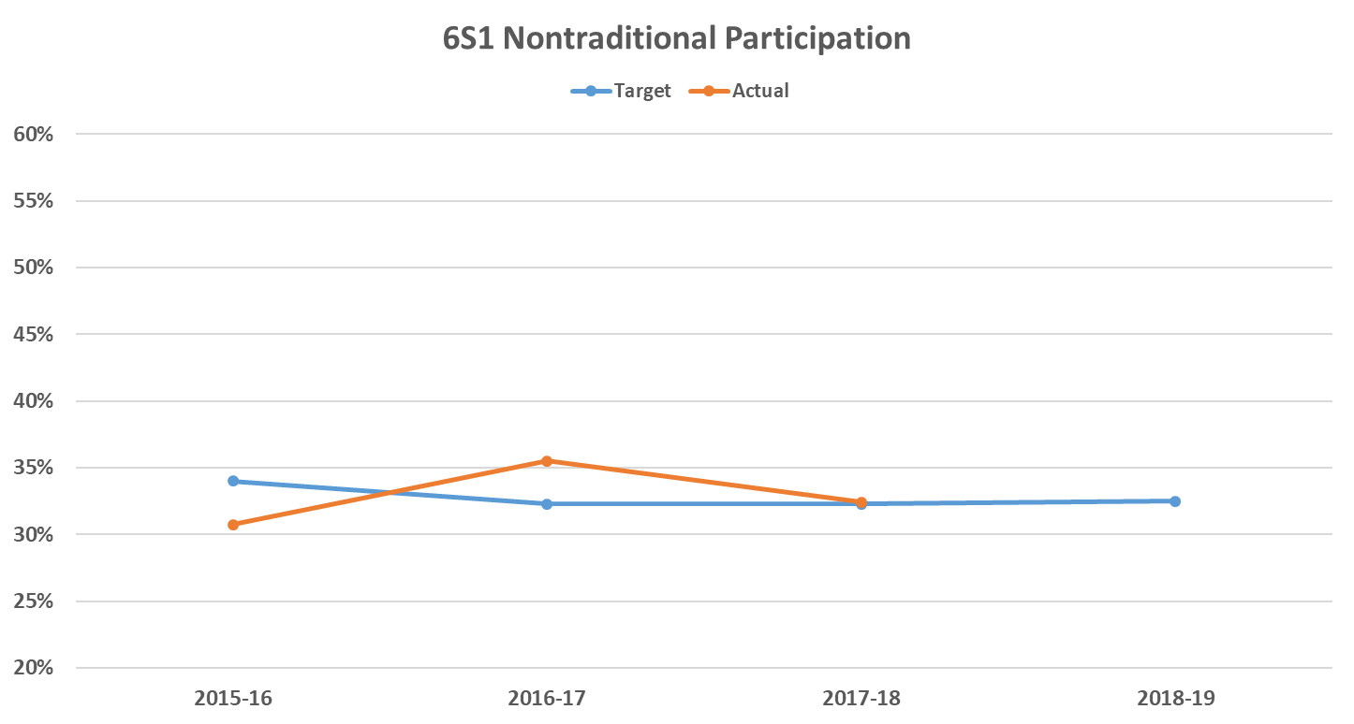

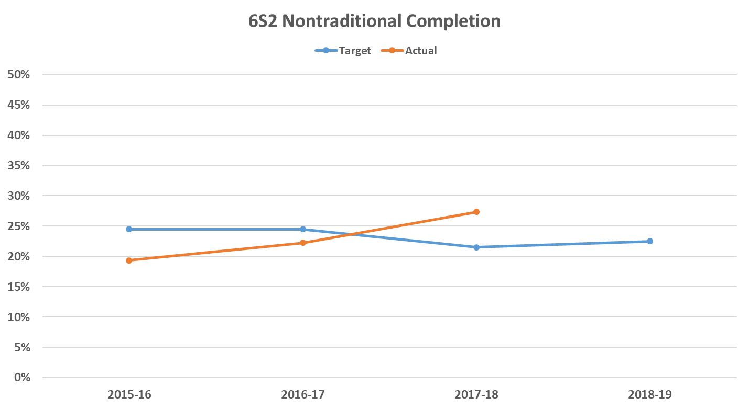

Setting Performance Targets
- What factors do you want the state to keep in mind?
- Do the increases in performance for secondary “concentrators” using a 2-credit definition ring true to you?
- Are there other changes coming that might impact performance that should be considered?
- If placement in employment is added on secondary side, how much is this likely to impact performance on that indicator?

Communicating Targets
- Background on performance targets (what they are, how they are used, etc)
- For each indicator:
  - Definitions for numerator and denominator for Perkins V
  - Baseline level and 4 years of proposed targets
  - Rationale for why the target was chosen (If it appears low why did we go that way? Trend data for how we arrived at our number, etc)
- How can we reach stakeholders?
- How can we make targets more meaningful?
- Are there other things we could pair with this comment process to make people more likely to respond?

Next Steps
- In-person Meeting, October 8, 9:00-noon
  - Additional data collection needs
  - Accountability-related state plan elements
  - College and career readiness indicator

