Work-based Learning Workgroup Meeting Notes
July 10, 2019

Current State of Work-based Learning in Oregon
- Oregon Department of Education does not have a work-based learning definition
  - The data collection system has a definition, but it is not policy
- An approved CTE Program of Study does NOT require a work-based learning experience
- Oregon Perkins V needs assessment found that there is a need for “meaningful work-based learning experiences, such as internships and registered apprenticeships.”

Workgroup Objectives
- Develop a common definition of work-based learning and related elements for Oregon, including descriptions of purposes of work-based learning at different learner levels (including middle school, high school and postsecondary).
- Determine if any changes need to be made to the current data collection around work-based learning for high school graduation. If so, develop a proposal for those changes.
- If the accountability workgroup selects work-based learning as the secondary program quality measure, work with that group to provide input into suggested numerator, denominator, measurement approaches and performance target.
- Finalize recommendations for improving work-based learning using the Perkins V state plan.
- Develop suggestions for state technical assistance and professional development related to work-based learning.
- Develop suggestions for engaging more employers around work-based learning.

Findings from the Needs Assessment

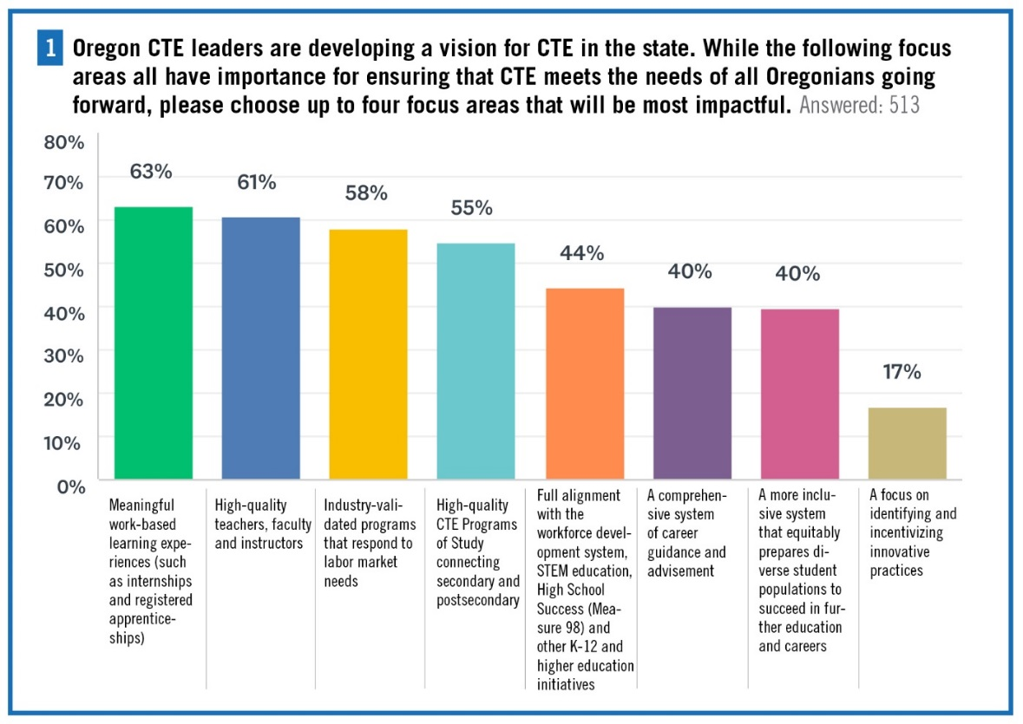
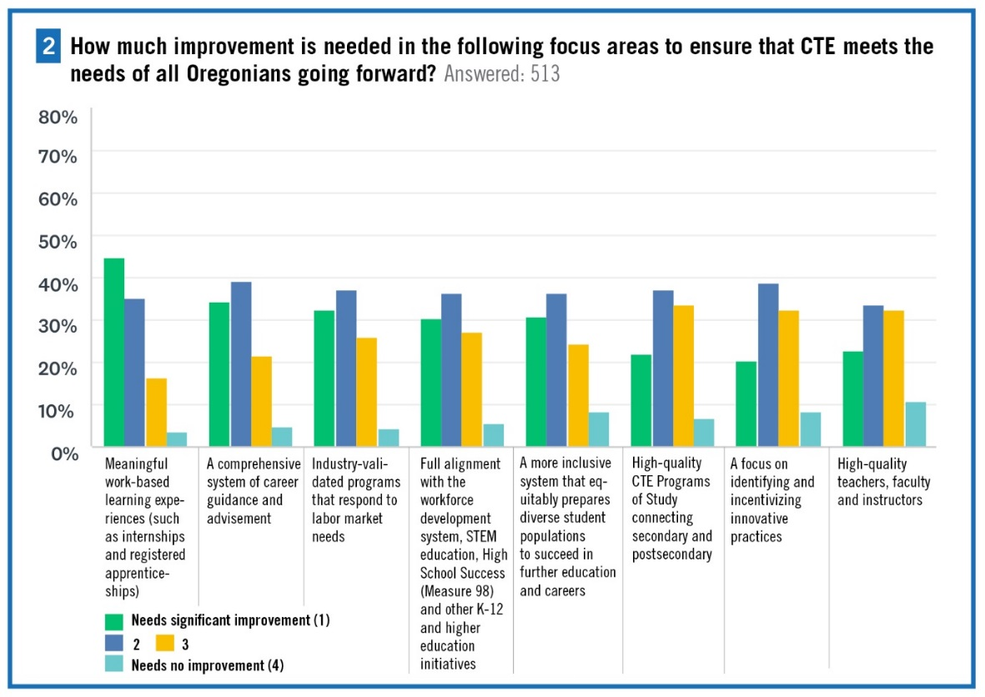

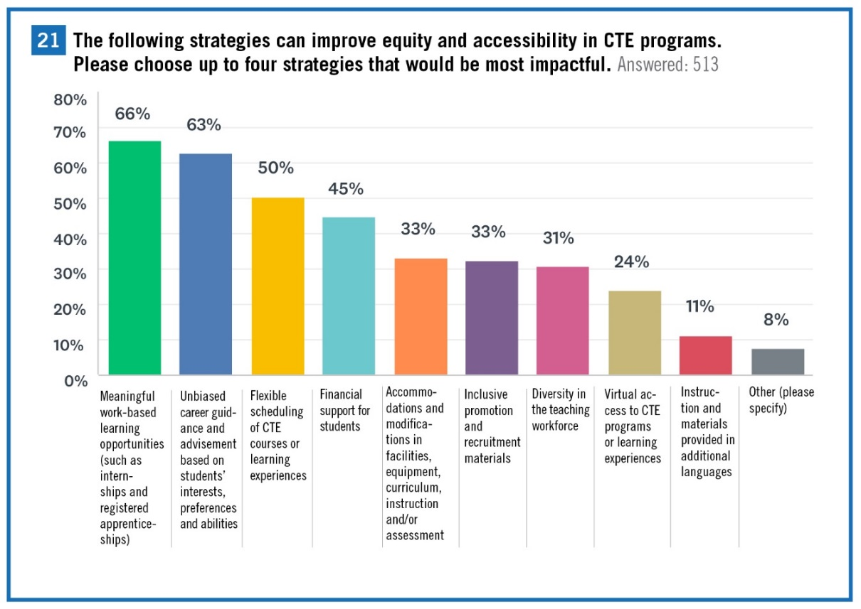

Needs Assessment Recommendations
- Bring together stakeholders in work-based learning to develop common terminology and messaging.
- Define the purposes of work-based learning at different learner levels, and develop weighting for accountability.
- Further recognize work-based learning in POS application, approval and renewal materials and quality rubrics.
- Provide more state guidance on work-based learning, including program examples, templates, professional development and technical assistance.
- Consider piloting innovative models of work-based learning, such as virtual and simulated work-based learning, that can expand access to more students.
- Consider the use of the reserve fund to explore and incentivize work-based learning models.

Work-based Learning in Perkins V
- Work-based learning.—The term ‘work-based learning’ means sustained interactions with industry or community professionals in real workplace settings, to the extent practicable, or simulated environments at an educational institution that foster in-depth, firsthand engagement with the tasks required in a given career field, that are aligned to curriculum and instruction.

Work-based Learning in Oregon: Strengths
Brainstorm what is working well about work-based learning in Oregon.
- Public/private partnerships
- Shift in support from business and industry
- Local Control
  - Local control allows institutions to be responsive to the specific needs of areas.
- “Pockets of Excellence”
  - Nonprofits in OR focus on expanding access and scaling WBL to special populations
- Increased willingness to reexamine BOLI
- Voter and state legislature investments
- Scalability
- Internships

Parking Lot
- Local control mandate
- Internships (unpaid) vs paid work experience (federal court guidelines)
- Concerns that WBL is a default equity strategy. It can be an equity strategy, but requires careful thought and design to reach our underserved populations.
- “Are we considering creating a work-based learning manual for the state?”
- Shared place for workgroup to add resources

Work-based Learning in Oregon: Challenges
Brainstorm challenges related to WBL in Oregon.
- Priority Challenges
  - Transportation (access)
  - Guidelines/Roadmaps for educators and business/industry
  - Statewide communication
  - Industry Engagement
  - Stigma/Recruitment
  - “Paperwork”/Data
- Lack of common manuals and definitions
- Employer engagement at the high school level
- Access, especially for students in rural communities
- Need to better identify and highlight “pockets of success”
- Need professional development/education for industry partners and school counselors
- Employers have liability concerns
- Need to better articulate the return on investment to employers

Addressing the Challenges
For the top three priority challenges (based on a vote), participants answered the following questions:
- Are there best practices for addressing this challenge or places in the state that are working through it successfully?
- Are there policy changes at the state level that could address this challenge statewide?
- How could additional resources help to address this challenge statewide?
- How could technical assistance or professional development help to address this challenge statewide?
- How could business and industry partners help to address this challenge statewide?

Priority Challenge: Industry Engagement
- Create guidelines/handbook
  - Advisory board handbook guidelines/ selection process
- Intentional mentorship programs
- Incentivize employers (tax breaks)
- Technical assistance to industry partners and an evaluation process
- Educate business/industry about opportunities
- Provide quality pay for CTE faculty
- Revisit license requirements for CTE educators (so retirees could serve)
- Pedagogy training for CTE faculty and industry mentors
- Make the process to get involved easier
- Foster shared investment and risk
  - Can Perkins funds be given to business? (vs. industry contributions to education [shared investment])
  - Change the value so that’s a win/win situation
- Consider encore career paths
- Give advisory group model structure
- Understand needs/wants (intentionality to support this)
  - Define the problem
- Recognize that there is a difference between knowing how to perform a skill and knowing how to teach a skill- have the “doers” help to inform educators to advise curriculum and reinforce curriculum with a specific skill or trade

Priority Challenge: Statewide Communication
- Resources:
  - A virtual tool to house regional experiences, partners, industry WBL needs
    - State longitudinal data system
  - State listserv, database of resources
  - State/stakeholder contacts
  - Best practice database w/ option to submit ideas (interactive)
  - State website for CTE/work-based learning opportunity to improve access to info
- Define terms/common language -> streamline
- Improve messaging alignment among CCWD/HECC and ODE
- Foster networks (professional learning networks)
  - Consider businesses’ time (Jan/Feb)
- Stakeholder groups must include “boots on the ground”
- Professional development, info and training
  - Professional learning community for work-based learning that is cross representational

Priority Challenge: Guidelines/Roadmaps for Educators and Business/Industry
- 1. Are there best practices for addressing this challenge or places in the state that are working through it successfully?
  - Career pathways framework (define that to be useful to industry)
  - “Tools” to support the implementation (from other states- Kansas, Washington, etc.)
- 2. Are there policy changes at the state level that could address this challenge statewide?
  - Policy documents to provide risk/liability and reward of work-based learning options
  - Communication to synthesize policy for business related to rules/risk/ BOLI (training)
  - Consistent terminology with components
    - Define internship
    - Define work-based learning
    - Define paid work experience
  - Non-negotiable to flexible framework for local control
  - FTE reimbursable (increase funding/reimburse; categorical funding)
  - Clarify roles
    - Define work-based learning coordinator and requirements or training to become one (state institution for work-based learning)
  - Consistent/simplified statewide work-based learning paperwork (rather than district-specific student/employer paperwork)
  - Consistent crediting for work-based learning
- 3. How could additional resources help to address this challenge statewide?
  - Guided pathways
  - Work Opportunity Tax Credit (WOTC) addition for businesses engaging in work-based learning programs
- 4. How could technical assistance or professional development help to address this challenge statewide?
  - Career readiness planning, communication, engagement, and return on investment to stakeholder
  - Cross representation - think tanks for state-wide strategic plan and innovation based on successful models
  - Professional development for work-based learning coordinators (safety, OSHA, student prep for job shadows, etc.)
  - Common communication visuals for industry outreach
- 5. How could business and industry partners help to address this challenge statewide?
  - Curriculum development and alignment
  - Visual representations to reveal work-based learning options in “the system”
  - Create easily accessible training/material for industry that doesn’t lose them in the process

Defining Work-based Learning
- What should the goals be of work-based learning at this level?
- What types of activities help to meet those goals?
- What characteristics help to identify those activities as “high-quality”?

