Oregon Perkins V Work-based Learning Workgroup Virtual Meeting Notes
August 5, 2019

Workgroup Objectives
- Develop a common definition of work-based learning and related elements for Oregon, including descriptions of purposes of work-based learning at different learner levels (including middle school, high school and postsecondary).
- Determine if any changes need to be made to the current data collection around work-based learning for high school graduation. If so, develop a proposal for those changes.
- If the accountability workgroup selects work-based learning as the secondary program quality measure, work with that group to provide input into suggested numerator, denominator, measurement approaches and performance target.
- Finalize recommendations for improving work-based learning using the Perkins V state plan.
- Develop suggestions for state technical assistance and professional development related to work-based learning.
- Develop suggestions for engaging more employers around work-based learning.

Highlights From First Meeting
- Pockets of excellence throughout the state – there are good things happening
- Need more common definitions, guidance, professional development and statewide communication
- Access is critical issues – numerous barriers:
  - Transportation
  - Lack of opportunities in rural/small communities
  - Employer engagement
- Other thoughts:
  - Workgroup participants have broad array of experiences with work-based learning; whatever is decided will influence more than the CTE system
  - Shift in thinking: focus on learner outcomes vs. focus on funding sources
  - Policy barriers
    - Existing policies may be something that this group examines (ex: child labor laws)
      - Compliance with policies may conflict with the objectives- where are the opportunities to revisit policies?
      - Certification requirements- who do we entrust to be the educators?

Secondary Program Quality Indicator
Mini-survey Summary
- Sent to stakeholders
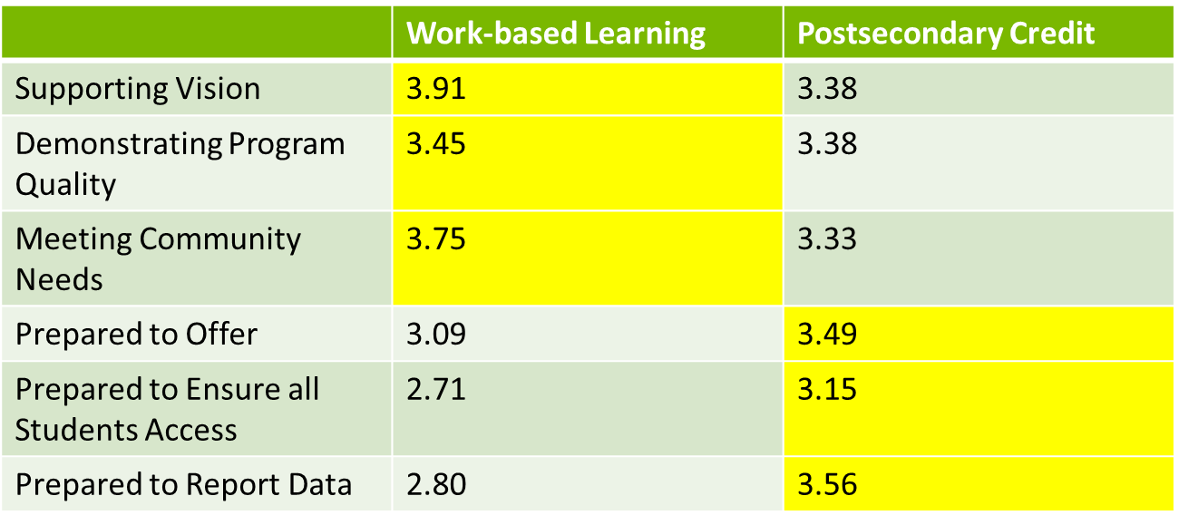

If you had to choose today, which of these measures would you like the state to adopt to meet federal data reporting requirements?

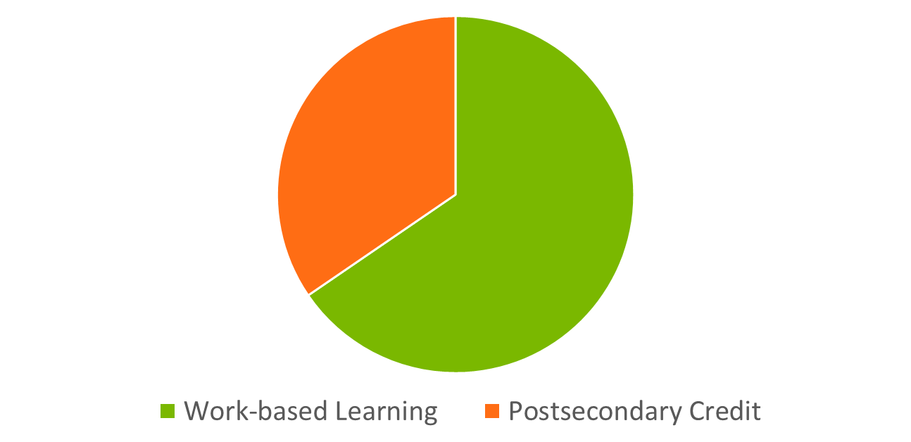

Summary of Comments from Survey
- Concern about WBL in rural schools/small communities
- Opportunities limited in some fields for WBL
- Skills provided by WBL very useful
- Postsecondary credit only valuable for college-bound (although can be problematic then too)
- Teacher credentials an issue for postsecondary credit
- Neither are great option

What next?
- Interest in WBL – seems to be support for it based on value to students
- Measurement/reporting and access a concern
- How could we address?
  - Clear definitions
  - State TA
  - Reasonable targets

Defining Work-based Learning
- Want the definition of work-based learning to apply to different levels of education
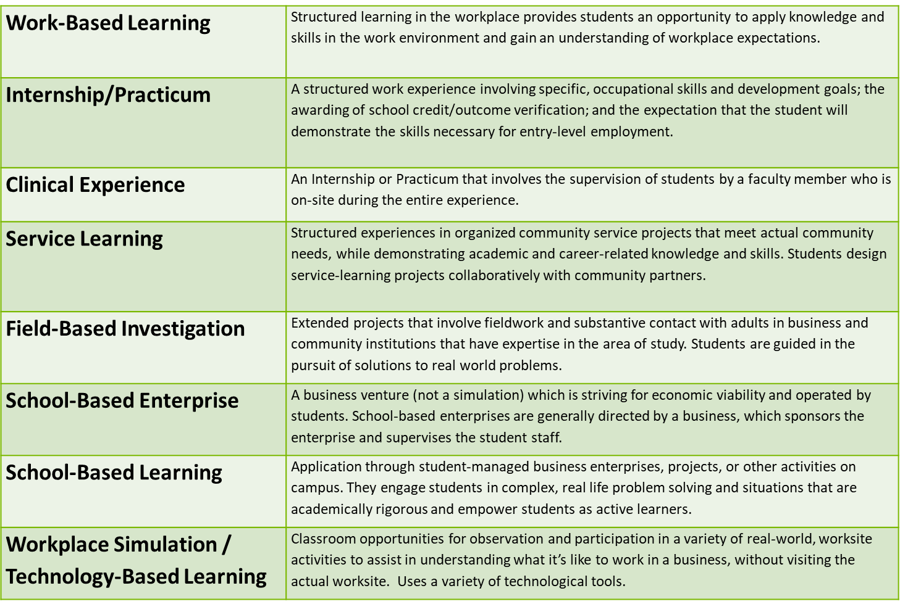

WBL in Perkins V
- Work-based learning.—The term ‘work-based learning’ means sustained interactions with industry or community professionals in real workplace settings, to the extent practicable, or simulated environments at an educational institution that foster in-depth, firsthand engagement with the tasks required in a given career field, that are aligned to curriculum and instruction.

Defining Work-based Learning
- Description of sustained interactions with industry or community professionals
  - Sustained interaction means:
    - Closed loop:
      - Planning: define what each other’s roles and objectives are;
      - Implementation : do the work
      - Evaluation: finding area of improvement
    - Continuous partnership between school and industry/community
    - Long enough that the novelty wears off
  - Sustained interaction would not be:
    - Only a month or two week opportunity
    - Defined by the number of times a student is attending or hours
  - Need to define the program/structure that you are relating the sustained interactions to
  - Can’t just be sustained interaction, must also be quality and meaningful interactions
    - Meaningful interactions means:
      - Providing experiences where the students can relate to young people on the job site ( based on age, background, ethnicity, etc.)
      - Thoughtful learning objectives for students and engaging activities at the worksite that align with leaners’ goals (intentional and quality placement)
  - Sometimes sustainability is not possible from an industry perspective- need to set realistic expectations
    - Long-term work-based learning opportunities, especially unpaid internships, can be overwhelming and cumbersome for both students, staff and industry.
    - Shorter term experiences can sometimes be higher quality than longer term experiences.
  - How do we measure employer satisfaction?
  - Need list of qualities someone in the field would need to be successful
- Description of real workplace settings (or simulated environments?)
  - Best case scenario: real-world experiences in the workplace
  - When possible, learners should be in the workplace, but sometimes simulated experiences are the best that you can provide a student (ex: healthcare)
  - In regards to a simulated environment, the closer the environment mimics the real-world scenario, the more context you are able to provide learners
  - Example of simulated environment: Students virtually connect with other students on a regional team with a manufacturing employer who gave them project-based learning simulations. Lisa from School to Career in Hillsboro had a successful virtual mentorship program: https://hillsborochamberor.com/stc/stc-special/
  - Where is the line between a simulated environment vs. a lab activity?
    - Simulated environments are more interested in the “hard skills” that are relevant to employment
    - Simulated environments are informed and vetted by industry
  - What should not count as work-based learning?
    - If the simulated environment is not designed or shaped significantly by industry, then it would not constitute work-based learning
  - Key element in workplace setting or a simulated environment is sustained industry engagement
- Description of alignment to curriculum and instruction
  - Direction of the alignment- curriculum and instruction should be aligned to industry needs or standards
  - Ensure that students complete an exploratory or preparatory CTE course prior to participating in work-based learning. The course has to have a connection to their work-based learning experience and their future goals
  - Consider how to better align the work-based learning to the aspiration of students
  - Alignment to curriculum and outcome- where is the credit being awarded?
  - Alignment to credit bearing opportunities for students, whether secondary or postsecondary

Next Steps
- Virtual meeting: September 9, 3:30
- In-person meeting: October 8 or 9

