The Oregon STEM Education Initiative

The Oregon Department of Education is disseminating the Oregon STEM Education Initiative. The initial input for the STEM Initiative was provided by representatives from business and education including organizations that focus on STEM education both inside and outside of the school day. The Oregon STEM Education Initiative will:
- Define STEM education and goals related to preparation for college, careers, and citizenship.
- Identify critical components needed for improvement in STEM education.
- Describe a mechanism for linking educators and communities interested in improving STEM education.
Definition for Oregon STEM Education
“An approach to teaching and lifelong learning that emphasizes the natural interconnectedness of the four separate STEM disciplines. The connections are made explicit through collaboration between educators resulting in real and appropriate context built into instruction, curriculum, and assessment. The common element of problem solving is emphasized across all STEM disciplines allowing students to discover, explore, and apply critical thinking skills as they learn. “
Outcomes for Oregon STEM Education
Student outcomes for STEM education at any level include:
- Improving student performance in STEM related content;
- Increasing interest in and improve preparation for STEM careers; and
- Becoming proficient in STEM concepts necessary to make personal and societal decisions.
In order to reach these goals, there will need to be a change in the complexity of the STEM content; the knowledge and skill teachers bring to instructional practice, and the engagement of students in the instruction. These three aspects of teaching and learning interact with each other in complex ways to change what Richard Elmore describes as the instructional core. The Oregon STEM Framework identifies six components of a broad strategy to change the instructional core and reach the desired student outcomes.
Linking STEM Educators
Oregon is engaging in a networking model for promoting changes in STEM education statewide that are effective and coordinated. Similar models are at various stages of development in other states such as Ohio, New Mexico, North Carolina, and Massachusetts. In these states, regional networks of schools are being formed to support coherent improvement in STEM education. This concept is identified by the Carnegie Foundation as Networked Improvement Communities and is described in some detail in a document that can be found at http://www.carnegiefoundation.org/sites/default/files/bryk-gomez_building-nics-education.pdf

Components of Oregon STEM Education
Improving STEM education in Oregon will require more than a new curriculum, more professional development, or enhanced after-school activities. The Components of Oregon STEM Education describe the broader set of issues that need to be addressed so that the individual actions of schools, districts, state agencies, educational program providers, businesses, and communities provide maximum impact. Key components of Oregon STEM Education include Effective Instruction, Effective Learning Environments, Coherent Standards and Policies, Effective Leadership, Community Engagement, and Evaluation and Research.
Effective Instruction
Teachers are central to effective STEM instruction whether they are teaching science or mathematics in a school, coaching a robotics team, leading a 4-H club, or guiding a group through a museum. A STEM teacher can be someone who has completed a professional education program, attended training sessions, or accumulated life experience in STEM disciplines. They can hold a variety of credentials and teach in a variety of settings. STEM teachers create opportunities for students to make connections between science, technology, engineering and mathematics and use that knowledge and critical thinking skills as they problem solve.
In order to improve teacher effectiveness in STEM instruction teachers need professional development opportunities to improve their knowledge and skills. Additionally, teachers need to be able to collaborate with others on the development of STEM learning opportunities for students, improve practice through lesson studies, and have access to coaching support.
Effective Learning Environments
STEM learning is influenced by both the physical and social environments. With an emphasis on problem solving and critical thinking in STEM, students need to be part of a social environment that encourages dialogue with teachers and other students. Effective learning requires an environment that includes appropriate pacing of instruction, grouping of students and feedback. Careful consideration of physical layout of classrooms or learning environments including appropriate tools and technologies is required to support social aspects of learning.
Coherent Standards and Policies
Coherent standards and policies help remove barriers to implementation and provide support for development of interconnected STEM education programs. Standards define what is expected to be taught and learned at each grade level. Coherent standards help support educators in understanding how to meet these standard expectations within a STEM learning environment.
Policies that influence STEM learning may be local, regional, statewide, public, or private. These policies need to be reviewed to make sure that they support rather than set up barriers to STEM teaching and learning.

Community Engagement
STEM education is the responsibility of a community that extends beyond schools. Business and industry has an interest in STEM education in order to grow a literate and innovative workforce. A wide range of organizations provide STEM learning opportunities through classes, competitive events, and mentorships. Parents and volunteers provide personal knowledge and experience that can engage and inspire students.
Engagement of the community in STEM education requires communication and collaboration. Community members who are not part of the school setting need to know how to interact with schools, teachers, and students in a meaningful and sustainable fashion. Schools need to understand what resources are available and how to best incorporate those resources into the educational setting. Collaborations between schools and communities can also provide positive support for policy.
Effective Leadership
Effective Leadership is critical to ensuring equitable access to high quality STEM teaching and lifelong learning. Leaders may come from both inside and outside of the schools. An effective leader may be a teacher leader, a school level administrator, a district level curriculum specialist, a regional professional development provider, ESD or school district superintendent, state level education specialist, a community member, or an industry representative.
Effective Leadership requires the engaging others about the importance of STEM, sharing success stories based on data, and building capacity by helping others succeed in providing STEM learning opportunities for students. Effective Leadership includes focused instructional leadership as well as developing and implementing coherent policies, advocacy for equity, providing and supporting effective learning environments, establishing and maintaining the infrastructure and facilities necessary to support teachers in the delivery of effective STEM instruction, building connections to community, parents, and businesses, and ensuring accountability at every level.
Evaluation and Research
Evaluation of the Oregon STEM Framework is essential for monitoring the impact of this work and fine tuning based on lessons learned. Our ability to illustrate what STEM learning looks like and the impact on student achievement is imperative for developing sustainable STEM learning opportunities for our students. Research will help us as we provide training for leadership and teachers by providing information about successful strategies, efficiencies, and greater ability to communicate the importance of STEM to our students, parents and community members. Evaluation includes monitoring progress and lessons learned in addition to identification of best practices in STEM.

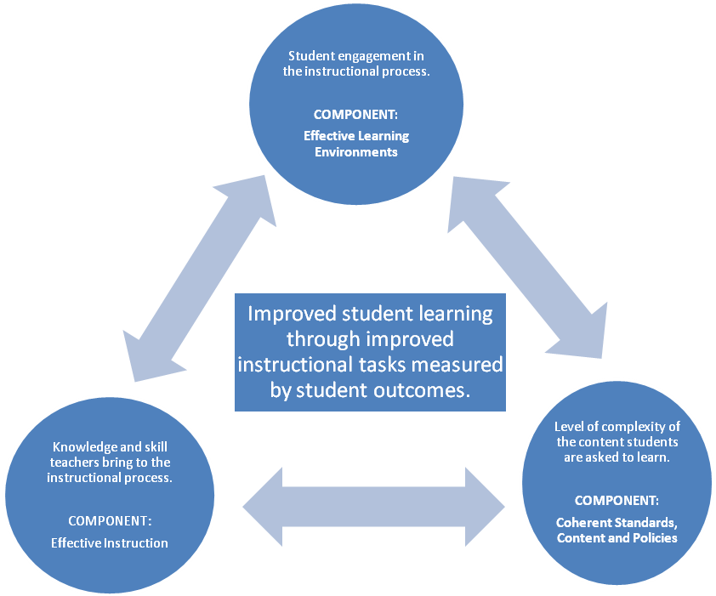
The first three components address the three aspects of the instructional core as illustrated in the diagram below. The last three are drivers to accelerate the process of change. Without the drivers, changes in the instructional core may languish due to lack of direction, resources, and knowledge.
Driver Components
Evaluation and Research -- Effective Leadership -- Community Engagement

STEMx – Multi-state STEM Education Network

Oregon is one of thirteen state STEM networks to join STEMx. STEMx provides an accessible platform for states to share, analyze and disseminate quality STEM education tools to transform education, expand the number of STEM teachers, increase student achievement in STEM and grow tomorrow’s innovators. The Network:
Educates — Defines what quality STEM teaching and learning looks like and connects state networks and partners across the country to accelerate the spread of universally rigorous and transformative STEM educational opportunities to reach and impact more students.

Engages — Spurs partnerships and engages stakeholders across K-12 and higher education, business, government, philanthropy and the community to amplify STEM teaching and learning opportunities for students across the Network and the country.
Exchanges — Promotes sharing of high-quality STEM resources and tools that span STEM teaching and learning, quality metrics and measurements, policy and advocacy, communication and community engagement and state network planning and ultimately increase student achievement.

Oregon Department of Education STEM Team:

Jamie Rumage, STEM Education Specialist
Jamie.rumage@state.or.us
Carla Wade, Technology Education Specialist
Carla.wade@state.or.us
Mark Freed, Math Education Specialist
Mark.freed@state.or.us
Cheryl Kleckner, Science Education Specialist
Cheryl.kleckner@state.or.us
Tom Thompson, Industrial & Engineering Systems Education Specialist
Tom.thompson@state.or.us

