Enhancing Student Opportunities Data Collections

Coordinated Early Intervening Services Collection

User Guide
September 2023
OREGON DEPARTMENT OF EDUCATION
Office of Student Services
255 Capitol Street NE
Salem, OR 97310-0203

Contents
What’s New 1
September 2023 1
Getting Access on the District Website 2
Overview 4
Submission Steps 5
Step 1: CEIS DATA 5
Step 2: USE OF IDEA FUNDS FOR CEIS 7
Step 3: Review 9
Contact Information 9
ODE Help Desk & Data Security and Privacy Overview 10
Contact Information 10
Services 10
Help Desk vs. Data Team – who to call? 10
ODE Help Desk: What to Expect 10
Data Security and Privacy 11
Student Data Security: Handle with Care 11
ODE Policies 11
Information Security Questions 11

What’s New
Changes for the Coordinated Early Intervening Services collection for 2023-2024.

September 2023
- The Use of Funds for CEIS tab changes:
  - Renamed Field: Projected count of students without disabilities (allowed for CEIS and CCEIS)
  - New Field: Projected count of students with disabilities (allowed for CCEIS only)
  - New Calculated Field: Projected count of students who will receive the academic or behavioral services and supports (locked field that is the calculation of fields 1 and 2)
- No changes to the CEIS Data tab.
- Added sections for ODE HelpDesk/Data Security/Privacy.

Getting Access on the District Website
The Coordinated Early Intervening Service (CEIS) collection is accessed within the IDEA Data Manager. If you do not already have access, please contact your district’s Security Administrator.
If you do not know who your District Security Administrator is, go to the District Home page, and on the right-hand side beneath QUICK LINKS, click Find Security Administrator.
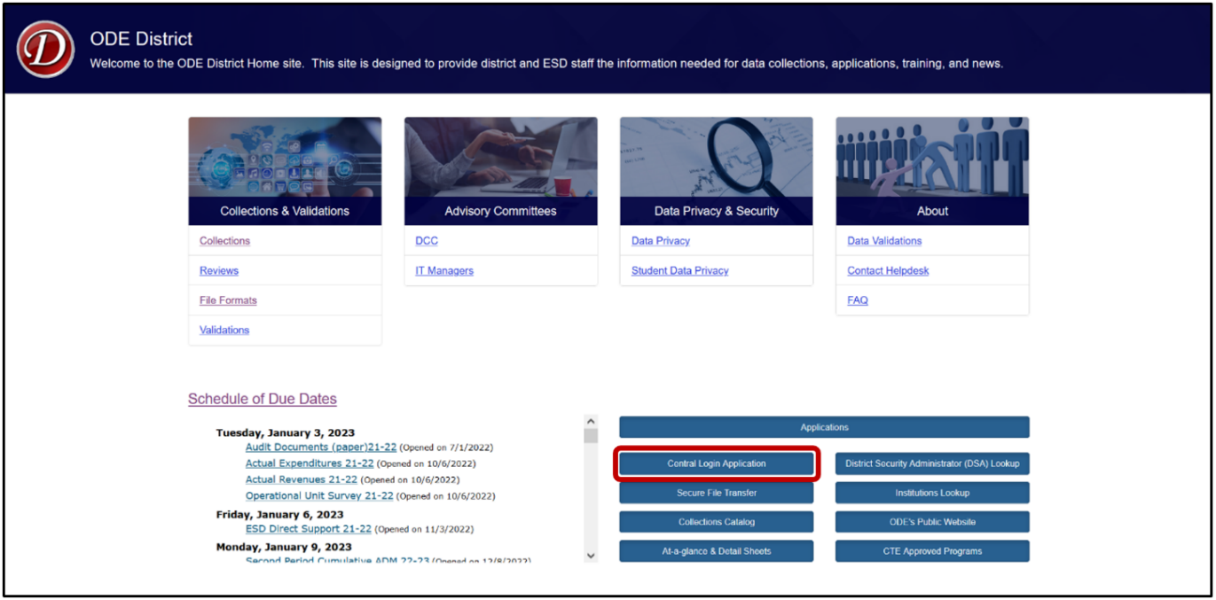
On the Search for Security Administrator page, follow the instructions on the screen.
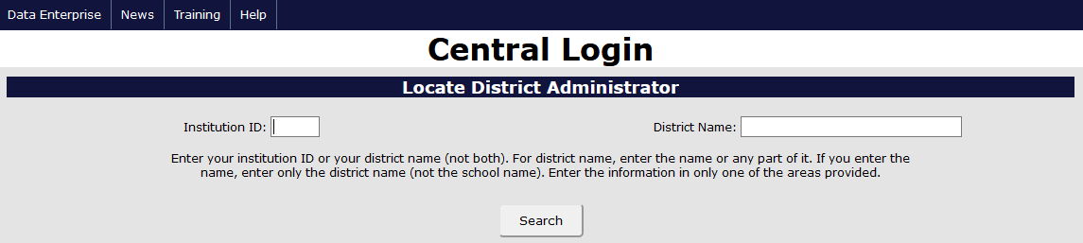
When requesting access to applications such as collections or the IDEA Data Manager, data submitters must request Primary Submitter and Modify rights. Users should verify with their District Security Administrator that they have both permissions. Without both, users will not have the ability to view, submit or edit data.

Once logged into the District website, select IDEA Data Manger in the Applications List.
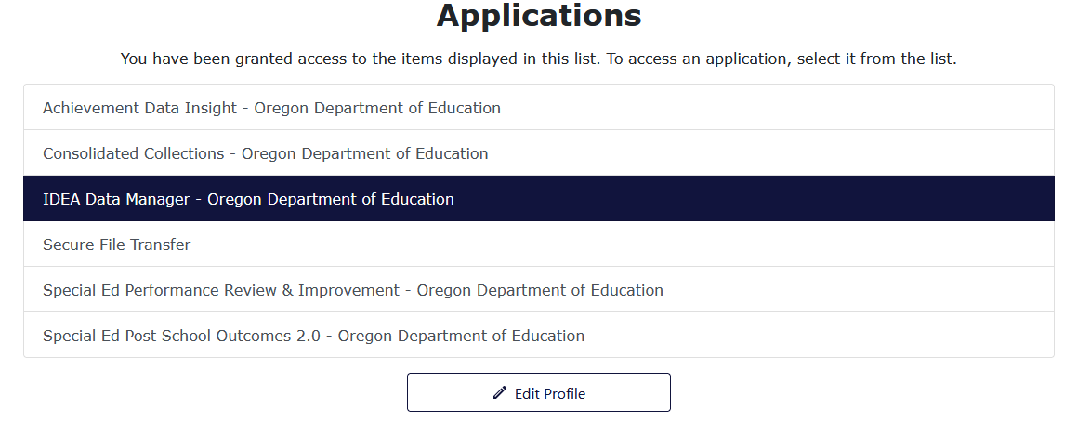
Once in the IDEA Data Manger, select Other Collections in the Left Navigation Menu. From there, select CEIS to access the data entry tabs.
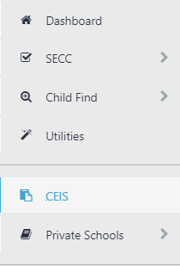

Overview
All districts must complete, submit and verify a submission for the Coordinated Early Intervening Services (CEIS) Collection. The CEIS collection contains three tabs:
Tab 1. OVERVIEW. This provides an overview of the collection.
Tab 2. CEIS DATA. Data entry for the PRIOR school year.
Tab 3. USE OF IDEA FUNDS FOR CEIS. Data entry for the CURRENT school year.
Note: the information reported on this tab will tie to the data your district will collect and report in Tab 2 (CEIS Data) next year.
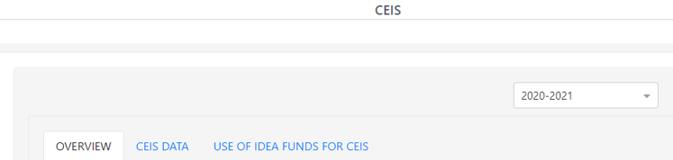
Both tabs 2 and 3 must be submitted and verified for your submission to be considered complete.
To see prior year data, use the School Year drop menu on the top right. Click the drop arrow to expand the menu.
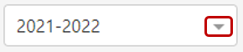
After clicking the arrow, the drop menu will display the prior years available to view. These prior year screens are view only and are not editable as the collection windows are closed.
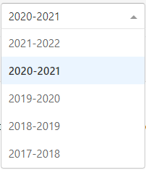

Submission Steps

Step 1: CEIS DATA
This tab collects information concerning CEIS during the prior year.
If Voluntary CEIS:
- Indicate if your district voluntarily used up to 15% of its IDEA funds for CEIS. If your district indicated it would reserve funds in prior year collection, “Yes” will be preselected for your district.
- If No, click the Save button in the bottom right, then the Submit & Verify Button. Proceed to Step 2: Use of IDEA Funds for CEIS.
- If Yes, answer questions A through C (see below).
If Required CEIS:
- If your district was identified for significant disproportionality for the respective school year, “Yes” will be preselected for your district.
- Answer questions A through C (see below).
A. Enter CEIS Student Count. This is the total number of students who received CEIS from your district during the prior school year. This is an unduplicated count. Note that this count cannot be zero if funds were used for CEIS. Count each student who received CEIS using IDEA funds.
B. Enter Special Education Student Count. This is the total number of students who received special education services under Part B of IDEA in the prior AND CEIS during the current and/or preceding two-years. This is an unduplicated count. Count each student only once.
The example below is for the 2019-2020 collection, where the total number of special education students is from the 2018-2019 school year, and the three prior years for receiving CEIS were 2016-2017, 2017-2018 and 2018-2019.

C. Enter Actual Expenditures For CEIS. This is the total amount of prior year IDEA Funds your district expended/is expending. This amount can be expended in one year or over two years. Note the exact amount your district is expending for CEIS is required for the federal reporting purposes.
The example below is for the 2019-2020 collection, regarding the 2018-2019 IDEA Funds expenditures, which can be expended during 2018-2019 or during 2018-2019 and 2019-2020.
- Enter Total Amount of 2018-2019 IDEA Funds Reserved For CEIS (C1). This is the total amount of 2018-2019 IDEA Flow-Through Funds that your district set aside for voluntary or required CEIS.
- Enter Actual Expenditures for 2018-2019 (C1a). This the total amount that your district expended in 2018-2019. It can be the total indicated in C1 or a portion if your district is expending these funds over two years.
- Enter Actual Expenditures for 2019-2020. Enter “0” if total amount was expended in 2018-2019 only (C1b). If expending the funds over two years, enter the remainder to be expended. C1a plus C1b must equal C1.
- Check the Total Amount of 2018-2019 IDEA Funds Reserved For CEIS. If a red bar with a note appears, an incorrect value was entered. Verify and correct amounts entered for C1, C1a or C1b.
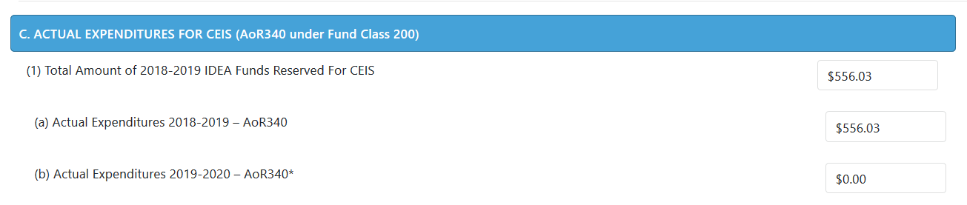
- Click the Save button in the bottom right, and if no errors are displayed in red in the top right, click the Submit & Verify button.
- Proceed to Step 2. Use of IDEA Funds for CEIS.

Step 2: USE OF IDEA FUNDS FOR CEIS
This tab collects information concerning the district’s planned use of IDEA funds for CEIS during the current school year. The IDEA Flow-Through estimates and 15% cap are shown at the top of this tab.
A. IDEA Funds Reserved For CEIS
If Voluntary CEIS:
- If “No, Not Required” click the Save button in the bottom right, and if no errors are displayed in red in the top right, click on the Submit & Verify button.
- If “Yes, Voluntary” answer questions B through C (see below).
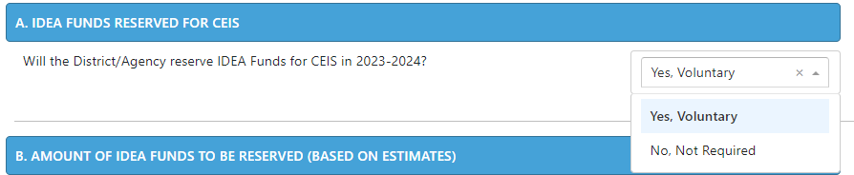
If Required CEIS:
- If your district was identified for significant disproportionality, “Yes, Required” will be preselected and not editable by your district.
- Answer questions B through C (see below).
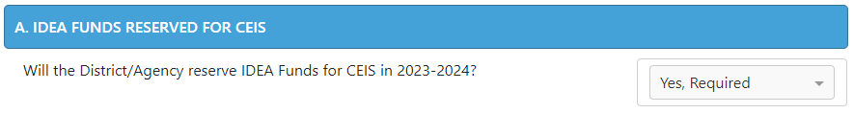
B. Enter the Total amount of IDEA Funds the District/Agency will reserve for CEIS.*
If Voluntary CEIS, this cannot exceed the capped amount shown, which is 15% of your IDEA Funds. The district will need to determine how much of the 15% they will reserve for CEIS.
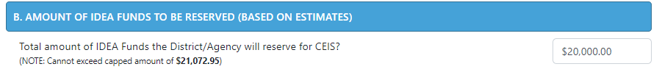
If Required CEIS, the district must expend the entire capped amount shown, which is 15% of your IDEA Funds.
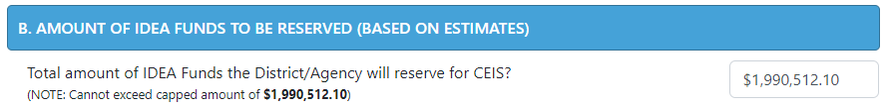
*Note that in the event that your estimated flow-through amount changes, the capped amount will change and your district will need to adjust actual expenditures for CEIS accordingly.
C. Enter information for CEIS Activities Planned.
- Grade levels: Select low grade from dropdown then select high grade from dropdown. This is the grade range that will be the focus of the CEIS Activities planned.
- Group served: Select Group to be served from dropdown. Note if Voluntary, “Students without Disabilities” must be selected. If Required, either can be selected.
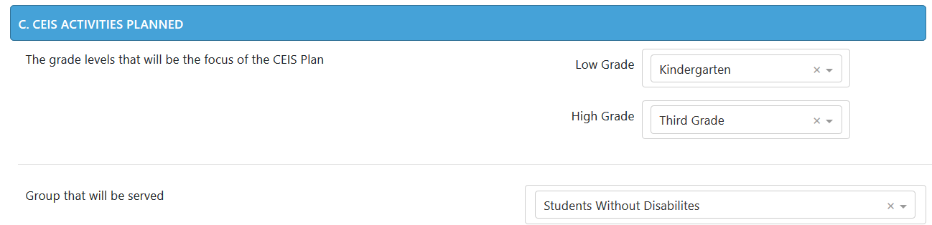
- Select Academic/behavioral area or areas that will be the focus of the CEIS Plan. Note that up to four areas may be selected.
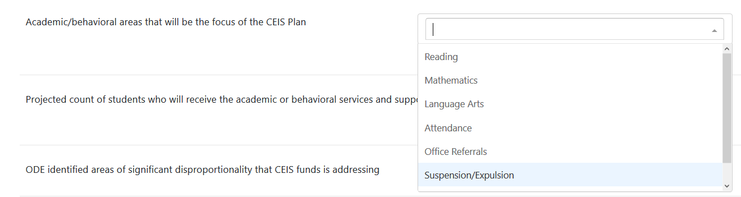
- Enter Projected Count of Students. This is an estimate and not expected to be the exact count of students receiving services and supports. The exact count will be reported next year on the CEIS Data tab.

- Enter Activity Type and Description. You may enter up to five activities. Select the activity type and then provide a general description of the activity. Descriptions should be brief but descriptive enough to convey the activity to be implemented using CEIS funds. Note: If Required CEIS, the activities should relate to identified area(s) of significant disproportionality that CEIS funds is addressing.
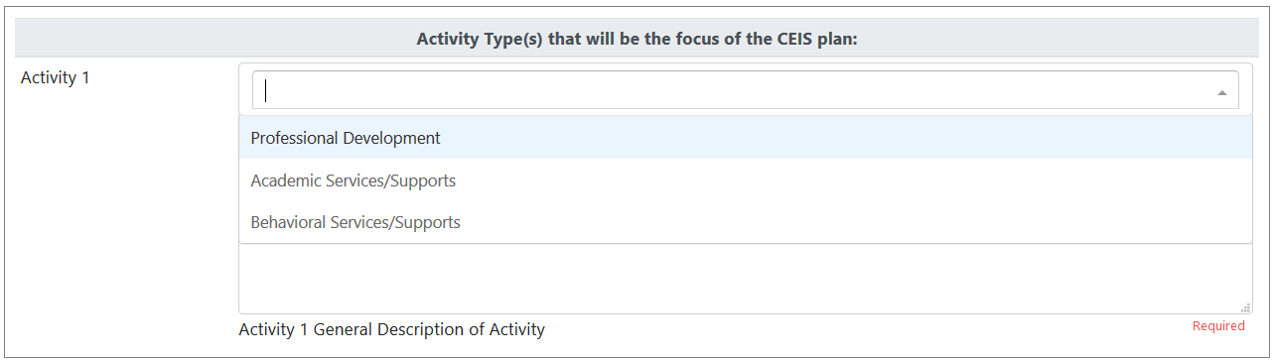
- Click the Save button in the bottom right, and if no errors are displayed in red in the top right, click on the Submit & Verify button.
- Proceed to Step 3. Review

Step 3: Review
Check your responses to all questions on both tabs.
- If no errors, your submission is now complete.
- If errors, correct, then click on the Save and Submit & Verify buttons again.
Printing. Your submission information may be printed by clicking on the Print button.

Contact Information
For further assistance, please contact:
- Cynthia Garton, 503-508-7492 or cynthia.garton@ode.oregon.gov
- Jackie McKim, 971-240-0234 or jackie.mckim@ode.oregon.gov

ODE Help Desk & Data Security and Privacy Overview

Contact Information
ODE Helpdesk ODE.Helpdesk@ode.state.or.us (503) 947-5715

Services
ODE Help Desk can
- Provide technical assistance with how to submit your data
- Check to see if your data has submitted
- Provide assistance with questions about access rights and permissions
ODE Help Desk can not
- Submit your data for you
- Make changes to your data
- Answer content area questions

Help Desk vs. Data Team – who to call?
Question | Answer
How to report a student? | Data Team
Why won’t my data submit? | Data Team (will refer to HelpDesk if needed)
Audit/Error Corrections? | Data Team
How can I get a new user added? | ODE Help Desk

ODE Help Desk: What to Expect
When you call or email ODE Help Desk, the best way to contact the ODE Help Desk is at ODE.helpdesk@state.or.us or (503) 947-5715.

Data Security and Privacy
The student data that you collect, handle, and submit is protected student data governed by:
- Family Educational Rights and Privacy Act (FERPA) (34 CFR Part 99)
- Oregon Identity Theft Protection Act
- And in some cases, the Health Insurance Portability and Accountability Act (HIPAA), such as the transfer of records between agencies
Consequences: Loss of protected data can have financial impact to your school, district, or ESD, including fines and cost of remediation!

Student Data Security: Handle with Care
Basic tips to protect student level data
- Use Secure File Transfer. Never send information that would identify an individual student via email, not even to the ODE Help Desk or a member of the Data Team. Emails sent to and from the ODE are considered public record.
  - In order to provide information to ODE, it is advisable to send only the student’s SSID number
  - Never send student’s name, birth date, telephone number, grade or anything else that could be used to identify a specific student.
  - On ODE’s Secure File Transfer users can send secure documents to ODE Staff.
  - The Consolidated Collections manual has instructions how to send a Secure File Transfer.
- Never share your username and password
  - You are responsible for everything done in the system using your username and password
  - Avoid storing your password in an obvious place (desk drawers, under keyboards, sticky notes on monitors are all bad places to store passwords)
- Use a Passphrase instead of a Password
  - Passphrases are sentences you can remember and include spaces and punctuation.
  - Example: Trust the force, Luke!
  - Example: Scotty, beam us up.
- Lock your computer monitor (Window key +L) when you leave your desk
  - Avoid leaving your monitor open and unattended
- Never store or transport student data on an unencrypted thumb drive/flash drive
  - Portable drives are one of the biggest risk factors for losing large volumes of data
The privacy and security of student data depends upon you.
People are the most important part of information security

ODE Policies
Handling Confidential Information
Information Asset Classification

Information Security Questions
Contact ODE Chief Information Security Officer and Team at ODE.Infosec@ode.state.or.us.

