Enhancing Student Opportunities Data Collections

Private School Data Collection

User Guide
September 2023
OREGON DEPARTMENT OF EDUCATION
Office of Enhancing Student Opportunities
255 Capitol Street NE
Salem, OR 97310-0203

Contents
What’s New 1
September 2023 1
Getting Access for Private School 2
Collection Overview 4
Submission 5
Private School – Enrollment 5
Overview 6
School Information 7
Enrollment Counts 8
Consultation 9
Final Steps 10
Private School – Proportionate Share 11
Overview 11
Section I: Student Population 12
Section II: IDEA Part B 611 Funds (Age 3-21) 13
Section III: IDEA Part B 619 Funds (Age 3-5) 14
Final Steps 15
Review 16
Contact Information 16
ODE Help Desk & Data Security and Privacy Overview 17
Contact Information 17
Services 17
Help Desk vs. Data Team – who to call? 17
ODE Help Desk: What to Expect 17
Data Security and Privacy 18
Student Data Security: Handle with Care 18
ODE Policies 18
Information Security Questions 18

What’s New
Changes for the Private School collection for 2023-2024.

September 2023
- The Proportionate Share Screen changes:
  - Only the carryover fund fields will be edited for districts. All other fields are locked.
- No changes to the Private School Enrollment Screen.
- Added sections for ODE HelpDesk/Data Security/Privacy.

Getting Access for Private School
The Private School Data, or Parentally Placed Private School (3PS) Data collection is accessed within the IDEA Data Manager. If you do not already have access, please contact your district’s Security Administrator.
If you do not know who your District Security Administrator is, go to the District Home page, and on the right-hand side beneath QUICK LINKS, click Find Security Administrator.
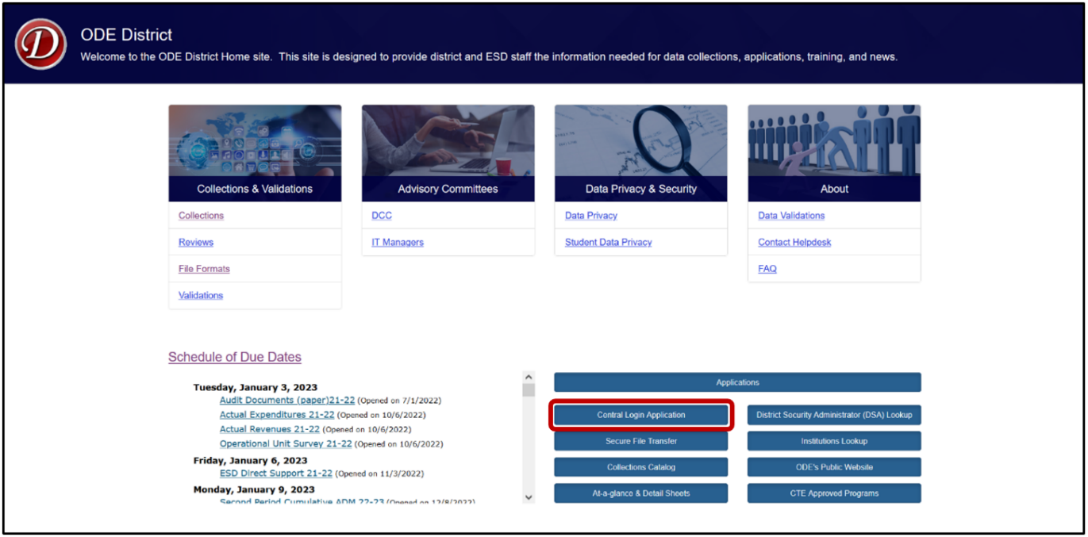
On the Search for Security Administrator page, follow the instructions on the screen.
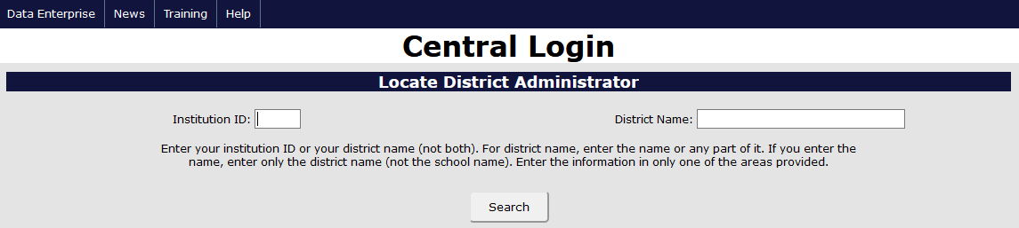
When requesting access to applications such as collections or the IDEA Data Manager, data submitters must request Primary and Modify rights. Users should verify with their District Security Administrator that they have both permissions. Without both, users will not have the ability view, edit, save and submit/verify their data.
Once logged into the District website, select IDEA Data Manager in the Applications List.
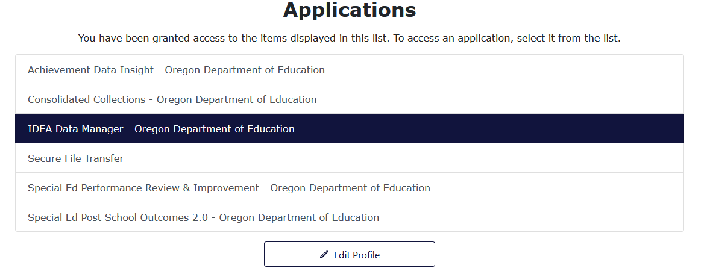
Once in the IDEA Data Manger, select Private Schools in the Left Navigation Menu. From there, select Private Schools – Enrollment or Private Schools – Proportionate Share.
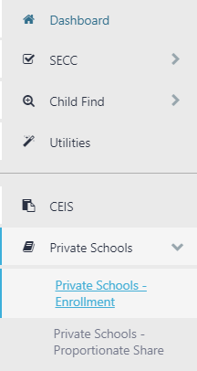

Collection Overview
All districts must complete, submit and verify a submission for the Private School Data (Parent Placed Private School Data or 3PS) Collection. The Private School collection contains two separate menus:
Menu 1. Private Schools – Enrollment. Data entry for the current school year.
Menu 2. Private Schools – Proportionate Share. Review of average allocation and total proportionate share for the current school year.
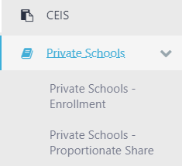
For both Enrollment and Proportionate Share screens, the current collection year will be defaulted to Not Yet Submitted.
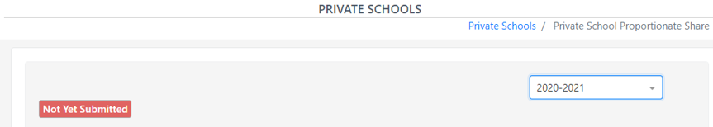
To see prior year data, use the School Year drop menu on the top right. Click the drop arrow to expand the menu.
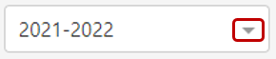
After clicking the arrow, the drop menu will display the prior years available to view. These prior year screens are view only and are not editable as the collection windows are closed.
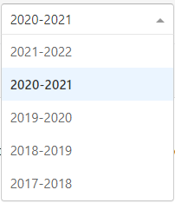

Submission

Private School – Enrollment
This menu collects information concerning Parent Placed Private School enrollment and consultation for the current school year. Enrollment is an annual snapshot of total parent placed private school students as of October 1. Consultation is held with both private school representatives and parent representatives of parent placed private school children ages 3-21 with disabilities.
The Private Schools – Enrollment menu will first ask if the district has private school(s) within its boundaries. All districts are expected to answer this question.
This screen will default based on how districts answered the prior year, and will roll this response year to year.
- If No, click the Save button in the bottom right, then the Submit & Verify button. Proceed to menu 2, Private Schools – Proportionate Share.
- If Yes, enter information regarding the private schools, consultation, and enrollment counts before clicking the Save and Submit & Verify buttons. Then proceed to menu 2.
The data entry screen is hidden when No is selected, and is not hidden when Yes is selected. If changing selection to Yes, the data entry screen will appear.

Overview
The Private School – Enrollment data entry screen contains fields for school information, enrollment counts, age range totals, a total school enrollment, and consultation process. This screen will default a school list based on what districts provided the prior year, and school information will roll year to year.
Enrollment is a snapshot of October 1 of all parent placed students ages 3-21 (not just special education students) in private schools located in the district’s boundaries. Include enrollments for Pre-Kindergarten (ages 3-5), Kindergarten (age 5), and ages 6-21 Note that schools for 3-4 year olds must be in combination with any elementary grades, K-8.
Do not include specialized facilities such as corrections or detentions, long term care or treatment, hospitals, state schools, public alternative schools, or public charter schools. Do not include district placed students.
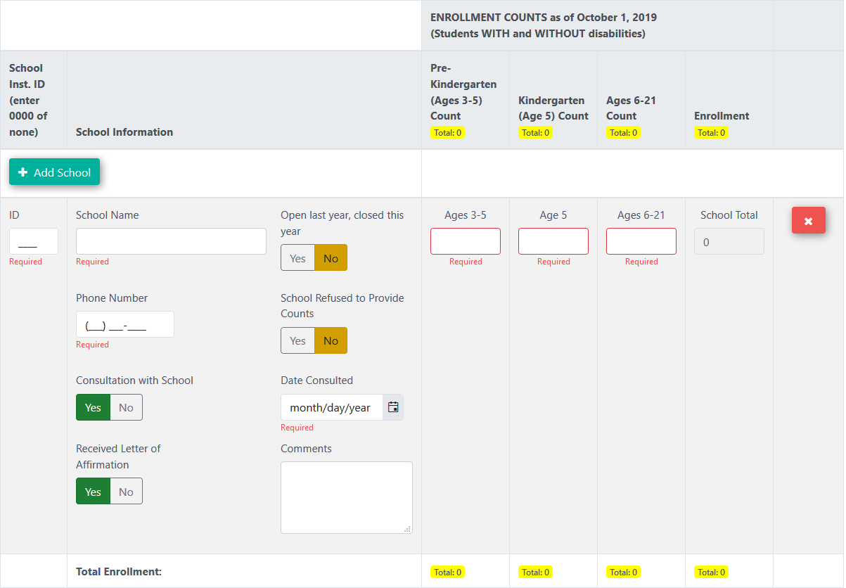

The Enrollment and Consultation header for the data entry screen contains column titles for School ID, School Information, Enrollment counts by age group and a total enrollment. As private school enrollment counts are entered, a count of total enrollment will populate in this header.
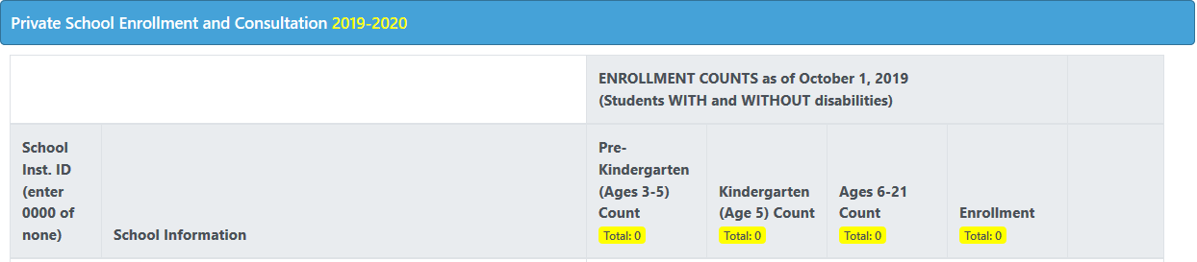

School Information
If a school is not listed, or a new school opens within the district boundaries, click the Add School button. This will add the new school to the list.
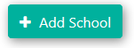
There are three required school information fields: ID, Name and Phone.
- ID: private schools that are registered or approved will have an Institution ID number. If there is no number, enter four zeros (0000).
- School Name: the private school name.
- Phone Number: the private school’s telephone number.
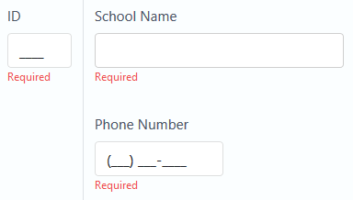
If a school closed during the prior school year, use the “Open Last year, closed this year” flag. The default is set to No. When the Yes flag is selected, the school will not roll the following collection year.
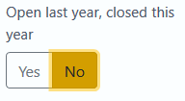
When Yes is selected, data entry fields become hidden, except for ID, School Name and Comments.
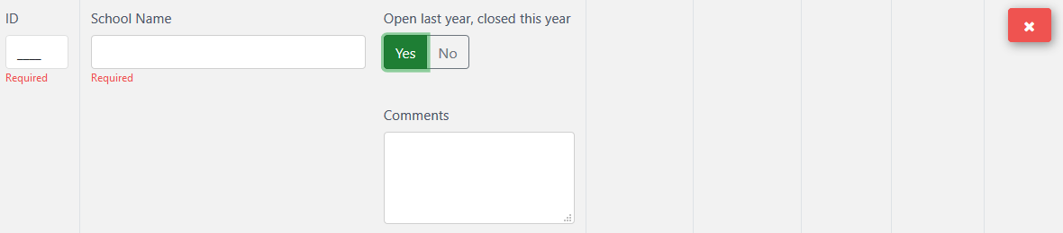

Enrollment Counts
If a school refuses to provide enrollment counts, users can use the “School Refused to Provide Counts” flag. The default is set to No.
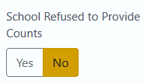
When Yes is selected, the enrollment fields become hidden.
There are three required fields to enter enrollment counts: Pre-Kindergarten (Ages 3-5), Kindergarten (Age 5), and Ages 6-21. Enter the enrollment counts of parent placed students in the district boundaries.
- Enter the total enrollment of the private school as of October 1 (students with and without disabilities).
- Include enrollments for Pre-Kindergarten (ages 3-5), Kindergarten (age 5), and ages 6-21.
  - Schools for 3-4 year olds must be in combination with any elementary grades, K-8. OAR 581-015-2475 through 581-015-2483.
- If the count is zero for any field, enter zero (0).
- Exclude any students placed in a private school by public school districts.
- If a school is missing from the list or a new school opened in the last year, use the New School button to add the school.
- If a school refuses to provide and enrollment count, change the “School Refused to Provide Counts” selection to Yes.
The data screen provides a School Total field, which calculates that school’s total enrollment, based on counts entered in the three required enrollment fields.
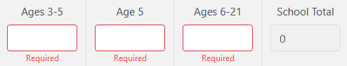
If users need to remove a school due to inaccurate information or testing the data entry fields, there is a delete button. Do not use for closed schools. If a school has closed, change the “Open last year, closed this year” selection to Yes.
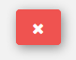
When clicked, a warning message will appear. Click Delete School to remove the school from the list, or Cancel to back out.
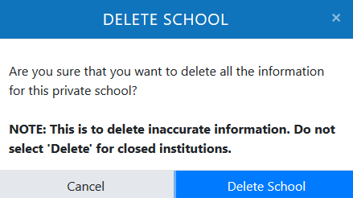

Consultation
The Consultation with School flag is to indicate if a consultation meeting was held with the private school. This flag does not have a default selection. It is a required field and users must select either Yes or No.
The district is required to consult with both private school representatives and parent representatives of parent placed private school children ages 3-21 with disabilities. Topics include, but are not limited to the Child Find process, determination of the Proportionate Share of federal IDEA funds, and special education and related services provided.
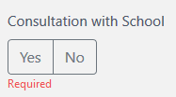
Participation in consultation and affirmation processes applies only to non-profit private schools, including religious schools, that meet the state’s definition of an elementary or secondary school. P-K schools (3-5) must be in a combination with any elementary grades (K-8).
If No is selected, users may move on to the next school in the list. If on the last school, click the Save and Submit & Verify buttons.
If Yes is selected, additional required consultation fields will appear.
- Date Consulted: the date consulted with the private school.
- Received Letter of Affirmation flag: if the school submitted a signed letter to the district regarding the consultation and the determined services for the school year.
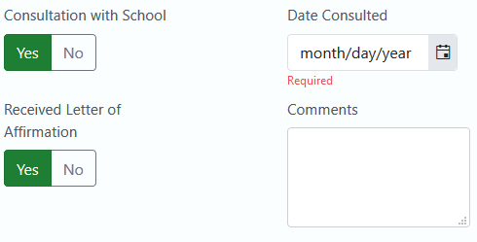

Final Steps
The data entry screen also includes an optional comment field, for any comment the district would like to provide.
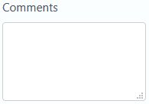
As with the Enrollment screen header, a count of total enrollment will populate in the screen’s footer, as the private school enrollment counts are entered.
Click the Save button in the bottom right, and if no errors are displayed in red in the top right, click the Submit & Verify button.

Private School – Proportionate Share
This menu shows funds to expend for the current school year. Child Count data, IDEA Part B Flow Through Funds and the calculations for average allocation and total proportionate share are displayed for districts to review. This screen will load the estimates and calculations annually. During the main collection window, the IDEA Flow-Through Estimates will be displayed.
The Private School – Proportionate Share menu allows districts without private schools and those with no eligible parent placed students to view the average allocation per child. This will give an idea of what districts would expend per student, if a private school were to open or a child be found eligible for special education.
All districts with private schools should review this menu. While clicking the Save and Submit & Verify buttons is not required, all the buttons are still active.

Overview
The Private School – Proportionate Share screen contains three sections: student population as submitted on the Special Education Child Count; average allocation and total proportionate share of 611 funds; and average allocation and total proportionate of 619 funds.
This menu screen displays Child Count data based on the district’s submission the prior collection year. The data is a snapshot of special education students as of December 1. This screen also displays the IDEA Part B Flow Through Estimates. This amount is the total LEA gross amount before adjustments are made. The Child Count data and IDEA Funds are used to calculate the allocation per eligible student and/or total proportionate share of federal IDEA funds available to serve parent placed private school children. The application will recalculate proportionate share and average allocation for the review window.
Proportionate share tells a district, private schools officials, and parents how much of the IDEA Part B funds that must be expended in the current school year to provide equitable special education and related services for eligible parent placed private school children.

Section I: Student Population
The student population is used with the IDEA Funds to calculate funding for parent placed special education students.
This section will display what the district submitted on the prior year’s Child Count Collection, broken down into two areas: Ages 3-5 and Ages 6-21.
Age 3-5 will display:
- Total Age 3-5 Special Education Parentally Placed Private School Count (served and not served)
  - Pre-K Age 3-5 (ECSE)
  - Kindergarten Age 5
- Total Age 3-5 December Special Education Child Count (SECC) Enrolled in Public School
  - Pre-K Age 3-5 (ECSE)
  - Kindergarten Age 5
Age 6-21 will display:
- Total Age 6-21 Special Education Parentally Placed Private School Count (served and not served)
- Total Age 6-21 December Special Education Child Count (SECC) Enrolled in Public School
In this section, the fields appear gray because they are locked. Counts included in Sections A and B only include students with disabilities.
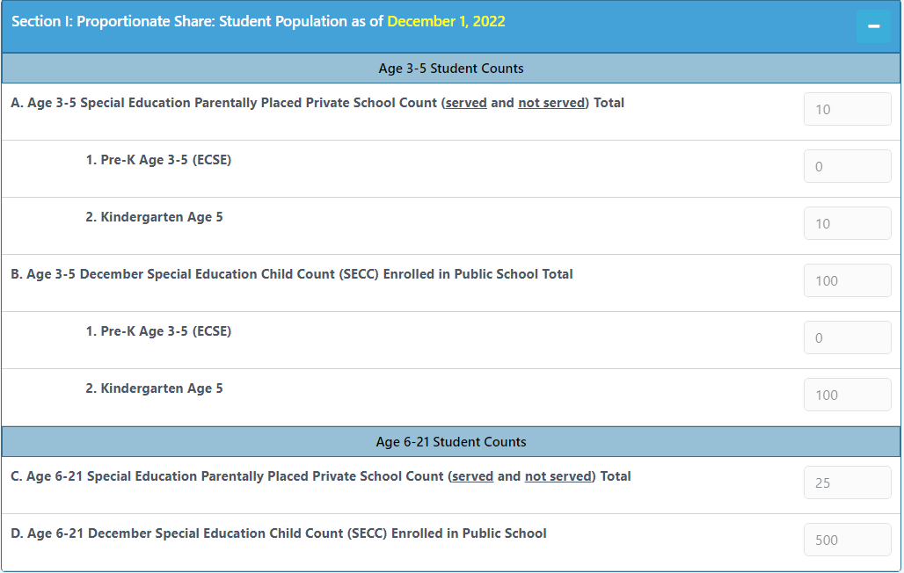
If a district needs to make edits, contact the data team.

Section II: IDEA Part B 611 Funds (Age 3-21)
The IDEA Funds are used with the student population to calculate funding for parent placed special education students.
This section will display current year IDEA Funds and prior year’s Child Count:
- Unexpended Part 611 Funds - Prior Year Carry Over from prior year
- Total Federal Gross IDEA Part B 611 Funds for current year
- Total Eligible Public & Private Ages 3-21
- Average 611 Allocation per Eligible Child (Public & Private)
- Total Current Year 611 to be expended on Parentally Placed Private Ages 3-21
- Total 611 Proportionate Share Funds to Expend (Age 3-21)
In this section, all but one of the fields appear gray because they are locked. The IDEA Funds and calculation fields are not open for editing. The only field open for editing is the Unexpected 611 Prior Year Carry over field.
Field E is the total 611 (proportionate share) funds before any carryover is entered into Field A, and Field F is the total 611 proportionate share funds after carryover is entered. If there is no carryover from the prior year, these fields will display the same information.
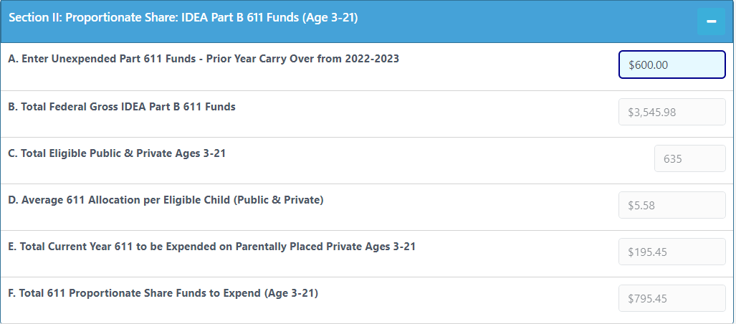
If a district needs to enter carryover funds from the prior year, this screen will re-calculate the Total Proportionate Share (Field F) for Section II.
Reminder! This section is for review. The only field that is editable is the Prior Year Carryover.

Section III: IDEA Part B 619 Funds (Age 3-5)
The IDEA Funds are used with the student population to calculate funding for parent placed special education students.
This section will display current year Estimates and prior year’s Child Count:
- Unexpended Part 619 Funds - Prior Year Carry Over from prior year
- Total Federal Gross IDEA Part B 619 Funds for current year
- Total Eligible Public & Private Ages 3-5
- Average 619 Allocation per Eligible Child (Public & Private)
- Total Current Year 619 to be expended on Parentally Placed Private Ages 3-5
- Total 611 Proportionate Share Funds to Expend (Age 3-5)
In this section, all but one of the fields appear gray because they are locked. The IDEA Funds and calculation fields are not open for editing. The only field open for editing is the Unexpected 619 Prior Year Carry over field.
Field E is the total 619 (proportionate share) funds before any carryover is entered into Field A, and Field F is the total 619 proportionate share funds after carryover is entered. If there is no carryover from the prior year, these fields will display the same information.
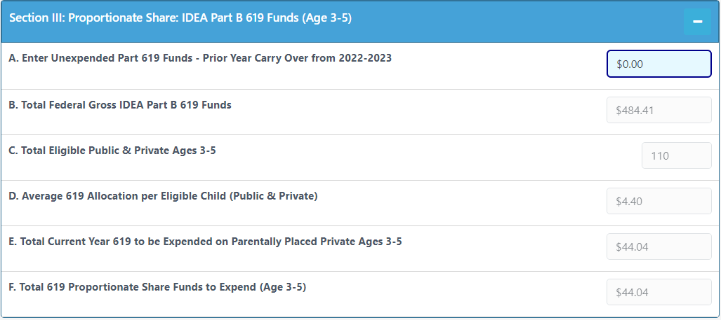
If a district needs to enter carryover funds from the prior year, this screen will re-calculate the Total Proportionate Share (Field F) for Section III.
Reminder! This section is for review. The only field that is editable is the Prior Year Carryover.

Final Steps
If making changes, click the Save button in the bottom right. There should be no errors displayed in red in the top right. If not making changes, no action is needed.
Optional: Click the Submit & Verify button. Districts are not required to submit and verify Proportionate Share. However, as required by 34 C.F.R. § 300.134(b), the consultation process must include a determination of the proportionate share of Federal funds available to serve parentally-placed private school children with disabilities, including how the proportionate share of funds is calculated.

Review
Check your responses to all questions on both menus.
- If no errors, your submission is now complete. If desired, click the Save and Submit & Verify buttons.
- If errors, correct, then click the Save and if desired, Submit & Verify buttons.
Your submission information may be printed by clicking on the Print button. This is located on both menus.

Contact Information
For further assistance, please contact Cynthia Garton at 503-508-7492 or cynthia.garton@ode.oregon.gov.

ODE Help Desk & Data Security and Privacy Overview

Contact Information
ODE Helpdesk ODE.Helpdesk@ode.state.or.us (503) 947-5715

Services
ODE Help Desk can
- Provide technical assistance with how to submit your data
- Check to see if your data has submitted
- Provide assistance with questions about access rights and permissions
ODE Help Desk can not
- Submit your data for you
- Make changes to your data
- Answer content area questions

Help Desk vs. Data Team – who to call?
Question | Answer
How to report a student? | Data Team
Why won’t my data submit? | Data Team (will refer to HelpDesk if needed)
Audit/Error Corrections? | Data Team
How can I get a new user added? | ODE Help Desk

ODE Help Desk: What to Expect
When you call or email ODE Help Desk, the best way to contact the ODE Help Desk is at ODE.helpdesk@state.or.us or (503) 947-5715.

Data Security and Privacy
The student data that you collect, handle, and submit is protected student data governed by:
- Family Educational Rights and Privacy Act (FERPA) (34 CFR Part 99)
- Oregon Identity Theft Protection Act
- And in some cases, the Health Insurance Portability and Accountability Act (HIPAA), such as the transfer of records between agencies
Consequences: Loss of protected data can have financial impact to your school, district, or ESD, including fines and cost of remediation!

Student Data Security: Handle with Care
Basic tips to protect student level data
- Use Secure File Transfer. Never send information that would identify an individual student via email, not even to the ODE Help Desk or a member of the Data Team. Emails sent to and from the ODE are considered public record.
  - In order to provide information to ODE, it is advisable to send only the student’s SSID number
  - Never send student’s name, birth date, telephone number, grade or anything else that could be used to identify a specific student.
  - On ODE’s Secure File Transfer users can send secure documents to ODE Staff.
  - The Consolidated Collections manual has instructions how to send a Secure File Transfer.
- Never share your username and password
  - You are responsible for everything done in the system using your username and password
  - Avoid storing your password in an obvious place (desk drawers, under keyboards, sticky notes on monitors are all bad places to store passwords)
- Use a Passphrase instead of a Password
  - Passphrases are sentences you can remember and include spaces and punctuation.
  - Example: Trust the force, Luke!
  - Example: Scotty, beam us up.
- Lock your computer monitor (Window key +L) when you leave your desk
  - Avoid leaving your monitor open and unattended
- Never store or transport student data on an unencrypted thumb drive/flash drive
  - Portable drives are one of the biggest risk factors for losing large volumes of data
The privacy and security of student data depends upon you.
People are the most important part of information security

ODE Policies
Handling Confidential Information
Information Asset Classification

Information Security Questions
Contact ODE Chief Information Security Officer and Team at ODE.Infosec@ode.state.or.us.

OAR 581-015-2475 through 581-015-2483

