How to Access SECC Regional Reports
- Login on the district home page site https://district.ode.state.or.us/home/.
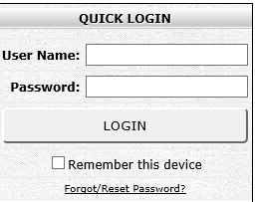
- An Applications list will appear on the next page. Click on Consolidated Collections.
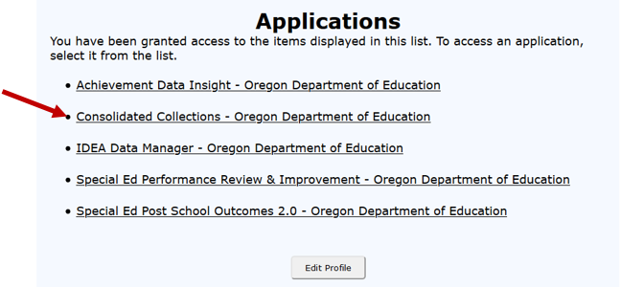
- Select Reports tab, located next to Status Tracking tab.
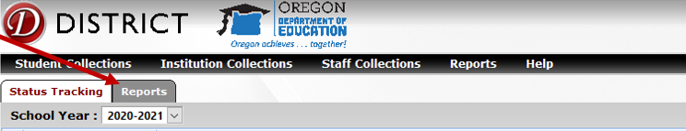
- From the Collection menu, select “Special Education Child Census (SECC).”
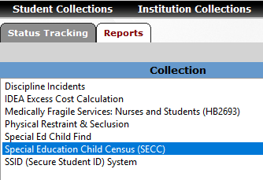
- In the Report Year menu that appears below or to the right, select the DecSECC Report from the collection year needed.
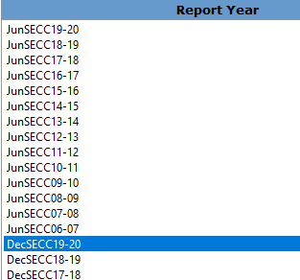
- In the Report menu that appears below or to right, select “Regional Report - Detail” or you can choose “Regional Report – Summary.”
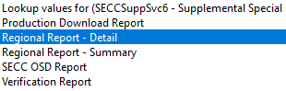
- A pop-up will appear with the appropriate report, identifying the year requested. This report can be exported to Excel or PDF if desired.
If you need assistance with this process, call anyone in the Data Team:
- Jackie McKim, 503-947-5629 or jackie.mckim@state.or.us
- Cynthia Garton, 503-947-5817 or cynthia.garton@state.or.us

