| Oregon Department of Education logo | **State Performance Plan (SPP)**  **Fact Sheet**  **Indicator C11: State Systemic Improvement Plan** | | | |
| --- | --- | --- | --- | --- |
|  | |  |  |  |

# **Oregon State Performance Plan**

Under the Individuals with Disabilities Education Act of 2004 (IDEA), the Oregon Department of Education (ODE) is required to submit a six-year State Performance Plan (SPP) to the Office of Special Education (OSEP). The OSEP has developed key performance measures, known as indicators, to measure both compliance and results. The OSEP sets the targets for compliance indicators and the ODE sets targets for the results indicators. The SPP must include targets for each results indicator. The ODE reports on progress made toward these indicators each year in the Annual Performance Report (APR). Every six years the ODE must review results targets and engage key partners in the development of new targets. Please see the [ODE State Performance Plan and Annual Reports for Special Education webpage](https://www.oregon.gov/ode/reports-and-data/SpEdReports/Pages/State-Performance-Plan-and-Annual-Performance-Report-for-Special-Education.aspx) for more information.Decorative design

# **What does this indicator measure and why is it important?**

A multi-year plan for how the state improves outcomes for children with disabilities served under IDEA, the State Systemic Improvement Plan (SSIP) is a part of the Office of Special Education Programs’ (OSEP) Results Driven Accountability framework and is Indicator 11 of the State Performance Plan. Given Oregon’s unique seamless system of services for birth to five, this Indicator measures improvements for infants, toddlers, and preschoolers being served under IDEA.

The State Identified Measurable Result (SiMR) is to increase the number and percentage of young children who demonstrate progress in social-emotional development, and approaches to learning, otherwise known as Child Outcomes for the State Performance Plan.

Positive Child Outcomes reflect improved social emotional skills, self-regulation, and social-communication skills. These are all essential early learning skills that impact a child’s ability to communicate, learn new concepts, build relationships, regulate their emotions, solve problems, engage in routines and activities across the day, manage frustration, and manage their body’s response to the environment. Supporting the development of these skills also mediates risk for exclusion and isolation of students experiencing disability throughout the lifespan.

# **How is this indicator measured?**

Improvement is measured by examining progress of Summary Area 1 for A and B of Indicator C3 and B7, Child Outcomes. Indicator C3 measures the percentage of infants and toddlers with Individualized Family Service Plans (IFSP) who demonstrate improved:

* A. Positive social-emotional skills (including social relationships);
* B. Acquisition and use of knowledge and skills (including early language/ communication); and
* C. Use of appropriate behaviors to meet their needs. (20 U.S.C. 1416(a)(3)(A) and 1442)

Indicator B7 addresses a Free Appropriate Public Education (FAPE) in the Least Restrictive Environment (LRE) by measuring Percent of preschool children aged 3 through 5 with IEPs who demonstrate improved:

* A. Positive social-emotional skills (including social relationships);
* B. Acquisition and use of knowledge and skills (including early language/ communication and early literacy); and
* C. Use of appropriate behaviors to meet their needs.

The summary Statement 1 captures the percentage of infants, toddlers, and preschoolers who substantially increased their rate of in the area of positive social-emotional skills and in the acquisition and use of knowledge and skills by the time they exited either the EI or ECSE program.

This indicator shows developmental and educational results for infants, toddler, and preschool children in our EI/ECSE programs. These results are tied to Student Success Act funding as individual county EI/ECSE programs use these data to prioritize improvement in selected outcomes.

# **What are the historical targets and how has Oregon performed over time?**

# Oregon's Indicator C3 Data

# Oregon's Indicator C3 Data

Part C (Indicator C3):

| **FFY** | **2015** | **2014** | **2015** | **2016** | **2017** | **2018** | **2019** |
| --- | --- | --- | --- | --- | --- | --- | --- |
| A1 Target ≤ | *Baseline* | 81.40% | 82.00% | 85.40% | 85.40% | 85.40% | 85.40% |
| Data | 84.89% | 81.54% | 84.89% | 85.08% | 84.83% | 85.29% | 85.92% |
|  | | | | | | | |
| B1 Target ≤ | *Baseline* | 64.20% | 64.30% | 66.70% | 66.70% | 66.70% | 66.70% |
| Data | 66.42% | 61.33% | 66.42% | 64.32% | 61.85% | 61.40% | 61.98% |

Indicator B7: A1 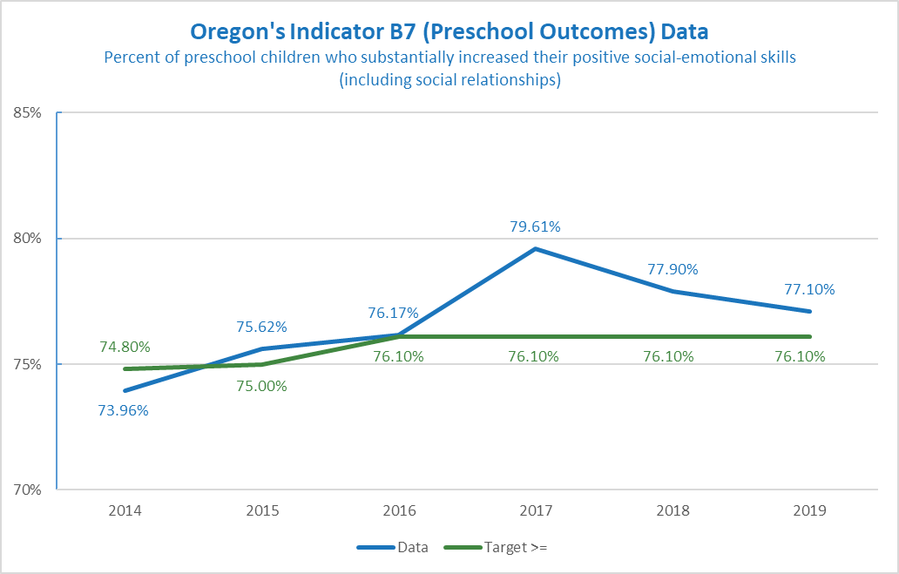

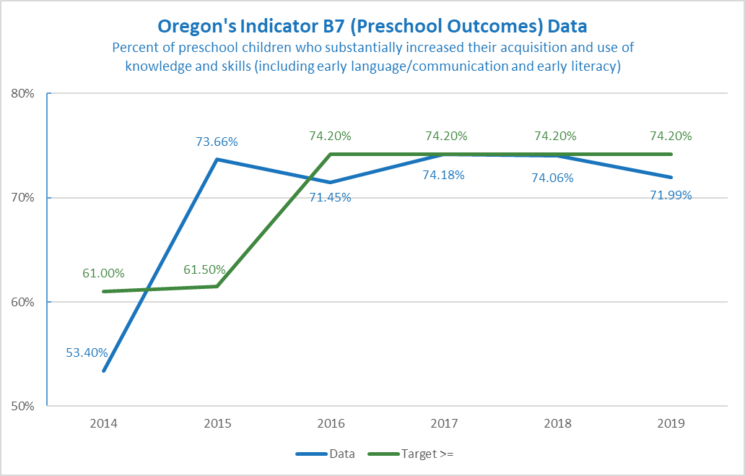

Part B 619 (Indicator B7):

| **FFY** | **2015** | **2014** | **2015** | **2016** | **2017** | **2018** | **2019** |
| --- | --- | --- | --- | --- | --- | --- | --- |
| A1 Target ≤ | *Baseline* | 74.80% | 75.00% | 76.10% | 76.10% | 76.10% | 76.10% |
| Data | 75.62% | 73.96% | 75.62% | 76.17% | 79.61% | 77.90% | 77.10% |
|  | | | | | | | |
| B1 Target ≤ | *Baseline* | 61.00% | 61.50% | 74.20% | 74.20% | 74.20% | 74.20% |
| Data | 73.66% | 53.40% | 73.66% | 71.45% | 74.18% | 74.06% | 71.99% |

# **Does the baseline need to be set or reset for this indicator? If yes, what is the new baseline?**

No, the baseline does not need to be set or reset.

# **What are the new targets?**

The ODE will not set new targets until we hear from our partners. There are several ways to set new targets. It could be a percentage increase, start with the end game in mind, or examine trends over time and make predictions based on trends. Some helpful information about setting targets:

* Targets are meant to support improved results and outcomes for children and families. They should be within reach but still show growth.
* Change takes time. Targets can be created with this understanding in mind. For example, targets may stay the same for several years in a row, and then increase slightly during the final target year (FFY 2025). Or show a slight increase each year.
* The goal for this indicator is to be at or above the target.

**Example A**

| **FFY** | **2020** | **2021** | **2022** | **2023** | **2024** | **2025** |
| --- | --- | --- | --- | --- | --- | --- |
| **Indicator C3** | | | | | | |
| A1 Targets ≥ | 85.40% | 85.50% | 85.50% | 85.60% | 85.60% | 85.70% |
| B1 Targets ≥ | 66.70% | 66.80% | 66.80% | 66.90% | 66.90% | 67.00% |
| **Indicator B7** | | | | | | |
| A1 Targets ≥ | 76.10% | 76.20% | 76.20% | 76.30% | 76.30% | 76.40% |
| B1 Targets ≥ | 74.20% | 74.30% | 74.30% | 74.40% | 74.40% | 74.50% |

Example A shows a gradual increase.

**Example B**

| **FFY** | **2020** | **2021** | **2022** | **2023** | **2024** | **2025** |
| --- | --- | --- | --- | --- | --- | --- |
| **Indicator C3** | | | | | | |
| A1 Targets ≥ | 85.40% | 85.60% | 85.80% | 86.00% | 86.20% | 86.40% |
| B1 Targets ≥ | 66.70% | 67.90% | 68.10% | 68.30% | 68.50% | 68.70% |
| **Indicator B7** | | | | | | |
| A1 Targets ≥ | 76.10% | 76.30% | 76.50% | 76.70% | 76.90% | 77.10% |
| B1 Targets ≥ | 74.20% | 74.40% | 74.60% | 74.80% | 75.00% | 75.20% |

Example B shows more growth.

**If you need more information about this indicator in order to provide input, please contact Meredith Villines, Education Specialist, at** [**meredith.villines@ode.state.or.us**](mailto:meredith.villines@ode.state.or.us)