Overview
Title II, Part A funds are made available on July 1 of the fiscal year and remain available for obligation for a period of 27 months. This 27-month period includes an initial 15-month period of availability and an automatic 12-month extension permitted under the “Tydings Amendment”. “Carryover” is the term often used to refer to funds that have not been spent as originally obligated by the district.

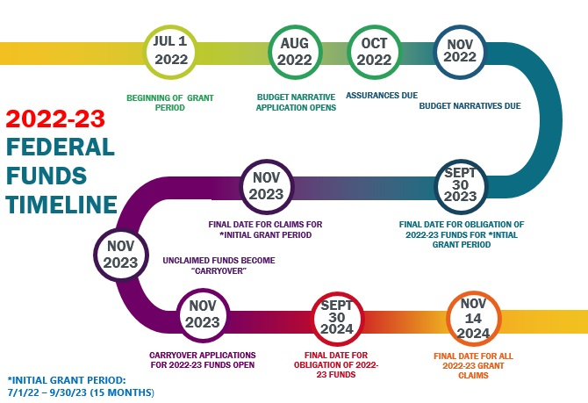
Transferred Funds
A district may choose to transfer funds from Title II-A into another title program during the first 15 months of allocation. However, these funds remain in EGMS under Title II-A and must be claimed from the Title II-A grant. If a district does not claim all the transferred funds by the end of the initial grant period, a Title II-A carryover application will automatically be generated for any remaining funds.

Completing the Application
In mid-November districts have access to the carryover application on the secure district site. Districts may carry over 100% of the remaining funds. These funds must be obligated by September 30th and claimed by November 14th. Carryover requests must include:

- An explanation for why funds were not spent and which activities in the original narrative did not take place. There are many reasons why a district may find themselves with carryover funds available. For example, fewer educators may have participated in a training than was projected.

- A separate line item for each allowable expense. Though these funds were originally received as part of the previous year’s grant, each activity must be associated with a prioritized need identified in the current year’s IIA Needs Assessment. Consequently, the current year’s application must be in process before carryover requests can be reviewed.

- A description of the allowable activities that the district would like to undertake. Carryover activities are subject to the same allowability requirements as those in the original application. In the case of transferred funds, carryover applications must reflect activities aligned with the program into which funds were transferred.
Create a separate line item for each proposed strategy. All strategies included in the Budget Narrative should include:
- The related need from the Needs Assessment (WHY did you choose this strategy);
- A brief description of the strategy/activity (WHAT are the knowledge and skills participants will obtain);
- The type and number of staff involved (WHO is participating); and
- The measure(s) used to determine whether the strategy is generating the results you expect. (HOW will you measure impact)

Revising Approved Carryover Applications
Once a carryover application has been approved, it cannot be withdrawn from the system and resubmitted electronically. If your district needs to revise its approved carryover application, please complete the Carryover Revision Request Form and email Sarah Martin at sarah.martin@ode.oregon.gov.

Private Schools and Equitable Services

Funds allocated for eligible non-public students must be obligated in the fiscal year for which the funds are received (July 1 – September 30 of the following year). Any funds not encumbered by the private school by September 30 will be added to the district’s carryover funds. However, if circumstances beyond the district or private school’s control did not allow for the complete obligation of the proportionate share, the remaining balance must be carried over.

Reminders
- All strategies/activities must meet the USED definition of professional learning as "...high quality, sustained, intensive" (e.g.; what is the frequency; how is the strategy part of a sustained, job-embedded plan for professional learning)
- The percentage of FTE should be included when requesting to fund any staff position as well as the number of staff supported by the position.
- Impact is not restricted to student achievement, and can include impact on educator practice. Evidence of impact could include surveys, educator evaluation data, attendance, behavior, graduation rate, course participation, etc.

Communications regarding Title II-A are provided through this listserv. Please sign up if you wish to receive Title II-A notifications.

