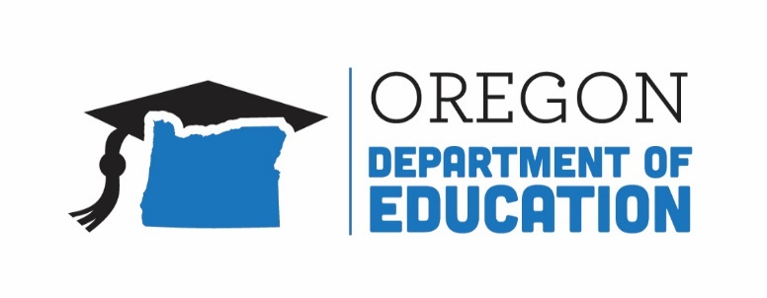
Oregon achieves . . . together!

Title IA Committee of Practitioners (CoPs) Webinar

Wednesday, November 29, 2017
1:30-2:30 PM
ODE Studio A, Salem, OR

Agenda

1:30 PM Welcome & Introductions (Lisa)

1:35 PM Review and Update Bylaws (Lisa)

1:45 PM Private Schools Updates (Russ)

2:00 PM Title IV-A Student Support and Academic Enrichment Grant (Melinda)

2:20 PM Comprehensive Needs Assessment Work (Lisa)

2:25 PM Questions and Additional Agenda Items from Committee

2:30 PM Next Steps (Lisa)
Potential Future Agenda Items
Future Meeting Dates: Wednesday, February 28th at 1:30 PM
Wednesday, May 2nd at 1:30 PM

