Kick Start for New Teacher Mentors

Kick Starting the Mentor- Beginning Teacher Relationship
Participant Guide and Resources

This module is intended to support new beginning teacher mentors in getting started successfully prior to the first full, in-person “Oregon Mentor 101” training.

Kick Starting the Mentor-Mentee Relationship is designed to provide a mindset and guidance for embarking on the mentoring journey with a beginning teacher. It sets the stage for all future meetings and provides useful tools for the mentor. Oregon’s Mentoring 101 trainings will delve deeper into these topics and extend mentor professional learning to other topics that will support mentor development.

The activities are based primarily (with some adaptation) on the online Mentor Modules developed by Caitlin McMunn Dooley, Ph.D., Nick Sauers, Ph.D. and Cassandra Matthews, with funding from the U.S. Department of Education’s Teacher Quality Partnership grant – http://www.mentormodules.com Other materials used are from, or adapted from, Mentoring New Teachers Through Collaborative Coaching: Linking Teacher and Student Learning By Kathy Dunne, Susan Villani

Session Objectives

- Determine important elements for building and maintaining trust.
- Understand the roles and responsibilities of a mentor and how to effectively launch your first meetings with your mentees.
- Familiarize self with Coaching Conversations, the Collaborative Discussion Guide and Mentor Language/Stems.

Overview

- Trust and Relationship Building
- Teacher Identity
- Coaching Language and Techniques

SEASONAL BUDDIES

Make an agreement with four different people. For each season, use the diagram below to record the person with whom you made an
agreement. Only make an agreement if the same season is open on both of your diagrams.
Spring_ _

Winter_ _

Fall___________________

Summer______________

Mentor-Beginning Teacher Relationships

Think-Write-Share

- Take a minute to think about the following prompts.
- Take 2 minutes to write down your thoughts.
- Share out with your table group for 4 minutes.

- What does trust look like and sound like?

- What qualities of yours might help or hinder you in becoming a good mentor?
The Good Mentor, Article Reading with Final Word Protocol

The Final Word Protocol

Useful for short reads, when there is a need for your group to learn from examining research and written materials together.

- Everyone reads the review silently with pen in hand, highlighting and taking notes, then identifies the most significant idea, in their opinion, addressed in the review. (5-10 minutes)
- Sharing Round One (four minutes)

1. One member of the group shares his or her significant idea (a sentence or a passage) but does not elaborate on it.

2. The other participants each have one minute to respond. They can agree or disagree, offer examples, raise a question, contribute details, or otherwise share their thoughts. No one else talks, until it is their turn to respond.

3. Once everyone has responded, the first person who shared has ‘the last word’ by responding and summarizing what she has heard and learned.

- Repeat until everyone has shared and had ‘the last word’.

4. Whole group share out.

Compare Two Videos of First Interactions

As you view these two video clips of the first interactions between beginning teachers and mentors, keep these questions in mind:
- In each video, how does the beginning teacher respond to the mentor’s initial approach?
- Which mentor’s initial approach better supports the building and development of trust? Why?
- What advice would you give to Marcia (in the 2nd video) to help her start out successfully building trust?
- How would you help a beginning teacher become more reflective by identifying areas of strength as well as areas that may need improvement?
- If Marcia had to do it all over again, how should she approach Joan?

After viewing, as a table group, complete a Venn Diagram Poster and be prepared to share out with the whole group.

Graphic Organizer for Comparing 2 Videos
Notes from the First Video: | Notes from the Second Video:

What do the two videos have in common?

First Video:
Second Video:

Hear from the Experts, Seasonal Partners Talk

After viewing Dr. Nancy Dana and Dr. Steven Athanases, talk with your Summer Seasonal Partner about these questions:

- What Does Dr. Dana think are the 3 essential skills?

- What does she say is the 1st step in building a relationship with your new teacher?

- How does she suggest you approach a defensive mentee?

- What does “reading the mentoring situation” mean?

- According to Dr. Athanases, who is the primary client? The ultimate client?

- How can a mentor use observation notes to address both clients?

First Meeting Practice-Triads- How to Build Trust

First meeting Guidelines-Begin to lay the foundation for a trusting relationship:

Share your excitement about your work and the opportunity for growth for both of you.
Get to know each other by asking questions.
Listen openly to needs and concerns
Provide practical assistance, such as
- Arranging the room
- Finalizing rules or procedures
- Getting first week’s lesson plans set
- Cataloging books
- Making sense of start-of-the-year paperwork
- Duplicating materials

Clarify each of your roles and expectations
Provide both assistance and a vision of your instructional mentoring

“Getting to Know You” Tool
First Meeting
Mentor Name:  Date: | Mentee Name:  Time:
Tell me about your background:
What experiences have you had with teachers and students? Describe your student teaching (or first year) experience. What did you learn?

Why do want to be a teacher? Tell me about your teacher preparation program. What other responsibilities, professionally or personally do you have?
Tell me what you have learned (know) about the school? Community?
What would you say are your teaching strengths?
What teaching responsibilities are you concerned about?
What ideas do you have to address these concerns?
Have you created your lesson plans? What can I do to help you during the first few weeks both with instructional needs and managing students?
What would you like to get from our work together in mentoring?
What kind of support from me would you find helpful?
How have you thought about getting to know colleagues? The community? The building itself?
*Tell the mentee a little about yourself and why you agreed to be a mentor. Be positive and optimistic.
Set the stage for a team experience by collaboratively establishing a routine time for you both to share information, questions and concerns.
Talk about the purpose and goals of your district’s mentoring program.
What will be some immediate next steps for each of you?
- Contact info
- Review and sign the Letter of Commitment (if you feel they are ready and are an ODE funded program)
- Determine days, times of meetings, etc.

Teacher Identity

As you view the video clip, think about these questions:

- Leilani has several concerns. As her mentor, where would you begin?
- What would you do to support a beginning teacher who feels confident with subject matter knowledge but needs support with adjusting her lessons to meet students varied developmental levels?
- In addition to classroom management, what other concerns do you think beginning teachers may have?

Article: What New Teachers Really Need

Jot any thoughts, questions.
- What were new teachers 5 top concerns?
- What are some strategies the article suggests for mentors?

The Phases of a First-Year Teacher’s Attitude Toward Teaching

1. Anticipation Phase
Before teachers start their first assignment, they are idealistic, excited, and anxious.

2. Survival Phase
During the first month of school the new teacher is bombarded with a variety of problems and situations that he or she has not anticipated. Besides planning and preparing lessons, the new teacher is responsible for organization tasks like taking lunch counts, announcing PTA fundraising drives, and establishing classroom routines and procedures.

3. Disillusionment Phase
Around November, new teachers begin to question their commitment and their competence. They are faced with Back to School Night, parent conferences, and observations by their principals.
Just when they are running fast to keep pace with varied obligations, they need to run even faster. It is a time of distress. Surviving this phase may be the toughest challenge for new teachers.

4. Rejuvenation Phase
After winter break, new teachers feel rested and rejuvenated. There is a slow rise in their attitudes. They come back with renewed hope and a better understanding of the job. They are relieved that they have survived the first half of the year.

5. Reflection Phase
This is the time new teachers review their curriculum, classroom management, and teaching strategies. It is a “what worked and what will I do differently” stage. The end of the year is approaching, and they start thinking about next year. It is a time of self-analysis.

6. Anticipation “Phase II”
Having experienced their first year of teaching with its successes and challenges and the various accompanying attitudes, new teachers typically end the year with a fresh anticipation and excitement as they look ahead to their next year of teaching.

Figure 1:
The Phases of a First-Year Teacher’s Attitude Toward Teaching
Anticipation

Anticipation II
Survival
Reflection
Rejuvenation
Disillusionment
AUG SEP OCT NOV DEC JAN FEB MAR APR MAY JUN JUL

Note. From “The Stages of a Teacher’s First Year” by E. Moir, 1999, in A Better Beginning: Supporting New Teachers, Marge Scherer (Ed.), Alexandria, VA: Association of Supervision and Curriculum Development. Copyright 1999 by Association for Supervision and Curriculum Development. Adapted with permission.

Mentoring New Teachers Through Collaborative Coaching: Facilitation and Training Guide
Triads

Discuss the following:
- Do you recall going through these Phases?
- How did you get through them?
- Why is support the first weeks and months of school so important?
- What can mentors do to help beginning teachers develop positive professional identities?
- How do the concerns of beginning teachers differ from those of experienced teachers?
- Think back to your first year of teaching and some of the feelings you experienced. What advice would you give to a new teacher who confides in you that she feels like she doesn’t know what she is doing?
Thank your group and return to seats.

Reflection

How might mentoring conversations facilitate growth in beginning teachers’ instructional practice?

Coaching Cycle Video

After viewing video dialogue in your Table Group:
- What did you notice about the coaching (mentoring) cycle?
- How did the mentor, Diane, decide what data to collect?
- What did you notice about the Elana’s biases? How did Diane address Elana’s bias?
- Elana struggles between “maintaining high expectations” and “looking at the data”–data which may or may not evidence exceptional learning. How can you help a beginning teacher achieve this balance between expectations and attending to data?
- What did you notice about the end of the post-observation conference? What is the mentor’s role here?
Your Group’s biggest “Take Away?” Share out with whole group.

Roles and Stances for Mentoring: 3 Cs

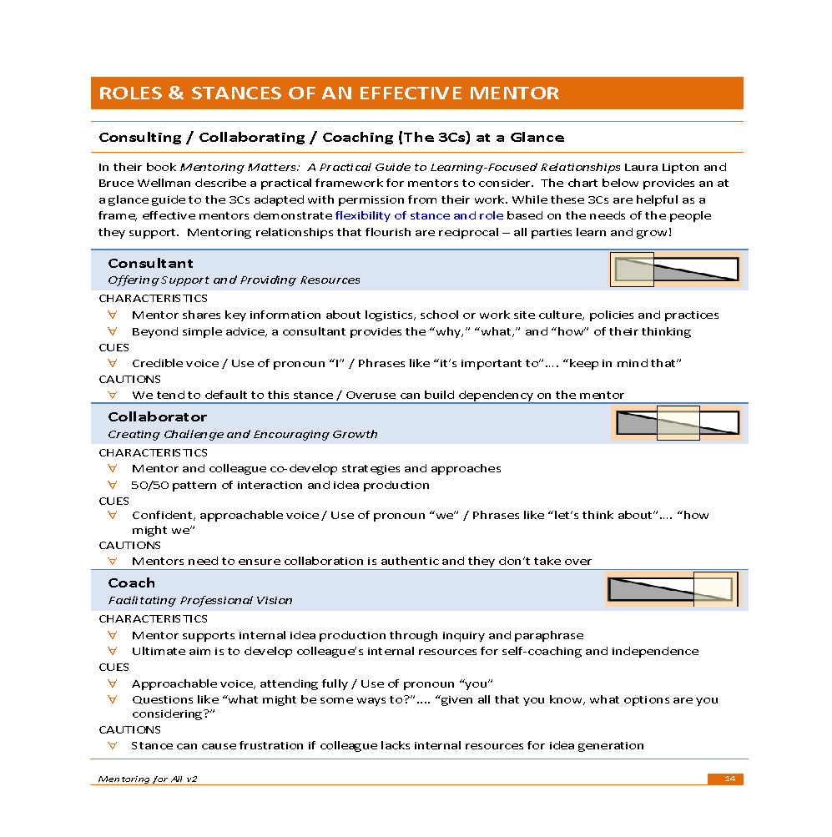

10 Strategies for Collecting Data When Observing

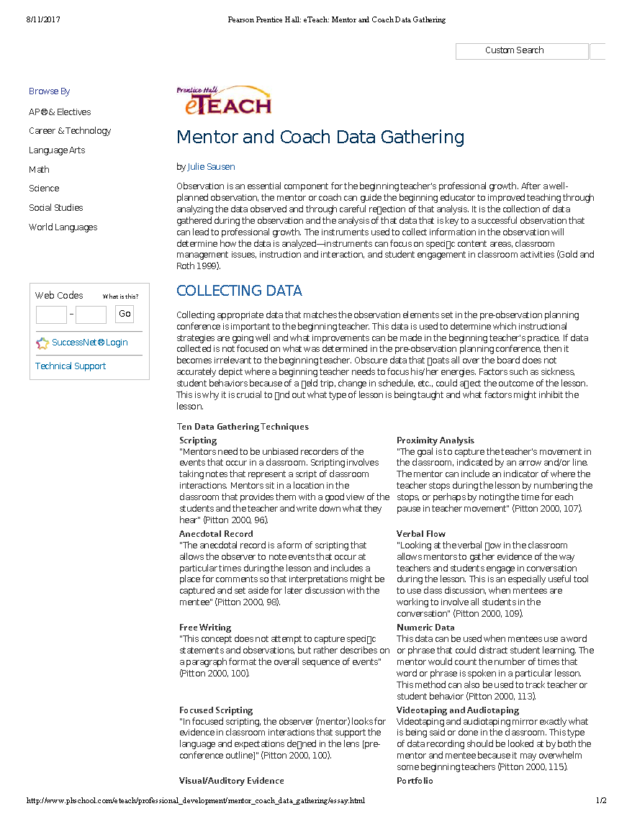
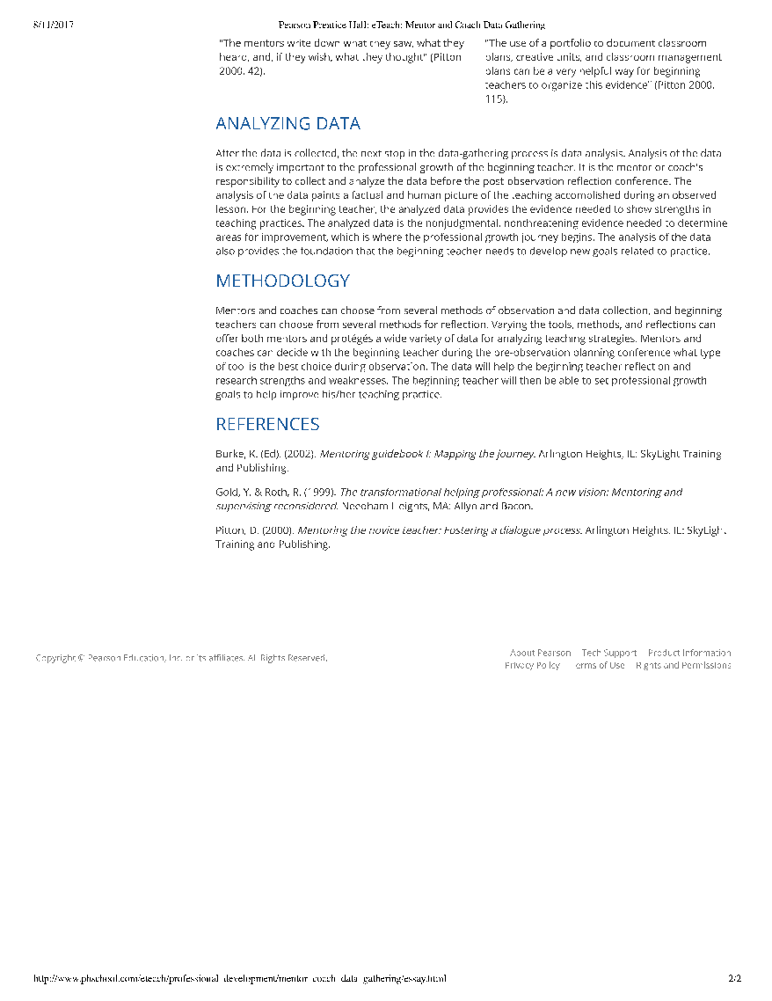

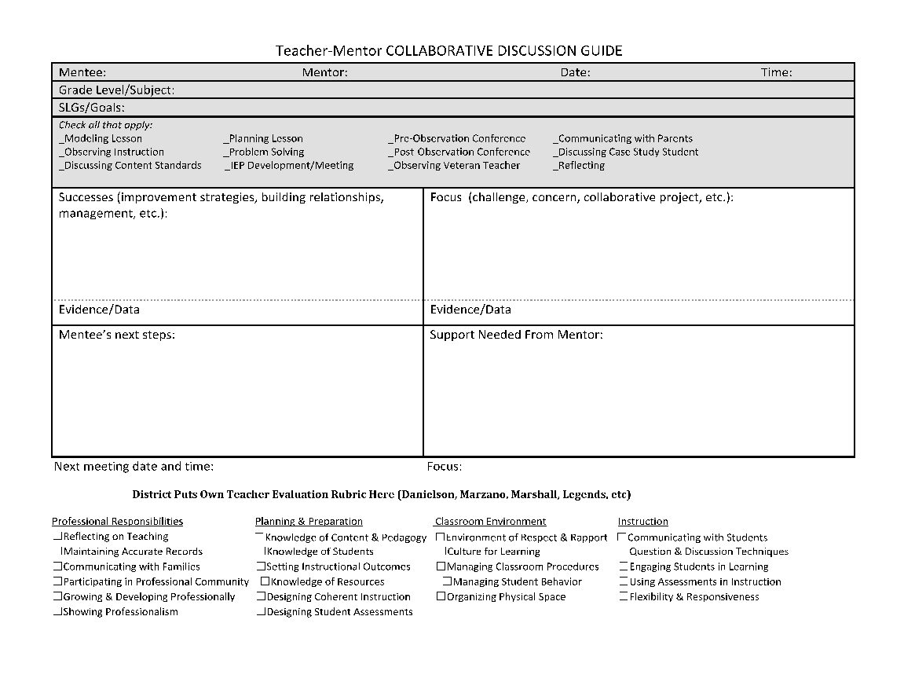
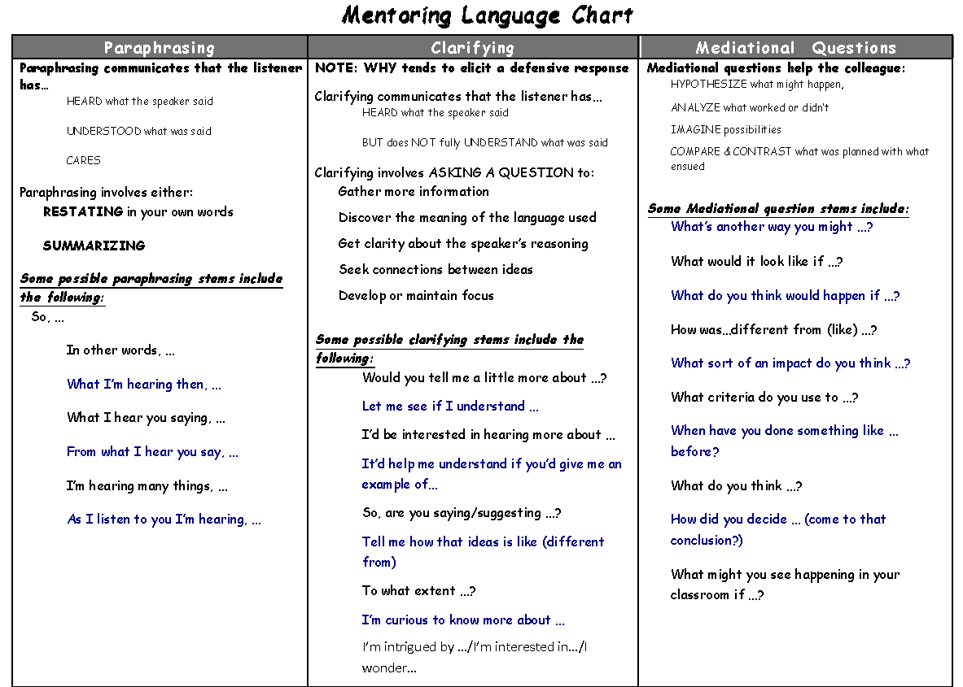
Suggestions | Teachable Moments | Non-Judgmental Responses
“OPEN” suggestions…  Are expressed with invitational, positive language and voice tone  Offer choices to encourage ownership  Are often expressed as a question (or include a “tag question”) to invite further thinking  Are achievable: enough to encourage, but not to overwhelm  May provide information about the mentor’s thinking and decision-making  Suggestion Stems:  One thing I’ve learned/noticed is …  A couple of things to keep in mind …  From our experience, one thing we’ve noticed  Several/some teachers I know have tried a  couple of different things in this sort of  situation and maybe one might work for you  What I know about _______________ is …  Something/some things to keep in mind when  dealing with…  Something you might consider trying is …  There are a number of approaches …  Sometimes it’s helpful if …  Try following suggestion with a question that invites the teacher to imagine/hypothesize how the idea might work in his/her context.  How might this look in your classroom?  To what extent might that work in your situation/with your students?  What do you imagine might happen if you were to try something like that with your class?  Which of these ideas might work best in your classroom? | Teachable moments are spontaneous opportunities that offer the mentor a chance to:  Fill in instructional gaps  Help the teacher make good choices/decisions  Help the teacher to take “the next step”  When taking advantage of a teachable moment, it’s important to:  Share in the spirit of support  Be brief: focus on the essential  Be strategic  Avoid using jargon or sounding pedantic (not talking down to them)  Some possible stems include the following:  One thing to keep in mind is …  If you’re interested in _____, it’s important to …  What I know about ______ is …  It’s sometimes/usually helpful to _____ when … | Non-Judgmental Responses help to:  Build trust  Promote an internal locus of control  Encourage self-assessment  Develop beginning teacher autonomy  Foster risk-taking  Possible examples:  Identify what worked and why  I noticed how when you _____ the students really _____  Encourage  It sounds like you have a number of ideas to try out! It’ll be exciting/interesting/great to see which works best for you!  Ask the teacher to self-assess  How do you think the lesson went and why?  Ask the teacher to identify her/his role  What did you do to make the lesson so successful?  Listen  Ask sincere questions  Show enthusiasm for and interest in the teacher’s work and thinking  I’m interested in learning/hearing more about …  I’m really looking forward to …  DANGER: Too much praise is detrimental

Practicing Mentoring Conversations: INSTRUCTIONS

Form Triads (groups of 3)

1. Assume the following roles:
∙ Beginning Teacher: Chooses a scenario to start the conversation (who are you? 5th grade teacher? High school Science? Special Ed?)
∙ Mentor
- Use the CDG and the Mentoring Conversation Guide (next page) to guide the conversation.
- Things to consider:
1) Mentor Language (in packet)
2) The 3 Cs Mentoring Stance Framework (previous
page)
3) Does the BT provide a verbal or non-verbal entry
point for you to offer to come in his/her classroom
and collect data?
∙ Observer
- Record language you hear the mentor use that builds trust, establishes a focus, supports the BT’s movement forward.
- The mentor may stop the conversation and use the observer as a resource for possible next steps.

2. You will have 10 minutes for the practice conversation.
3. You will have 5 minutes to debrief the practice conversation, led by the observer.

Mentoring Conversation Guide

Mentor: Observer:
Steps | Mentoring Language Heard by Observer
1. Begin the Conversation and assess teacher needs
o Make connections with the mentee and build trust
o Seek to understand the mentee’s successes and challenges in general
2. Establish a focus for the session
a. Understand the new teacher’s problem (listen, paraphrase, ask clarifying questions
b. Assess the new teacher’s needs and move into the appropriate mentor role. (3Cs)
c. Use clarifying questions to separate what is factual from what is interpretation (e.g. “These students don’t listen” becomes “fact” when the fact is that a certain percentage of the students don’t listen X amount of the time.)
3. Support the BT’s movement forward by
a. Reflective listening
b. Mediational questions
4. Promote accountability by
a. Identifying the specific next steps
b. Agreeing to a follow-up meeting

Reflections on Coaching Cycle Components

*Optional if time allows
Share out :

- If a beginning teacher lacks ideas, asks for help or doesn’t recognize the problem, which mentoring stance would you take? What are some possible actions you can take to support her?
- During a pre-observation conference, your mentee asks you to help her with pacing her lessons. What kinds of data collection techniques might you suggest to address this goal?
- Imagine your mentee makes the following statement about a student during your post-observation conference: “Meghan comes from a very affluent home, so I expected her to come up with many connections to the text. My English learners, however, always have trouble with text connections and that’s really frustrating.” How would you respond? How would you support this beginning teacher in reframing her thinking?

Final Reflection Prompt

Summarize new learning and reflect on next steps. Jot down responses to prompts below. Then, turn and talk to neighbor.
What are my 2-3 key “takeaways” from today’s session?
What are my next steps in preparing for my first meeting with my mentee?
What ongoing support will I need in this role?

