Mentor Observation Tool
Class Traffic
The observer tracks the movement of the teacher around the classroom and identifies (by numbering the interactions) which students or groups the teacher interacts with.
Teacher: ____________________________ Mentor:__________________________________
Area of Instruction: _________________ Standard:___________________________________
Observation Focus: _____________________________________________________________
- Individualized instruction
- Teacher connection to students throughout a lesson
- Teacher proximity to students
- Student behavior

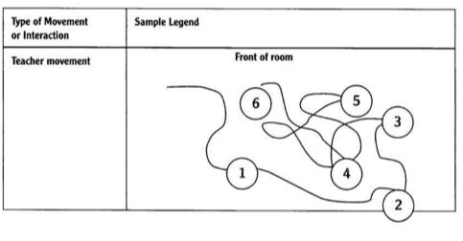
Ask teacher to be observed for a seating chart prior to this observation.
