Collaborative Discussion Guide Tool: Guidelines for Use

The Collaborative Discussion Guide is a tool used to guide reflective, learning focused conversations. These conversations are based on models of Cognitive Coaching from Costa and Garmston, Collaborative Coaching from West Ed, and Appreciative Inquiry from https://appreciativeinquiry.champlain.edu/ as adapted by TeachOntario Canada in Mentoring for All.

Appreciative Inquiry (AI) is an “attributes-based” approach that can be used to facilitate reflective conversations either during formal professional learning sessions or as part of the ongoing dialogue between mentors and colleagues. At the core of AI is the belief that all participants come to mentoring relationships possessing many strengths and that by building on these assets, the answers to the issues and challenges they face can be collaboratively constructed.

This thinking is why the CDG Tool always begins with an examination of what is working well in current practice (themes of success). Many of these themes can then be applied as actual strategies to collaboratively address specific challenges and issues.

Before the Conversation
Remember that the mentor should be the one using the tool, filling it out while the beginning teacher has the freedom to think and share. Be sure you are listening well as you document the beginning teacher’s thoughts, ideas, questions, needs in each of the 4 boxes. Remember to use your Mentor Language Stems to help guide your conversation.

Beginning the Conversation: Themes of Success Successes: What’s already working well?

Often in our practice we can focus on what is not working –creating time for paired conversations about what is working well can help bring to the fore the strengths and attributes of both new colleagues and mentors as well as highlighting the successes they’ve experienced in the
year. Following this segment of the conversation, mentors may note common threads or themes that ran through their beginning teacher’s stories of success. Some of these “themes of success” may actually provide useful strategies for the challenges and issues they encounter.

Example learning focused language:
As you think about your commitment to making a difference for students, tell a story about the best experience you have had so far in your work this year?

Continuing the Conversation: Issues and Challenges
Focus: What’s not working so well? What are your challenges/concerns?
Acknowledging the “real world” challenges both new and experienced colleagues encounter in their work brings authenticity to the AI process. As the listener in the conversation, it is important for mentors to remember their role is non-evaluative and supportive.

Example learning focused language:
As you think about your students and their learning, what issues you are encountering? (i.e. What are the stones in your shoe?)

Concluding the Conversation: Practical Ideas and Next Steps
Mentee’s Next Steps and Support needed from Mentor: collaborative harvesting of ideas
Often when someone expresses a challenge they have already given the issue a great deal of prior thought.
For mentors, awareness of flexibility of stance and role is critical at this point of the process. Based on what they are hearing; mentors may decide to:
- Consult (offer support and resources)
- Collaborate (create challenge and encourage growth)
- Coach (facilitate professional vision)

Example learning focused language:
What specific ideas / strategies / resources are you considering to address the issue or concerns expressed? So What / Now What – share an individual action plan of possible next steps (next day / next week / next month)

After the Conversation

What was the emphasis of the conversation?
The CDG Tool is confidential between the mentor and beginning teacher. It serves to document and organize your work together, and provides a toll to reflect on progress during the year. The tool is NOT evaluative. However, many mentors, coaches, and beginning teachers find it helpful to note how their work aligns with and supports the district’s professional teaching standards. It can identify areas of focus for mentor-beginning teacher work.
Therefore, there is space to check off whether the conversation recorded related to:
Modeling a lesson, observing instruction, discussing content standards, lesson planning, problem solving, IEP development, post observation meeting, observing another teacher together, communicating with parents, discussing a specific student, or general reflection.
Many districts also prefer to have a space at the bottom of the CDG to list their teaching standards, as the example on the sample CDG uses the Danielson Framework for Teaching Standards.

Set a next meeting date?
At the conclusion of the discussion, be sure to set a date and time for your next conversation and/or observation, and be sure to follow up on the things you and the teacher agreed to try in the Next Steps boxes. Give the teacher a copy (or email) of the completed CDG for their records/reflection.

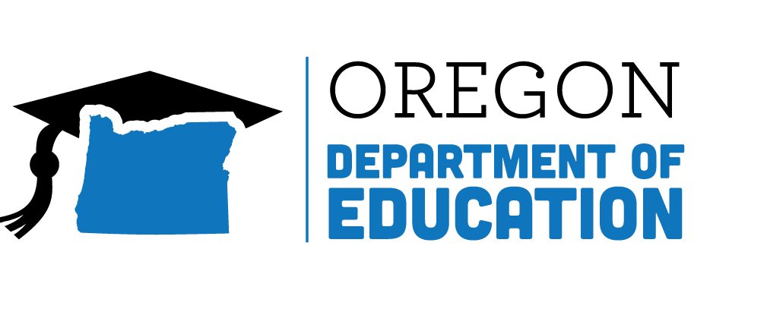
Teacher-Mentor COLLABORATIVE DISCUSSION GUIDE
Mentee: |  | Mentor: |  | Date & Time:
Grade Level/Subject:
SLGs/Goals:
Check all that apply:
- Modeling Lesson  - Observing Instruction  - Discussing Content Standards | - Planning Lesson  - Problem Solving  - IEP Development/Meeting |  | - Pre-Observation Conference  - Post-Observation Conference  - Observing Veteran Teacher |  | - Communication with Parents  - Discussing Case Study Student  - Reflecting
Successes (improvement strategies, building relationships, management, etc.): |  |  | Focus (challenge, concern, collaborative project, etc.):
Evidence/Data |  |  | Evidence/Data
Mentee’s next steps: |  |  | Support Needed From Mentor:
Next meeting date and time: |  |  | Focus:

District Puts Own Teacher Evaluation Rubric Here (Danielson, Marzano, Marshall, Legends, etc)

Professional Responsibilities | Planning & Preparation | Classroom Environment | Instruction
- Reflecting on Teaching | - Knowledge of Content & Pedagogy | - Environment of Respect & Rapport | - Communicating with Students
- Maintaining Accurate Records | - Knowledge of Students | - Culture for Learning | - Question & Discussion Techniques
- Communicating with Families | - Setting Instructional Outcomes | - Managing Classroom Procedures | - Engaging Students in Learning
- Participating in Professional Community | - Knowledge of Resources | - Managing Student Behavior | - Using Assessments in Instruction
- Growing & Developing Professionally | - Designing Coherent Instruction | - Organizing Physical Space | - Flexibility & Responsiveness
- Showing Professionalism | - Designing Student Assessments

Based on models of Cognitive Coaching from Costa and Garmston, Collaborative Coaching from West Ed, and Appreciative Inquiry from https://appreciativeinquiry.champlain.edu/ as adapted by TeachOntario Canada in Mentoring for All, and New Teacher Center CAL, 2016

