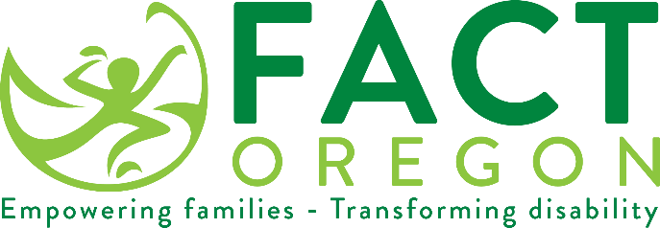

Sample Early Childhood Special Education Survey Letter

Hello,

The Oregon Department of Education (ODE) conducts a parent survey each year to learn how well [ECSE Programs] are reaching out to parents of children in special education. If you receive a survey, please fill it out and return it in the self-addressed, stamped envelope or complete the online version by going to the stated web address.

The survey results report the percent of families who report that early childhood special education services have helped the family:
A. Know their rights;
B. Communicate their children's needs effectively; and,
C. Help their children develop and learn.

[ECSE Programs] is committed to engaging parents in their child’s education. Parents are a valued part of our team and essential in developing and implementing your child’s IFSP. Your participation enhances the effectiveness on your child’s early intervention program and can have a positive impact on your child.

If you have questions regarding services through [ESD], please contact [name] at [phone number]. We value your input and encourage your participation.

Mandy Stanley
mandy.stanley@ode.oregon.gov
503-551-1364

Sincerely,

XXXXXX

