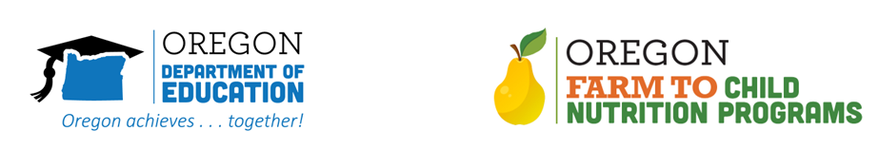

Introduction

This Toolkit is designed to help school districts communicate about their farm to school programs and how they use school gardens to engage students and promote healthy food choices.

We recognize how important it is to help students, families, staff, school board members, local officials and other members of the community understand how state and local funding has been used to design and implement school gardens and locally-sourced farm to table meals at school. Through greater awareness, these programs have an opportunity to flourish, impacting more students and families over time.

Background on Oregon’s Farm to School Program
Oregon Department of Education established its farm to school program in 2009. At the heart of this work is fostering a space for students and staff to engage in garden-based education while building curiosity and shared awareness of healthy food choices. The program supports purchases of Oregon foods for meal programs which supports the local food system, connects students with their communities, and provides nourishing meals that also serve as educational opportunities.

How Many Programs Exist?
Oregon currently has 788 school gardens, and approximately 400 Sponsors of the National School Lunch Program and the Child & Adult Care Food Program that are reimbursed for Oregon grown and processed food through the ODE Child Nutrition Program Farm to School Grant. We are proud to support this work!

What’s in this Toolkit?
This toolkit contains templates, draft language and ideas for districts to use to communicate effectively with their local community.

For additional resources, or for support with telling your local stories, please contact Rick Sherman.
503-385-6998
Rick.sherman@ode.oregon.gov | www.bit.ly/f2sor

