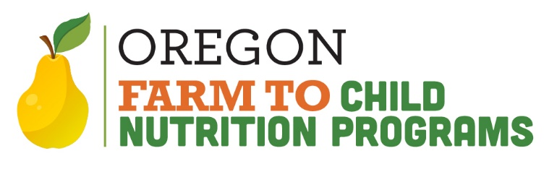

Hello all,

On my first day working at this job, the very first question I got was “how many school gardens ARE there in Oregon?” Of course, this was not an easy question to answer, and I found out there was really no way to find out easily. Furthermore, I was told that it would be too difficult to devise a system to get this information, as all other States don’t know this information as well! I didn’t have the first clue as to how many there are. So, I put it as one of my goals to figure this out. I then called each and every school in Oregon. I personally called over a thousand schools whenever I had a few minutes to spare every day over the course of over three months with a simple “yes or no” question: Do you guys have a school garden?

The next step was to circle back with these schools and identify a “person in charge” of the garden, with contact information so we could disseminate information. We have since found out that most of these garden personnel felt all alone, and have been able to connect with them so they can find one another in their own communities for support. We have invited all to our first annual School Garden Summit in January 2014, and are continuing to expand on this support by creating regional school garden “hubs” in many areas.

The result of all of this is the Oregon school garden map, which can be found when you go to the ODE Farm to CNP website and click on the school garden webpage. At the completion of the first phase of the project, 386 gardens were identified. After years of research and reconnecting with the schools, as of 3/1/24 we are at 788 gardens!

The pdf county map shows how many schools in each county have gardens. I started with a list of approximately 2,000 schools. Schools are identified as schools that participate in the NSLP as those are the schools that I can support. Many schools are listed multiple times, but have the same address, like K-12’s or high schools that have four or five “schools” under one roof. After all that, we landed on approximately 1200 properties that would have the possibility of having a garden or not. This is the number that is represented on the map. Each county has a box that has a format of: # of gardens / total schools, and the percentage of those schools that have gardens. Also, these “schools” don’t necessarily fit in neat and tidy categories. Examples are charter schools, private schools, residential child care institutions, camps, etc.

Oregon was the first State to identify all of our gardens. I have an accompanying database in which to track baseline data for our school gardens, so we can see our potential growth. This data is in the process of being updated automatically each year, as there is no way I want to make all those phone calls again! The neat thing about this list is that I have a place to start to find out how our program grows, and a list of contacts to disseminate information such as school garden food safety and best practices. The next step is to send an email to all contacts confirming the status of the Garden Coordinator, and then send a link to the new garden food safety manual and invitation to join the Oregon Farm to School/School Garden Network mailing list to disseminate more information like this.

Rick

Rick Sherman
Farm To School / School Garden Coordinator
Oregon Department of Education
Phone: (503) 947-5863
Email: Rick.Sherman@ode.oregon.gov

