July 28, 2017

TO: Child Care Centers, Adult Day Care, Head Start, At Risk, Homeless and Outside School Hours Programs participating in the Child and Adult Care Food Program

RE: CACFP Reimbursement Rates for FY 2017-2018
Effective July 1, 2017 – June 30, 2018

The Oregon Department of Education Child Nutrition Programs (ODE CNP) announces the annual adjustment to the national average payment rates plus cash-in-lieu of commodities for meals served in child care centers, adult day care, Head Start, at-risk, homeless and outside school hours programs, effective July 1, 2017, through June 30, 2018.

Breakfast | Rate
Free . . . . . . . . . . . . . . . . . . | $ 1.75
Reduced Price . . . . . . . . . . | $ 1.45
Above Scale. . . . . . . . . . . . | 0.30 ¢

Lunch-Supper | Rate | Cash-in-lieu | Total
Free . . . . . . . . . . . . . . . . . . | $ 3.23 | + 0.2325 ¢ = | $ 3.4625
Reduced Price . . . . . . . . . . | $ 2. 83 | + 0.2325 ¢ = | $ 3.0625
Above Scale. . . . . . . . . . . . | 0.31 ¢ | + 0.2325 ¢ = | .5425 ¢

Supplement (Snacks) | Rate | Reimbursement Rates:  (All amounts are expressed in dollars or fractions of dollars)
Free . . . . . . . . . . . . . . . . . . | 0.88 ¢
Reduced Price . . . . . . . . . . | 0.44 ¢
Above Scale. . . . . . . . . . . . | 0.08 ¢

If you have questions concerning the reimbursement rates, please contact your assigned Child Nutrition Specialist.

Sincerely,
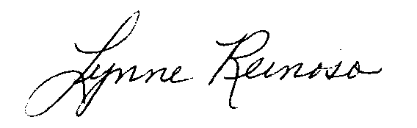
Lynne Reinoso, Manager, Community Nutrition
Child Nutrition Programs
Office of Student Services

K:\~Memos\_CACFP Memos-Unnumbered\2017-18\Adult\Reimbursement Rates\Memo 7-28-17.docx

