Direct Certification Download Issues

ODE CNP has identified two errors with the direct certification downloads and have work arounds until the fix can go into production.

The first is the weekly download email that notifies sponsors they have a download waiting. After performing the steps to download the file, the sponsor receives the message that the data file is empty.

To work around this, instead of using the first radio button on the left hand side of the screen “New Direct Certifications since your institution’s last download only” use the second radio button “Download Weekly Results”. On the right hand side of the screen, choose the months you want to download, then click SNAP and/or Foster. Make sure to click the “Hide Duplicates”

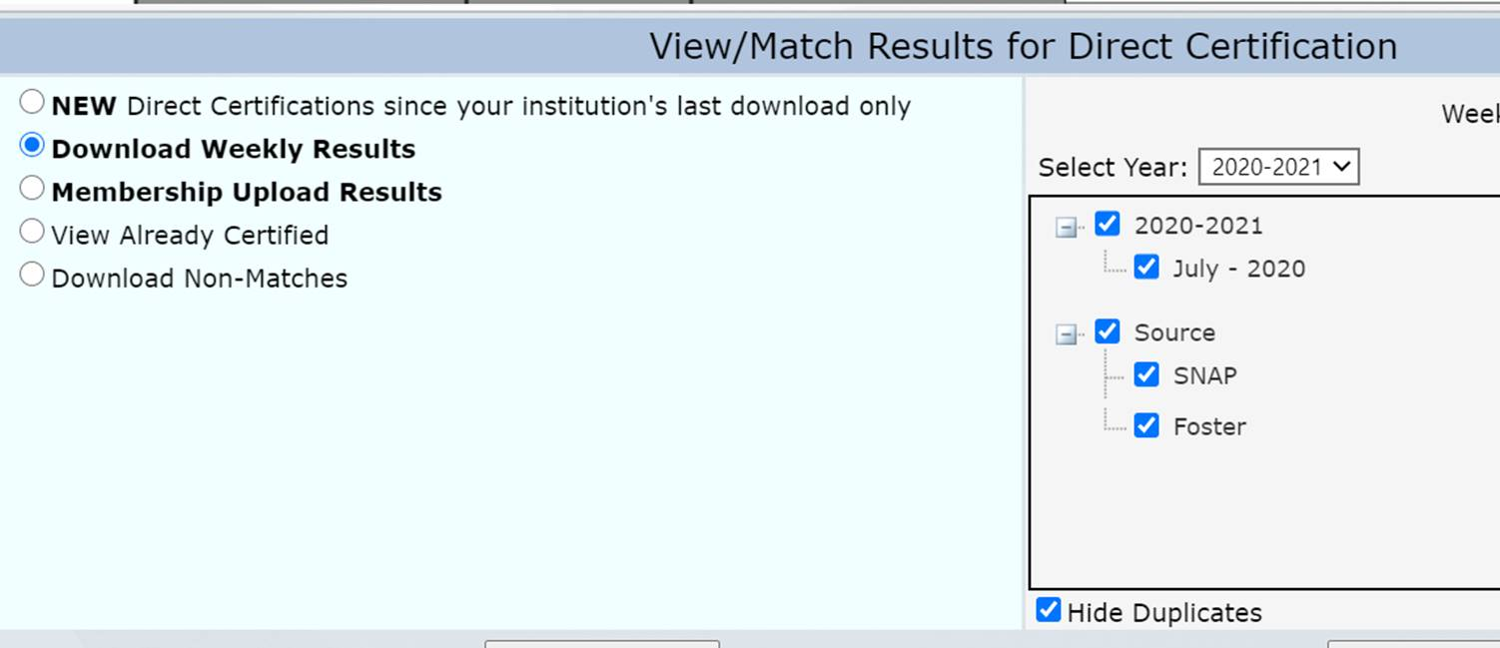

You will receive the weekly download in your email. When you open it, you will see the second issue is that there are duplicate Student ID numbers in column S (DistrictStdntID).

To remove these, filter on column U (SSIDMatchCode). Go to the data tab, click on filter, then go to the drop-down on column U and choose “Y2”.

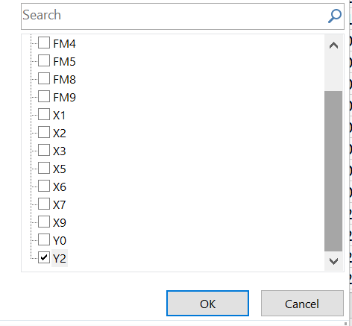

Then change all of the numbers in column S to “0”

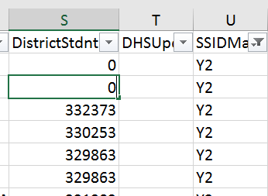

Remove all of the filters, and save your file. You should now be able to upload into your Nutrition Software.