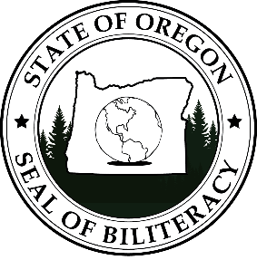

Oregon State Seal of Biliteracy
Data Submission Timeline
2022 Graduation Year

Post-Secondary - WINTER 2022
Data Submission ------------------------------------------------------ Jan. 7 to Jan. 14
Data Verification -------------------------------------------------- Jan. 17 to Jan. 21
Printing --------------------------------------------------------------------------- Jan. 24 to Jan 28
Mailing Certificates/Seals ------------------------- Jan 31 to Feb. 4

K-12 - SPRING 2022:
Data Submission ------------------------------------------------------ April 21 to May 6
Data Verification -------------------------------------------------- May 9 to May 13
Printing -------------------------------------------------------------------------- May 16 to May 20
Mailing Certificates/Seals ------------------------- May 23 - May 27

Post-Secondary – SUMMER 2022
Data Submission ------------------------------------------------------ June 6 to June 10
Data Verification -------------------------------------------------- June 13 to June 17
Printing --------------------------------------------------------------------------- June 20 to June 24
Mailing Certificates/Seals ------------------------- June 27 to July 1

All - FALL 2022:
Data Submission Fall ------------------------------------------ Sept. 8 to Oct. 14
Data Verification --------------------------------------------------- Oct. 17 – Oct. 21
Printing -------------------------------------------------------------------------- Oct. 24 to Oct. 28
Mailing Certificates/Seals -------------------------- Oct. 31 to Nov. 4
Oregon achieves . . . together!

