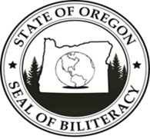
Currently, all 50 states and Washington DC are either in the early stages or have fully adopted a statewide Seal of Biliteracy. The Oregon Department of Education approved the Oregon State Seal of Biliteracy (OSSB) in April of 2016, after a successful pilot year.

The intent of the Seal of Biliteracy is to recognize and value the native language/s students speak and bring to their English academic studies, to value language programs in schools, to encourage students in the study of languages, and to create generations of citizens, ready for a multilingual society.

The Oregon State Seal of Biliteracy recognized 22 different languages in 2020, including Chinuk Wawa, Nez Perce, and Umatilla, three of the languages spoken by several of the nine federally recognized tribes in Oregon. In addition, students from the Oregon School of the Deaf earned the Seal in American Sign Language (ASL).

The Oregon State Seal of Biliteracy is the first in the nation to collaborate with post-secondary institutions to offer the Seal. Currently, two state universities and one community college offer the Biliteracy Seal to their students.

OREGON STATE SEAL OF BILITERACY – 2019-2020
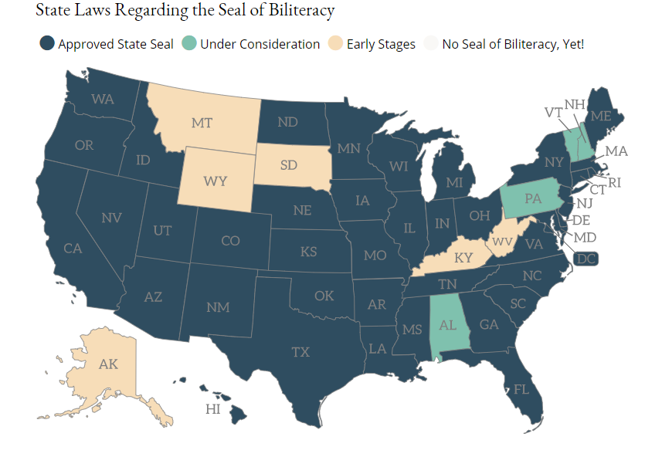

There are many benefits for students earning the Seal of Biliteracy. Students new to a school district may sit for a partner language assessment and earn World Language high school credit, freeing them to take other credits necessary to graduate. Students may also earn credit or course considerations when applying for admission to post-secondary institutions, depending on the assessment used. Through the OSSB, Oregon has the opportunity to encourage its recipients to enter into the teaching profession and help to increase the number of teachers who more closely represent the diversity of Oregon students.

Additional benefits come in the area of employment, as employers learn more about the Seal and begin to seek biliterate employees. This recognition will also serve the students as they aspire to enter programs and opportunities that look for students who are ready to contribute to a global society.

There are also cognitive benefits to being bilingual. Studies show that the bilingual brain can focus, problem-solve, and multi-task at a higher level and that being bilingual is thought to delay the onset of dementia. ¹

GROWTH OF THE SEAL OF BILITERACY
(*2020 lower due to COVID)

Each year of the Oregon State Seal of Biliteracy has seen more districts participate. From 11 districts in 2015, there were 51 districts, including two charter schools, and one post-secondary institution, Chemeketa, George Fox, and WOU that participated in the OSSB in 2020. As the map to the left indicates, there are is more work to do to bring the OSSB statewide.

DISTRICTS IN OREGON OFFERING THE BILITERACY SEAL:
Amity | Lake Co. | Portland Public
Ashland | Lake Oswego | Redmond
Beaverton | Lincoln Co. | Reynolds
Bend-LaPine | McMinnville | Salem-Keizer
Bethel | Medford | Santiam Canyon
Canby | Molalla | Silver Falls
Central Linn | Mt. Angel | Siuslaw
Corvallis | Newberg | Springfield
Douglas Co | North Clackamas | St. Paul
Eagle Point | North Marion | Three Rivers/Jos. Co.
Estacada | North Santiam | Tigard/Tualatin
Eugene | North Wasco Co. | Tillamook
Forest Grove | ODE | West Linn/Wilsonville
Grants Pass | Ontario | Willamina
Greater Albany | Oregon City | Woodburn
Gresham-Barlow | OSD | Chemeketa *
Hillsboro | Pendleton | George Fox *
Hood River | Phoenix-Talent | Western Oregon *
Criteria for Earning the Oregon State Seal of Biliteracy
Students must meet three criteria to earn the OSSB from their Oregon high schools. Two of these three criteria must be met by the spring of the student’s senior year. The student must be on track for graduation and meet the state English language proficiency assessment in both reading and writing (this criteria was waived for 19-20). Students must also score at the Intermediate High level on a partner language assessment. The partner language assessment can be taken at any time during high school and the scores banked until the student graduates.

Data Submission
There are two opportunities for districts to submit OSSB candidate information: through spring and fall collections. The data collection windows for the spring and fall collections are as follows:
- Spring – Thursday, the third week of April through Friday, the first week of May
- Fall – Thursday, the first full week of September through Friday, the last week of September/first of October.
Beginning the school year of 2020-2021, there will be two additional data collection windows to accommodate post-secondary institutions offering the Seal:
- Winter – Thursday, the first week of January through Friday, the third week of January
- Summer – Thursday, the first week of June through Friday, the third week of June

However, built into the Biliteracy Seal data collection is the opportunity for students who graduated up to two years prior, to still earn the Biliteracy Seal, upon proof of meeting all three criteria, should the high school missed submitting the student or the district hadn’t yet established a Biliteracy Seal program..

Approved Assessments
The assessments approved by Oregon for the SoBL are varied in languages offered and in cost. They are called Partner Language Assessments and students demonstrate their proficiency in a language/s other than English. Students will assess in all four domains of reading, writing, listening, and speaking. To see a complete list of approved assessments, see appendices.

Language of Origin Makes a Difference
The language a student first learned to speak affected the demographics of students who earned the Biliteracy Seal in 2019. The majority of the students who earned the Biliteracy Seal spoke English as their primary language, very closely followed by students who spoke Spanish is their primary language. Subsequently, Spanish was most frequent language in which students demonstrated intermediate high proficiency to earn the Biliteracy Seal.

<5 in Bambara, Catalan, Creole/Pidgin, Danish, Hindi, Hungarian, Kannada, Karen, Khmer, Lao, Lithuanian, Mayan, Norwegian, Tamil, Thai, Tibetan, Udmurt, Xhosa, Amharic, ASL Filipino, Hebrew, Italian, Portuguese, So. American Indian, Somali, Tagalog, Telugu, Turkish, Gujarati, Persian.

<5 in Amharic, Nez Perce, Portuguese, Tagalog, Filipino, Hebrew, Polish, Chinuk Wawa, Somali, Korean, Romanian, Umatilla

However, it is important to look at the English Learner (EL) status of the students (K-12 only) earning the Oregon State Seal of Biliteracy to get a clear picture of who has access to this award. Although an initial analysis indicates that the majority of the students who earned the Biliteracy Seal were Never EL students, a deeper analysis shows that when Never EL students’ primary language was analyzed, there were many more Heritage language speakers than native English speakers earning the OSSB. The graphics below indicate the percentage of students who were currently in program, who had exited program, and who have never been in the EL program.

Out of the 54,745 EL students in Oregon schools in 2020, 1,116 earned the OSSB for a representation of 2.12%.

Dual, Transitional Bilingual, and Revitalization Programs Bring Students to the Seal
In 2020, through collaboration with Tribal Government to Government Education Committee members and Directors from the Confederated Tribes of the Grand Ronde Community and the Confederated Tribes of the Umatilla Indian Reservation, and due to their exemplary language revitalization efforts, eight students earned and the Oregon State Seal of Biliteracy in the Chinuk Wawa, Nez Perce, and Umatilla languages.

Other students learn English and another language by participating in Dual Language and Transitional Bilingual programs. This program participation data point was added to the Biliteracy Seal data collection in 2020. Districts indicated if a student who, for one year or more, had participated in a course of study where academic content is taught in English and another language. This data is included to demonstrate the connection between these two programs and attainment of the Oregon State Seal of Biliteracy.

24.4% of all OSSB recipients participated in a Dual Language or Transitional Bilingual course of study sometime in their academic studies prior to graduating high school.

Student Demographics by Race and Ethnicity
Of the 2,427 high school students who graduated in 2020 and earned the Biliteracy Seal, 1,199 identified themselves as Hispanic. The remaining 1,228 students were mostly white, followed by Asian, Black, and American Indian/Alaska Native. Just under 100 students identified as Multi-Racial with two or more races indicated. One of the flaws in this analysis is that often AI/AN students also identify as Hispanic, so they become invisible in the count and appear in the Multi-Racial numbers, as do other race groups.

Beginning 2021, data on gender, race, and ethnicity will be collected at the post-secondary level.

To portray a more accurate picture of who the students are that earned the Biliteracy Seal, three categories are used to tell a more inclusive story. This method was approved by the Office of Indian Education for the American Indian/Alaska Native student data and has been carried over to other racial groups for the purpose of this report. The first category is to account for students and the single race and Not Hispanic/Latino/a/x. The second is to look at the students who are one or more race, Not Hispanic/Latino/a/x. The last category looks at a single race and Hispanic/Latino/a/x.

There are still limitations to this type of racial analysis, as the five races indicated in the data collection do not identify students from Eastern Europe or Mediterranean countries and don’t reflect the entire identity of the student.

First in the Nation to Offer OSSB in Post-Secondary
Oregon is the first state in the nation to promote and include post-secondary colleges and universities in the statewide Biliteracy Seal program. It began with a presentation before the Higher Education Coordinating Commission in 2017 and led to a partnership with Chemeketa Community College’s language department. After in-depth collaboration and examination of criteria and assessments, and through Chemeketa’s Spanish Heritage Language coursework, the first students earned the Biliteracy Seal in 2017. This collaboration is integral, since participation in the Biliteracy Seal is optional for districts. Not every high school offers the Biliteracy Seal, so many students were entering Chemeketa without the opportunity to earn it and wanted that distinction for career and advancement considerations.

The Higher Education Coordinating Commission is partnering with the ODE to create a statewide understanding of the criteria and rigor, with the goal of having a uniform method to either award students who have earned the Biliteracy Seal in high school course credit or placement considerations, and develop a program at their level to award the Biliteracy Seal for post-secondary efforts.

Current Post-Secondary Criteria

National Efforts to Recognize Biliteracy

H.R.3119 – Biliteracy Education and Teaching Act – Introduced and then referred to the House Committee on Education and Labor on June 5, 2019. This bill directs the Department of Education to award renewable two-year grants to states to establish or improve, and carry out, Seal of Biliteracy programs to recognize student proficiency in speaking, reading, and writing in both English and a second language.
