“1492.0”
by Jonnie Tate Walker, Mniconjou Lakota and an enrolled citizen of the Cheyenne River tribe in central South Dakota
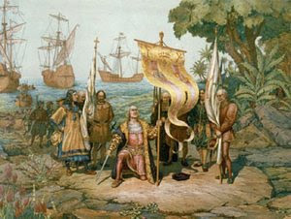
In fourteen hundred ninety-two
An explorer sailed for Asia true
But lost, got he, this Italian chap
Unsure East from West – who needs a map?

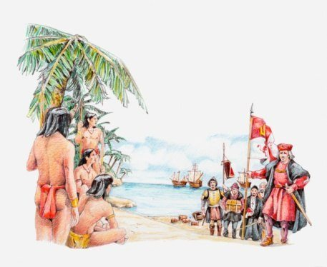
So upon an island Columbus’ ships did land
Land filled with many a child, woman, and man
Despite the Taino Arawak people, Columbus did proclaim
“’Tis the Indies! (Or whatever. I declare it for Spain.)”

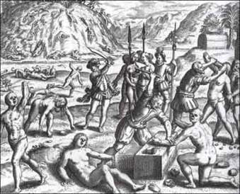
The explorer could do no wrong
His wit was short as his sword was long
He demanded gold from the people there
When he got some – then none – he did despair
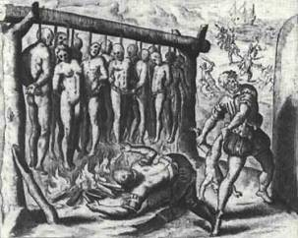
So he murdered and pillaged and raped with abandon
All of which he journaled and recorded from his cabin
And to the royals of Spain he did report
“To bodies, not gold, we shall resort.”

For Columbus had found – yes, discover he did
A new use for the savages, on whose mortal parts the wealthy bid
Money for slaves – his voyages he could salvage
And salvage his name (cuz dehumanizing Natives grants modern passage)

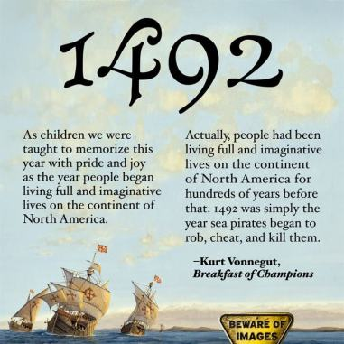
Instead of “Lost Explorer” he could be credited
With discovering America (history edited)
Nevermind the people already here
Most would be dead in a few hundred years

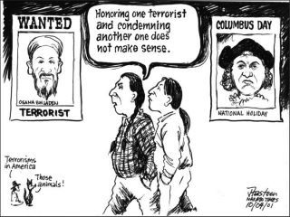
Now this lost explorer, this terrorist bloke
Makes our country look the biggest joke
As the masses cry “Hero!” and celebrate his deeds
Indigenous people continue to bleed

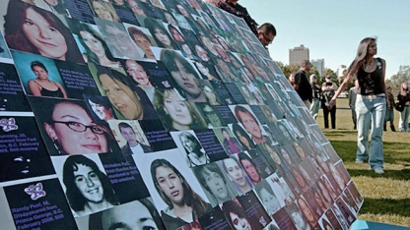
Assault, rape, human trafficking, and death
Columbus squeezed ‘til we breathed our last breath
And today – his legacy – our women still struggle for air
We go missing and murdered and… nobody cares

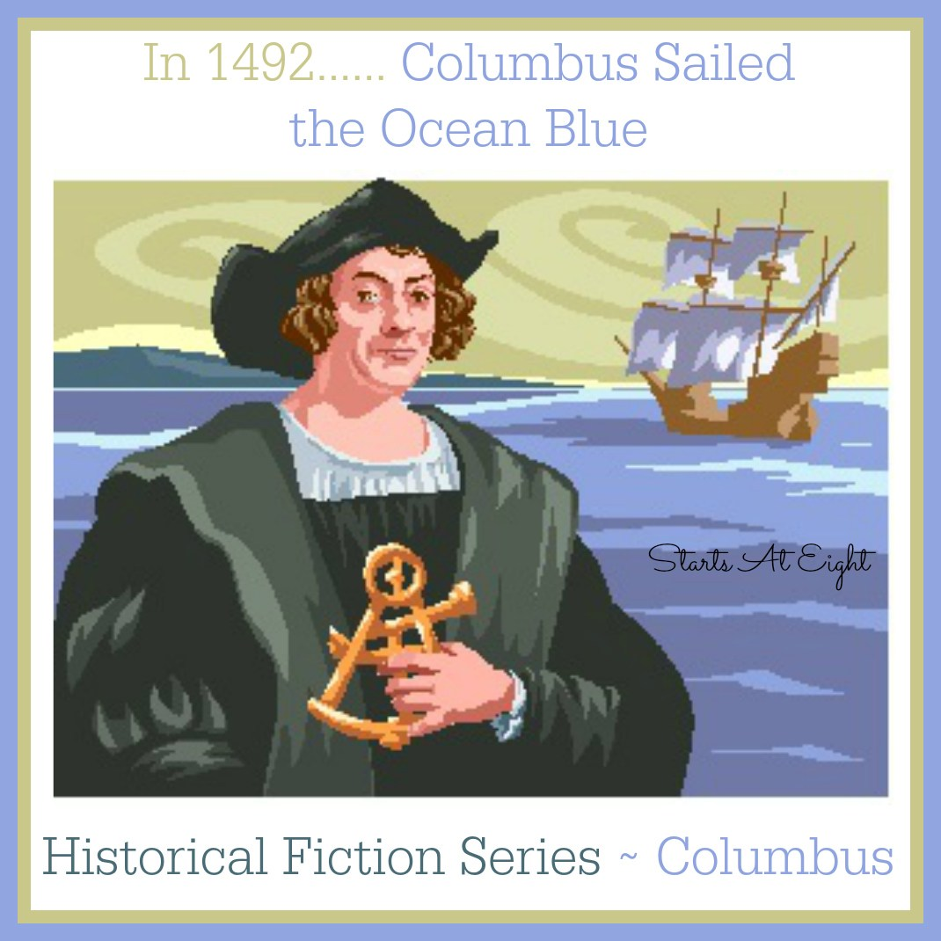
And our kids – Oh, our kids! – have lies shoved down their throats
Their history books filled with mythic discovery boats
“Columbus Day” we recognize every October
Fabrications and falsehoods repeated over and over

And yet
And YET
The stage has been set
By learneds and activists all covered in sweat

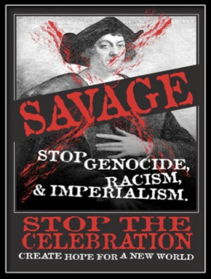
Fighting to educate our lawmakers and kids
“Better school curriculums!” we say, “Whitewashed histories we forbid!”
We march and we protest and we write up proposals
“Abolish Columbus Day – to the waste disposal!”
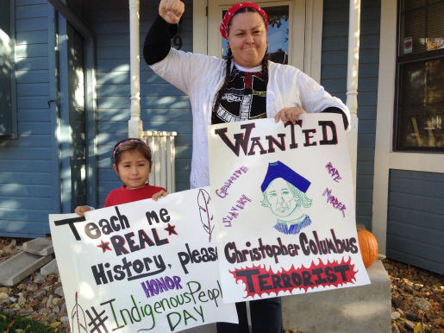
And while ridding the world of this monstrous wrongdoing
We find ourselves growing and evolving and pursuing
New heights to our knowledge, better ways to progress
Inclusion is possible with these grievances redressed

We ask all to consider – no – really, think bigger
So big a boom sounds in your brain’s pulled trigger
Let’s honor our nation’s first people, we say
Join us in celebrating Indigenous Peoples Day

