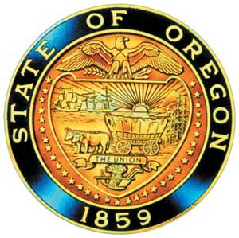
Tina Kotek, Governor

AI/AN Advisory Committee Members

Chair Tamara Henderson
Vice Chair Leilani Sabzalian
Angie Fasana
Portland, Position Open
Kainoa Sandberg
Sonya Moody-Jurado
Molly Hockema
Alternate: Marsha Frost
Chris Mansayon
Juliana Marez
Julie Bettles
Luhui Whitebear
Modesta Minthorn
Alternate: Pamela Shippentower
Nicole Butler-Hooten
Robin Butterfield
Sandy Henry
Shelby Maerz
Valerie Switzler
Diane Teeman

Office of Indian Education
April Campbell, Director
Renee Roman Nose, Native American Student Success Coordinator
Brent Spencer, Indian Education Coordinator
Brandon Culbertson, Education Engagement Coordinator
Stacy Parrish, Indian Education Specialist
Raina Reece, Executive Support Specialist
Jennifer Belle, Office Specialist
Natalie Altermatt, Executive Support Specialist

2023 Meeting Dates
May 9th, 2023

American Indian/Alaska Native Advisory Committee
April 11th, 2023
9:30 a.m. – 12:00 p.m.
Oregon Department of Education
Join by Zoom

AGENDA

9:30 1.0 Call to Order, Opening Remarks Chair Henderson
1.1 Opening Blessing TBD
1.2 Committee Roll Call/Introductions
1.3 Introductions & Welcome to Partners Chair Henderson

9:40 2.0 Review of March 2023 Minutes All

9:45 3.0 Office of Indian Education
3.1 SSP Update
3.2 Updates – April Campbell & Team

1o:10 4.0 Presentation Sody Fearn
4.1 Early Learning Transitions

10:30 Break

10:40 5.0 Presentation Valeria Atanacio
5.1 Raise Up Oregon: A Statewide Early Learning System Plan

11:00 6.0 OIEA Update

11:10 7.0 AI/AN Advisory Committee Business
7.1 Open Seat: Portland & New committee member process
7.2 Annual DAS-CHIRO- 2023 Preventing Discrimination & Harassment training

11:45 8.0 Community Comment Chair Henderson
Public testimony may be submitted ahead of time in writing to
AIAN.AdvisoryCommittee@OregonLearning.org
11:50 9.0 Other Business and Next Meeting Agenda Items All
9.1 Proposed May 9th meeting 9:30 a.m. – 12:00 p.m.
9.2 Next Steps

12:00 Adjourn

